American Experience The Codebreaker
Premieres Monday, January 11, 2021 on PBS

Season Opener Explores the Fascinating Secret Life of Pioneering Cryptanalyst Elizebeth Smith Friedman

(Boston, MA) — American Experience The Codebreaker tells the fascinating story of Elizebeth Smith Friedman, the groundbreaking cryptanalyst whose painstaking work decoding thousands of messages for the U.S. government would send infamous gangsters to prison and bring down a massive, near-invisible Nazi spy ring in WWII. A suburban wife and mother, she led a secret double life that would only come to light decades after her death, when classified government files were unsealed. But together with her husband, the legendary cryptologist William Friedman, Elizebeth helped develop the methods that led to the creation of the powerful new science of cryptology and laid the foundation for modern codebreaking today. Based on the book The Woman Who Smashed Codes: A True Story of Love, Spies, and the Unlikely Heroine Who Outwitted America's Enemies by Jason Fagone, the film is written and directed by Chana Gazit, produced by Chana Gazit and Hilary Klotz Steinman, and executive produced by Cameo George. Narrated by Kate Burton, The Codebreaker premieres Monday, January 11, 2021, 9:00-10:00 p.m. ET (check local listings) on American Experience on PBS, PBS.org and the PBS Video App.
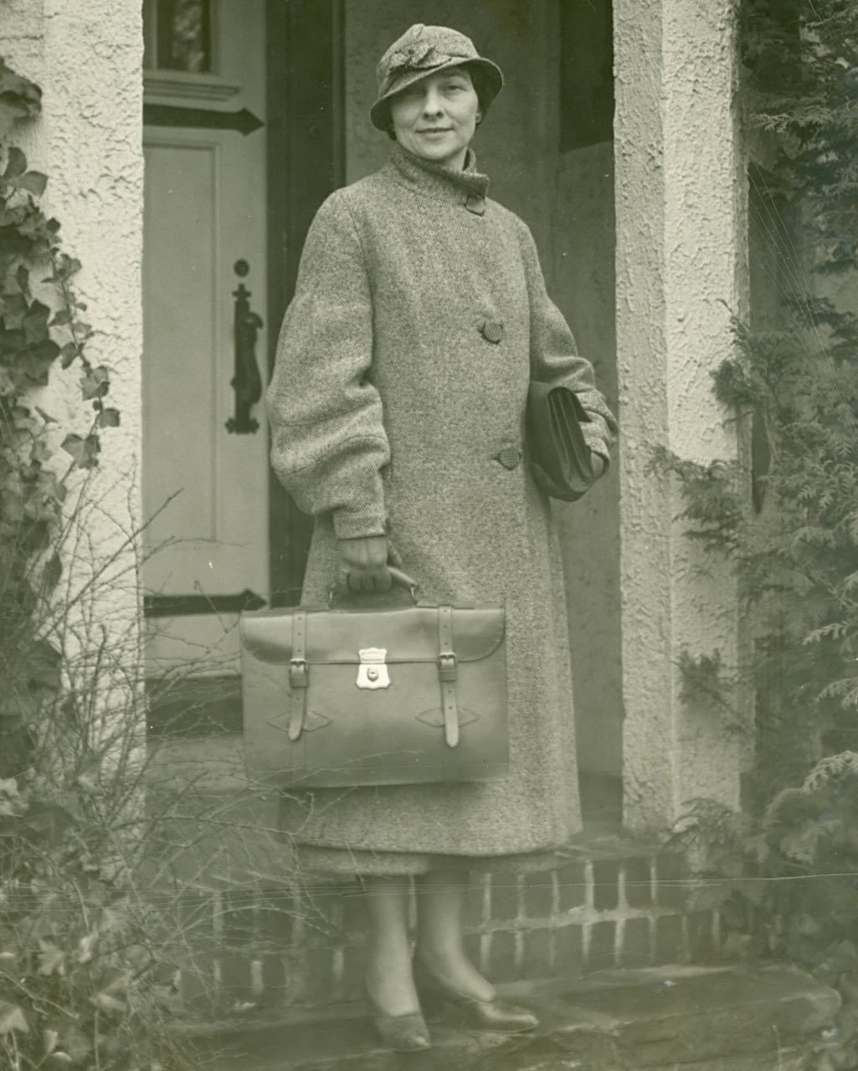
Credit: George C. Marshall
Foundation Library

"Elizebeth Friedman is someone you may never have heard of, but she had a tremendous influence on our country’s history,” said Cameo George, American Experience executive producer. “As a woman in a traditionally male-dominated field that she herself pioneered, she fought sexism throughout her career but, through sheer brilliance, was able to shape an amazing legacy — taking down mobsters and helping to win not one but two World Wars! We are excited to share her remarkable story with viewers.”

Born in 1892 into a Quaker family in small-town Indiana, Elizebeth dreamed of escape from an early age. Following graduation from college, she became a teacher but quickly tired of the job and traveled to Chicago searching for a new life. While there, she visited the Newberry Library to see a rare copy of Shakespeare’s 1623 First Folio. Noticing her interest in Shakespeare, the librarian insisted she meet a local millionaire industrialist who had a particular interest in the subject. Just hours after their meeting, George Fabyan whisked Elizebeth off to Riverbank, his massive 350-acre estate in Geneva, Illinois.

At Riverbank, the eccentric Fabyan had established a vibrant community of scholars and scientists — part think tank, part laboratory. He assigned Elizebeth to one of his pet projects – trying to prove that the works of Shakespeare were written by Francis Bacon, who had supposedly inserted a secret code into the plays that confirmed his authorship. The job was tedious, but Elizebeth discovered she had a remarkable talent for decoding ciphers and recognizing patterns.

She met William Friedman at Riverbank, a geneticist and amateur photographer who also pitched in on the project to photograph and enlarge the Shakespeare texts. Together they dug into Fabyan’s collection of codebreaking books, exchanging insights and ideas; they soon fell in love. They also concluded that Fabyan’s Shakespeare theory had no validity and was nothing but a pipe dream. They stole away from Riverbank, married, and planned to leave, but the advent of World War I changed their plans.

In part, the first world war was unlike any before, because the invention of radio allowed the transmission of encrypted secret messages. Since the U.S. had no codebreaking agency, Fabyan saw an opportunity to help his country and enhance his fame, establishing America’s first codebreaking unit with Elizebeth and William in charge. Soon they were breaking codes for the War, Navy, State and Justice Departments, inventing their own methodology along the way. But six months into the war, the Army established its own Cypher Bureau. The Friedmans moved to Washington D.C., where William went to work for the Army Signal Corps and Elizebeth cared for their growing family.

In 1925, the Coast Guard unexpectedly called on Elizebeth. Prohibition had triggered an explosion of criminal activity, with rum runners taking to the seas to deliver bootleg liquor up and down the coasts using sophisticated codes on shortwave radios. Understanding the damage organized crime was inflicting on the nation, Elizebeth discovered how criminal syndicates ran their enterprises and became a crucial witness in a series of dramatic trials, taking down the operations of some of the most notorious gangsters in the country.
Elizebeth’s work went beyond decrypting the messages. She weaponized the data she gathered to pioneer the development of strategic intelligence, establishing the model for today’s fusion centers.

Her country called again in 1941, following the attack on Pearl Harbor. Now working for the Navy, Elizebeth and her team were assigned to monitor communications between a South American Nazi spy ring and the German high command. German U-boats were attacking Allied transport ships and by March of 1942, Nazi submarines had sunk more than a million tons of supplies and killed thousands of soldiers. Unraveling the encrypted messages, Elizebeth soon identified Hitler’s top spy in South America, Sargo, whose network was transmitting the Allied ship locations, including that of the Queen Mary, the Allies largest supply ship. Before the Nazis could strike, Elizebeth was able to warn the captain, who safely brought the ship to port.

Elizebeth’s remarkable counter-intelligence operation was thwarted by J. Edgar Hoover, who, eager for glory, ordered the arrest of the South American spies, which made national headlines but cut off the government’s information pipeline. When Sargo eluded capture and rebuilt his network, it was Elizebeth who was asked to monitor his communications again. In the end, she gave information to the Allies that allowed them to break up the ring and prevent the Germans from gaining a foothold in South America. Within months, the Nazi threat in the Western Hemisphere was eliminated, but Elizebeth was forced to sign an oath promising her secrecy until death. She died in 1980 in a nursing home in New Jersey, taking her secret life to the grave.

About the Participants

Jason Fagone is a journalist at the San Francisco Chronicle and author of The Woman Who Smashed Codes.

Amy Butler Greenfield is the author of the upcoming YA biography Secrets & Spies: The Hidden Life of Codebreaker Elizebeth Smith Friedman.

David Hatch is an NSA historian at the agency’s Center for Cryptologic History.

Vince Houghton is director of the National Cryptologic Museum at the NSA in Maryland.

Barbara Osteika is a writer and former historian of the Bureau of Alcohol, Tobacco and Firearms (ATF).

Colonel Rose Mary Sheldon is the former chair of the history department at Virginia Military Institute and the author of the definitive guide to the Friedman Collection at the George C. Marshall Foundation Library.

American Experience The Codebreaker

Written and Directed by  Based on the Book  Produced by | CHANA GAZIT  THE WOMAN WHO SMASHED CODES  BY JASON FAGONE  CHANA GAZIT  HILARY KLOTZ STEINMAN
Edited by  Narrated by | JON NEUBURGER  KATE BURTON

American Experience is a production of GBH Boston
Executive Producer | CAMEO GEORGE
About the Filmmakers

Chana Gazit (Producer, Writer, Director) is an award-winning producer/director/writer with extensive experience in documentary filmmaking. Her work has been honored with multiple Emmy nominations and three Emmy Awards, and has been recognized by the Alfred I. duPont-Columbia Journalism Awards, the Peabody Awards, the Writers Guild Awards, and the Sundance Film Festival. Gazit’s portfolio includes seven films for American Experience: Chicago ‘68, Surviving the Dust Bowl, Meltdown at Three Mile Island, Fatal Flood, The Pill, Test Tube Babies, and The Forgotten Plague. Some of Gazit’s career highlights include two acclaimed PBS series: a four-part biography of Franklin Roosevelt and a four-part biography of Lyndon Johnson. Her films have been featured in major stand-alone series including: Healing and the Mind with Bill Moyers, Slavery & the Making of America, Destination America, This Emotional Life, Angle of Attack, and Broadway or Bust. Gazit is also the writer of award-winning television documentaries including All the President’s Men Revisited, Lincoln@ Gettysburg, Inside the White House, and Bill Moyers’ “Progressives.” Gazit recent work includes an episode for American Divided; a four-part series on Epix, an episode of the CNN series Soundtracks, a biography of Jeff Bezos and the rise of Amazon, and an exposé on the impact of captivity on the killer whales at SeaWorld.

Hilary Klotz Steinman (Producer) is an Emmy Award-winning producer and has been producing historical, vérité, and investigative documentary films for over 20 years, with a focus on women’s history and the impact of technology on American lives. Steinman’s previous collaborations with Chana Gazit for American Experience including the Emmy Award-winning film The Pill and Test Tube Babies. Steinman recently produced the independent documentary features Death By Design and Children of the Inquisition. Steinman was honored with the Christopher Award and an Emmy nomination for the PBS series Slavery and the Making of America and an Emmy nomination for her research on the Bill Moyers PBS series Becoming American: The Chinese Experience. Steinman’s work has also been featured on NBC, MSNBC, CNBC, Al Jazeera and at the New York Historical Society.

Cameo George (Executive Producer) is an Emmy Award-winning producer, writer, and journalist with more than 20 years of experience in documentary, broadcast television, and digital content production. George has produced, developed, and commissioned innovative programming at CNN, NBC News, ABC News, and digital media startup OZY.com. She was the senior producer of CNN’s groundbreaking series Black in America and Latino in America and the executive producer of the eight-hour PBS documentary series 16 for '16: The Contenders, which was also broadcast on the BBC. George joined American Experience from ABC News, where she was Head of Development for Longform projects, responsible for creating a pipeline of docuseries and feature documentary films across Walt Disney Television platforms including ABC News, Hulu, National Geographic, and Disney+.

About American Experience
For more than 30 years, American Experience has been television’s most-watched history series, bringing to life the incredible characters and epic stories that have shaped America’s past and present. American Experience documentaries have been honored with every major broadcast award, including 30 Emmy Awards, four duPont-Columbia Awards and 18 George Foster Peabody Awards. PBS’s signature history series also creates original digital content that innovates new forms of storytelling to connect our collective past with the present. Cameo George is the series executive producer. American Experience is produced for PBS by GBH Boston. Visit pbs.org/americanexperience and follow us on Facebook Twitter, Instagram and YouTube to learn more.

Major funding for American Experience provided by Liberty Mutual Insurance, Consumer Cellular and by the Alfred P. Sloan Foundation. Additional funding provided by the Robert David Lion Gardiner Foundation, The Documentary Investment Group, the Corporation for Public Broadcasting and public television viewers.

* * *
Press Contacts:
CaraMar Publicity
Mary Lugo 770-623-8190 lugo@negia.net
Cara White 843-881-1480 cara.white@mac.com
Abbe Harris 908-244-5516 abbe.harris@caramar.net

For further information and photos visit http://www.pbs.org/pressroom

