American Experience The Feud
Premieres Tuesday, September 10, 2019 on PBS

New Film Reveals the Real Story Behind the Infamous Hatfield-McCoy Feud

(BOSTON, MA) - The most famous family conflict in American history, the Hatfield-McCoy feud evolved into a mythic American tale of jealousy, rage and revenge – and one which helped create the negative “hillbilly” stereotype that has shaped attitudes towards Appalachia for more than a century. Yet the truth is much more than a tale of two warring families. It is the story of a region and its people forced into sudden change by Eastern capitalists, who transformed Appalachia from an agrarian mountain community into a coal and timber producing workplace owned and run primarily by outside interests. Written, directed and produced by Randall MacLowry and executive produced by Mark Samels, The Feud premieres Tuesday, September 10, 2019, 9:00-10:00 p.m. ET on PBS, PBS.org and the PBS App.
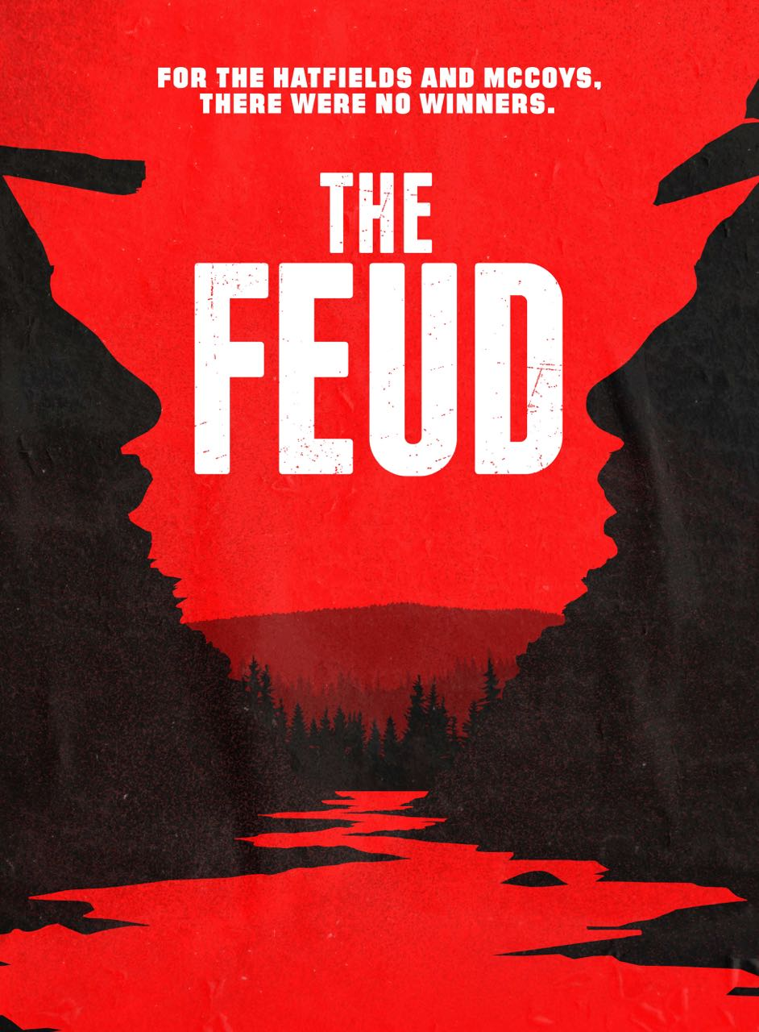
Deep in the rugged and remote mountains of Central Appalachia, the Tug Fork Valley was the edge of the American frontier in the early 1800s. The Hatfields and the McCoys were among the earliest white settlers in the valley, inhabiting both sides of the Tug Fork, which formed the border between Kentucky and Virginia (later West Virginia). Like most families in the area, the Hatfields and McCoys eked out a living by farming the narrow and steep hollows and foraging for game and wild edibles in the surrounding forests.
Anderson Hatfield, also known as “Devil Anse,” grew up on the Virginia side of the Tug. Randolph McCoy lived on a neighboring farm before moving with his wife and family across the river to Kentucky. These men would become the patriarchs of the legendary feud.
After the Civil War, which had divided loyalties in the region and created the new state of West Virginia, Tug Valley residents worked to rebuild their community. With industrialization increasing at a breakneck pace, investors began eyeing Central Appalachia for its natural resources. Industrialists saw the pristine forest not as a source of life and livelihood, but as the promise of great wealth.
Anderson Hatfield also saw new opportunities. He started his own timber company, and, despite being illiterate, proved to be a savvy and opportunistic businessman, hiring relatives and neighbors to man his crew. His workers floated logs down the Tug Fork to the Big Sandy River and on to the Ohio where sawmills churned out the lumber that was building America. Randolph McCoy, who struggled to support his family of 16 children on his small farm, bitterly resented Hatfield’s success.
On a Kentucky Election Day in 1882, an altercation sparked a dramatic escalation in the tension between the two families. A fight broke out leading to the death of one of Anderson Hatfield’s brothers at the hands of three of Randolph McCoy’s sons. Anderson decided to take justice into his own hands. With the help of family members and employees, he captured the three McCoy brothers and executed them. The violence shocked the community and Randolph wanted revenge, but there was little effort to bring the Hatfields to justice. A few years later, the feud was reignited when Perry Cline, a politically influential attorney and relation of Randolph McCoy who also had a grudge against Anderson Hatfield, convinced Kentucky’s governor to help facilitate the arrest of Hatfield and his men.

But it would be New Year’s Day 1888 that made the names “Hatfield” and “McCoy” famous across the country. That night, a group of men, led by two of Anderson Hatfield’s sons, surrounded Randolph McCoy’s cabin, intending to kill McCoy. As a gunfight broke out, the attackers set the cabin on fire. Randolph managed to escape, but two of his children were killed and his wife was severely injured.

News of the brutal crime made national headlines. The press decried not only the violence, but the mountain people’s entire way of life. “I have been away in Murderland for nearly ten days,” wrote a New York City journalist who published An American Vendetta, the first book to tell the tale of the feud. “No one would believe that there is in this country such a barbarous, uncivilized and wholly savage region.” To outside industrialists and urban America, the people of Appalachia were seen as backwards, violent and an obstacle to progress, and characterizing local families as uncivilized and different became part of a justification for dispossessing many of the mountaineers from their land.

After the Norfolk & Western completed its railroad through the Tug Valley, massive timbering operations denuded the hillsides, and company-owned coal camps spread along the creek bottoms where there once had been farms. By that time, Anderson Hatfield had sold his land to a coal agent and moved farther up in the mountains out of the Tug Valley. Like many of his neighbors, he had lost his land to outside capitalists.
The Hatfields, McCoys and other mountain families found ways to adapt to the new economic and social order or moved out of Appalachia altogether. But the legacy of the feud remained. And the “hillbilly” image, popularized by reports of the Hatfield-McCoy feud, continues to permeate American popular culture.

“The Hatfield-McCoy feud conjures up this exaggerated image of two warring families shooting at each other across a river for no good reason, but the story of the feud is really about the impact of capitalism and industrialization on rural America,” said producer/director MacLowry. “Mountain families lost their land and their livelihoods in the face of this enormous pressure, and became the victims of media accounts that depicted them as violent, uncivilized, and standing in the way of progress. The Hatfield-McCoy feud is part of that story.”

“The feud between the Hatfields and McCoys is the most famous family drama in American history, yet it is little understood,” said Mark Samels, executive producer of American Experience. “Restored to its full historical context and viewed from all angles, the story becomes a far richer tale of how powerful outside forces upended the lives of people caught between tradition and an uncertain future. No part of the country has suffered more from crude stereotypes than Appalachia, and no event played a bigger role in creating those negative images than the feud. It's a story that resonates as deeply today as ever before.”

The Feud will be available on DVD from PBS Distribution and can be purchased at ShopPBS.org.

About the Participants

Anthony Harkins is Associate Professor of History at Western Kentucky University and author of Hillbilly: A Cultural History of an American Icon and editor, with Meredith McCarroll, of Appalachian Reckoning: A Region Responds to Hillbilly Elegy.

Robert Hutton is Senior Lecturer in the Department of History at the University of Tennessee, Knoxville, and author of Bloody Breathitt: Politics & Violence in the Appalachian South.

Charles Keeney is a West Virginia historian and founding member of the West Virginia Mine Wars Museum.

Dean King is author of The Feud: The Hatfields and McCoys: The True Story.

Kimberly McCoy is a Hatfield family descendant who is married to a McCoy family descendant.

Bill Richardson is the curator of The Hatfield-McCoy Country Museum in Williamson, West Virginia.

Steven Stoll is Professor of History at Fordham University and author of Ramp Hollow: The Ordeal of Appalachia.

Altina Waller is Professor Emerita of History at the University of Connecticut and author of Feud: Hatfields, McCoys and Social Change in Appalachia, 1860-1900.

About the Filmmakers

Written and Directed by | RANDALL MACLOWRY
Produced by | REBECCA TAYLOR  RANDALL MACLOWRY
Edited by | MARK DUGAS
Narrated by  Coordinating Producer  Original Music  Cinematography | MICHAEL MURPHY  TRACY HEATHER STRAIN  TOM PHILLIPS  STEPHEN MCCARTHY  JUSTIN LITTON

American Experience is a production of WGBH Boston
Senior Producer | SUSAN BELLOWS
Executive Producer | MARK SAMELS

Randall MacLowry (Producer/Director/Writer) is an award-winning filmmaker who crafts documentaries and non-fiction media projects through The Film Posse, the production company he co-founded with his wife and business partner Tracy Heather Strain. A director, writer, producer and editor with over 30 years of experience, MacLowry’s credits include films for American Experience, most recently producing and directing The Swamp, The Battle of Chosin and The Mine Wars, NOVA, AMERICAN MASTERS, Unnatural Causes: Is Inequality Making Us Sick?, and Race: The Power of an Illusion. With Strain, MacLowry produced and edited the critically acclaimed Sighted Eyes/Feeling Heart, the first feature documentary about the late playwright and activist Lorraine Hansberry, which had its world premiere at the 2017 Toronto International Film Festival. MacLowry received a Writers Guild award for the 2013 NOVA episode The Fabric of the Cosmos: The Illusion of Time and the 2014 American Experience episode Silicon Valley, and his American Experience films The Gold Rush and The Mine Wars won the Organization for American Historians’ Erik Barnouw Award. MacLowry is a graduate of Wesleyan University, where he has served as a visiting instructor.

Mark Samels (Executive Producer) conceives, commissions and oversees all films for the PBS flagship history series American Experience. Samels has overseen more than 130 films, expanding both the breadth of subjects and the filmmaking style embraced by the series, allowing for more contemporary topics and witness-driven storytelling. Beginning his career as an independent documentary filmmaker, he held production executive positions at public television stations in West Virginia and Pennsylvania before joining WGBH. Samels is a founding member of the International Documentary Association and has served as a governor of the Academy of Television Arts & Sciences. A graduate of the University of Wisconsin, Samels holds honorary Doctor of Humane Letters degrees from Emerson College and Elizabethtown College.

About American Experience
For 30 years, American Experience has been television’s most-watched history series. Hailed as “peerless” (The Wall Street Journal), “the most consistently enriching program on television” (Chicago Tribune) and “a beacon of intelligence and purpose” (Houston Chronicle), the series brings to life the incredible characters and epic stories that have shaped America’s past and present. American Experience documentaries have been honored with every major broadcast award, including 30 Emmy Awards, four duPont-Columbia Awards and 17 George Foster Peabody Awards; the series received an Academy Award® nomination for Best Documentary Feature in 2015 for Last Days in Vietnam. American Experience also creates original digital content that uses new forms of storytelling to connect our collective past with the present. Visit pbs.org/americanexperience and follow us on Facebook, Twitter, Instagram and YouTube to learn more.

Major funding for American Experience provided by Liberty Mutual Insurance, Consumer Cellular and by the Alfred P. Sloan Foundation. Additional funding provided by the Robert David Lion Gardiner Foundation, The Documentary Investment Group: The Estate of Gwenn Therrien, in memory of Gwenn Therrien and Michael Blake, the Corporation for Public Broadcasting and public television viewers. American Experience is produced for PBS by WGBH Boston.

* * *
Press Contacts:
CaraMar Publicity
Mary Lugo 770-623-8190 lugo@negia.net
Cara White 843-881-1480 cara.white@mac.com
Abbe Harris 908-244-5516 abbe.harris@caramar.net

For further information and photos visit http://www.pbs.org/pressroom

