“The Gilded Age”

Premieres February 6, 2018, on PBS

TCA Panelists

Edward T. O’Donnell (Participant) is an Associate Professor of History at Holy Cross College in Worcester, MA. He is the author of several books including (as co-author) the U.S. History college-level textbook Visions of America: A History of the United States 3rd edition, Ship Ablaze: The Tragedy of the Steamboat General Slocum and Henry George and the Crisis of Inequality: Progress and Poverty in the Gilded Age.
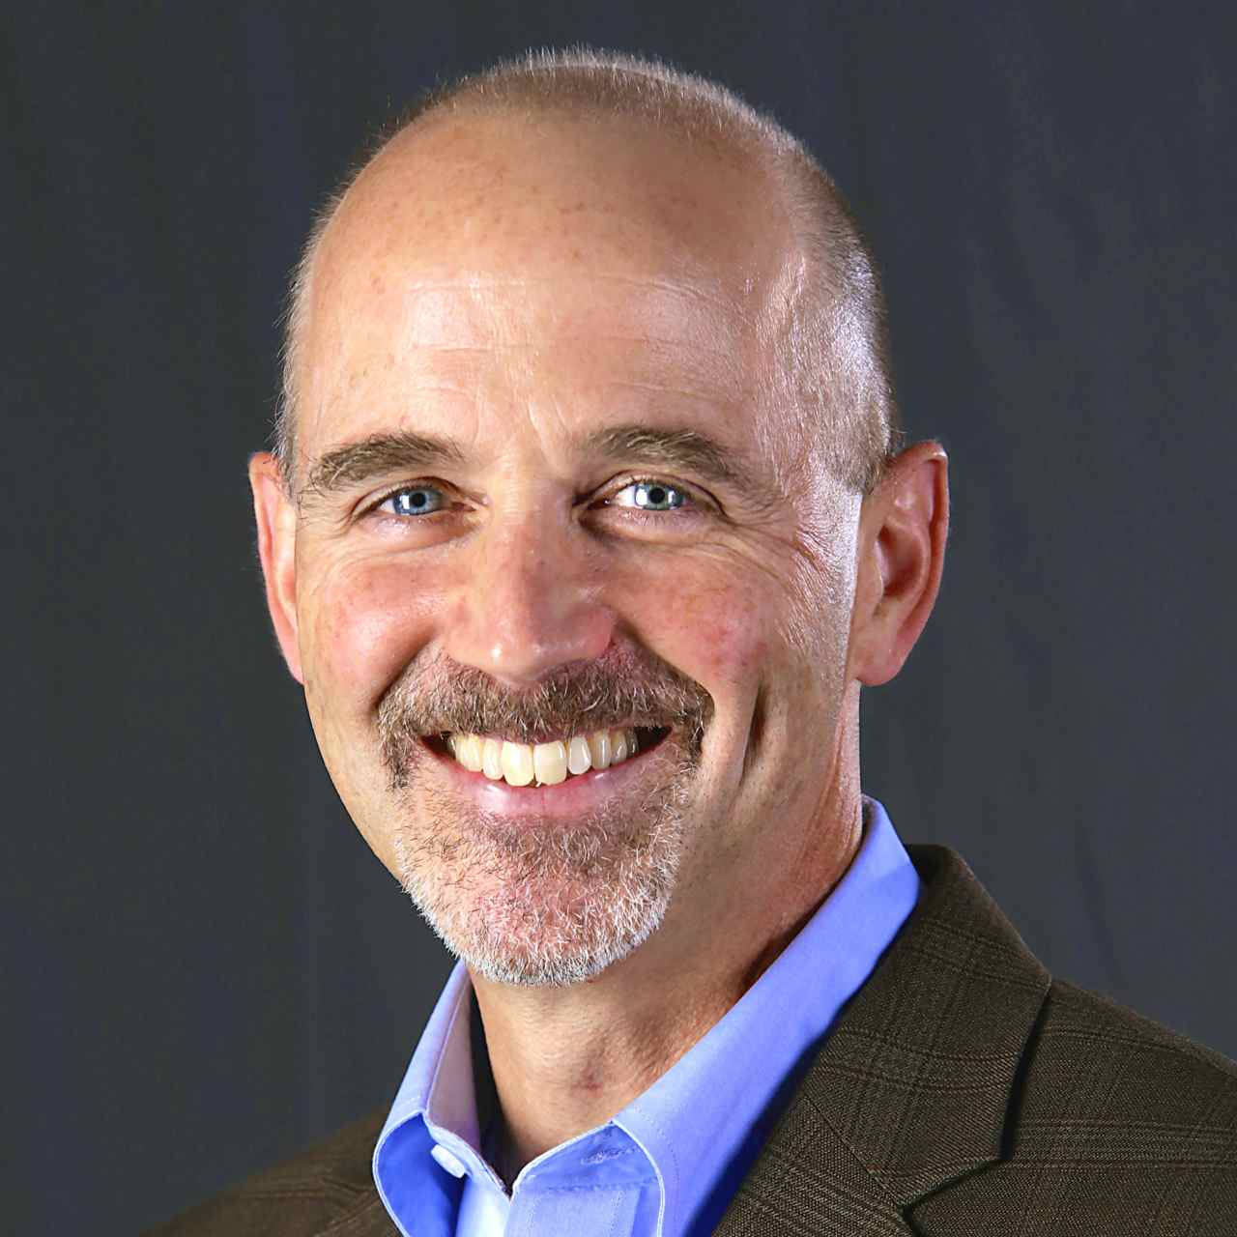

O’Donnell also hosts a popular podcast, In the Past Lane, that explores topics in U.S. history. He also writes history-themed opinion pieces for outlets such as the Huffington Post, Newsweek and The New York Times, and has created video courses for the Great Courses company titled “Turning Points in American History” and “America in the Gilded Age and Progressive Era.” He has curated several major museum exhibits on American history, has appeared in several historical documentaries, and provided historical insight and commentary for PBS, the Discovery Channel, the History Channel and NPR.

Nell Irvin Painter (Participant) is the Edwards Professor of American History, Emerita, at Princeton University. Her acclaimed works of history include Standing at Armageddon, Sojourner Truth and The New York Times best-seller The History of White People, which have received widespread attention for their insights into how we have historically viewed and translated ideas of gender, value, hierarchy and race. She holds an MFA from the Rhode Island School of Design and a BFA from Mason Gross School of the Arts. Her visual artwork has been shown at numerous galleries and in many collections, including the San Angelo Museum of Fine Art, the Brooklyn Historical Society and Gallery Aferro. She lives in Newark, New Jersey, and the Adirondacks.
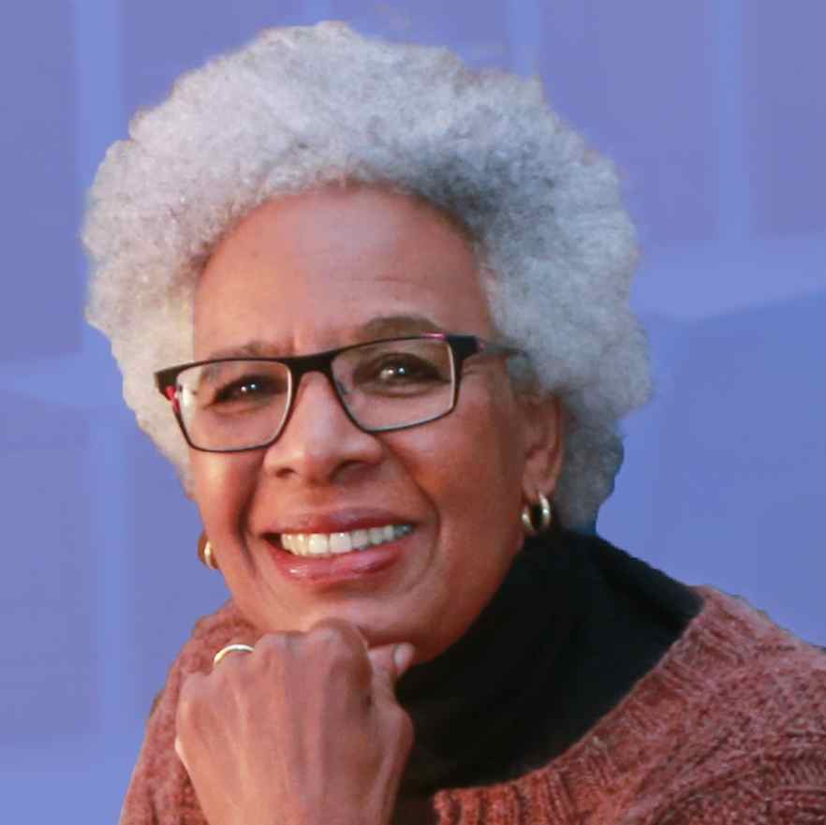
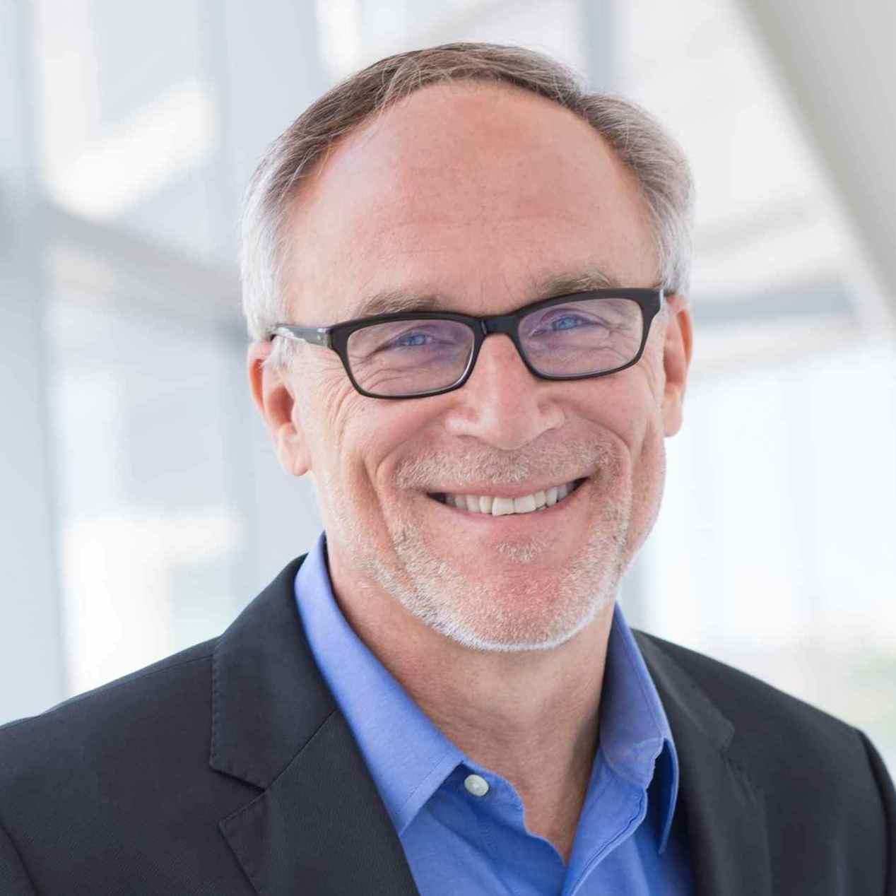
Mark Samels (Executive Producer of American Experience). As executive producer of the PBS flagship history series, Samels conceives, commissions and oversees all American Experience films. Samels has overseen more than 120 films, expanding both the breadth of subjects and the filmmaking style embraced by the series, allowing for more contemporary topics and more witness-driven storytelling. Beginning his career as an independent documentary filmmaker, he held production executive positions at public television stations in West Virginia and Pennsylvania before joining WGBH. Samels is a founding member of the International Documentary Association and has served as a governor of the Academy of Television Arts & Sciences. A graduate of the University of Wisconsin, Samels holds honorary Doctor of Humane Letters degrees from Emerson College and Elizabethtown College.

Mark Zwonitzer (Writer) is an author and documentary filmmaker specializing in American history and politics, with an emphasis on biography. He has been producing, directing and/or writing acclaimed documentaries for PBS for 25 years. His work for American Experience includes writing the Emmy-winning JFK and the Emmy-nominated Walt Disney; he directed the American Experience films Walt Whitman and The Massie Affair, among others. Additional work includes Battle of the Bulge (with Thomas Lennon), The Pilgrimage of Jesse Jackson, The Irish in America: Long Journey Home (Episode Two), Joe DiMaggio: The Hero’s Life (with Richard Ben Cramer), Transcontinental Railroad, and a four-hour history of the United States Supreme Court. His work in television has been honored with the duPont-Columbia Award, the George Foster Peabody Award, the Writers Guild Award, the American Bar Association’s Silver Gavel, the International Documentary Association’s Award for Outstanding Achievement in Limited Series, the Japan Foundation’s President’s Prize and numerous Emmy nominations.
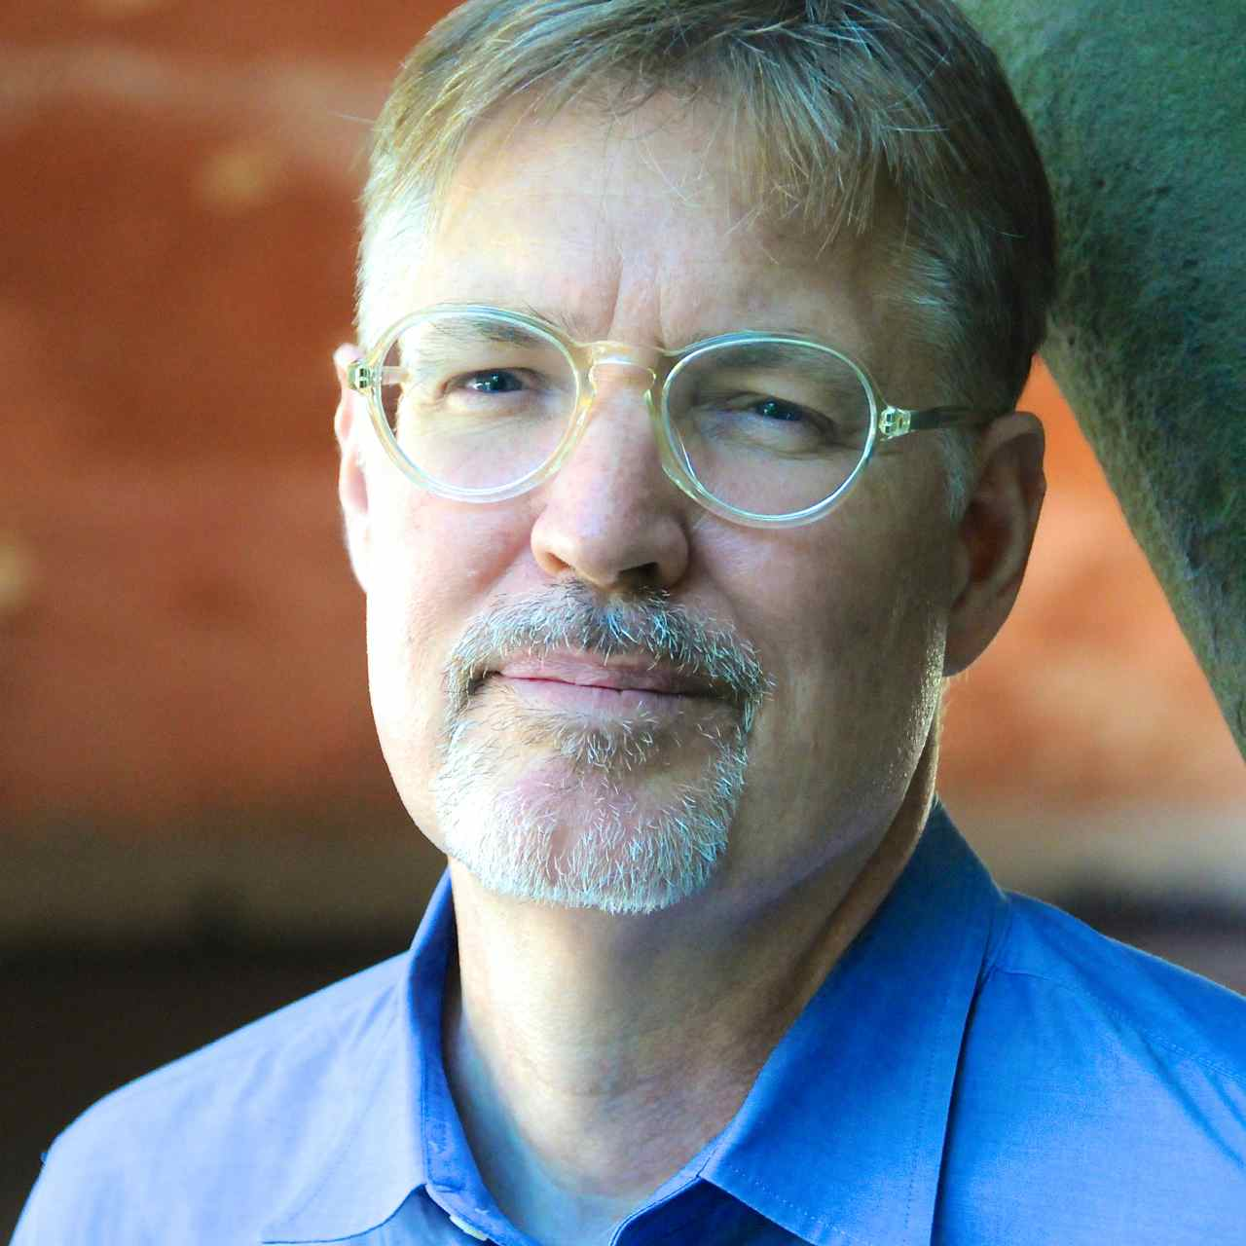

His most recent book, The Statesman and the Storyteller: John Hay, Mark Twain and the Rise of American Imperialism, was published in the spring of 2016. His first book, Will You Miss Me When I’m Gone (with Charles Hirshberg), was a finalist for the National Book Critics Circle Award, a New York Times Notable Book of 2002, and an American Library Association’s Booklist Editor’s Choice in biography.

###

