American Experience The Harvest
Premieres Tuesday, September 12, 2023, on
PBS and Streaming on PBS.org

Pulitzer Prize-winning Author Douglas Blackmon Explores His Experiences as Part of Leland, Mississippi’s First Integrated Public School Class in 1970

(Boston, MA) – Pulitzer Prize-winning author Douglas A. Blackmon looks back on his experience as a member of the first class of Black and white children to attend all 12 grades together in Leland, Mississippi, in The Harvest, a new documentary that premieres on American Experience Tuesday, September 12, 2023, 9:00-11:00 p.m. ET (check local listings) on PBS, PBS.org and the PBS App. The film, produced by Blackmon and Sam Pollard and executive produced by Cameo George, is a deeply personal depiction of one Southern town’s painful struggle to integrate its public schools and the continuing repercussions still felt more than 50 years later. The film, part of a special two-night event exploring the legacy of school integration, will be preceded by The Busing Battleground, premiering September 11.
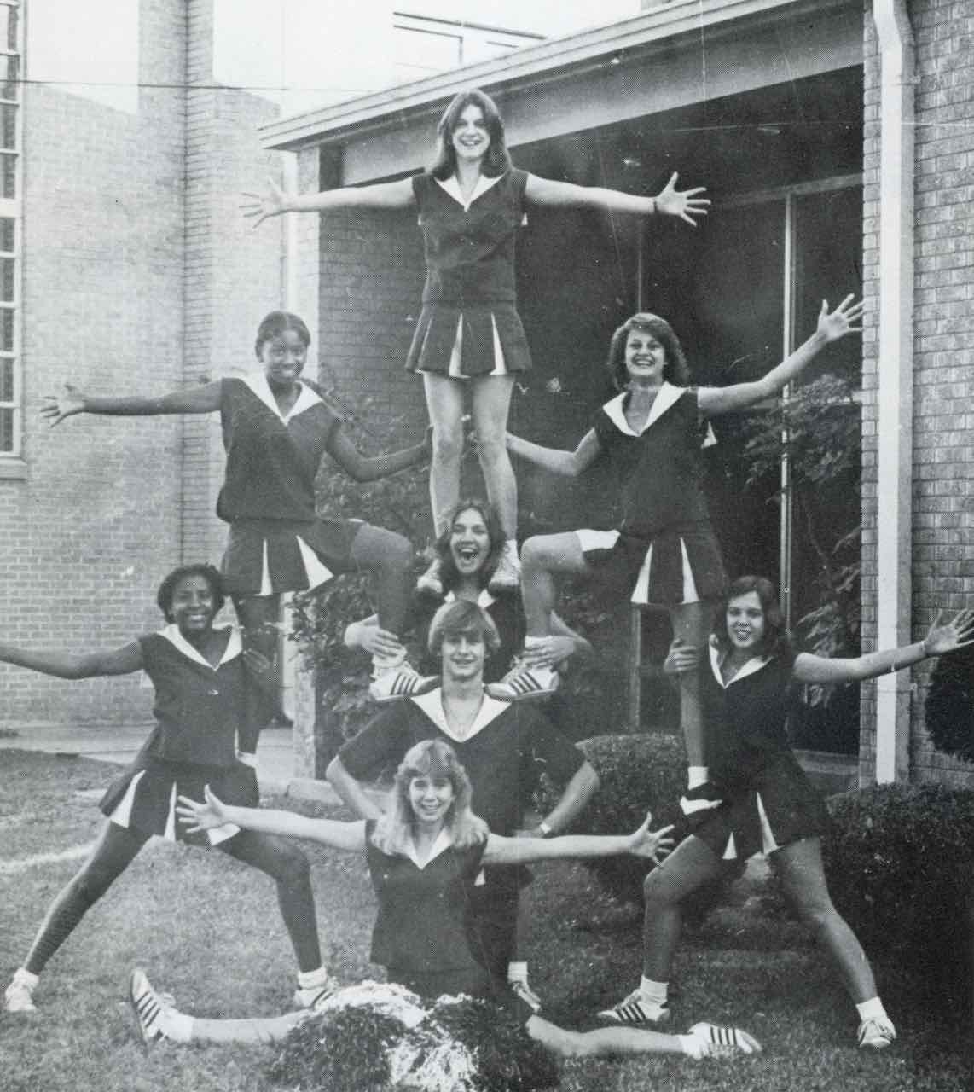
Caption: Mississippi’s Leland High School cheerleaders in the 1979 yearbook.
Credit: Leland School District

After the 1954 Supreme Court’s landmark Brown v. Board of Education decision ruled that racial segregation in public schools was unconstitutional, little more than token efforts were made to desegregate Southern schools. That changed dramatically on October 29, 1969, when the high court ordered Mississippi schools to fully — and immediately — desegregate. As a result, a group of children, including six-year-old Blackmon, entered school in the fall of 1970 as part of the first class of Black and white students who would attend all 12 grades together in Leland, Mississippi.

Set against vast historic and demographic changes unfolding across America, The Harvest steps back in time to explore Mississippi’s brutal history of racial intolerance and segregation — a world in which schools for Black children were not only separate but deeply underfunded, often inaccessible, and sometimes nonexistent.

The Harvest then follows the brave coalition of Black and white citizens who worked to create racially integrated public schools in the most unlikely place: a 1960s cotton town in the middle of the Mississippi Delta, the most rigidly segregated area in America. It tells the extraordinary story of how that first class became possible, then traces the lives of Blackmon and his classmates, teachers and parents through high school graduation in 1982. It is a riveting portrait of how those children’s lives were transformed and how the town — and America — were changed. But as the film follows the lives of those children into the present, it is also a portrait of what our society has lost in its failure to finish the work begun a generation ago.

Narrated by Blackmon and featuring candid interviews with his fellow pupils and others, the film follows the experiences of Blackmon’s class through school integration, deep friendships and awkward separations, in classrooms and on playgrounds, in plays and athletics, at homecoming and graduation. The film reveals that while many interracial friendships were formed in school, racial divisions often still existed outside the classroom.

Moving into the present, The Harvest discovers that the success of those first years of integration has gradually fallen apart. In the 50 years since Douglas and his classmates began first grade, the local economy faltered and white families almost entirely abandoned public schools. And, as the schools once more became racially divided, the town’s racial divisions have deepened. But even amid those disappointments, many members of that first class have returned to Leland, committed to giving back to their community. Blackmon finds hope in the lives of his classmates, who have gone on to become the town’s police chief, a federal judge, an Army colonel, a high school deputy principal, and a school superintendent. Through the story of Leland, The Harvest paints a fascinating portrait of one town and one extraordinary class of students, and offers a timely look at the continuing challenges of racial division and education equity still facing America today.
American Experience The Harvest will stream simultaneously with broadcast on all station-branded PBS platforms, including PBS.org and the PBS App, available on iOS, Android, Roku, Apple TV, Amazon Fire TV, Android TV, Samsung Smart TV, Chromecast and VIZIO. The film will also be available for streaming with closed captioning in English and Spanish.

About the Participants

Billy Barber, Leland High School student and Chief of Police.
Bob Blackmon, pro-integration activist and Douglas Blackmon’s father.
Bryan Blackmon, Leland High School student and Douglas Blackmon’s brother.
Sarah Blackmon, math teacher in the integrated Leland High, community activist and Douglas Blackmon’s mother.
Cedric Bush, Leland High School student and current Washington County Justice Court Judge in Leland.
Lincoln Coggin, Leland High School student.
Betty Coleman, teacher, working initially in Leland’s all-Black schools and then, after integration, in the racially mixed public schools.
Jessie King, Leland High School student and current Superintendent of Leland’s Schools.
Jim Lacey (deceased), editor of the Leland Progress in the 1960’s and ’70s.
Kevin Magee, Leland High School student.
John McCandlish, Leland High School student.
Evelyn Gordon Murray, Leland High School student and member of the School Board in Leland.
Bob Neill, an organizer of the all-white private academy established in 1969 to preserve segregation.
Pamela Pepper, Leland High School student and U.S. District Court Judge in Wisconsin.
Van Poindexter, Leland High School student and former U.S. Army colonel.
Donald Richardson, Leland High School student, is assistant principal at the historic Little Rock Central High School in Arkansas.
Veronica Richardson, Donald Richardson’s mother.
Edna Scott (deceased), was principal of the all-Black elementary school at the time of integration, and later served as principal of the integrated elementary school after 1969.
Vernice Sanders, parent and activist before and after integration.
Brandon Taylor, Leland High School student and Leland’s School Board President.
Jerald Jones Woolfolk, Leland High School student and former President of Lincoln University.

American Experience The Harvest

Produced by  Edited by  Cinematography by  Original Score by  Written by | DOUGLAS A. BLACKMON  SAM POLLARD  JON NEUBURGER  MARY MANHARDT  ANNE DECORTE  RYAN PARKER  J.R. SHIRAKBARI  DOUGLAS A. BLACKMON

A Five Dollar Films Production in Cooperation with the Georgia Humanities Council for
American Experience

American Experience is a production of GBH Boston
Executive Producer | CAMEO GEORGE

About the Filmmakers

Douglas A. Blackmon (Writer, Producer) is a Pulitzer-Prize winning author, journalist, and filmmaker. His first book, Slavery by Another Name: The Re-Enslavement of Black Americans from the Civil War to World War II, won a Pulitzer Prize in 2009 for its searing revelation of a largely forgotten system that continued to hold African-Americans in forced labor after the Civil War and persisted deep into the 20th century. He was also co-executive producer of the acclaimed documentary film based on Slavery by Another Name, which premiered at the Sundance Film Festival in 2012, attracted more than five million viewers in its first broadcasts on PBS, and continues to be regularly rebroadcast on public television stations across the U.S.

Blackmon and a team of other reporters at The Wall Street Journal were finalists for a Pulitzer Prize in 2011 for coverage of the BP oil spill in the Gulf of Mexico, and he was a member of the Journal staff awarded a Pulitzer in 2002 for coverage of the 9/11 terror attacks. Over the course of his career in journalism, he has witnessed and written about some of the most important events of our time, including the fall of the Berlin Wall, multiple U.S. presidential elections, natural disasters such as Hurricane Katrina, post-Apartheid South Africa, and war crimes during the civil war in the former Yugoslavia.

From 2012 until 2018, Blackmon was a member of the faculty and a senior fellow in presidential studies at the University of Virginia, and host of American Forum, a 30-minute television interview program carried nationwide every week on more than 250 public television stations. Currently, he directs the Narrating Justice Project at Georgia State University in Atlanta, where he also serves as a Professor of Practice in the Creative Media Industries Institute.

Sam Pollard (Producer) is an accomplished feature film and television video editor, and documentary producer/director. Between 1990 and 2010, Pollard edited a number of Spike Lee’s films including Mo’ Better Blues, Jungle Fever, Girl 6, Clockers, and Bamboozled. Pollard and Lee co-produced a number of documentary productions for the small and big screen: Four Little Girls, a feature-length documentary about the 1963 Birmingham church bombings, which was nominated for an Academy Award and When The Levees Broke, a four-part documentary that won numerous awards, including a Peabody and three Emmy Awards. Five years later, in 2010, he co-produced and supervised the edit on the follow-up to Levees, If God Is Willing And Da Creek Don’t Rise.

Since 2012, Pollard has completed as a producer/director Slavery By Another Name, a 90-minute documentary for PBS that was in competition at the Sundance Festival; August Wilson: The Ground On Which I Stand, a 90-minute documentary in 2015 for American Masters; Two Trains Runnin,’ a feature- length documentary in 2016 that premiered at the Full Frame Film Festival; and Sammy Davis Jr., I’ve Gotta Be Me, also for American Masters, which premiered at the 2017 Toronto International Film Festival. In 2019, Mr. Pollard co-directed the six-part series Why We Hate, which premiered on The Discovery Channel. In 2020, he was one of the directors on the HBO Series Atlanta’s Missing and Murdered: The Lost Children. That year he also completed MLK/FBI, which premiered at the 2020 Toronto Film Festival and the New York Film Festival. His latest documentary, The League, opened theatrically in July 2023.

Pollard was born and raised in New York but spent much of his young adult years visiting Mississippi, the home of his father’s family.

Cameo George (Executive Producer, American Experience) is an Emmy Award-winning producer, writer and journalist with more than 20 years of experience in documentary, broadcast television and digital content production. George has produced, developed and commissioned innovative programming at CNN, NBC News and ABC News. She was the senior producer of CNN’s groundbreaking series Black in America and Latino in America and executive producer of the eight-hour PBS documentary series 16 FOR '16: THE CONTENDERS, which was also broadcast on the BBC. George joined American Experience from ABC News, where she was head of development for long-form projects, responsible for creating a pipeline of docuseries and feature documentary films across Walt Disney Television platforms, including ABC News, Hulu, National Geographic and Disney+.

About American Experience

For 35 years, American Experience has been television’s most-watched history series, bringing to life the incredible characters and epic stories that have shaped America’s past and present. American Experience documentaries have been honored with every major broadcast award, including 30 Emmy Awards, five duPont-Columbia Awards and 19 George Foster Peabody Awards. PBS’s signature history series also creates original digital content that innovates new forms of storytelling to connect our collective past with the present. Cameo George is the series executive producer. American Experience is produced for PBS by GBH Boston. Visit pbs.org/americanexperience and follow us on Facebook, Twitter, Instagram and YouTube to learn more.

Major funding for American Experience provided by the Corporation for Public Broadcasting, Liberty Mutual Insurance, and the Alfred P. Sloan Foundation. Major funding for The Harvest provided by the National Endowment for the Humanities: Democracy demands wisdom, W.K. Kellogg Foundation: A Partner with Communities Where Children Come First, the Arthur Vining Davis Foundations: Investing in Our Common Future, members of The Better Angels Society including The Fullerton Family Charitable Fund, and Chasing the Dream, a public media initiative from The WNET Group, reporting on poverty, justice, and economic opportunity in America. Additional series funding for American Experience provided by the Robert David Lion Gardiner Foundation, the Documentary Investment Group, and public television viewers.

The Harvest is distributed internationally by PBS International.

* * *
Contacts:
CaraMar Publicity
Mary Lugo 770-851-8190 lugo@negia.net
Cara White 843-881-1480 cara.white@mac.com
Abbe Harris 908-244-5516 abbe.harris@caramar.net

For further information and photos visit http://www.pbs.org/pressroom

