American Experience The Island Murder
Explores the Sensational True Crime Story that Captivated a Nation

Encore Broadcast on Tuesday, April 17, 2018

(BOSTON, MA) — In the waning days of summer 1931, Honolulu’s tropical tranquility was shattered when a young Navy wife made a drastic allegation of rape against five nonwhite islanders. What unfolded in the following days and weeks was a racially charged murder case that would make headlines across the nation, enrage Hawai`i’s native population, and galvanize the island’s law enforcers and the nation’s social elite. Written and produced by Mark Zwonitzer and executive produced by Mark Samels, The Island Murder (originally broadcast in 2005 under the title The Massie Affair) will have an encore broadcast on American Experience on Tuesday, April 17, 2018, 9:00-10:00 p.m. ET (check local listings) on PBS.
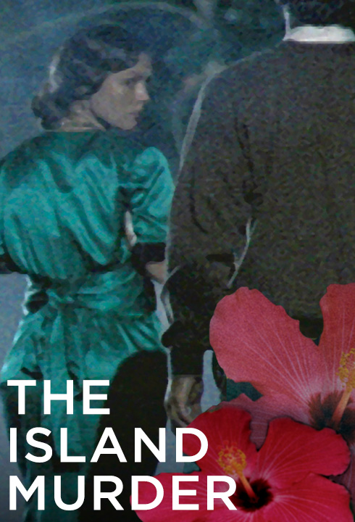

In the 1930s, Hawai`i was an American territory and thought of by many as a paradise in the Pacific. But beneath the peaceful veneer, tensions were building. The workforce was struggling with a depression-era job market and racial tensions were about to erupt. The population of white mainlanders, or haoles as they were called, was growing rapidly. The Navy bases on the island also created tension, as the military men showed little respect for nonwhites. Many natives were convinced that the mainlanders were taking over.

Tensions hit the boiling point on September 12, 1931, when Lieutenant Thomas Massie and his 20-year-old wife Thalia joined a Navy crowd at the Ala Wai Inn, a Honolulu nightspot. Well known for their volatile relationship, the couple had an argument, and Thalia stormed out. Hours later she reported that she had been assaulted but could not identify the men who attacked her or the car they were driving due to darkness.

Despite lack of evidence, five islanders were quickly rounded up and charged with the crime. The accused included two native Hawai`ians, one Hawai`ian-Chinese man, and two Japanese men. The driving forces behind the trumped-up charges, it turned out, were high-ranking Naval officials, including the admiral in charge at Pearl Harbor, Yates Stirling.

Portrayed as a victim whose womanhood had been violated, Thalia became the center of a media frenzy. The five defendants were painted as criminal fiends, heathens. But while Thalia fared well in the press, there was plenty of gossip around town about her wild behavior and liaisons with other officers. Thalia’s mother, New York socialite Grace Hubbard Bell Fortescue, flew to Honolulu to support her daughter and protect the family’s reputation. But Grace would play a much larger role in the tragedy that was unraveling.

At the November trial, Thalia offered graphic testimony, even identifying her assailants by name. However, there was scant evidence to corroborate her story, and the jury could not agree on a verdict. Forced to declare a mistrial, the judge set the defendants free.

Grace Fortescue and Thomas Massie took matters into their own hands, setting out to force a confession from one of the suspects, Joseph Kahahawai. When coercion turned to violence, Kahahawai was shot and killed. Papers across the nation eagerly carried reports of the “honor killing.”

Despite a passionate defense by Clarence Darrow, Grace and Thomas were convicted of manslaughter and sentenced to ten years in prison. But under pressure from the Hoover Administration, Congress, and the Navy, Governor Lawrence Judd caved, reducing the sentence to just one hour. The people of Hawai`i were incensed.

“Even today, this remains a painful piece of Hawai`i’s history,” says producer Mark Zwonitzer. “Joe Kahahawai’s murder and the aftermath shed light on the egregious institutional racism that stretched from the halls of power in the U.S. government to its outermost territory.”

The Navy shipped Grace, Thomas and Thalia out on the first available boat to California, where they were met with a hero’s welcome “The Massie affair is a little-known story to most Americans, but to a great extent, this ignited Hawai`i’s own civil rights movement,” says American Experience executive producer Mark Samels. “The film is a powerful reminder of the injustices that are part of the tapestry of American history.”

About the Filmmakers

Written, produced, and directed by Mark Zwonitzer
Edited by Bruce Shaw
Director of photography: Michael Chin
Music by Brian Keane
Narrated by Blair Brown

A HiddenHill Productions film for American Experience

American Experience is a production of WGBH Boston

Senior Producer | Susan Bellows
Executive Producer | Mark Samels

Mark Zwonitzer (Writer/Producer/Director) is an author and documentary filmmaker specializing in American history and politics, with an emphasis on biography. He has been producing, directing and/or writing acclaimed documentaries for PBS for 25 years. His work for American Experience includes writing the Emmy-winning JFK and the Emmy-nominated Walt Disney; he also directed the American Experience film Walt Whitman, among others. Additional work includes Battle of the Bulge (with Thomas Lennon), The Pilgrimage of Jesse Jackson, The Irish in America: Long Journey Home (Episode Two), Joe DiMaggio: The Hero’s Life (with Richard Ben Cramer), Transcontinental Railroad, and a four-hour history of the United States Supreme Court. His work in television has been honored with the duPont-Columbia Award, the George Foster Peabody Award, the Writers Guild Award, the American Bar Association’s Silver Gavel, the International Documentary Association’s Award for Outstanding Achievement in Limited Series, the Japan Foundation’s President’s Prize and numerous Emmy nominations. His most recent book, The Statesman and the Storyteller: John Hay, Mark Twain and the Rise of American Imperialism, was published in the spring of 2016. His first book, Will You Miss Me When I’m Gone (with Charles Hirshberg), was a finalist for the National Book Critics Circle Award, a New York Times Notable Book of 2002, and an American Library Association’s Booklist Editor’s Choice in biography.

Mark Samels (Executive Producer). As executive producer of the PBS flagship history series, Samels conceives, commissions and oversees all American Experience films. Samels has overseen more than 120 films, expanding both the breadth of subjects and the filmmaking style embraced by the series, allowing for more contemporary topics and more witness-driven storytelling. Beginning his career as an independent documentary filmmaker, he held production executive positions at public television stations in West Virginia and Pennsylvania before joining WGBH. Samels is a founding member of the International Documentary Association and has served as a governor of the Academy of Television Arts & Sciences. A graduate of the University of Wisconsin, Samels holds honorary Doctor of Humane Letters degrees from Emerson College and Elizabethtown College.

About American Experience
For 30 years, American Experience has been television’s most-watched history series. Hailed as “peerless” (The Wall Street Journal), “the most consistently enriching program on television” (Chicago Tribune), and “a beacon of intelligence and purpose” (Houston Chronicle), the series brings to life the incredible characters and epic stories that have shaped America’s past and present. American Experience documentaries have been honored with every major broadcast award, including 30 Emmy Awards, four duPont-Columbia Awards, and 17 George Foster Peabody Awards; the series received an Academy Award® nomination for Best Documentary Feature in 2015 for Last Days in Vietnam. American Experience also creates original digital content that uses new forms of storytelling to connect our collective past with the present. Visit pbs.org/americanexperience and follow us on Facebook, Twitter, Instagram and YouTube to learn more.

Major funding for American Experience provided by Liberty Mutual Insurance and by the Alfred P. Sloan Foundation. Additional funding for American Experience provided by The Robert David Lion Gardiner Foundation, the Corporation for Public Broadcasting and public television viewers. American Experience is produced for PBS by WGBH Boston.

* * *
Press Contacts:
CaraMar Publicity
Mary Lugo 770-623-8190 lugo@negia.net
Cara White 843-881-1480 cara.white@mac.com
Abbe Harris 908-244-5516 abbe.harris@caramar.net

For further information and photos visit http://www.pbs.org/pressroom

