American Experience The Movement and the “Madman”
Premieres Tuesday, March 28, 2023, on PBS and Streaming on PBS.org

Explore the Little-Known Story of the Dramatic 1969 Showdown
Between President Nixon and the Anti-War Movement

(BOSTON, MA) – The Movement and the “Madman” shows how two antiwar protests in the fall of 1969 — the largest the country had ever seen — pressured President Nixon to cancel what he called his “madman” plans for a massive escalation of the U.S. war in Vietnam, including a threat to use nuclear weapons. At the time, protestors had no idea how influential they could be and how many lives they may have saved. Told through remarkable archival footage and firsthand accounts from movement leaders, Nixon administration officials, historians, and others, the film explores how the leaders of the antiwar movement mobilized disparate groups from coast to coast to create two massive protests that changed history. Directed by Stephen Talbot, The Movement and the “Madman” premieres as a Special Presentation of American Experience on Tuesday, March 28, 9:00-10:30 p.m. ET (check local listings) on PBS, PBS.org and the PBS App.
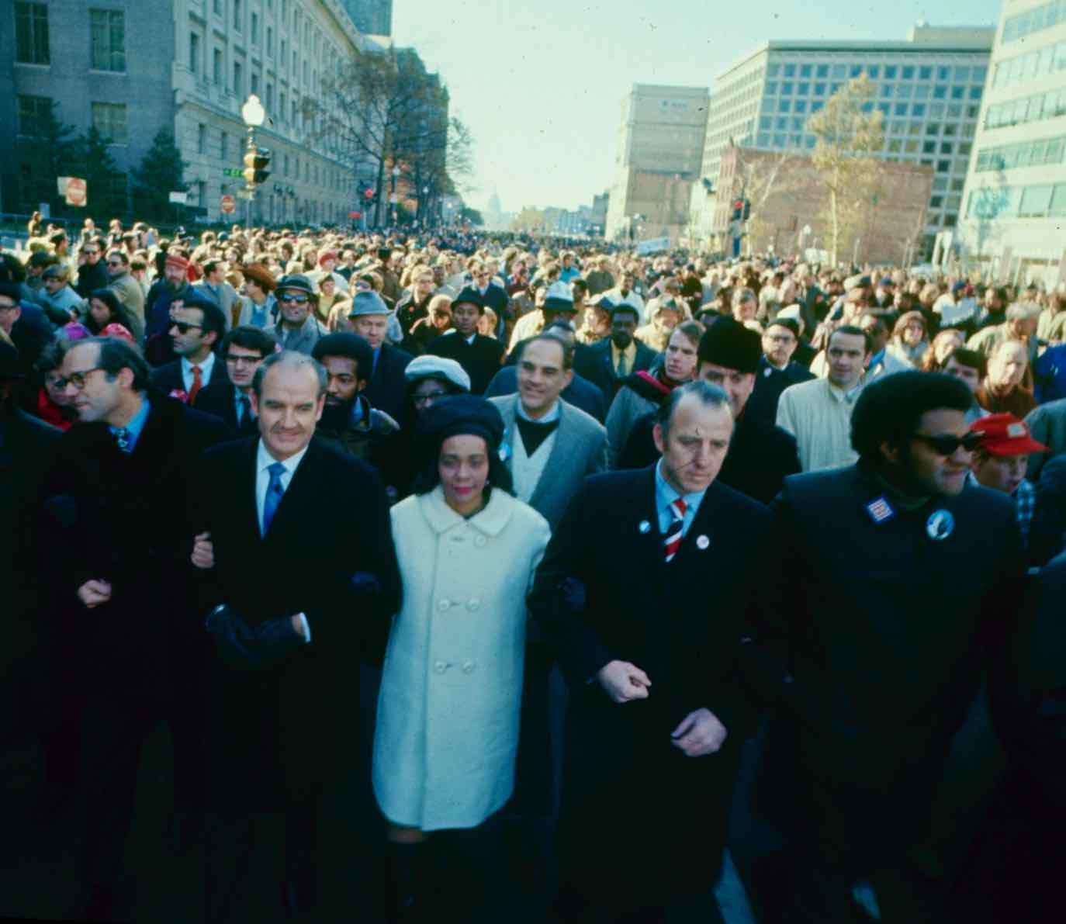
November 15, 1969 march in Washington, DC led by Coretta Scott King.
Credit: Pond 5.

By 1968, the U.S. had been at war in Vietnam for four years and there were over 500,000 troops on the ground. 31,000 Americans had been killed, Nixon had defeated Democratic nominee Hubert Humphrey, and the antiwar movement decided that something dramatic needed to be done.

Although Nixon publicly belittled the movement, he was acutely aware that Lyndon Johnson’s presidency had essentially been brought down by the constant chants of protestors surrounding the White House. While on the campaign trail, Nixon vowed never to use nuclear weapons in Vietnam but, now in office, he came up with a plan to end the war: his “madman” strategy. “His secret plan was to threaten the North Vietnamese with nuclear weapons,” said Morton Halperin, a Defense Department veteran and an aide to Henry Kissinger. “He was convinced that the way to make the threat credible was for the North Vietnamese to fear that he was crazy and might actually do this.”

In clandestine talks with the Soviet ambassador in Washington and the North Vietnamese in Paris, Nixon and Kissinger set a November 1, 1969, deadline for Hanoi to accept U.S. terms for ending the war or face disastrous consequences. The National Security Council and the Pentagon began military preparations for bombing North Vietnam, mining Haiphong harbor, and using tactical nuclear bombs near the Chinese and Laotian borders. They codenamed the plan “Operation Duck Hook.”

Unaware of the plan and with casualties continuing to mount, the leaders of the antiwar movement developed new and bigger ideas for protests in the fall. The first was to call for a Moratorium on October 15, 1969, a nationwide protest with an emphasis on local demonstrations throughout the country. The second plan, created by a sprawling coalition known as the New Mobilization Committee to End the War in Vietnam, was to organize what they hoped would be the largest peace marches and rallies the country had ever seen, scheduled for November 15, in Washington D.C. and San Francisco.

With an estimated two to three million people taking part on hundreds of campuses and over 200 cities and towns across the country, the October 15 Moratorium succeeded beyond the organizers’ wildest dreams. Dispelling the myth that the antiwar movement consisted solely of “hippies” and leftists, the Moratorium crowds consisted of labor leaders, church groups, civil rights activists, Democrat and Republican lawmakers, housewives, veterans, families and more. “The word ‘protestor’ generally evokes an image of long hair and love beads,” reported ABC commentator Howard K. Smith. “But today, the crowds that marched and chanted and cheered the speeches looked more like a cross-section picked by the Census Bureau.”

Stunned by the success of the Moratorium — and facing the prospect of another massive protest on November 15 — Nixon decided to call off “Operation Duck Hook.” Years later, he wrote: “Although publicly I continued to ignore the raging antiwar controversy, I had to face the fact that it had probably destroyed the credibility of my ultimatum to Hanoi.”

But Nixon had one more move left and, later that month, he ordered a secret worldwide alert of U.S. nuclear forces to send what he called “a special reminder” to the Soviets and North Vietnamese of what he might unleash. “Nixon assumed that he could bend Cold War adversaries to his will by making them fear that he was crazy enough to launch a nuclear attack,” said William Burr, co-author of Nixon’s Nuclear Specter: The Secret Alert of 1969, Madman Diplomacy, and the Vietnam War.

Following the Moratorium’s success and with the November 15 demonstrations soon approaching, Nixon focused on discrediting the antiwar movement and the media for their positive coverage of the protests. In a nationally televised speech on November 3, Nixon blamed demonstrators for undermining the war effort and appealed to what he called “the great silent majority” for support.

Tensions built as the protests neared, with Nixon barricading the White House with buses and military troops. When November 15 arrived, as many as half a million protestors descended on Washington, while another 250,000 rallied in San Francisco. It was the largest single-day protest the country had ever experienced. Within earshot of the White House, the enormous crowd on the Washington Mall sang John Lennon’s “Give Peace a Chance” as folk singer Pete Seeger shouted, “Are you listening, Nixon?”

He was. Nixon’s “madman” plan was shelved, and the nuclear alert ended. “It was only decades later, when the archives were released, that we realized what, in fact, we had accomplished,” said Moratorium and Mobilization co-organizer David Hawk. “We now know we had a big impact on Nixon and Kissinger, what they thought they could get away with in November, namely blowing Vietnam to bits, and maybe even using nuclear weapons,” said organizer Rev. Dick Fernandez. “They had to take it off the table. There were too many of us who were saying no.”

About the Interviewees (Audio Only)

Christian Appy is a professor of history at the University of Massachusetts, Amherst, and author of
American Reckoning: The Vietnam War and Our National Identity.

Sam Brown was the lead organizer of the October 15, 1969 Moratorium.

Stephen Bull is a Vietnam veteran who served as Richard Nixon’s personal aide from 1969-1974.

Willian Burr is co-author of Nixon’s Nuclear Specter: The Secret Alert of 1969, Madman Diplomacy, and the Vietnam War.

Brenda Cavanaugh (deceased) was an antiwar activist whose husband was killed in Vietnam.

David Cortright is Director of Policy Studies at the Kroc Institute for International Peace Studies at the University of Notre Dame. He participated in the November 15, 1969, march in Washington as part of a contingent of GIs and veterans. He is the author of Soldiers in Revolt: GI Resistance During the Vietnam War.

Carolyn Eisenberg is a professor of U.S. History and American Foreign Relations at Hofstra University and author of Fire and Rain: Nixon, Kissinger, and the Wars in Southeast Asia.

Daniel Ellsberg was an early supporter of the war in Vietnam but grew to oppose it. A military analyst with the RAND Corporation and the Department of Defense, he advised Kissinger in the winter of 1968-69 on President-elect Nixon’s Vietnam war plans.

Reverend Dick Fernandez was the director of Clergy and Laity Concerned about Vietnam and a significant player in the October and November 1969 protests.

Morton Halperin was a Defense Department official from 1966-1969. He became privy to Kissinger and Nixon’s nuclear threats and resigned as Kissinger’s aide in late 1969.

David Hartsough was a Quaker antiwar lobbyist in Washington during the Vietnam War.

David Hawk was one of the four main organizers of the October 15, 1969 Moratorium.

Joan Libby Hawk was on the staff of the October 15 Moratorium in Washington, D.C.

Frank Joyce was an antiwar and antiracism activist from Detroit.

Anthony Lake served in Vietnam as a young diplomat and became an aide to Henry Kissinger in the Nixon
Administration. Involved in the “madman” strategy, Lake quit in protest during Nixon’s invasion of Cambodia in April/May 1970.

Susan Miller-Coulter was the co-coordinator of the March Against Death in Washington, D.C., November 13-14, 1969.

David Mixner was one of the four main co-organizers of the October 15, 1969 Moratorium.

Roger Morris was special assistant to Henry Kissinger, working on secret negotiations with North Vietnamese diplomats in Paris in 1969.

Mary Posner organized the October 15 Moratorium at Ball State University and attended the march in D.C.

Don Riegle was a Republican congressman from Flint, Michigan, who became an early and outspoken opponent of the Vietnam War.

Melvin Small is Professor Emeritus of History at Wayne State University in Detroit, MI.

Margery Tabankin was an antiwar activist at the University of Wisconsin, Madison who took part in the October 15 Moratorium and then organized students to go to D.C. for the November march.

Joseph Urgo was stationed at a small Air Force base in Atlantic City, NJ, guarding a squadron of jet fighters and their nuclear missiles during what he later learned was Nixon’s worldwide nuclear exercise in October 1969.

Cora Weiss was a leader of the national group Women Strike for Peace and co-chair of the New Mobilization Committee to End the War in Vietnam, which organized the November 1969 mass marches and rallies in Washington, DC, and San Francisco.

Tom Wells is the author of The War Within: America’s Battle Over Vietnam.

American Experience The Movement and the “Madman” will stream simultaneously with broadcast on all station-branded PBS platforms, including PBS.org and the PBS App, available on iOS, Android, Roku, Apple TV, Amazon Fire TV, Android TV, Samsung Smart TV, Chromecast and VIZIO. It will also be available for streaming with closed captioning in English and Spanish.

About the Filmmakers

American Experience The Movement and the “Madman”

Producer and Director  Editor  Executive Producer | STEPHEN TALBOT  STEPHANIE MECHURA  ROBERT LEVERING

American Experience is a production of GBH Boston

Stephen Talbot (Director) is an Emmy, duPont and Peabody award-winning filmmaker who has produced, written or directed more than 40 documentaries for public television, primarily for the PBS series FRONTLINE and KQED (San Francisco). His FRONTLINE films include The Best Campaign Money Can Buy, The Long March of Newt Gingrich, Justice for Sale and News War: What’s Happening to the News. He directed the PBS history special 1968: The Year That Shaped a Generation, and produced and wrote PBS biographies of authors Dashiell Hammett, Ken Kesey, Carlos Fuentes, Maxine Hong Kingston and John Dos Passos. He was the co-creator and executive producer of the PBS music specials Sound Tracks: Music Without Borders. Talbot also served as the series editor for FRONTLINE’s international series, Frontline World: Stories from a Small Planet, and the senior producer of documentary shorts for the PBS series INDEPENDENT LENS. As a student at Wesleyan University, he made his first documentary film about the November 1969 anti-war protests in Washington, DC.

About American Experience

For 35 years, American Experience has been television’s most-watched history series, bringing to life the incredible characters and epic stories that have shaped America’s past and present. American Experience documentaries have been honored with every major broadcast award, including 30 Emmy Awards, five duPont-Columbia Awards and 19 George Foster Peabody Awards. PBS’s signature history series also creates original digital content that innovates new forms of storytelling to connect our collective past with the present. Cameo George is the series executive producer. American Experience is produced for PBS by GBH Boston. Visit pbs.org/americanexperience and follow us on Facebook, Twitter, Instagram and YouTube to learn more.
Major funding for American Experience provided by the Corporation for Public Broadcasting, Liberty Mutual Insurance, and the Alfred P. Sloan Foundation. Funding for The Movement and the “Madman” provided by the Jonathan Logan Family Foundation. Additional series funding for American Experience provided by the Robert David Lion Gardiner Foundation, the Documentary Investment Group, and public television viewers.

The Movement and the “Madman” is distributed internationally by PBS International.

* * *
Contacts:
CaraMar Publicity
Mary Lugo 770-851-8190 lugo@negia.net
Cara White 843-881-1480 cara.white@mac.com
Abbe Harris 908-244-5516 abbe.harris@caramar.net

For further information and photos visit http://www.pbs.org/pressroom

