American Experience The Race Underground

To Have Encore Broadcast on Tuesday, November 12, 2019

Film Explores the Battle to Build America’s First Subway

(BOSTON, MA) — In the late 19th century, as America’s teeming cities grew increasingly congested, the time had come to replace the nostalgic horse-drawn trolleys with a faster, cleaner, safer, and more efficient form of transportation. Ultimately, it was Boston — a city of so many firsts — that overcame a litany of engineering challenges, the greed-driven interests of businessmen, and the great fears of its citizenry to construct America’s first subway. Based in part on Doug Most’s acclaimed non-fiction book of the same name, The Race Underground tells the dramatic story of an invention that changed the lives of millions. Written, produced and directed by Michael Rossi and executive produced by Mark Samels, The Race Underground will have an encore broadcast on American Experience Tuesday, November 12, 2019, 9:00-10:00 p.m. ET (check local listings) on PBS.
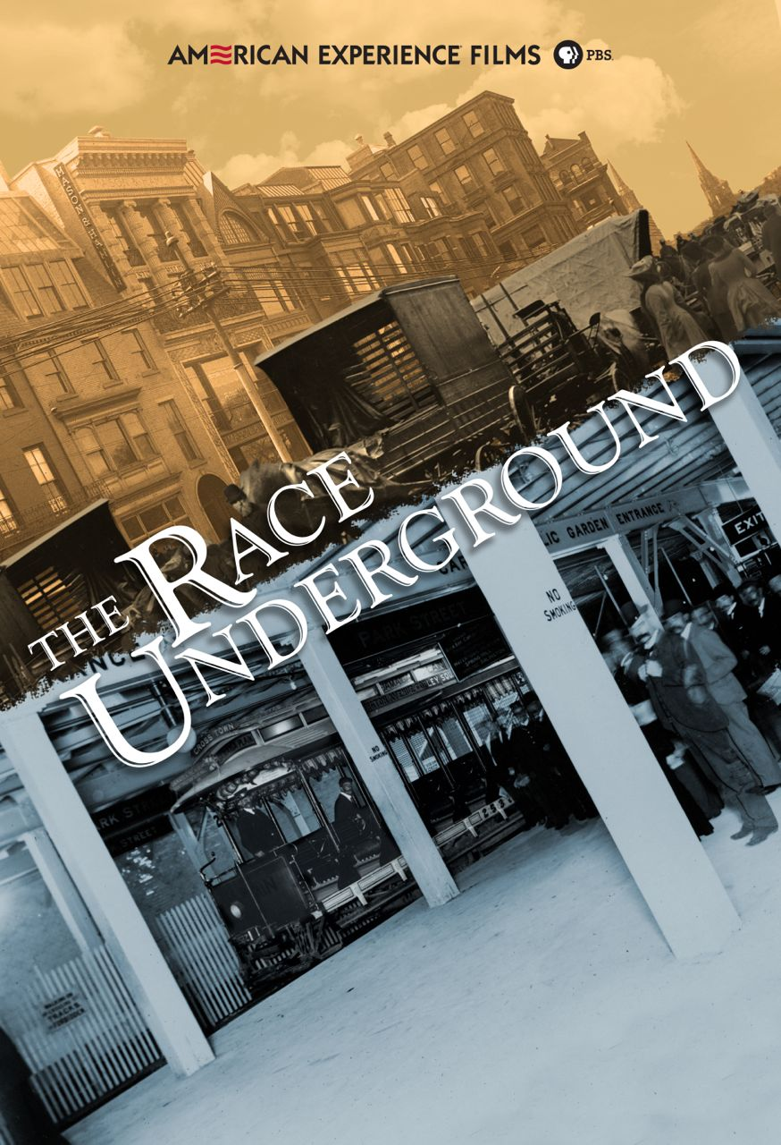

“Each day, millions of Americans step onto a subway car and travel underground and don’t think twice about it,” said American Experience Executive Producer Mark Samels. “It’s fascinating to see how the concept of the subway — a seemingly impossible invention that once struck terror in the heart of the public — so quickly became an everyday part of life for millions of American commuters.”

In the late 1800s, Boston reigned as America’s most crowded city, with nearly 400,000 people packed into a downtown of less than one square mile. With more than 8,000 horses pulling the trolleys, the city was filthy and noisy, reeking of manure and packed with humanity.

But a young American inventor named Frank Sprague had a revolutionary idea. Inspired by his visits to the London Underground, Sprague envisioned a subway system that would trade London’s soot-spewing coal-powered steam engine with a motor run on the latest technology — electricity. After an early job with his idol Thomas Edison, Sprague launched his own venture, the Sprague Electric Railway & Motor Company. Seeking investors, he first struck out with financier Jay Gould after almost setting the mogul on fire during a demonstration. He soon found backing with the wealthy capitalist Henry Whitney, who owned a fortune in suburban Boston real estate and quickly saw the financial upside of connecting his desirable residential neighborhoods with the city’s economic center. Whitney also proposed the consolidation of Boston’s seven existing streetcar companies — all under his control. When the Massachusetts General Court granted Whitney the monopoly, he announced an unprecedented plan — to build the nation's first subway.
Powered by Sprague's technology and enthusiastically supported by Boston Mayor Nathan Matthews, the project threw the city into a voluble debate.

“The Boston subway was not a foregone conclusion, not by a long shot. There was a petition at one point where 12,000 businessmen opposed the subway,” said historian Stephen Puleo. “There were going to be streets torn up, sewer systems affected, water lines affected, electrical lines affected. Secondly, folks felt like traveling underground was very close to the netherworld, that you were getting closer to the devil, that you were taking this great risk in God’s eyes by traveling on a subway.”

The debate raged on, but the Mayor finally convinced the city that the new subway would provide much-needed jobs and not infringe on the city’s beloved Boston Common. After two years of construction, Boston’s new subway made its first trip on September 1, 1897. Despite lingering fears, more than 250,000 Bostonians rode the underground rails on its first day. In its first year of operation, 50 million passengers would ride the Boston system, and within ten years, New York and Philadelphia opened subways, with more American cities to follow.

“Frank Sprague lived in the shadow of Edison but played as important a role in the development and growth of cities as any person in our history,” said author Doug Most. “His motor is one of the most important contributions, right there alongside Henry Ford’s vehicle and the Wright Brothers’ plane, as one of the most important engineering achievements of our time.”

* * *

About the Participants, in Alphabetical Order

Asha Weinstein Agrawal is Director of MTI’s National Transportation Finance Center at San José State University, and also an Associate Professor in the Urban and Regional Planning Department at San José State.

Brian Cudahy is a historian of mass transit and author of several books including Change at Park Street Under: The Story of Boston's Subways and Cash, Tokens, and Transfers: A History of Urban Mass Transit in North America.

Frederick Dalzell is a historian and author of Engineering Invention: Frank J. Sprague and the U.S. Electrical Industry.

Mark Gelfand is an associate professor of history at Boston College.

Clifton Hood is a professor of history at Hobart and William Smith Colleges and author of 722 Miles: The Building of the Subways and How They Transformed New York.

Doug Most is the director of strategic growth and content at The Boston Globe and author of The Race Underground: Boston, New York, and the Incredible Rivalry That Built America’s First Subway.

Stephen Puleo is a historian and author whose books include A City So Grand and The Boston Italians.

Rosalind Williams is Bern Dibner Professor of the History of Science and Technology at MIT and author of
Notes on the Underground: An Essay on Technology, Society, and the Imagination.

About the Filmmakers

A Rossi Films Production For American Experience

Written, Produced and Directed by Michael Rossi
Edited by Jon Neuburger
Narrated by Michael Murphy
Coordinating Producer Melissa Martin Pollard
Based in part on the book The Race Underground: Boston, New York, and the Incredible Rivalry That Built America’s First Subway by Doug Most
Original Music by Gary Lionelli
Cinematography by Jason Longo

American Experience is a production of WGBH Boston

Senior Producer Susan Bellows
Executive Producer Mark Samels

Michael Rossi (Writer/Producer/Director) has spent the last 17 years producing, directing, shooting and editing national programs for public television. In 2012, Rossi received an Emmy Award for his work as Coordinating Producer of the children’s engineering series Design Squad. His production credits for American Experience include Building the Alaska Highway, The Gold Rush (2007 Erik Barnouw Award), We Shall Remain, The Rise and Fall of Penn Station, and the upcoming The Bombing of Wall Street. He also served as an embedded filmmaker on the 2011 Student Freedom Ride and produced a series of short films for Freedom Summer @ 50, profiling participants of the 1964 Freedom Summer project in Mississippi. Rossi’s credits for FRONTLINE include The Silence, which traces the healing between the small, Yup'ik village of St. Michael, Alaska, and the Catholic Church in the devastating aftermath of sexual abuse perpetrated by priests in the 1960s and 1970s.

Rossi completed the B.A./M.A. program in U.S. History at Boston College. His cinematography is exhibited in many independent documentary films including Before You Know It, directed by PJ Raval (SXSW premiere, 2013) and The Sad Fates of Mr. Toledano, directed by Joshua Seftel (Tribeca Film Festival, 2015). Rossi's recent projects include The Master Palindromist, a feature-length documentary about Barry Duncan, a self-proclaimed master of reversibility honing his skills in an effort to reassess his life, and possibly change the world; and a series of four short films profiling U.S. Olympic rowers in conjunction with the American Experience broadcast of The Boys of '36.

Mark Samels (Executive Producer) conceives, commissions and oversees all films for the PBS flagship history series American Experience. Samels has overseen more than 130 films, expanding both the breadth of subjects and the filmmaking style embraced by the series, allowing for more contemporary topics and witness-driven storytelling. Beginning his career as an independent documentary filmmaker, he held production executive positions at public television stations in West Virginia and Pennsylvania before joining WGBH. Samels is a founding member of the International Documentary Association and has served as a governor of the Academy of Television Arts & Sciences. A graduate of the University of Wisconsin, Samels holds honorary Doctor of Humane Letters degrees from Emerson College and Elizabethtown College.

About American Experience

For 30 years, American Experience has been television’s most-watched history series. Hailed as “peerless” (The Wall Street Journal), “the most consistently enriching program on television” (Chicago Tribune) and “a beacon of intelligence and purpose” (Houston Chronicle), the series brings to life the incredible characters and epic stories that have shaped America’s past and present. American Experience documentaries have been honored with every major broadcast award, including 30 Emmy Awards, four duPont-Columbia Awards and 17 George Foster Peabody Awards; the series received an Academy Award nomination for Best Documentary Feature in 2015 for Last Days in Vietnam. American Experience also creates original digital content that uses new forms of storytelling to connect our collective past with the present. Visit pbs.org/americanexperience and follow us on Facebook, Twitter, Instagram and YouTube to learn more.

Major funding for American Experience provided by Liberty Mutual Insurance, Consumer Cellular and by the Alfred P. Sloan Foundation. Additional funding provided by the Robert David Lion Gardiner Foundation, The Documentary Investment Group, the Corporation for Public Broadcasting and public television viewers. American Experience is produced for PBS by WGBH Boston.

* * *

Press Contacts:
CaraMar, Inc.
Mary Lugo 770-623-8190 lugo@negia.net
Cara White 843-881-1480 cara.white@mac.com
Abbe Harris 908-244-5516 abbe.harris@caramar.net

For further information and photos visit http://www.pbs.org/pressroom

Photo credit: ©WGBH Educational Foundation. Images courtesy of Boston Athenaeum, City of Boston Archives, Historic New England, Museum of the City of New York, and New York Transit Museum.

