American Experience The Secret of Tuxedo Park
Premieres Tuesday, January 16, 2018 on PBS

The Story of the Mysterious Tycoon Turned Scientist Who Helped
Win World War II

(BOSTON, MA) — In the fall of 1940 the fate of Western civilization hung in the balance. Hitler’s armies were encamped along the English Channel, preparing for an invasion of Britain. In a desperate bid to form a technological alliance with the then-neutral United States, British Prime Minister Winston Churchill sent a small team of scientists on a clandestine transatlantic mission to deliver his country’s most valuable military secrets to America’s scientific leaders. When Churchill’s emissaries arrived, they delivered the most precious item in their collection — a revolutionary radar component — to a mysterious Wall Street tycoon, Alfred Lee Loomis. Loomis had for years led a double life, spending his days earning vast fortunes on Wall Street and his weekends working with the world’s leading scientists at his private laboratory in Tuxedo Park, outside New York City. Using his connections, his money, and his brilliant scientific mind, Loomis assembled a team of the brightest scientists, and directed their efforts such that radar would arguably play a more decisive role than any other weapon in the war. Based on Tuxedo Park: A Wall Street Tycoon and the Secret Palace of Science that Changed the Course of WWII by Jennet Conant, The Secret of Tuxedo Park reveals the long-overlooked story of an extraordinary yet unheralded man. Written and directed by Rob Rapley and executive produced by Mark Samels, The Secret of Tuxedo Park premieres on American Experience on Tuesday, January 16, 9:00-10:00 p.m. ET (check local listings) on PBS.
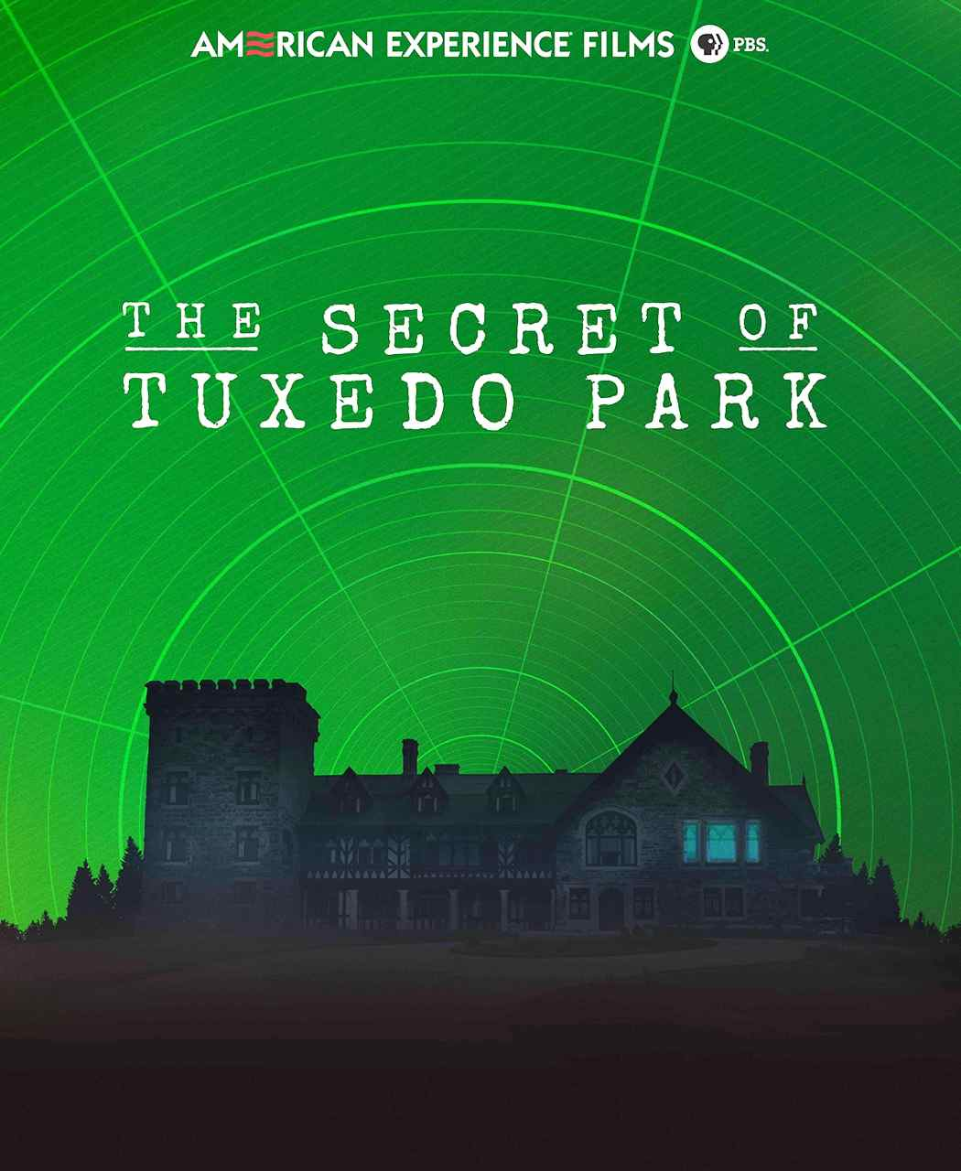

“To think that this unknown man, toiling in a secret lab, with some of the greatest scientific minds of the era, made such a profound impact on the outcome of the Second World War is remarkable,” said Mark Samels, American Experience executive producer. “These little-known but fascinating stories add new dimension to our understanding of history.”

Alfred Loomis didn’t start out reclusive, a millionaire, or even a scientist. After graduating from Harvard in 1912, he became a corporate lawyer on Wall Street, married well, and settled in the upscale suburb of Tuxedo Park, outside New York City. But under his conventional façade was a man of fierce ambition, obsessed with scientific exploration. With the outbreak of World War I, Loomis got a reprieve from the humdrum world of finance; he was posted to the Army’s research center in Maryland, where he got his first intoxicating taste of science on a large scale.

Following the war, Loomis’s plan was to amass enough of a fortune to pursue science full-time. Even as he was conquering Wall Street, Loomis kept up with the scientists he had met during the war, including physicist Robert Wood. Loomis enlisted Wood, and the two men began exploring the effects of high frequency waves using a massive GE oscillator they installed in his mansion’s garage. Quickly outgrowing his makeshift lab, Loomis purchased nearby Tower House, an enormous crumbling Gothic mansion, and turned it into a state-of-the-art laboratory. The fiercely private Loomis shunned publicity but the comings-and-goings of foreign scientists gave rise to rumors and speculation about what was transpiring at his mysterious lab.

In the spring of 1933, Loomis was finally wealthy enough to walk away from Wall Street, and devote himself entirely to research at Tower House. Loomis pioneered ultrasound technology, became a leading authority in precise measurements of time, and, using his son as a subject, became one of the first to measure and describe the stages of sleep. As author Jennet Conant says of Tower House, “It’s beyond a scientific playground. This is a scientific idyll. There is nothing like it anywhere in the world. Einstein refers to Loomis’s compound as a ‘palace of science’ and it truly is.”

As the 1930s drew to a close, the rumblings from Europe became increasingly dire. Most Americans wanted nothing to do with another European war, but Loomis saw it differently. He had seen Hitler’s Germany with his own eyes, and had helped scientists — many of them Jews — escape the Nazis. With Europe still at peace, Loomis dedicated himself to what must have seemed a forlorn hope: he would find a way to counter Germany’s technological edge. Loomis soon focused all his energies on the next generation of a vital new technology: microwave radar.

When the Germans invaded France in early 1940, President Roosevelt created a small but powerful organization to develop the sophisticated new weapons that would be needed in a war with Nazi Germany; Loomis was put in charge of the microwave radar section. But even with the resources of the federal government, Loomis’s program slowly ground to a halt. Nobody knew how to build one vital component that would make microwave radar a reality. As Loomis was about to give up, Churchill decided to make one of the biggest gambles of the war. British scientists had been making headway on the radar problem, but they lacked the resources to continue. In a daring move, Churchill handed the Americans his country’s most precious military secrets — jet engines, anti-submarine devices, explosives and, most importantly, a new type of radio tube called the cavity magnetron — the very thing Loomis’s microwave radar team needed.

Several companies were interested in getting their hands on the burgeoning new program but Loomis instead created a new type of research operation at the intersection of industry, the military, and academia — what became known as the “Rad Lab’ at MIT. Thanks to Loomis and his team of nearly 4,000 people, the U.S. would go to war in December 1941 with a radar program as advanced as any in the world. The breadth of the Rad Lab’s innovation was on full display during the invasion of Normandy, when airplanes equipped with radar sets bombarded the coastline, radar beacons guided parachute troops, a navigation system known as landing craft control directed the invasion forces and radar-directed guns protected the infantry from air attack. After the Japanese surrender, when their story could finally be told, the radar men could justly claim “the Bomb only ended the war, radar won it.”

The Rad Lab closed its doors at the end of 1945. When Loomis died in 1975, his passing attracted little attention. He wouldn’t have wanted it any other way.

The Secret of Tuxedo Park will be available on DVD on from PBS Distribution and can be purchased at ShopPBS.org. Online viewing begins January 17, 2018 at pbs.org.

* * *
About the Participants, in Alphabetical Order

Robert Buderi is the founder, CEO, and editor in chief of XConomy and one of the foremost journalists covering business and technology. Before taking his most recent position as a research fellow in MIT's Center for International Studies, Buderi served as Editor in Chief of MIT's Technology Review. He is the author of four books about technology and innovation including The Invention That Changed the World (1996).

Jennet Conant is the author of four bestsellers including Tuxedo Park: A Wall Street Tycoon and the Secret Palace of Science that Changed the Course of WWII.

Michael Hiltzik is a Pulitzer Prize-winning journalist who writes the daily blog “The Economy Hub” for The Los Angeles Times.

Jackie Quillen is Alfred Loomis’s granddaughter.

Jacqueline Loomis is Alfred Loomis’s daughter-in-law.

Mary Loomis is Alfred Loomis’s granddaughter.

David Zimmerman is a professor of history at the University of Victoria and author of Top Secret Exchange: The Tizard Mission and the Scientific War and Britain’s Shield: Radar and the Defeat of the Luftwaffe.

About the Filmmakers

An Apograph Productions Film for American Experience in association
with Rena Shulsky David and Sami David

Written and Directed by | ROB RAPLEY
Narrated by | CAMPBELL SCOTT
Edited by | R.A. FEDDE
Produced by | NAZENET HABTEZGHI  ROB RAPLEY
Original Music by | TOM PHILLIPS
Cinematography | BUDDY SQUIRES, ASC
American Experience is a production of WGBH Boston
Senior Producer | SUSAN BELLOWS
Executive Producer | MARK SAMELS
Rob Rapley (Writer/Director) has written, produced and directed a number of films for American Experience, including, most recently, episode three of The Great War and Murder of a President. His three previous films for the series — The Poisoner’s Handbook, The Abolitionists and Wyatt Earp — received two Emmy nominations, a Writers Guild Award, a Writers Guild Award nomination, a Western Heritage Award and a Western Writers of America Award. Rapley also produced The Greely Expedition, Buffalo Bill, Trail of Tears and two episodes of the acclaimed PBS series on the Supreme Court. He was previously nominated for Emmy Awards for his work on Bill Moyers’ “Becoming American: The Chinese Experience” and “Loosely Mozart: The New Innovators of Classical Music.”

Mark Samels (Executive Producer). As executive producer of PBS’ flagship history series, Mark Samels conceives, commissions and oversees all American Experience films. Samels has overseen more than 120 films, expanding both the breadth of subjects and the filmmaking style embraced by the series, allowing for more contemporary topics and more witness-driven storytelling. Beginning his career as an independent documentary filmmaker, he held production executive positions at public television stations in West Virginia and Pennsylvania before joining WGBH. Samels is a founding member of the International Documentary Association and has served as a governor of the Academy of Television Arts & Sciences. A graduate of the University of Wisconsin, Samels holds honorary Doctor of Humane Letters degrees from Emerson College and Elizabethtown College.

About AMERICAN EXPERIENCE
For 30 years, American Experience has been television’s most-watched history series. Hailed as “peerless” (The Wall Street Journal), “the most consistently enriching program on television” (Chicago Tribune), and “a beacon of intelligence and purpose” (Houston Chronicle), the series brings to life the incredible characters and epic stories that have shaped America’s past and present. American Experience documentaries have been honored with every major broadcast award, including 30 Emmy Awards, four duPont-Columbia Awards, and 17 George Foster Peabody Awards; the series received an Academy Award® nomination for Best Documentary Feature in 2015 for Last Days in Vietnam. American Experience also creates original digital content that uses new forms of storytelling to connect our collective past with the present. Visit pbs.org/americanexperience and follow us on Facebook, Twitter, Instagram and YouTube to learn more.

Major funding for American Experience provided by Liberty Mutual Insurance and by the Alfred P. Sloan Foundation. Additional funding for The Secret of Tuxedo Park provided by The Documentary Investment Group: Marjie and Robert Kargman; and by the Corporation for Public Broadcasting and public television viewers. American Experience is produced for PBS by WGBH Boston.

* * *
Press Contacts:
CaraMar, Inc.
Mary Lugo 770-623-8190 lugo@negia.net
Cara White 843-881-1480 cara.white@mac.com
Abbe Harris 908-244-5516 abbe.harris@caramar.net

For further information and photos visit http://www.pbs.org/pressroom

