American Experience The Vote
Commemorates Women’s Vote Centennial in 2020

New Documentary Explores the Arduous Battle That Finally
Led to the Passage of the 19th Amendment

Narrated by Kate Burton, The Vote Features the Voices of Mae Whitman,
Audra McDonald, Laura Linney and Patricia Clarkson

Premieres Monday and Tuesday, July 6-7, 2020 on PBS

(Boston, MA) — American Experience The Vote, a new four-hour, two-part documentary series, tells the dramatic story of the epic — and surprisingly unfamiliar — crusade waged by American women for the right to vote. Focusing primarily on the movement’s final decade, the film charts American women’s determined march to the ballot box, and illuminates the myriad social, political and cultural obstacles that stood in their path. The Vote delves into the controversies that divided the nation in the early 20th century –– gender, race, state's rights, and political power — and reveals the fractious dynamics of social change. Written, directed and produced by Emmy Award-winner Michelle Ferrari and executive produced by Susan Bellows and Mark Samels, The Vote premieres Monday and Tuesday, July 6-7, 2020, 9:00-11:00 p.m. ET (check local listings) on American Experience on PBS, PBS.org and the PBS Video App.
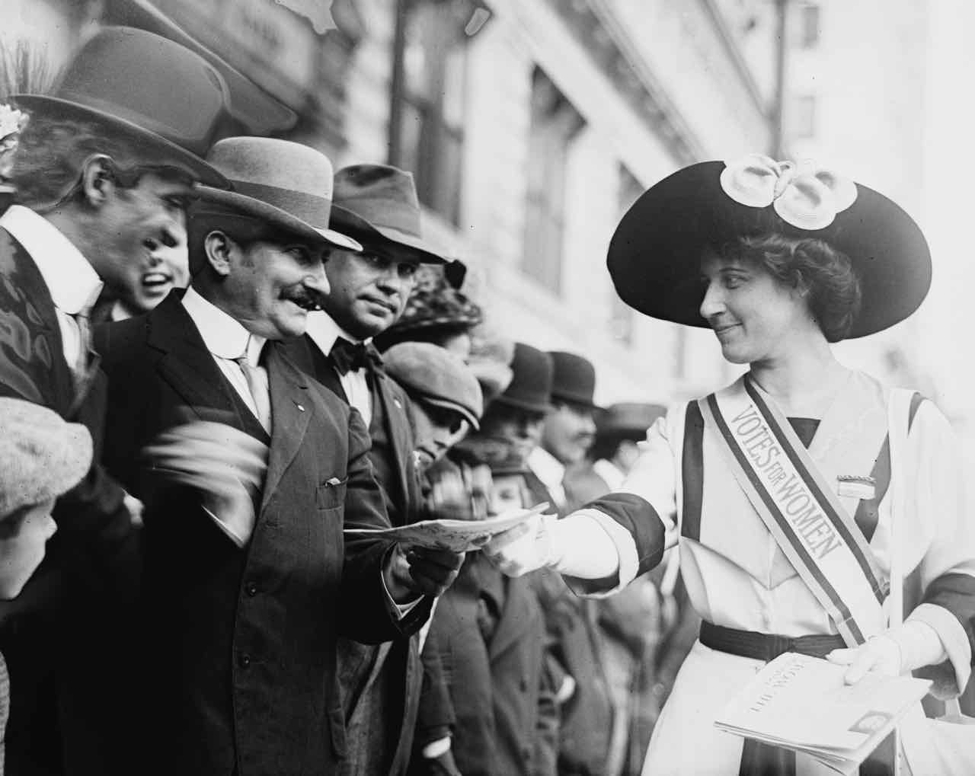Credit: Bain News Collection, Library of Congress.

The documentary is part of the PBS Trailblazers summer programming lineup honoring the 100th anniversary of the passage of the 19th Amendment of women’s suffrage. The series is narrated by Kate Burton and features the voices of the unsung warriors of the movement: Mae Whitman (Alice Paul), Audra McDonald (Ida B. Wells), Laura Linney (Carrie Chapman Catt) and Patricia Clarkson (Harriot Stanton Blatch).

“The hard-fought campaign waged by American women for the right to vote was a truly transformative cultural and political movement, resulting in the largest expansion of voting rights in American history,” said executive producer Susan Bellows. “It’s also a story that has usually been reduced to a single page in the history books. The Vote restores this complex story to its rightful place in our history, providing a rich and clear-eyed look at a movement that resonates as much now as ever.”

A multi-platform engagement campaign for The Vote, funded by the Corporation of Public Broadcasting (CPB), includes a series of film screenings and discussions hosted by universities, museums and public television stations around the country. CPB will also fund grants to fifteen public television stations to produce local suffrage stories from across the country and extend the engagement around the topic of suffrage in those communities.

“CPB is proud to support American Experience which always gives us the story behind the stories that shaped our nation,” said Pat Harrison, president and CEO of CPB. “The Vote is storytelling at its finest, affirming that to achieve justice for all requires personal sacrifice, courage and persistence.”

“In 1920, the 19th Amendment to the U.S. Constitution gave women the right to vote.” It is an axiom of American history; yet seldom has an axiom more thoroughly obscured reality. Although rightly regarded as a milestone for both American women and American democracy, the 19th Amendment was not quite the simple turning point it is generally perceived to be. Millions of women voted before the amendment and millions more were prohibited from voting after it, particularly African American women in the South. Nor was the ballot a favor bestowed upon women by an enlightened, progressive society. The right to vote was, in fact, fought for and won –– by three generations of American women who, over the course of more than seven decades, not only carried out one of the most sustained and successful political movements in all of American history, but were also the first to employ the techniques of nonviolent civil disobedience that later would become the hallmark of American political protest.

From the moment the clamor for woman suffrage first was raised in the United States, in the 1840s, the question was how the vote would ever be won. Resistance to women’s participation in the political sphere came from every quarter of American society –– from political machines eager to maintain their power, industrial interests fearful for their profits, even many women, who were convinced that wielding the ballot would somehow diminish their influence in society. Compounding the opposition, from the late 19th century on, was the poisonous legacy of Reconstruction and the determination of the former Confederate states to preserve white supremacy, in large part by barring African Americans from the polls.

As of 1909, despite six decades of relentless struggle, suffragists could point to little in the way of progress. Just four states had extended the franchise to women; the federal woman suffrage amendment –– introduced in the Senate in 1878 –– had virtually no support on Capitol Hill; and most in the first generation of activists had gone to their graves without casting a ballot. What had begun as a crusade of the few, however, had become a mass movement –– and their collective impatience was mounting.

As suffragists attempted to navigate the treacherous shoals of the national political scene, time and again principle was sacrificed in the name of pragmatism. Unfolding after the Civil War, when racism was both “a political fact and a political strategy,” said historian Martha Jones, the crusade for woman’s suffrage mirrored its historical moment. When expedient, white suffragists proved willing to accommodate its pervasive and deeply pernicious politics of exclusion. The Vote engages this troubled history directly –– underscoring the contributions of women of color to the struggle, the challenges of coalition-building in a fundamentally unequal society, and most importantly, the significant limitations of the 19th Amendment.

“The lengths to which women had to go in their pursuit of the ballot will likely come as a surprise to most viewers,” said writer, director and producer Michelle Ferrari. “How many people are aware that suffragists were the first Americans to picket the White House? That those women were jailed, went on hunger strikes and were force-fed by authorities? And that the techniques of non-violent civil disobedience, which we usually associate with the Civil Rights Movement, were employed first by women fighting for the right to vote?”

Dramatic and thought-provoking, The Vote is, at its core, a story about power –– “who has it and who doesn't want to give it up,” said constitutional lawyer and writer Michael Waldman. “We’re still fighting over who has that power.”

In addition to the documentary series, American Experience will be launching She Resisted, an immersive, interactive website that explores the suffrage movement’s strategies through its most powerful images, brought to life through the striking dimension of color. By meticulously restoring color to archival stills and the upscaling and colorization of historical footage, She Resisted will offer a heightened immersive experience of the vision, perseverance and radicality of the women who won the vote.

Part One

Part One traces the rise of suffrage militancy, a direct-action approach to politics inspired by Britain’s notoriously militant suffragettes. First introduced in New York by Harriot Stanton Blatch, the daughter of women’s rights pioneer Elizabeth Cady Stanton, and later championed by Alice Paul, a well-educated, singularly-driven Quaker of the movement's third generation, the new, “unladylike” tactics heightened the movement’s visibility, as thousands of American women took to the streets to boldly demand their right to full and equal citizenship. During this time, the question of suffrage for African American women, already active in the movement, was seen as a liability in securing the full support of women and men in the former Confederacy. By 1911, “votes for women” had become, as one journalist noted, “the three small words which constitute the biggest question in the world today.” While galvanizing to many, such radical action was also divisive, stiffening the opposition and threatening to undermine the movement's credibility.

Part Two

Part Two examines the mounting dispute over strategy and tactics, and reveals how the pervasive racism of the time, particularly in the South, impacted women's fight for the vote. Stung by a string of bitter state-level defeats in the fall of 1915, the suffragists decided to concentrate their energies on the passage of a federal amendment. One faction, under the leadership of the National American Woman Suffrage Association’s President Carrie Chapman Catt, was determined to pursue a moderate course and work within the political system, while another, Alice Paul's National Woman’s Party, deployed ever-more confrontational and controversial methods of protest. The two efforts nevertheless pushed the movement to its crescendo in tandem, and forever transformed the politics of social change in America.

About the Participants (in alphabetical order)

Jad Adams is a writer/research fellow University of London and author of Women and the Vote: A World History (2014).

Colonel Beth Behn is a former commander at Fort Eustis, former Associate Professor of History at the United States Military Academy, and author of Woodrow Wilson's Conversion Experience (2012 PhD dissertation).

Tina Cassidy is the author of Mr. President How Long Must We Wait?: Alice Paul, Woodrow Wilson, and the Fight for the Right to Vote (2019).

Marcia Chatelain is a Provost's Distinguished Associate Professor of History and African American studies at Georgetown University.

Ellen DuBois is a Professor Emeritus of History at UCLA and author of Harriot Stanton Blatch and the Winning of Woman Suffrage (1997), Woman Suffrage and Women's Rights: Essays (1997), and Suffrage: Women's Long Battle for the Vote (2020).

Paula Giddings is Professor Emeritus of Africana Studies at Smith College, and author of When and Where I Enter: The Impact of Black Women on Race (1984) and Ida: A Sword Among Lions (2008).

Susan Goodier is a Professor of History at SUNY Oneonta and author of No Votes for Women: The New York State Anti-Suffrage Movement (2013) and Women Will Vote: Winning Suffrage in New York State (2017).

Martha Jones is the Society of Black Alumni Presidential Professor of History at Johns Hopkins University and author of All Bound Up Together: The Woman Question in African American Public Culture 1830-1900 (2009) and Vanguard: How Black Women Broke Barriers, Won the Vote, and Insisted Upon Equality for All (2020).

Alexander Keyssar is the Matthew W. Stirling Jr. Professor of History and Social Policy, Harvard Kennedy School and author of The Right to Vote: The Contested History of Democracy in America (2000).

Ellie Smeal is president and co-founder of the Feminist Majority Foundation.

Michael Waldman is president of the Brennan Center for Justice at NYU School of Law and author of The Fight to Vote (2016).

Mary Walton is a journalist and author of A Women’s Crusade: Alice Paul and the Battle for the Ballot (2010).

Susan Ware is an historian/biographer, an honorary women's suffrage centennial historian at Schlesinger Library, Radcliffe Institute, and author of Why They Marched: Untold Stories of the Women Who Fought for the Right to Vote (2019).

Elaine Weiss is a writer /journalist and author of The Woman’s Hour: The Great Fight to Win the Vote (2018).

Jill Zahniser is an independent historian and author of Alice Paul: Claiming Power (2014).

About the Filmmakers

“The Vote”
Part 1

Written and Directed by  Produced by | MICHELLE FERRARI  CONNIE HONEYCUTT  MICHELLE FERRARI
Edited by | NANCY NOVACK
Narrated by | KATE BURTON

Voices

PATRICIA CLARKSON
AUDRA MCDONALD
MAE WHITMAN

Part 2

Written and Directed by  Produced by | MICHELLE FERRARI  CONNIE HONEYCUTT  MICHELLE FERRARI
Edited by | ILYA CHAIKEN
Narrated by | KATE BURTON

Voices

PATRICIA CLARKSON
LAURA LINNEY
MAE WHITMAN

Original Score by  Design and Animations by | NATHAN HALPERN  MOLLY SCHWARTZ  ALISA PLACAS FRUTMAN
Co-Producer | RAFAEL DE LA UZ

American Experience is a production of WGBH Boston
Executive Producers | SUSAN BELLOWS
 | MARK SAMELS
A 42nd Parallel Films Production For American Experience
Michelle Ferrari (Writer, Producer, Director) has been creating innovative, critically acclaimed
documentary narratives for nearly two decades. Her work as a screenwriter and story editor has been seen on PBS, HBO, and at film festivals nationwide, and has garnered honors from the Writers Guild of America, the Western Writers Association, the Organization of American Historians, the Sundance Film Festival, and the Academy of Television Arts and Sciences. The writer of numerous American Experience films –– among them The Perfect Crime, Silicon Valley, Roads to Memphis, and Kit Carson –– Ferrari is perhaps best known for the highly rated Seabiscuit, which earned her a Primetime Emmy Award for Outstanding Writing. She most recently wrote and directed Edison, Rachel Carson, and 2019 Writers Guild Award winner The Eugenics Crusade for American Experience. Additional credits include the landmark PBS series Half the Sky and the Emmy-winning HBO documentary Marina Abramović: The Artist is Present. She is a graduate of the University of California, Berkeley, and holds an M.A. in American History from Columbia University.

Susan Bellows (Acting Executive Producer) is an award-winning producer and writer with more than 20 years of experience producing national programs for public television. Bellows was the producer and director of the Emmy Award-winning JFK, which premiered on American Experience in 2013, and writer, director and producer for The Bombing of Wall Street, which premiered on the series in 2018. Since joining the series in 2003, she has provided editorial support and guidance to its broadcast and digital work. Previously, Bellows served as senior producer for the Peabody and Emmy Award-winning series Africans in America. Her other producing credits include films for The Great Depression, for which she received an Emmy nomination, and America’s War on Poverty, both productions of Blackside, Inc. Bellows also co-produced New Worlds, New Forms for the WNET-produced series Dancing, an eight-hour landmark series on dance forms around the world.

About PBS Trailblazers
In the summer of 2020, PBS is celebrating the women’s vote centennial with a slate of multiplatform content honoring and commemorating U.S. women’s suffrage, the feminist movement and modern-day changemakers. In addition to AMERICAN EXPERIENCE The Vote, AMERICAN MASTERS Unladylike2020 is a multimedia series featuring courageous, little-known and diverse female trailblazers from the turn of the 20th century. And She Could Be Next (w.t.), a POV miniseries, follows women of color as political candidates and organizers who seek to expand the electorate, asking whether democracy itself can be preserved — and made stronger — by those most marginalized. And a two-part FIRING LINE WITH MARGARET HOOVER special documents what motivated several conservative women to run for office. MAKERS Not Done, examines the landscape of today’s multifaceted women’s movement and how feminist changemakers of today are making real progress toward true equality. Two fan-favorite PBS series will salute female changemakers: AMERICAN MASTERS with Toni Morrison: The Pieces I Am and Mae West: Dirty Blonde; and GREAT PERFORMANCES with Gloria: A Life, about Gloria Steinem, and Ann, about Texas governor Ann Richards. ANTIQUES ROADSHOW spotlights outstanding contributions from female athletes, artists, activists and more in the all-new special Women’s Work. The lineup also features two new miniseries: PREHISTORIC ROAD TRIP, hosted by the Field Museum’s Emily Graslie, who embarks on an epic adventure through America’s fossil country; and BBC co-production ROYAL HISTORY’S MYTHS AND SECRETS WITH LUCY WORSLEY, who investigates notable women and their roles in historical events. In addition, PBS will encore the critically acclaimed and award-winning FRONTLINE documentary For Sama, an intimate yet epic journey of one woman’s experience of the Syrian war.

About American Experience
For over 30 years, American Experience has been television’s most-watched history series. Hailed as “peerless” (The Wall Street Journal), “the most consistently enriching program on television” (Chicago Tribune) and “a beacon of intelligence and purpose” (Houston Chronicle), the series brings to life the incredible characters and epic stories that have shaped America’s past and present. American Experience documentaries have been honored with every major broadcast award, including 30 Emmy Awards, four duPont-Columbia Awards and 17 George Foster Peabody Awards; the series received an Academy Award® nomination for Best Documentary Feature in 2015 for Last Days in Vietnam. American Experience also creates original digital content that uses new forms of storytelling to connect our collective past with the present. Visit pbs.org/americanexperience and follow us on Facebook Twitter, Instagram and YouTube to learn more.

Major funding for American Experience provided by Liberty Mutual Insurance, Consumer Cellular and by the Alfred P. Sloan Foundation. Major funding for The Vote provided by the Corporation for Public Broadcasting, the National Endowment for the Humanities: Exploring the Human Endeavor. Additional funding for The Vote provided by The Arthur Vining Davis Foundations: Investing in Our Common Future and by The Barbara Lee Family Foundation Fund. Additional funding for American Experience provided by the Robert David Lion Gardiner Foundation, The Documentary Investment Group and public television viewers. American Experience is produced for PBS by WGBH Boston.

* * *
Press Contacts:
CaraMar Publicity
Mary Lugo 770-623-8190 lugo@negia.net
Cara White 843-881-1480 cara.white@mac.com
Abbe Harris 908-244-5516 abbe.harris@caramar.net

For further information and photos visit http://www.pbs.org/pressroom

