American Experience Voice of Freedom
Premieres Monday, February 15, 2021 on PBS

Film Explores the Life and Legacy of Singer Marian Anderson and Her Triumphant 1939 Concert at the Lincoln Memorial

(Boston, MA) — American Experience presents Voice of Freedom, a new documentary about singer Marian Anderson, whose talent broke down barriers around the world. Hailed as a voice that “comes around once in 100 years” and widely celebrated by both white and Black audiences at home, her fame wasn’t enough to insulate her from the indignities and trauma of racism and segregation. On Easter Sunday, 1939, she stepped up to a microphone in front of the Lincoln Memorial. Inscribed on the walls of the monument behind her were the words “all men are created equal.” Barred from performing in Constitution Hall because of her race, Anderson would sing for the American people in the open air. Narrated by Renée Elise Goldsberry (Hamilton), Voice of Freedom interweaves Anderson’s rich life story with this landmark moment in history, exploring fundamental questions about talent, race, fame, democracy and the American soul. Produced by Rob Rapley and executive produced by Cameo George, Voice of Freedom premieres Monday, February 15, 9:00-11:00 p.m. ET (check local listings) on American Experience on PBS, PBS.org and the PBS Video App.
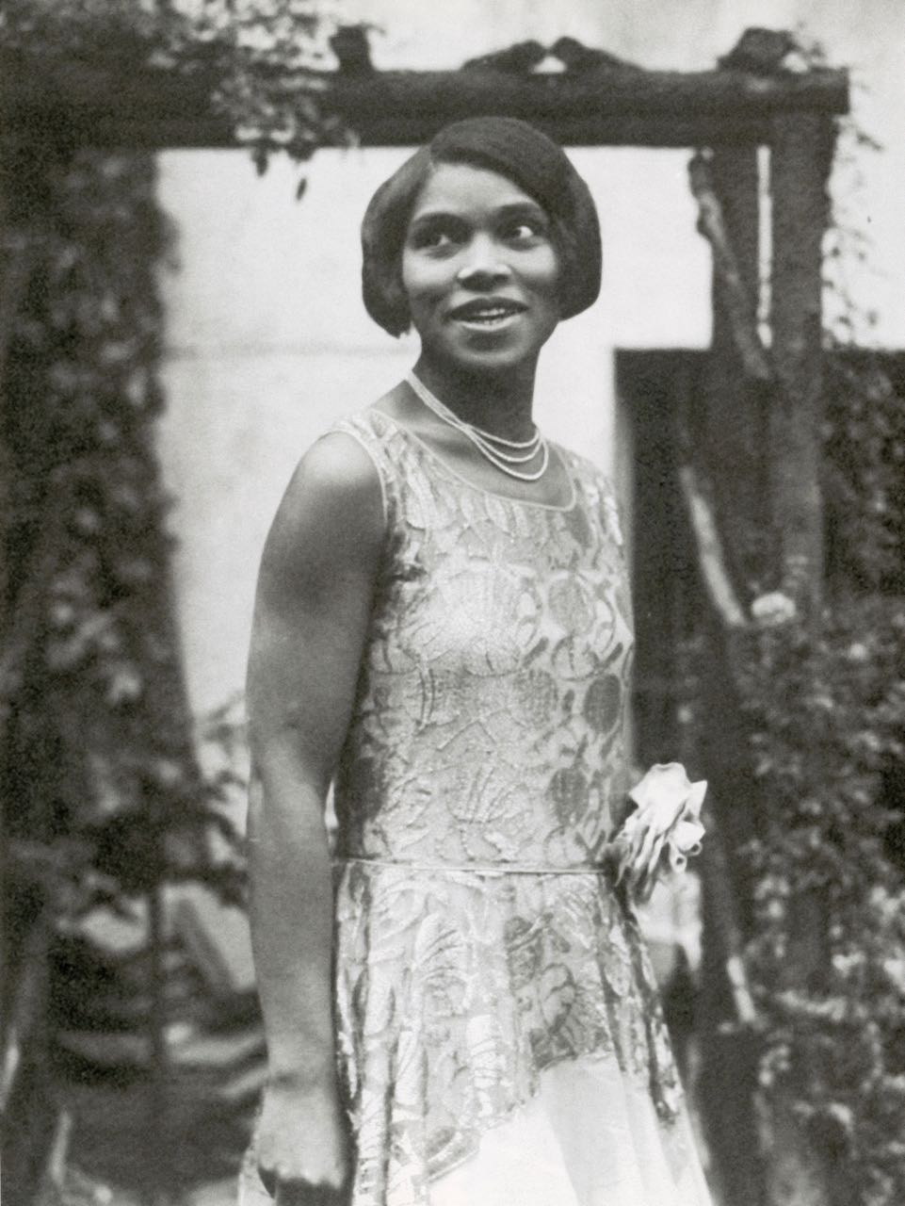
Credit: Science History Images / Alamy Stock Photo

“Marian Anderson was an artist first and foremost. She did not seek to become an icon of the civil rights movement,” said Cameo George, American Experience executive producer. “But when circumstances thrust themselves upon her, she did not waver, using her voice as a powerful force to transcend geographical, political and racial boundaries.”

Born in South Philadelphia in 1897, Marian Anderson’s life was shaped by two circumstances of her birth: her race and her extraordinary voice. Although she rose to the highest levels of the music world, racism impacted every aspect of her life, starting with a humiliating rejection from the Philadelphia Musical Academy when she was a teenager. By the early 1920s Anderson had achieved a certain level of success but was restricted in where she could perform, for whom she could perform and where she could study.

Aware of the success enjoyed by other African-American performers abroad, Anderson traveled to Europe in 1927. In London and Berlin, she found freedom and possibility and pursued the education she had been denied at home. She became a sensation in Scandinavia and conquered Paris. But by 1935, the rise of the Nazi party began closing doors; Anderson was effectively barred from performing in Germany for being “insufficiently Aryan.”

When Anderson was excluded from Austria’s prestigious Salzburg Music Festival, a friend defied authorities and arranged for her to sing in a hotel ballroom. Although the last Black singer to perform in Salzburg had been run out of town by Nazi thugs, Anderson insisted on keeping the date. Anti-Fascist musicians made a point of attending, including Arturo Toscanini, who said that her singing was something “one is privileged to hear only once in 100 years.” From then on, Anderson was known as the Voice of the Century.

“Marian Anderson is willing to show up, and she must show up, to indicate that she is not going to accept the terms of social inequality, of artistic inequality,” said scholar Kira Thurman. “I think that says a lot about who she was — her insistence on demonstrating her dignity in the midst of such harsh racial oppression and violence.”

When Anderson returned to the U.S. in 1935, she was a rich and famous woman. But she was still a second-class citizen in her own country. Everywhere she traveled, the color of her skin shaped where she ate, slept, socialized, and worked. In the South, except for a few big cities, she was once again limited to the old circuit of Black colleges and churches.

In January 1939, events began unfolding that would put her at the center of the fight for civil rights and change her life forever. Anderson had agreed to perform a benefit concert for Howard University on Easter Sunday, April 9. The Daughters of the American Revolution had rejected Howard University’s proposal to use Constitution Hall, the only suitable venue for the concert, because the DAR didn’t allow Black performers. Walter White, head of the National Association for the Advancement of Colored People, decided to fight the decision and called Eleanor Roosevelt, the DAR’s most illustrious member. She declined to resign from the DAR but did lend her name to a campaign to pressure the organization directly, as did some of the most famous musicians in the world. But the effort failed to attract national attention. With just a few weeks remaining, the First Lady resigned from the DAR and the controversy became front-page news across the country. Anderson, on tour at the time, wasn’t told about the resignation in advance and read about it in the newspapers.

Although the publicity surrounding Roosevelt’s resignation was an enormous victory for the NAACP, there was still no venue for the concert. But Walter White had an inspiration: a free outdoor event on the steps of the Lincoln Memorial. President Roosevelt granted permission, saying that Anderson “can sing from the top of the Washington Monument if she wants to.”

Anderson’s concert on Easter Sunday, April 9, 1939, became one of the largest gatherings ever in the nation’s capital — 75,000 people — and millions more listened to the radio broadcast. When she finished singing, Anderson spoke to the crowd for the first and only time. “My dear friends,” she said, “I am so overwhelmed that I cannot express myself. I hope you will ever find me grateful for the wonderful things you have done for me. Please try to imagine all the things I cannot say.” For the rest of her life, Anderson would be remembered for this concert, an event she never discussed outside her inner circle. The concert also helped enshrine the Lincoln Memorial as a symbol of civil rights, freedom and justice.

By the 1950s, a new generation was energizing the civil rights movement. In 1951, the NAACP asked Anderson and other Black artists to stop playing in segregated venues. Anderson refused, believing that her performances had helped improve race relations in the South more effectively than more militant tactics. The NAACP disagreed, and in January 1951, they boycotted Anderson’s concert in Richmond, Virginia; only then did she agree to join the campaign.

Some found Anderson’s reticence disappointing, but to others it made her the ideal agent of change. In 1955, at the age of 58, Anderson became the first Black performer at New York’s Metropolitan Opera.

The year that began with Anderson’s Met debut ended with the emergence of 26-year-old Reverend Martin Luther King, Jr., onto the national scene. King had listened to Anderson’s Easter Sunday concert on the radio when he was ten years old, and although he embraced tactics that Anderson had described as “militant,” he revered her still. In August 1963, King’s allies extended an invitation for her to sing at the March on Washington.

“Marian Anderson understood the power of her presence,” said Allida Black. “She understood, in a very personal way, the history and symbolism that she carried. What Marian Anderson is going to say is, ‘My voice is as worthy if not better than any other voice in my field. And I must be heard.’”

Marian Anderson died on April 8, 1993.

About the Participants

Allida M. Black is Research Professor of History and International Affairs at The George Washington University and Project Director and Editor of The Eleanor Roosevelt Papers, a project to teach and apply Eleanor Roosevelt’s writings and discussions of human rights and democratic politics.

Angela Brown is a dramatic soprano who has performed on the leading opera and symphonic stages across six continents. She made her acclaimed Metropolitan Opera debut in the title role of Aida during the 2004-2005 season.

Lucy Caplan writes about music, history and culture, both as a scholar and a critic, and is a lecturer on history and literature at Harvard University. She is the author of High Culture on the Lower Frequencies: African Americans and Opera, 1900-1933, which explores how early 20th-century African Americans redefined the genre of opera as a wellspring of antiracist activism, collective sociality and aesthetic innovation.

Alisha Lola Jones is an assistant professor, folklore and ethnomusicology, Indiana University.

Adriane Lentz-Smith is an associate professor of history and African & African American studies at Duke University. She teaches courses on Black Lives, the Black Freedom Struggle, and history in fiction and fact.

Carol Oja is the William Powell Mason Professor of Music, Harvard University. She is working on a book provisionally titled Civil Rights in the Concert Hall: Marian Anderson and the Racial Desegregation of Classical Music.

Jillian Patricia Pirtle is chief operating officer of the National Historical Marian Anderson Residence Museum & Society in Philadelphia.

Sharon Vriend Robinette is the author of “My Life in the White World: The European-American Representation of Marian Anderson, 1939-1957,” a doctoral dissertation submitted to the Graduate College of Bowling Green State University.

Kira Thurman is an assistant professor of Germanic languages and literature and history at the University of Michigan. She is also a classically-trained pianist.

Leslie Ureña is associate curator of photographs at the National Portrait Gallery. She curated “One Life: Marian Anderson” in 2019.

Denise VanBuren is President General of the Daughters of the American Revolution.

American Experience Voice of Freedom

Written and Directed by  Produced by  Narrated by | ROB RAPLEY  ROB RAPLEY  EMILY HARROLD  RENÉE ELISE GOLDSBERRY
Edited by | STEVEN J. GOLLIDAY

American Experience is a production of GBH Boston
Executive Producer | CAMEO GEORGE

About the Filmmakers

Rob Rapley (Writer, Director, Producer) has written, produced and directed a number of films for American Experience, including, most recently, The Man Who Tried to Feed the World. Other films for the series include The Secret of Tuxedo Park, episode three of The Great War and Murder of a President. Three previous films for the series — The Poisoner’s Handbook, The Abolitionists and Wyatt Earp — received two Emmy nominations, a Writers Guild Award, a Writers Guild Award nomination, a Western Heritage Award and a Western Writers of America Award. Rapley also produced the first episode of Henry Louis Gates’ Reconstruction, The Greely Expedition, Buffalo Bill, Trail of Tears and two episodes of the acclaimed PBS series on the Supreme Court. He was previously nominated for Emmy Awards for his work on Bill Moyers’ Becoming American: The Chinese Experience and Loosely Mozart: The New Innovators of Classical Music.

Cameo George (Executive Producer of American Experience) is an Emmy Award-winning producer, writer, and journalist with more than 20 years of experience in documentary, broadcast television, and digital content production. George has produced, developed, and commissioned innovative programming at CNN, NBC News, ABC News, and digital media startup OZY.com. She was the senior producer of CNN’s groundbreaking series Black in America and Latino in America and the executive producer of the eight-hour PBS documentary series 16 for '16: The Contenders, which was also broadcast on the BBC. George joined American Experience from ABC News, where she was Head of Development for Longform projects, responsible for creating a pipeline of docuseries and feature documentary films across Walt Disney Television platforms including ABC News, Hulu, National Geographic, and Disney+.

About American Experience
For more than 30 years, American Experience has been television’s most-watched history series, bringing to life the incredible characters and epic stories that have shaped America’s past and present. American Experience documentaries have been honored with every major broadcast award, including 30 Emmy Awards, four duPont-Columbia Awards and 18 George Foster Peabody Awards. PBS’s signature history series also creates original digital content that innovates new forms of storytelling to connect our collective past with the present. Cameo George is the series executive producer. American Experience is produced for PBS by GBH Boston. Visit pbs.org/americanexperience and follow us on Facebook Twitter, Instagram and YouTube to learn more.

Major funding for American Experience provided by Liberty Mutual Insurance, Consumer Cellular and by the Alfred P. Sloan Foundation. Additional funding provided by the Robert David Lion Gardiner Foundation, The Documentary Investment Group, the Corporation for Public Broadcasting and public television viewers.

* * *
Press Contacts:
CaraMar Publicity
Mary Lugo 770-623-8190 lugo@negia.net
Cara White 843-881-1480 cara.white@mac.com
Abbe Harris 908-244-5516 abbe.harris@caramar.net

For further information and photos visit http://www.pbs.org/pressroom

