American Experience Zora Neale Hurston: Claiming A Space
Premieres Tuesday, January 17, 2023, on PBS and Streaming on PBS.org

New Biography of the Trailblazing Writer and Anthropologist

(BOSTON, MA) – American Experience presents Zora Neale Hurston: Claiming a Space, a new in-depth biography of the influential author whose groundbreaking anthropological work would challenge assumptions about race, gender and cultural superiority that had long defined the field in the 19th century. Directed by Tracy Heather Strain, produced by Randall MacLowry and executive produced by Cameo George, the film premieres on American Experience on Tuesday, January 17, 9:00-11:00 p.m. ET (check local listings) on PBS, PBS.org and the PBS Video app.
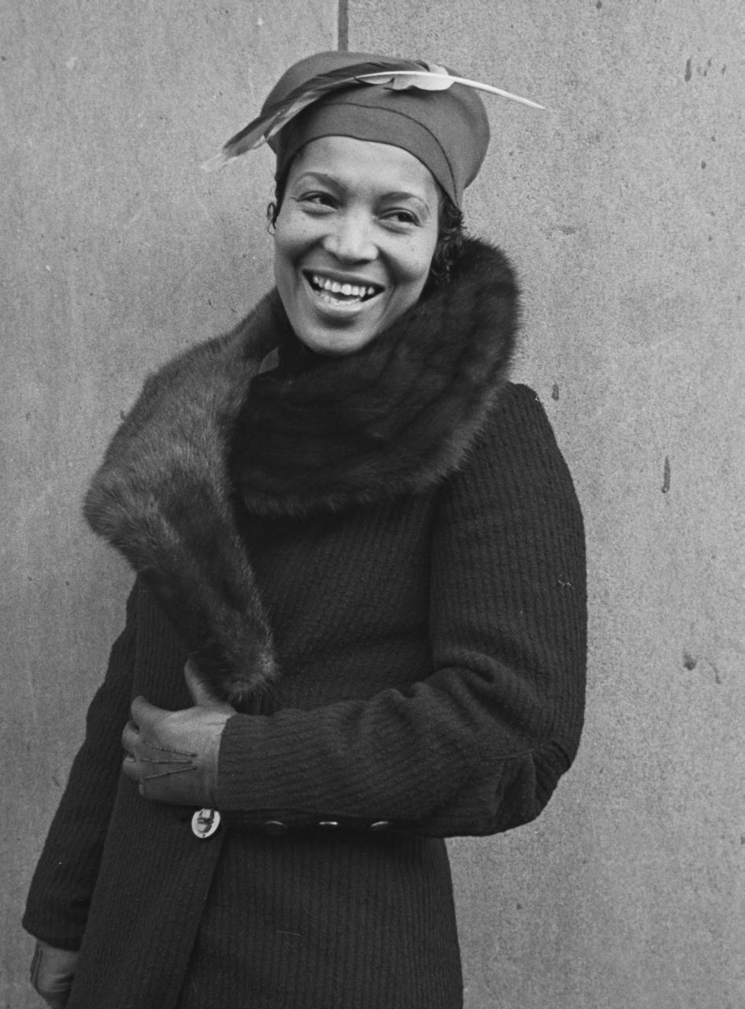
Credit: Yale University Library

Raised in the small all-Black Florida town of Eatonville, Zora Neale Hurston studied at Howard University before arriving in New York in 1925. She would soon become a key figure of the Harlem Renaissance, best remembered for her novel Their Eyes Were Watching God. But even as she gained renown in the Harlem literary circles, Hurston was also discovering anthropology at Barnard College with the renowned Franz Boas. She would make several trips to the American South and the Caribbean, documenting the lives of rural Black people and collecting their stories. She studied her own people, an unusual practice at the time, and during her lifetime became known as the foremost authority on Black folklore.

Immersing herself in the worlds of her participants, Hurston focused on building trust. She interviewed Cudjo Lewis, one of the last known surviving Africans of the slave ship Clotilda, collected folklore at lumber camps, phosphate mines and turpentine distilleries and studied “hoodoo” in New Orleans. Her techniques paid off, yielding a plethora of material, which Hurston turned into a series of papers, plays and stories. By 1932, she had been published twice in the Journal of American Folk-Lore.

In 1936, with the help of two Guggenheim fellowships, Hurston traveled to Haiti and Jamaica and focused on her literary and scientific work. While in Haiti, she wrote Their Eyes Were Watching God, mixing memory, fiction and research. In 1937, the novel was published to acclaim, followed by Tell My Horse, her second ethnographic book, in 1938. But royalties from both books were not enough to give Hurston financial security.

Despite her success, the end of Hurston’s life was marked by money woes and a multitude of setbacks. To make ends meet, she published her autobiographical book Dust Tracks on a Road in 1942. While the book helped establish her as a literary celebrity, Hurston still struggled financially. She eventually landed in the Black community of Fort Pierce, Florida, where she worked a series of odd jobs.

On January 28, 1960, at the age of 69, Zora Neale Hurston died in near obscurity following a stroke in a nursing home. Although now heralded as a great literary figure, her work in anthropology — and her pivotal role in elevating Black culture and folklore — is only now being fully appreciated.
“Zora Neale Hurston has long been considered a literary giant of the Harlem Renaissance, but her anthropological and ethnographic endeavors were equally important and impactful,” says American Experience executive producer Cameo George. “Her research and writings helped establish the dialects and folklore of African American, Caribbean and African people throughout the American diaspora as components of a rich, distinct culture, anchoring the Black experience in the Americas.”

American Experience Zora Neale Hurston: Claiming a Space will stream simultaneously with broadcast on all station-branded PBS platforms, including PBS.org and the PBS app available on iOS, Android, Roku, Apple TV, Amazon Fire TV, Android TV, Samsung Smart TV, Chromecast and VIZIO. The film will also be available for streaming with closed captioning in English and Spanish.

About the Participants

Lee D. Baker is a professor of Cultural Anthropology, Sociology, and African and African American Studies at Duke University and author of From Savage to Negro: Anthropology and the Construction of Race, 1896-1954 and Anthropology and the Racial Politics of Culture.

María Eugenia Cotera is an associate professor in the Mexican American and Latino Studies Department at the University of Texas and author of Native Speakers: Ella Deloria, Zora Neale Hurston, Jovita González, and the Poetics of Culture.

Eve Dunbar is a professor of English at Vassar College and the author of Black Regions of the Imagination: African American Writers Between the Nation and the World and co-editor of African American Literature in Transition: 1930-1940.

Carla Kaplan is the Davis Distinguished Professor of American Literature at Northeastern University and author of Zora Neale Hurston: A Life in Letters and Miss Anne in Harlem: The White Women of the Black Renaissance.

Charles King is a professor of International Affairs and Government at Georgetown University and the author of The New York Times bestselling Gods of the Upper Air: How a Circle of Renegade Anthropologists Reinvented Race, Sex, and Gender in the Twentieth Century.

Daphne Lamothe is a professor and chair of the Department of Africana Studies at Smith College and author of Inventing the New Negro: Narrative, Culture, and Ethnography.

Irma McClaurin is an activist bio-cultural anthropologist who studies the social construction of inequality, poet, the editor of Black Feminist Anthropology: Theory, Politics, Praxis, and Poetics, and founder of the Black Feminist Archive at the University of Massachusetts Amherst.

Tiffany Ruby Patterson is chair of the African American and Diaspora Studies Department at Vanderbilt University and the author of Zora Neale Hurston and a History of Southern Life.

About the Filmmakers

American Experience Zora Neale Hurston: Claiming a Space

Written and Directed by  Produced by  Edited by | TRACY HEATHER STRAIN  RANDALL MACLOWRY  TRACY HEATHER STRAIN  MARK DUGAS
American Experience is a production of GBH Boston
Executive Producer | CAMEO GEORGE

Tracy Heather Strain (Director/Writer/Producer), president and co-founder of the Film Posse, is an award-winning filmmaker. Strain directed, wrote and produced Sighted Eyes/Feeling Heart, her feature documentary about Lorraine Hansberry, which made its television debut on AMERICAN MASTERS and won a Peabody Award, an NAACP Image Award for Motion Picture Directing (Television) and the American Historical Association’s John E. O’Connor Award. A two-time Emmy-nominated filmmaker, her other directing and producing credits include “When the Bough Breaks” for the duPont Columbia Award-winning series Unnatural Causes: Is Inequality Making Us Sick? and “The Story We Tell” for Race: The Power of an Illusion. She directed, wrote and produced “Bright Like a Sun” and “The Dream Keepers” for Blackside’s six-part series I’ll Make Me a World: A Century of African American Art, which won a Peabody Award and Organization of American Historians’ Erik Barnouw Award. Her other American Experience credits include producer/director of Building the Alaska Highway; writer/director/producer of American Oz; producer of Silicon Valley; and coordinating producer of The Feud, The Swamp, The Battle of Chosin, The Mine Wars and The Rise and Fall of Penn Station. Strain is the Corwin-Fuller Professor of Film Studies at Wesleyan University.

Randall MacLowry (Producer) is an award-winning filmmaker who crafts documentaries at the Film Posse, the production company he co-founded with his wife and business partner Tracy Heather Strain. A director, writer, producer and editor with over 30 years of experience, MacLowry’s credits include films for the PBS series American Experience, most recently American Oz, The Feud, The Swamp and The Battle of Chosin; NOVA, AMERICAN MASTERS, Unnatural Causes: Is Inequality Making Us Sick? and Race: The Power of an Illusion. With Strain, MacLowry produced and edited the critically acclaimed Sighted Eyes/Feeling Heart, which had its world premiere at the 2017 Toronto International Film Festival and won a Peabody Award. MacLowry has received two Writers Guild Awards, and two of his American Experience films won the Organization for American Historians’ Erik Barnouw Award. MacLowry serves on the faculty of Wesleyan University’s College of Film and the Moving Image.

Cameo George (Executive Producer, American Experience) is an Emmy Award-winning producer, writer and journalist with more than 20 years of experience in documentary, broadcast television and digital content production. George has produced, developed and commissioned innovative programming at CNN, NBC News and ABC News. She was the senior producer of CNN’s groundbreaking series Black in America and Latino in America and executive producer of the eight-hour PBS documentary series 16 FOR '16: THE CONTENDERS, which was also broadcast on the BBC. George joined American Experience from ABC News, where she was head of development for long-form projects, responsible for creating a pipeline of docuseries and feature documentary films across Walt Disney Television platforms, including ABC News, Hulu, National Geographic and Disney+.

About American Experience

For 35 years, American Experience has been television’s most-watched history series, bringing to life the incredible characters and epic stories that have shaped America’s past and present. American Experience documentaries have been honored with every major broadcast award, including 30 Emmy Awards, five duPont-Columbia Awards and 19 George Foster Peabody Awards. PBS’s signature history series also creates original digital content that innovates new forms of storytelling to connect our collective past with the present. Cameo George is the series executive producer. American Experience is produced for PBS by GBH Boston. Visit pbs.org/americanexperience and follow us on Facebook, Twitter, Instagram and YouTube to learn more.

Major funding for American Experience provided by Liberty Mutual Insurance and by the Alfred P. Sloan Foundation. Additional funding provided by the Robert David Lion Gardiner Foundation, the Documentary Investment Group, the Corporation for Public Broadcasting and public television viewers.

All titles distributed internationally by PBS International.

* * *
Press Contacts:
CaraMar Publicity
Mary Lugo 770-851-8190 lugo@negia.net
Cara White 843-881-1480 cara.white@mac.com
Abbe Harris 908-244-5516 abbe.harris@caramar.net

For further information and photos visit http://www.pbs.org/pressroom

