Alt Text: Helen Keller Images
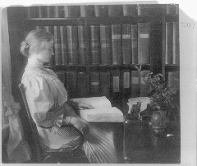
Caption: Helen Keller reading, 1907
Credit: Courtesy of Library of Congress
Alt text: Black and white image of Helen Keller reading using her hands in a library

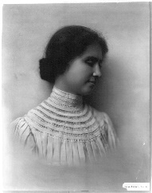
Caption: Helen Keller portrait, 1905
Credit: Courtesy of Library of Congress
Alt text: Black and white portrait of Helen Keller from the chest up

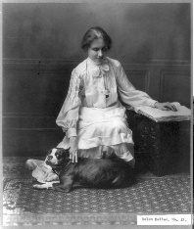
Caption: Helen Keller reading, 1904
Credit: Courtesy of Library of Congress
Alt text: Black and white image of Helen Keller reading using her hands

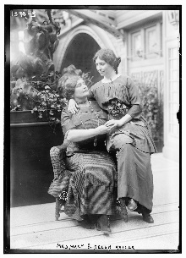
Caption: Helen Keller and Anne Macy, 1913
Credit: Courtesy of Library of Congress
Alt text: Black and white image of Helen Keller sitting on the lap of Anne Macy

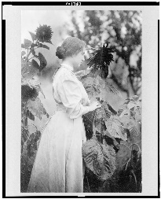
Caption: Helen Keller, 1907
Credit: Courtesy of Library of Congress
Alt text: Black and white image of Helen Keller touching a plant

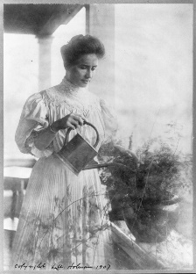
Caption: Helen Keller watering plant, 1907
Credit: Courtesy of Library of Congress
Alt text: Black and white image of Helen Keller watering a plant

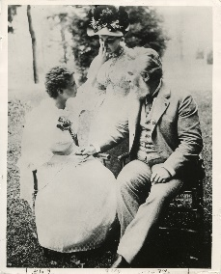
Caption: Helen Keller, Anne Sullivan and Alexander Graham Bell, 1894
Credit: Courtesy of Library of Congress
Alt text: Black and white image of Helen Keller sitting with Anne Sullivan and Alexander Graham Bell

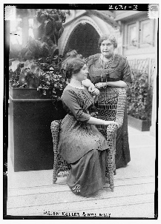
Caption: Helen Keller and Anne Sullivan, 1913
Credit: Courtesy of the Library of Congress
Alt text: Black and white image of Helen Keller and Anne Sullivan, one sitting on a chair and the other standing

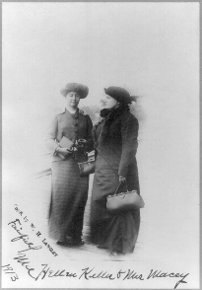
Caption: Helen Keller and Anne Sullivan, 1913
Credit: Courtesy of the Library of Congress
Alt text: Black and white image of Helen Keller and Anne Sullivan standing in winter hats and coats

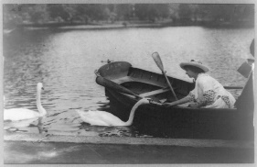
Caption: Helen Keller feeding swans, 1913
Credit: Courtesy of Library of Congress
Alt text: Black and white image of Helen Keller in a boat feeding a swan

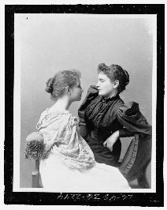
Caption: Helen Keller and Anne Sullivan, 1893
Credit: Courtesy of Library of Congress
Alt text: Black and white image of Helen Keller and Anne Sullivan sitting on a chair looking at each other
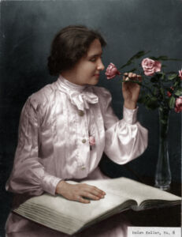
Caption: Helen Keller reading, 1904
Credit: Colorization by Jared Enos
Alt text: Helen Keller using her hand to read and smelling a flower


Caption: Helen Keller Radcliffe College graduation, 1904
Credit: The Alexander Graham Bell Association for the Deaf and Hard of Hearing (AG Bell)
Alt text: Helen Keller dressed in a graduation cap and gown

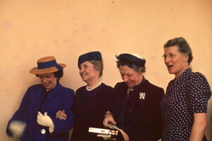
Caption: Helen Keller and Polly Thomson
Credit: Perkins School for the Blind
Alt text: Four women smiling in dresses

