OPENING THE DOOR TO THE WORLD’S MOST ASTOUNDING
ART COLLECTION AND ITS NEW HOME

– THE BARNES COLLECTION Debuts Friday, August 3, 2012, 9:00 p.m. ET
–

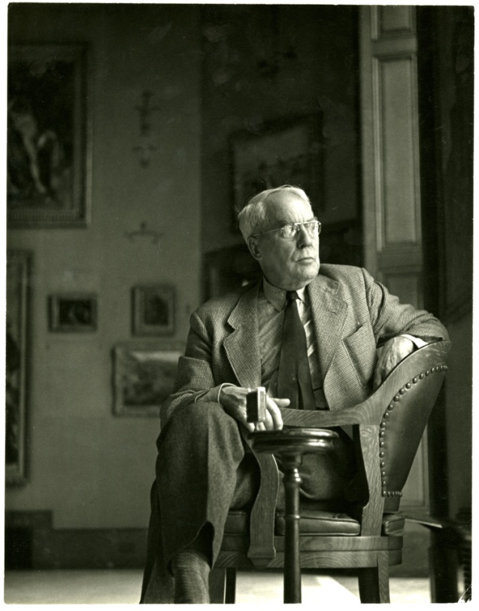
Pictured: Dr. Albert C. Barnes
Credit: Courtesy of Photographs © 2012 The Barnes Foundation
ARLINGTON, VA; June 25, 2012 – One of the world’s most astounding art collections was only recently made more accessible to the public, and a new film, THE BARNES COLLECTION, gives further insight into the life of Albert C. Barnes and his extraordinary collection as it moves from a private residence to an acclaimed new museum. On Friday, August 3, as part of the PBS ARTS SUMMER FESTIVAL, public television viewers get an exclusive look at the renowned Barnes Collection — more than 3,000 magnificent works by the most famous names in art, including Picasso, Cezanne, Renoir, Matisse and many others.

Produced by WHYY in Philadelphia, THE BARNES COLLECTION is a one-hour film that tells the story of the late Dr. Albert C. Barnes and his remarkable rise from Philadelphia’s working class to the top of the modern art world, tracing how Barnes’ passion for art led him to amass a collection of treasures that became both extraordinary and controversial. Each artwork illuminates a corner of Barnes’ story; his revealing personal letters — read by Emmy -nominated actor and Philadelphia native David Morse (“House,” The Green Mile, “St. Elsewhere”), who also narrates — guide viewers through his legacy.

THE BARNES COLLECTION follows a contemporary story, too, in the form of the internationally renowned team responsible for designing and constructing the Barnes’ new museum facility in Philadelphia. Barnes Foundation president and executive director Derek Gillman, and architects Tod Williams and Billie Tsien, reveal their creative processes, bringing viewers into the development of the museum from architectural drawings through construction to the triumphant public opening in May 2012. The documentary also traces the meticulous effort made to transfer the Barnes Foundation’s priceless works of art from their former home in suburban Merion, Pennsylvania, re-creating an environment that shows the collection as Barnes intended..

“Barnes was a complex character, a seeker in every way,” said Glenn Holsten, producer of THE BARNES COLLECTION. “We wanted to make sure the film portrayed his devotion for art, both understanding it and teaching it to others.”

The story of the Barnes Collection is not without significant controversy, as art-world purists, lawmakers, lawyers, and the general public took part in a years-long battle over the collection’s move from Barnes’ former home, from which — his will decreed — it should never be moved. Although it doesn’t dwell on the legal conflicts, THE BARNES COLLECTION leaves viewers to question what is gained and what is lost as the collection is relocated.

At its heart, THE BARNES COLLECTION is about art. High-definition footage brings viewers close to the works — close enough to discern the weft and warp of canvases and to marvel at the brushstrokes. No other film about the collection has had such intimate access to the works it comprises.

The PBS ARTS SUMMER FESTIVAL is a seven-part series that showcases diverse productions from top independent filmmakers who explore culture and art from around the globe. Festival films offer an in-depth look at music, theater, art, architecture, and cultural history from some of the world’s most unique locations. Award-winning television, film and stage star Anna Deavere Smith (“Nurse Jackie,” “The West Wing”) serves as host for the festival, which begins Friday, June 29, 2012 at 9 p.m. ET (check local listings.)

The full PBS ARTS SUMMER FESTIVAL schedule follows. Details at pbs.org/pressroom.
- MARIACHI HIGH, June 29, 2012, at 9 p.m. ET.
- ISLAMIC ART: MIRROR OF THE INVISIBLE WORLD, July 6, 2012, at 9 p.m. ET.
- JOHN LEGUIZAMO’S TALES FROM A GHETTO KLOWN, July 13, 2012, at 9 p.m. ET.
- HOMECOMING: THE KANSAS CITY SYMPHONY PRESENTS JOYCE DiDONATO, July 20, 2012, at 9 p.m. ET.
- HAVANA, HAVANA!, July 27, 2012, at 9 p.m. ET.
- THE BARNES COLLECTION, August 3, 2012, at 9 p.m. ET
- GREAT PERFORMANCES: “Tanglewood 75th Anniversary Celebration,” August 10, 2012, at 9 p.m. ET.

CREDITS
THE BARNES COLLECTION is produced by PBS member station WHYY in Philadelphia. Glenn Holsten, who helmed the PBS documentary Thomas Eakins: Scenes from Modern Life in 2002, serves as director and producer. WHYY executive producer Trudi Brown oversees the project. THE BARNES COLLECTION is made possible in part by Wilmington Trust.

About PBS
PBS, with its nearly 360 member stations, offers all Americans the opportunity to explore new ideas and new worlds through television and online content. Each month, PBS reaches nearly 123 million people through television and more than 21 million people online, inviting them to experience the worlds of science, history, nature and public affairs; to hear diverse viewpoints; and to take front row seats to world-class drama and performances. PBS’ broad array of programs has been consistently honored by the industry’s most coveted award competitions. Teachers of children from pre-K through 12th grade turn to PBS for digital content and services that help bring classroom lessons to life. PBS’ premier children’s TV programming and its website, pbskids.org, are parents’ and teachers’ most trusted partners in inspiring and nurturing curiosity and love of learning in children. More information about PBS is available at www.pbs.org, one of the leading dot-org websites on the Internet, or by following PBS on Twitter, Facebook or through our apps for mobile devices. Specific program information and updates for press are available at pbs.org/pressroom or by following PBS Pressroom on Twitter.

– PBS –

CONTACTS: Jennifer Marcus/John Michael Kennedy, Goodman Media International for PBS, Tel: 212-576-2700; PBSProgramming@goodmanmedia.com

Carrie Johnson/Michae Godwin, PBS, Tel.: 703-739-5129/ 703-739-8483; cjohnson@pbs.org, mmgodwin@pbs.org

For images and additional up-to-date information on this and other PBS programs, visit PBS PressRoom at pbs.org/pressroom.

