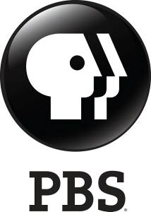

PBS’ Groundbreaking BIG BLUE LIVE Sets New Bar for Digital and Social Audience Engagement in a Natural History Series

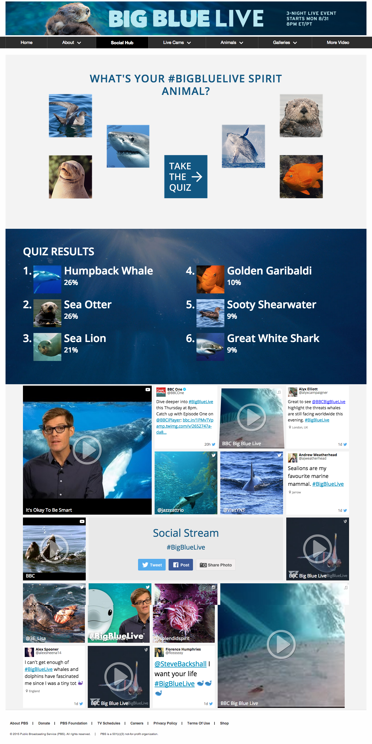

Screengrab of PBS.org/BigBlueLive Social Hub. Courtesy PBS
Arlington, VA; Aug. 26, 2015 – For three nights, starting August 31, PBS airs BIG BLUE LIVE, its first live nature program centering on the extraordinary annual confluence of marine life in and around Monterey Bay, California. Concurrently, the series is inspiring the largest and most diverse digital and social engagement integration in PBS history and one of the largest ever for a natural history program. Elements include a robust multimedia presence on numerous social and digital platforms, additional as-it-happens content on pbs.org/bigbluelive, and integration of social and digital elements into the three-night live broadcast.
Screengrab of http://pbs.org/bigbluelive.
Courtesy of PBS.
"PBS and its member stations are known for bringing unique, thought-provoking and eye-opening programming to viewers across multiple platforms,” said Don Wilcox, Vice President of Digital Marketing and Services for PBS. "With BIG BLUE LIVE we are inviting the national audience to actively participate in a celebration of one of nature’s greatest spectacles. This ambitious real-time event is a testament to PBS’ commitment to delivering high-quality science and nature programming, and finding ways to continuously engage and surprise the public we serve."

The immersive viewer experience is intended to make the show exciting and engaging for audiences of all ages and to spur family-centered viewing. In addition to watching the PBS broadcast at 8:00-9:00 p.m. ET and PT, viewers also have the option to enjoy the series in a multitude of ways:

- A live simulcast of BIG BLUE LIVE will air at PBS.org/BigBlueLive, where viewers will have a chance to interact with a variety of live marine wildlife camera feeds throughout Monterey Bay.
- The site will also serve as a social hub, helping the audience discover, explore and join the national conversation about the creatures and conservation effort, including perspectives from the local communities of PBS member stations.
- Photographs, videos, animated GIFs and live streams via Periscope will fuel social media integration of BIG BLUE LIVE with PBS, BBC, Monterey Bay Aquarium and NOAA’s Office of National Marine Sanctuaries.
- Viewers of the three nights of live broadcasts will be exposed to an interactive experience on social media, online and on-air that includes live polls, real-time Q&As and caption contests, among other surprises that could unlock exclusive content.
- Co-hosts Dr. M Sanjayan (@msanjayan) and Liz Bonnin (@lizbonnin) will live-tweet and engage with audiences by responding to questions and comments throughout the broadcast.
- Joe Hanson (@jtotheizzoe), host of PBS Digital Studios’ “It’s Okay to Be Smart,” will also take viewers behind-the-scenes at Monterey Bay via Periscope throughout the three days.

- PBS LearningMedia, a media-on-demand digital service that provides PreK-12 educators free access to more than 100,000 digital resources, has developed a marine word search and marine bingo that can be played alongside the broadcast. For more information and tools, including interactives, lesson plans and videos for classroom use visit www.pbslearningmedia.org.

More information on the BIG BLUE LIVE broadcast can be found at PBS.org/BigBlueLive. An embeddable promo can be found here, and photos can be found here (log-in required). Follow PBS on Facebook, Twitter, Instagram, YouTube, Tumblr and Periscope to join the conversation on all things #BigBlueLive.

About PBS
PBS, with over 350 member stations, offers all Americans the opportunity to explore new ideas and new worlds through television and online content. Each month, PBS reaches more than 103 million people through television and over 33 million people online, inviting them to experience the worlds of science, history, nature and public affairs; to hear diverse viewpoints; and to take front row seats to world-class drama and performances. PBS’ broad array of programs has been consistently honored by the industry’s most coveted award competitions. Teachers of children from pre-K through 12th grade turn to PBS for digital content and services that help bring classroom lessons to life. PBS’ premier children’s TV programming and its website, pbskids.org, are parents’ and teachers’ most trusted partners in inspiring and nurturing curiosity and love of learning in children. More information about PBS is available at www.pbs.org, one of the leading dot-org websites on the Internet, or by following PBS on Twitter, Facebook or through our apps for mobile devices. Specific program information and updates for press are available at pbs.org/pressroom or by following PBS Pressroom on Twitter.

About BBC
The BBC has an unrivalled global reputation for the factual content it produces across arts, history, documentaries and natural history, and broadcasts some 7,000 hours of high-quality, distinctive factual programs a year on television. The BBC is recognized as an industry leader in terms of innovation, consistently pushing the boundaries of its productions, delivered to our audience by the most engaging and inspirational experts.

– PBS –

For additional information, photos, interviews and more, contact:

Ellen Stanley Booth/Carrie Johnson/ PBS
esbooth@pbs.org; 202/744-1762 (mobile)
cjohnson@pbs.org; 703-739-5129

John Michael Kennedy/Chelsey Saatkamp, Goodman Media for PBS
PBSBigBlueLive@goodmanmedia.org; 212-576-2700

Deborah Schonfeld/Jennifer Marcus, BBC Worldwide North America
Deborah.schonfeld@bbc.com; 212-705-9498
Jennifer.marcus@bbc.com; 212-705-9550

For more information on this and other PBS programs, visit PBS PressRoom at pbs.org/pressroom.

