BREAKFAST SPECIAL 2: REVENGE OF THE OMELETS
Tuesday, December 25, 2012
8:00-9:00 p.m. ET on PBS

– New PBS Special Has Goofy Subtitle and Many Toasty Morning Treats –

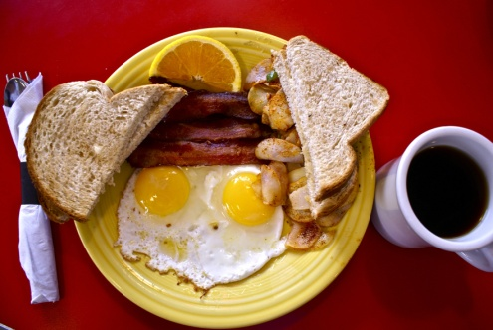
These sunny-side-ups are served at the
Hot Metal Diner near Pittsburgh, PA.
Photo credit: Rick Sebak, WQED Pittsburgh

Mmm, smell the bacon! How about some red-eye gravy on your grits? It’s time for BREAKFAST SPECIAL 2: REVENGE OF THE OMELETS, another PBS celebration of getting up and going out for a memorable morning meal.

This delicious new documentary airs Christmas night, Tuesday, December 25, 2012, 8:00-9:00 p.m. ET on PBS (check local listings), with an encore on Thursday, December 27, 2012, 9:00-10:00 p.m. ET.

There’s a diner in Connecticut, homemade biscuits in North Carolina, breakfast burritos and big pancakes in Pittsburgh. We find seaside specialties in New Hampshire, duck breast in Philadelphia, and salmon cakes in Detroit. On the Big Island of Hawaii, we sample loco moco, Portuguese donuts and scrumptious variations on all of the above!

Produced by popular PBS program-maker Rick Sebak (“A Hot Dog Program,” “A Flea Market Documentary” and “A Ride Along The Lincoln Highway” among others), this special is part travelogue, part food show, part tribute to the many men and women who get up early to make and eat our most important meal in unique and wonderful spots across the country. From coast to coast, cooks, servers, coffee drinkers and regulars at the counter all share their love and loyalty for breakfasts big and small.

“I still chuckle about the subtitle,” said producer Sebak recently. “When I went to see our budget director and told him we were going to do ‘Breakfast Special 2,’ he immediately said, ‘Oh, Revenge of the Omelets?’ I laughed and adopted that as our subtitle immediately. We don’t really have a story about any particular omelets in the show, but they get mentioned a lot. I think it’s just a great gimmick that we hope may catch the attention of viewers.”

Sebak and his sizzling crew started their shooting in their hometown of Pittsburgh, and then headed south to Raleigh, north to New England, east to Philadelphia and way west to Hawaii. They met and talked with lots of hungry Americans at these places:

- The Post Road Diner in Norwalk, Connecticut
- Big Ed’s in Raleigh, North Carolina
- Square Café in the Pittsburgh neighborhood called Regent Square
- Hot Metal Diner in West Mifflin, Pennsylvania
- Wentworth By the Sea Hotel & Spa on the coast of New Hampshire
- Carman’s Country Kitchen in South Philadelphia, Pennsylvania
- Connie & Barbara’s Soul Food Restaurant in Detroit, Michigan
- Ken’s House of Pancakes in Hilo, Hawaii
- Baker Tom’s Malasadas in Papaikou, Hawaii
- Hawaiian Style Café in Waimea, Hawaii

So there are traditional favorites like big pancakes, sausage and veggie omelets, but there are also unexpected delights like lobster hash with poached eggs, a breakfast burrito with chorizo and black beans, and a secret technique of injecting molasses into a biscuit.

“We never claim to have found the best breakfast spots,” said Sebak, “just some really good ones where the early morning camaraderie is as important as the scrambled eggs. As in the first ‘Breakfast Special,’ we wanted to find places where you would feel justified if you had to stand in a line to get a seat.”

For more information about BREAKFAST SPECIAL 2: REVENGE OF THE OMELETS, check out pbs.org/food and the Facebook page called BREAKFAST SPECIAL.

BREAKFAST SPECIAL 2: REVENGE OF THE OMELETS was made possible by the Corporation for Public Broadcasting and by contributions to PBS stations from viewers nationwide.

BREAKFAST SPECIAL 2: REVENGE OF THE OMELETS will be available from PBS Home Video: ShopPBS.org; 800-531-4727, 24 hours a day, 7 days a week.

Underwriters: Public Television Viewers, PBS and Corporation for Public Broadcasting
Producer: WQED Pittsburgh
Executive producer: Darryl Ford Williams
Producer/writer/narrator: Rick Sebak
Editor: Kevin Conrad
Camera: Bob Lubomski
Sound: Glenn Syska
Music: Buddy Nutt
Sound Mix: Frank Caloiero
Format: CC Stereo HD

– PBS –
CONTACTS: George Hazimanolis, WQED, 412-622-1366; ghazimanolis@wqed.org

For images and additional up-to-date information on this and other PBS programs, visit PBS PressRoom at pbs.org/pressroom.

© 2012 WQED Multimedia. All rights reserved.

