PBS to Gift Viewers with Guest Appearance from Vanessa Redgrave in
CALL THE MIDWIFE Holiday Episode

–Thursday, December 25, 2014 at 8:00p.m. ET

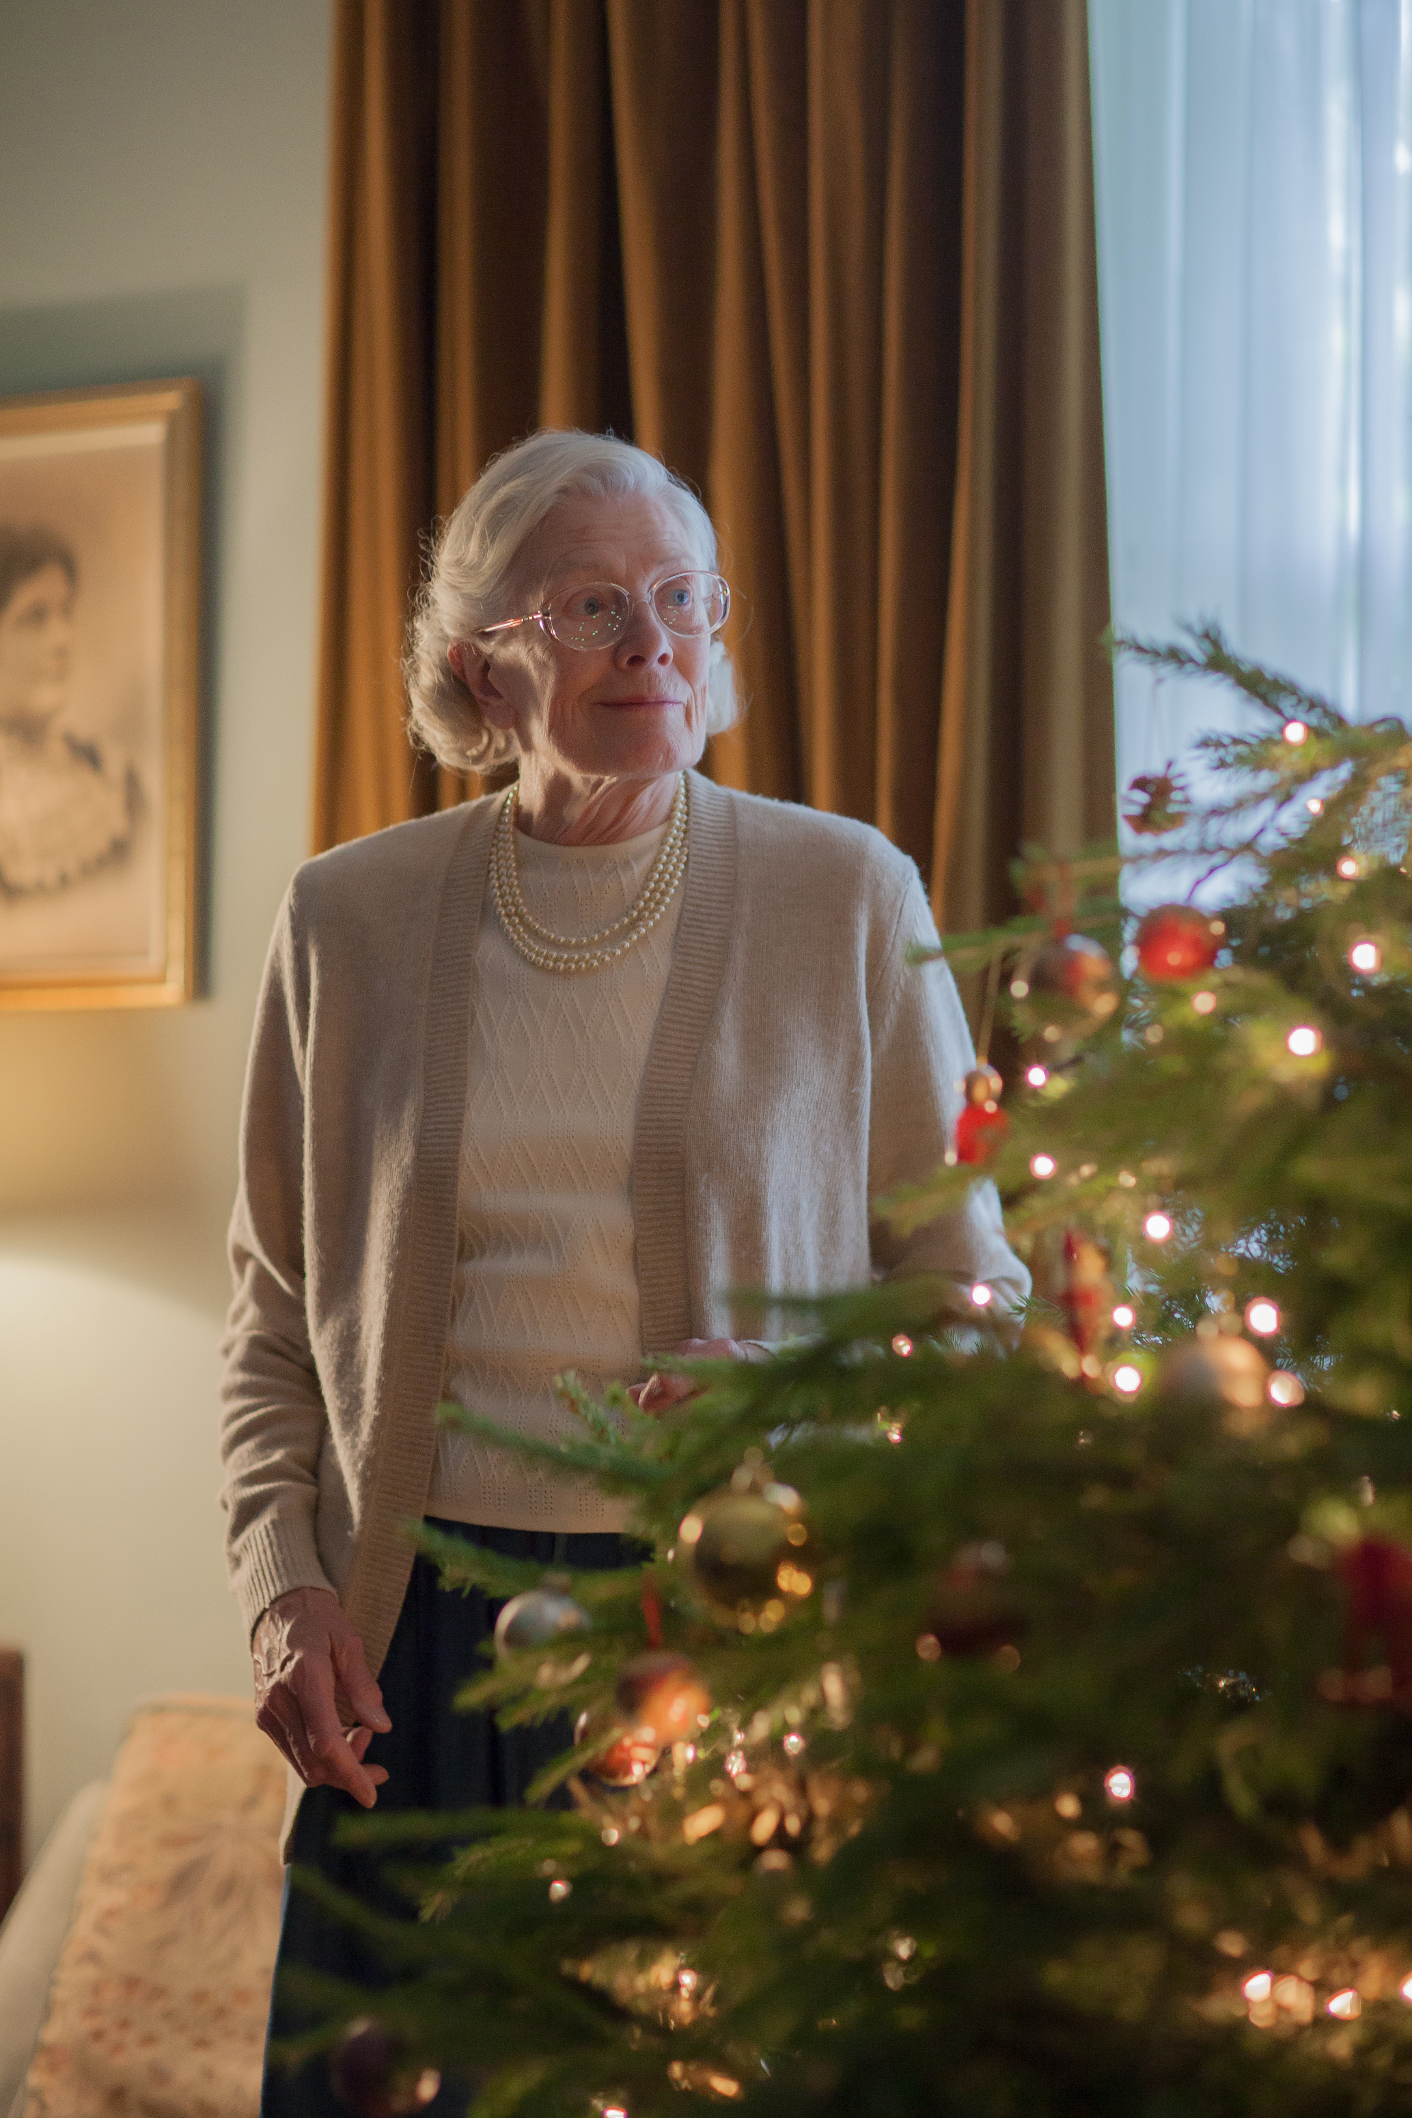
Mature Jennifer Worth played by Vanessa Redgrave. Courtesy of Laurence Cendrowicz/© Neal Street Productions

ARLINGTON, VA; NOVEMBER 13, 2014 – PBS has added to a robust December schedule with a variety of programs to celebrate the season, including a special holiday episode of the critically acclaimed British drama CALL THE MIDWIFE on Thursday, December 25. The episode is followed by a new VICIOUS “Holiday Special,” completing a block of British programming to celebrate Christmas Day.

CALL THE MIDWIFE HOLIDAY SPECIAL includes a guest appearance from show narrator Vanessa Redgrave. The actress will appear as the mature Jennifer Worth on screen for the first time. The special will lead the way to the fourth season of the hit drama, which returns to PBS on March 29, 2015, at 8:00 p.m. ET.

Pippa Harris, executive producer for Neal Street Productions, said: “We’re all delighted to be welcoming Vanessa Redgrave on screen, having hugely enjoyed her narration of the series to date.”

The holiday episode begins with a mature Jennifer at home in the early 21st century, opening her Christmas cards from both Cynthia and the Order of St Raymond Nonnatus. She reflects on the Christmases of her youth, and how much she missed the Nonnatus community during the first Christmas after her departure. Back at the Nonnatus House in 1959, the holidays have brought big changes for the midwives and the nuns. Cynthia is invited to join the order as a postulant, and after malpractice is uncovered at the York Lodge, Chummy is offered the permanent position of matron. With the New Year and a new decade approaching, what will the women choose and what will 1960 bring?

Season 3 of CALL THE MIDWIFE drew an average household audience rating of 2.5, translating into 3.6 million viewers, and the series saw an overall growth of 20 percent after its season one debut. The first series was the biggest new drama on BBC One in more than a decade, and the second season averaged a consolidated viewership of more than 10 million in the U.K. CALL THE MIDWIFE has won accolades across the industry, including 2013 BAFTA Craft awards for director Philippa Lowthorpe and for Christine Walmesley-Cotham for Make Up and Hair Design. Additionally, Miranda Hart received Best Actress at the National Television Awards this year. Audiences and critics in the U.S. were equally effusive, with Season 3 breaking the top ten spot in ratings on PBS and scoring 66 percent above the 2013-2014 season-to-date primetime average.

Based on the best-selling memoirs of Jennifer Worth, CALL THE MIDWIFE is a moving and intimate story of midwifery in London’s East End in the 1950s. Audiences can expect a mixture of laughter and tears in Season 4, along with new faces and captivating, emotional stories celebrating the people of Poplar and the much-loved residents of Nonnatus House. A new decade brings new and exciting challenges for the team at Nonnatus House. Will the nuns and midwives hold on to their traditional values in a rapidly changing world?

CALL THE MIDWIFE stars Jenny Agutter (“The Railway Children,” “Spooks”) as Sister Julienne, Pam Ferris (“Little Dorrit,” “Darling Buds of May”) as Sister Evangelina, Miranda Hart (“Miranda”) as Chummy, Judy Parfitt (“Little Dorrit,” Girl With a Pearl Earring), who was nominated for a 2013 Satellite Award for her work as Sister Monica Joan, Helen George (“Hollyoaks,” “Doctors”) as Trixie Franklin, Bryony Hannah (Cemetery Junction) as Cynthia Miller, Laura Main (“Monarch of the Glen”) as Shelagh and Cliff Parisi (“EastEnders”) as Fred. Joining the regular cast are Linda Bassett (“East Is East,” “Lark Rise to Candleford”) as Nurse Phyllis Crane and Charlotte Ritchie (“Life of Riley,” “Fresh Meat”) as Nurse Barbara Gilbert. Vanessa Redgrave provides the voice of the mature Jennifer Worth.

CALL THE MIDWIFE is created and written by Heidi Thomas; Executive producers are Pippa Harris and Heidi Thomas. The series is a Neal Street Production for BBC/PBS.

CALL THE MIDWIFE HOLIDAY SPECIAL will be available for viewing on the PBS Video Portal for 30 days after national broadcast.

CALL THE MIDWIFE contains mature content that may not be suitable for all audiences. Viewer discretion is advised. Rated TV-14.

CALL THE MIDWIFE (Season 4) will be available in 2015 on DVD and Blu-ray. Seasons 1, 2 and 3 are now available on DVD and Blu-ray on shopPBS.org. Additional items, including Jennifer Worth’s memoirs, published by Penguin Books, and The Life and Times of Call the Midwife, published by Harper Collins, are also available.

About BBC Worldwide North America Sales and Co-Productions
BBC Worldwide North America Sales & Distribution is one of five core businesses operating in the U.S. under BBC Worldwide, the commercial arm and wholly-owned subsidiary of the UK public service broadcaster, BBC (British Broadcasting Corporation). BBC Worldwide exists to maximize the value of the BBC’s assets for the benefit of the UK license payer and invests in programming in return for rights. The Sales & Distribution business negotiates, sells and distributes television programs to networks and secures co-production partners in the region.

About PBS
PBS, with its over 350 member stations, offers all Americans the opportunity to explore new ideas and new worlds through television and online content. Each month, PBS reaches nearly 109 million people through television and over 28 million people online, inviting them to experience the worlds of science, history, nature and public affairs; to hear diverse viewpoints; and to take front row seats to world-class drama and performances. PBS’ broad array of programs has been consistently honored by the industry’s most coveted award competitions. Teachers of children from pre-K through 12th grade turn to PBS for digital content and services that help bring classroom lessons to life. PBS’ premier children’s TV programming and its website, pbskids.org, are parents’ and teachers’ most trusted partners in inspiring and nurturing curiosity and love of learning in children. More information about PBS is available at www.pbs.org, one of the leading dot-org websites on the Internet, or by following PBS on Twitter, Facebook or through our apps for mobile devices. Specific program information and updates for press are available at pbs.org/pressroom or by following PBS PressRoom on Twitter.

About Neal Street Productions
Neal Street Productions was formed in 2003 by Sam Mendes, Pippa Harris and Caro Newling. The company has been successful in film, theatre and television with hit movies including Revolutionary Road, Jarhead and Starter for 10. Their diverse television slate includes the award-winning “Stuart A Life Backwards,” with Tom Hardy and Benedict Cumberbatch, and the hugely successful “Call the Midwife,” a ratings smash hit that, after three extremely successful series and two Christmas specials, returns to screens this year in the UK and US with another Christmas special, plus a further series early in 2015. Neal Street debuted their latest TV show, “Penny Dreadful,” on Showtime in the US and on Sky Atlantic this year to critical acclaim. The psychosexual TV horror series, written by John Logan, starred Josh Hartnett, Eva Green, Timothy Dalton and Rory Kinnear. Neal Street also produced the critically acclaimed and award-winning “The Hollow Crown” — a series of Shakespeare films for the BBC/PBS — starring Ben Whishaw, Tom Hiddleston and Jeremy Irons, and is due to start production on a second series of Shakespeare history plays, starting with Richard III starring Benedict Cumberbatch in the lead role. Nicolas Brown joined Neal Street as a company director in 2013, to work across the film and TV portfolio. On the theatre side, they have produced The Bridge Project, Shrek the Musical and the West End musical of Charlie and the Chocolate Factory, directed by Sam Mendes.

– PBS –

CONTACTS:
Alyssa Winters, Missy Greenberg, Elizabeth Sharkey, Alex Stromer, DKC, 212-685-4300; CallTheMidwife@dkcnews.com
Carrie Johnson, PBS, 703-739-5129; cjohnson@pbs.org

For images and additional up-to-date information on this and other PBS programs, visit PBS PressRoom at pbs.org/pressroom.

