PBS TO UNWRAP A SPECIAL HOLIDAY EDITION OF

CRITICALLY ACCLAIMED DRAMA “CALL THE MIDWIFE”

– Holiday Special to Air Sunday, December 30, 2012, at 7:30 p.m. –

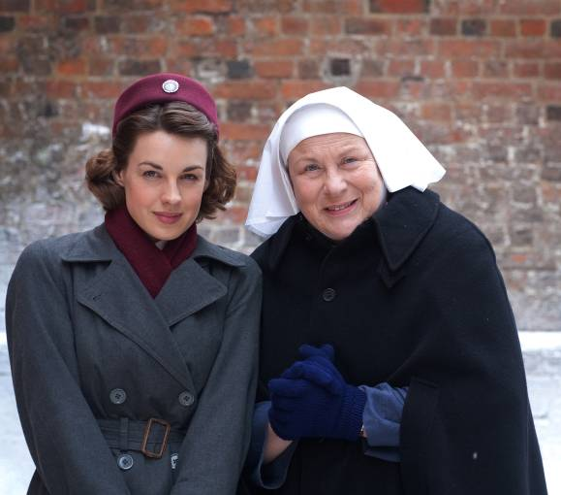
Jessica Raine as Jenny and Pam Ferris as Sister Evangelina.
Credit: Laurence Cendrowicz © Neal Street Productions

ARLINGTON, VA – December 6, 2012 -- PBS announced today that a special holiday episode of the critically acclaimed British drama CALL THE MIDWIFE will air Sunday, December 30, 2012, from 7:30 to 9:00 p.m. ET on PBS.

CALL THE MIDWIFE HOLIDAY SPECIAL will pave the way for a second season of the hit drama, which returns to PBS beginning March 31 for a full run.

As the nurses, nuns and community members come together this holiday season, nothing rings more true in Poplar than the virtues of charity and hope. In the special, the holidays are swiftly approaching and the nuns and midwives of Nonnatus House are busier than ever. When a young girl gives birth in secret and leaves the baby on the steps of Nonnatus House, the nurses pull together with the community to care for the newborn and find his mother. Meanwhile, Nurse Jenny Lee looks after Mrs. Jenkins, an elderly vagrant who has lost everything. And newly married Chummy spreads holiday cheer, bringing the children of Poplar together for a nativity play to remember.

Written by Heidi Thomas (“Cranford,” “Upstairs Downstairs”) and directed by Philippa Lowthorpe (“Five Daughters”) and Jamie Payne (“The Hour”), CALL THE MIDWIFE completed its first season in the U.S. in early November. In its UK debut, the series attracted 11.4 million viewers for its peak episode, making it the highest-rated BBC new drama launch on record; audiences and critics in the U.S. were equally effusive, with the Washington Post hailing it “absorbing and inspiring” and the Los Angeles Times saying it is “lovely and engaging.” TV Guide simply proclaimed it a “keeper.”

CALL THE MIDWIFE is a Neal Street production for BBC. Executive produced by Pippa Harris (Revolutionary Road, “The Hollow Crown”) and Heidi Thomas, the series is produced by Hugh Warren (“Survivors”).

Based on the best-selling memoirs of Jennifer Worth, CALL THE MIDWIFE is a moving and intimate story of midwifery in London’s East End in the 1950s. The first season followed a young Jenny Lee as she and her fellow midwives, attached to an order of nursing nuns, navigated life on the crowded streets of East End London.

CALL THE MIDWIFE stars Jessica Raine as Jenny Lee, along with Jenny Agutter (“The Railway Children,” “Spooks”) as Sister Julienne, Pam Ferris (“Little Dorrit,” “Darling Buds of May”) as Sister Evangelina, Miranda Hart (“Miranda”) as Chummy, Judy Parfitt (“Little Dorrit,” Girl with a Pearl Earring) as Sister Monica Joan, Helen George (“Hollyoaks,” “Doctors”) as Trixie Franklin, Bryony Hannah (Cemetery Junction) as Cynthia Miller, Laura Main (“Monarch of the Glen”) as Sister Bernadette and Cliff Parisi (“East Enders”) as Fred. Vanessa Redgrave provides the voice of the mature Jennifer.

CALL THE MIDWIFE HOLIDAY SPECIAL will be available for viewing on the PBS Video Portal for 30 days after national broadcast.

About PBS
PBS, with its nearly 360 member stations, offers all Americans the opportunity to explore new ideas and new worlds through television and online content. Each month, PBS reaches nearly 123 million people through television and more than 21 million people online, inviting them to experience the worlds of science, history, nature and public affairs; to hear diverse viewpoints; and to take front row seats to world-class drama and performances. PBS’ broad array of programs has been consistently honored by the industry’s most coveted award competitions. Teachers of children from pre-K through 12th grade turn to PBS for digital content and services that help bring classroom lessons to life. PBS’ premier children’s TV programming and its website, pbskids.org, are parents’ and teachers’ most trusted partners in inspiring and nurturing curiosity and love of learning in children. More information about PBS is available at www.pbs.org, one of the leading dot-org websites on the Internet, or by following PBS on Twitter, Facebook or through our apps for mobile devices. Specific program information and updates for press are available at pbs.org/pressroom or by following PBS Pressroom on Twitter.

About Neal Street Productions
Neal Street Productions was formed in 2003 by Sam Mendes, Pippa Harris and Caro Newling. The company has been successful in film, theatre and television with hit movies including Revolutionary Road, Jarhead and Starter for Ten. Their upcoming contemporary British thriller, Blood, starring Paul Bettany and Mark Strong, will be released in March 2013. Their diverse television slate includes the award-winning “Stuart A Life Backwards,” with Tom Hardy and Benedict Cumberbatch, and the hugely successful CALL THE MIDWIFE, which proved to be a ratings smash hit in the UK. This summer, they produced the critically acclaimed “The Hollow Crown” — a series of Shakespeare films for the BBC/PBS — starring Ben Whishaw, Tom Hiddleston and Jeremy Irons. A second series of CALL THE MIDWIFE is in production, and a new series, “The Flavia de Luce Mysteries,” based on the books by Alan Bradley, is being developed for the BBC. On the theatre side, they have produced The Bridge Project, Shrek the Musical, South Downs & The Browning Version, Enron, Three Days of Rain and are currently working on a new West End musical of Charlie and the Chocolate Factory, directed by Sam Mendes, which will make its world premiere in June 2013.

– PBS –

CONTACTS:
Alyssa Winters or Izzy Forman, DKC – 212-685-4300; Alyssa_Winters@dkcnews.com, Izzy_Forman@dkcnews.com

Carrie Johnson, PBS, 571-265-1738; cjohnson@pbs.org

For images and additional up-to-date information on this and other PBS programs, visit PBS PressRoom at pbs.org/pressroom.

