BBC WORLDWIDE AND PBS SIGN DEAL TO BRING
CRITICALLY ACCLAIMED “CALL THE MIDWIFE” TO THE US

Neal Street Productions’ Drama Will Premiere This Fall

– Highest-Rated New Drama Launch in BBC History
Strengthens PBS as a Destination for Drama on Sunday Nights Leading Into
MASTERPIECE CLASSIC “Upstairs Downstairs” –

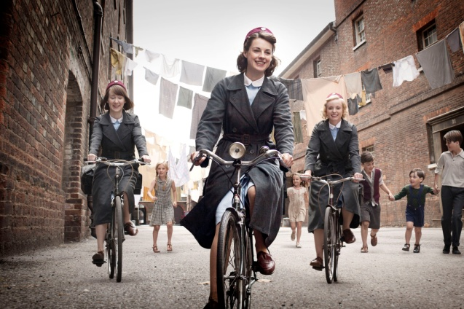
Cynthia (Bryony Hannah), Jenny (Jessica Raine), Trixie (Helen George)
Credit: Laurence Cendrowicz/© Neal Street Productions 2011
ARLINGTON, VA – May 15, 2012 -- BBC Worldwide America Sales & Distribution and PBS announced today the sale of the first season of the critically acclaimed British drama, CALL THE MIDWIFE to PBS.

The series will premiere on September 30, 2012 at 8:00 p.m. leading into MASTERPIECE CLASSIC “Upstairs Downstairs,” transforming Sunday nights into a destination for drama on PBS.

See preview clip here.

Written by Heidi Thomas (“Cranford,” “Upstairs Downstairs”) and directed by Philippa Lowthorpe (“Five Daughters”) and Jamie Payne (“The Hour”), CALL THE MIDWIFE completed its first season in the UK on BBC ONE in February 2012. Attracting 10.7 million viewers for its peak episode, CALL THE MIDWIFE was the highest-rated BBC new drama launch on record. A second season has been commissioned and will air in the UK in 2013. CALL THE MIDWIFE is a Neal Street production for BBC. Executive Produced by Pippa Harris (Revolutionary Road, “The Hollow Crown”) and Heidi Thomas. The series is produced by Hugh Warren (“Survivors”).

Matt Forde, EVP Sales and Co-productions, BBC Worldwide America said, “CALL THE MIDWIFE has been a phenomenal hit in the UK and we expect that its appeal will successfully cross the pond.” He continued, “Public television has historically set the standard for quality programming. We look forward to bringing unique content to PBS and continuing our long and mutually beneficial relationship.”

“CALL THE MIDWIFE is a riveting new series that strengthens PBS as a destination for drama on Sunday nights,” said Paula Kerger, PBS President and CEO. “We look forward to working with our BBC partners to introduce the story and the characters that were so beloved in Britain to the American audience.”
Based on the best-selling memoirs of Jennifer Worth, CALL THE MIDWIFE is a moving and intimate story of midwifery in London’s East End in the 1950s. The first season follows a young Jenny Lee as she and her fellow midwives, attached to an order of nursing nuns, navigate the crowded East End streets teeming with children, workers and a culture remarkably different from the wealthy English countryside where Jenny was raised.

Executive producer Pippa Harris said, “CALL THE MIDWIFE has excited the imagination of viewers in the UK and I am confident it will do the same in the US. Heidi Thomas’ witty and emotional scripts have perfectly captured a unique snapshot of British history, but the universal themes of childbirth, nursing and parenthood ring true throughout the world.”

CALL THE MIDWIFE stars Jessica Raine as Jenny Lee, along with Jenny Agutter (The Railway Children, “Spooks”) as Sister Julienne, Pam Ferris (“Little Dorrit,” “Darling Buds of May”) as Sister Evangelina, Miranda Hart (“Miranda”) as Chummy, Judy Parfitt (“Little Dorrit,” Girl with a Pearl Earring) as Sister Monica Joan, Helen George (“Hollyoaks,” “Doctors”) as Trixie Franklin, Bryony Hannah (Cemetery Junction) as Cynthia Miller, Laura Main (“Monarch of the Glen”) as Sister Bernadette and Cliff Parisi (“East Enders”) as Fred. Vanessa Redgrave provides the voice of the mature Jennifer.

The drama unfolds as Jenny meets her patients, including one woman who is on her 25th pregnancy and a young, 15 year-old prostitute pregnant for the first time. Initially shocked by the health and living conditions of the East End, Jenny soon learns to admire the families she works with, along with the sisters and fellow midwives who witness the daily drama of life in this vibrant community.

Full episodes of CALL THE MIDWIFE will be available for viewing on the PBS Video Portal for 30 days after each national broadcast.

The deal was brokered by Jemma Adkins, Senior VP Sales and Co-productions, BBC Worldwide Americas.

About BBC Worldwide Sales & Distribution
BBC Worldwide Sales & Distribution is one of seven core businesses under BBC Worldwide, the commercial arm and wholly-owned subsidiary of the UK public service broadcaster, BBC (British Broadcasting Corporation). BBC Worldwide exists to maximize the value of the BBC's assets for the benefit of the BBC, and invests in programming in return for rights. The Sales & Distribution business negotiates, sells and distributes television programs to networks and secures co-production partners, in the Americas region.

About PBS
PBS, with its nearly 360 member stations, offers all Americans the opportunity to explore new ideas and new worlds through television and online content. Each month, PBS reaches nearly 123 million people through television and more than 21 million people online, inviting them to experience the worlds of science, history, nature and public affairs; to hear diverse viewpoints; and to take front row seats to world-class drama and performances. PBS’ broad array of programs has been consistently honored by the industry’s most coveted award competitions. Teachers of children from pre-K through 12th grade turn to PBS for digital content and services that help bring classroom lessons to life. PBS’ premier children’s TV programming and its website, pbskids.org, are parents’ and teachers’ most trusted partners in inspiring and nurturing curiosity and love of learning in children. More information about PBS is available at www.pbs.org, one of the leading dot-org websites on the Internet, or by following PBS on Twitter, Facebook or through our apps for mobile devices. Specific program information and updates for press are available at pbs.org/pressroom or by following PBS Pressroom on Twitter.

About Neal Street Productions
New Street Productions was formed in 2003 by Sam Mendes, Pippa Harris and Caro Newling. The company has been successful in film, theatre and television with hit movies including Revolutionary Road and Starter for Ten; television productions as diverse as the award-winning BBC/HBO co-production “Stuart: A Life Backwards”, the hugely successful CALL THE MIDWIFE, and the upcoming BBC/NBC Universal/WNET Shakespeare mini-series “The Hollow Crown”; and in theatre the hits “Red” and “Shrek the Musical” as well as the forthcoming production of “Charlie and the Chocolate Factory.”

– PBS –

CONTACTS:
Carrie Johnson, PBS, 571-265-1738; cjohnson@pbs.org
Julianna Silva BBC Worldwide 212 705-0502 x77502 Juliana.silva@bbc.com

For images and additional up-to-date information on this and other PBS programs, visit PBS PressRoom at pbs.org/pressroom.

