CALL THE MIDWIFE (Season 10)
TCA Bios

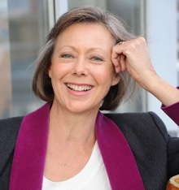
JENNY AGUTTER OBE trained at Elmhurst Ballet school. At the age of 11, she was cast as a young dancer in Walt Disney’s film “Ballerina.” She first played Roberta on television when she was 14 and almost three years later, after filming “Walkabout” in Australia, Lionel Jeffries asked her to play the same role in the film of “The Railway Children.” The following year, she played Fritha in the BBC TV film “The Snow Goose,” for which she won an Emmy. Jenny has recently been awarded with an OBE in the Queen's Honours list.
Jenny's most recent films include “Sometimes Always Never”; “Queen of the Desert,” “Captain America: The Winter Soldier”; Marvel's “Avengers Assemble”; “Burke and Hare”; and “Glorious '39.”
Jenny has also maintained a career in the theatre. She joined the Royal Shakespeare Company to play in “King Lear,” Edward Bond’s “Lear” and “Arden of Faversham.” She has played on Broadway opposite Derek Jacobi in “Breaking the Code.” She was Mrs. Darling in the 1998 Royal National Theatre production of “Peter Pan” with Ian McKellan as Hook. In 2008 she appeared in the West End production of “Equus,” opposite Daniel Radcliffe.
Jenny was Tessa in the successful BBC TV series “Spooks,” and played opposite John Hurt in the much acclaimed TV adaptation of “The Alan Clark Diaries,” shown on BBC4. More recently, she was in the BBC TV series “The Invisibles,” Talkback Thames production “Monday Monday,” and is currently shooting season 11 of CALL THE MIDWIFE.

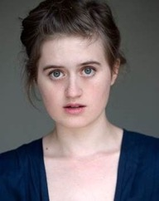
Ella Bruccoleri graduated from The Oxford School of Drama. Ella is a regular on BBC One’s CALL THE MIDWIFE as novice nun Sister Frances; she is currently filming season 11 of the show. Further credits include “Genius: Picasso” (Fox/National Geographic) and “The Last Kingdom” (Carnival Films/Netflix). Most recently, Ella shot roles for “All Creatures Great And Small” and Series 2 of BBC comedy-drama “Back To Life”.

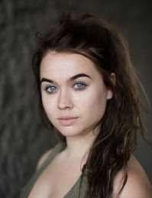
Megan Cusack is a native of Cork, Ireland and graduated from the London Academy of Music & Dramatic Art with a degree in acting. Megan made her theatrical debut in 2019 at Ireland’s National Theatre, the Abbey Theatre, in Edna O’Brien’s “The Country Girls.” Other stage credits include “The Dark Horse,” “Tennessee Williams: Women of Paradise,” “The Cherry Orchard” and “On the Outside,” among others. She joined the cast of CALL THE MIDWIFE in its 10th season as Pupil Midwife Nancy Corrigan.

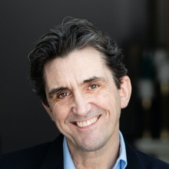
Stephen McGann is a leading British actor who has worked extensively in theatre and on screen, and has portrayed Dr. Turner in CALL THE MIDWIFE since its first season. In addition to acting, Stephen is the author of Dr. Turner's Casebook, Flesh and Blood: A History of My Family in Seven Sicknesses, and the soon-to-be released Call the Midwife—A Labour of Love: Ten Years of Love, Life and Laughter, an anniversary book celebrating the hit drama. He is married to Heidi Thomas, the writer and creator of the series.

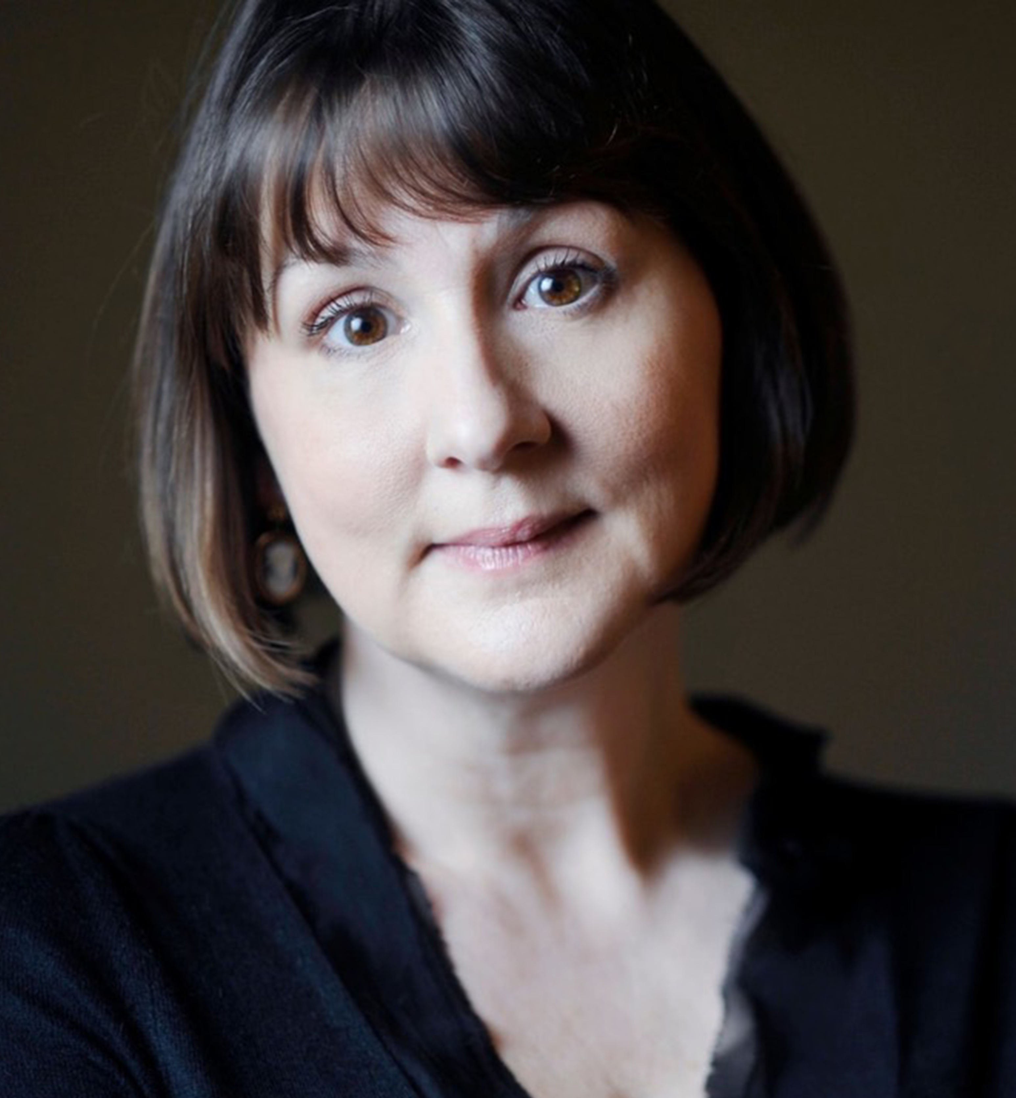
Heidi Thomas’ first stage play, “Shamrocks And Crocodiles,” won the John Whiting Award in 1985. Her play “Indigo” was performed by the Royal Shakespeare Company in their 1987/88 season. Other theatrical work includes “Some Singing Blood” at London's Royal Court Theatre and an adaptation of Ibsen's “The Lady from the Sea,” presented in London and at the National Theatre of Norway in Oslo. Her play “The House of Special Purpose” was staged at the Chichester Festival Theatre in 2010. A production of the musical “Gigi” was newly adapted by Heidi and ran at the Kennedy Centre in January 2015, and then on Broadway.

Heidi’s screen work includes an adaptation of “I Capture the Castle.” She is currently writing a screenplay based on Alan Bennett’s stage play “ALLELUJAH!”

Heidi’s extensive television work includes an adaptation of “Madame Bovary” for the BBC starring Frances O’Connor. In 2007, she was the creator, writer and executive producer of an eight-part period drama for the BBC called “Lilies.” She wrote the scripts for two major BBC adaptations of Elizabeth Gaskell's novellas “Cranford,” and an adaptation of the Noel Streatfeild novel “Ballet Shoes” for ITV.

In 2010, she was writer and executive producer of a major revival of the classic British television drama series “Upstairs Downstairs” for the BBC. In 2011, she adapted the Jennifer Worth memoirs “Call The Midwife” into an eight-part series for Neal Street Productions and the BBC. The series achieved record viewing figures for the channel and is now in its 11th season with Heidi as lead writer and executive producer.

In March 2008, Heidi received the Best Writer award at the UK Royal Television Society Awards for her work on “Cranford.” In April 2008, she received the Best Writer award at the UK Broadcasting Press Guild Awards for her work on “Cranford,” “Ballet Shoes” and “Lilies.” She was nominated for two BAFTA TV Awards for “Cranford” as well as a Primetime Emmy. In November 2008, she received the Writers' Guild of Great Britain Award for Best TV Series for “Cranford.” In 2011, she received a Primetime Emmy nomination for “Upstairs Downstairs.” In December 2012, the annual UK Women in Film and Television Awards presented her with the Technicolor Writing Award in recognition of her contribution to the industry.

In January 2019, Heidi was presented with the Outstanding Contribution to Writing Award by the Writers' Guild of Great Britain for her body of professional work.

She has honorary doctorates from the University of Liverpool and Edge Hill University.

