Actress and Producer Biographies

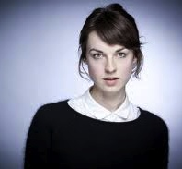
Jessica Raine – Jenny Lee
Raine graduated from RADA in July 2008. Following her professional debut in “Harper Regan” at the National Theatre, Raine was selected as one of The Observer newspaper’s “Hot List 2009” and the Telegraph newspaper’s “Stars to Shine in 2009.”
Other theatre credits includes “Earthquakes in London” (National Theatre), “Ghosts” (Duchess Theatre, West End), for which she was nominated for the Ian Charleston Award, and “Punk Rock” (Lyric Hammersmith/Royal Exchange, Manchester), for which she won the Best Actress in a Supporting Role at the Manchester Evening News Theatre Awards. Prior to filming CALL THE MIDWIFE, Raine played the lead role of Cleo in The National’s rare revival of Clifford Odets 1930’s New York comedy “Rocket to the Moon.”
Raine’s screen credits include a guest lead in “Doctor Who” for the BBC, Ridley Scott’s Robin Hood, Garrow’s Law and The Woman in Black.
Between shooting the first and second seasons of CALL THE MIDWIFE, she returned to her roots appearing at the Young Vic in “The Changeling,” directed by Joe Hill Gibbons.
Pam Ferris – Sister Evangelina
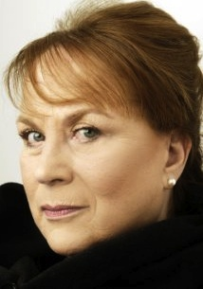
Ferris is perhaps best known as the terrifying Miss Trunchbull in Danny DeVito’s Matilda, although British audiences know and love her for her portrayal of the big-hearted Ma Larkin in the television series “The Darling Buds of May.”
Her other screen roles include Harry Potter and the Prisoner of Azkaban, Children of Men, Richard Eyre’s The Other Man and Nativity and Nativity 2. Most recently, she has starred in Malice in Wonderland directed by Simon Fellows, Ed McHenry’s Jackboots on Whitehall, and James McTeigue’s The Raven, opposite John Cusack.
Ferris has also starred in the UK’s most popular television shows, including “Where the Heart Is,” “Luther,” “Little Dorrit,” “Jayne Eyre,” “Our Mutual Friend,” “Linda Green,” “Clocking Off,” “Gavin and Stacey” and “Grandma’s House” and “Bessie and the Bell” in Carlton’s series of short films called First Sign of Madness, for which she won a Best Actress Award at the New York Festival in 2001.
In addition to her film and television work, Ferris has also starred in numerous theatre productions, including the successful Royal Court Theatre production of “Notes on Falling Leaves” for which she received an Evening Standard Theatre Award Nomination for Best Actress and, most recently, “The Entertainer” at the Old Vic, starring opposite Robert Lindsay, for which she received an Olivier Award Nomination for Best Supporting Actress, and won the 2008 Clarence Derwent Award for Best Supporting Actress.


Helen George – Trixie Franklin
George is featured in the Orlando Bloom movie The Three Musketeers, opposite the gorgeous Luke Evans and played Valerie in the 2011 Danny Dyer movie 7 Lives. She has also appeared on “Hollyoaks,” “Doctors,” “Hotel Babylon” and sang in Disney’s High School Musical and backing vocals on tour with Elton John.

Heidi Thomas – Series Creator, Writer and Executive Producer
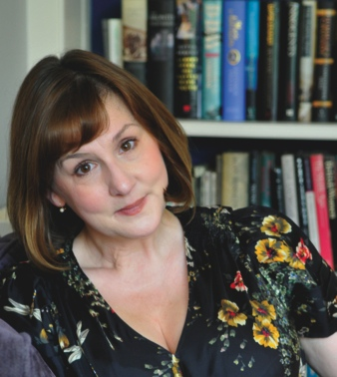
Heidi Thomas is an award winning and multiple BAFTA and Emmy nominated screenwriter, producer and playwright. Her plays have been produced by the Liverpool Playhouse, Chichester Festival and Royal Court theatres, and by the National Theatre Studio and the RSC. Thomas' television shows regularly achieve record-breaking viewing figures. In addition to CALL THE MIDWIFE, her series work includes “Soldier, Soldier,” “Dr Finlay,” “Kiss and Tell,” the rebooted “Upstairs Downstairs,” and the original BBC drama period series “Lilies.” Her adaptations of classic literature include “Madame Bovary,” “Ballet Shoes,” “Cranford,” “Return to Cranford” (all for the BBC) and the feature film I Capture the Castle. She is currently working on an adaptation of Elizabeth Gaskell’s Mary Barton and big-screen versions of Middlemarch and Edith Wharton’s The Buccaneers. Thomas is also the author of the book The Life And Times Of Call The Midwife, which blends 1950s social history with the behind-the-scenes story of the TV show.

Pippa Harris – Executive Producer
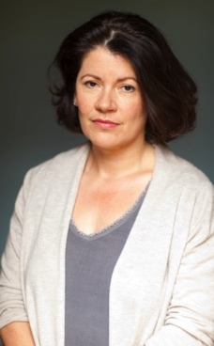
Pippa Harris established Neal Street Productions in 2003 with Sam Mendes and Caro Newling, and runs the company’s film and television division.
Since the formation of Neal Street Productions, Harris has produced Starter for Ten (2006) starring James McAvoy and Rebecca Hall, “Stuart: A Life Backwards” (2007) with Tom Hardy and Benedict Cumberbatch, and co-produced Jarhead (2006), starring Jake Gyllenhaal and Jamie Foxx, for Universal Pictures. In 2007, Harris executive produced Things We Lost in the Fire, starring Halle Berry and Benicio Del Toro, and in 2008 co-executive produced Sam Mendes’ Oscar-nominated Revolutionary Road.
Previously, Harris was the Head of Drama Commissioning for the BBC where her commissions included the Emmy award-winning “The Lost Prince,” “Cutting It” and the Prix Europa Best Drama Flesh and Blood.
Harris joined the BBC in 1997 as a Development Executive for BBC Films before becoming the Executive Producer of BBC Drama Serials. Her production credits include the BAFTA-winning dramas The Way We Live Now, Care and Warriors. Prior to joining the BBC, Harris worked in the drama divisions of Carlton TV and Channel 4 as a development executive.
Harris also developed and executive produced the critically acclaimed BBC Two Shakespeare mini-series “The Hollow Crown. She sits on the board of BAFTA and is the deputy chair of their film committee. She is also a Governor of Central School of Speech and Drama.

