Miranda Hart Biography

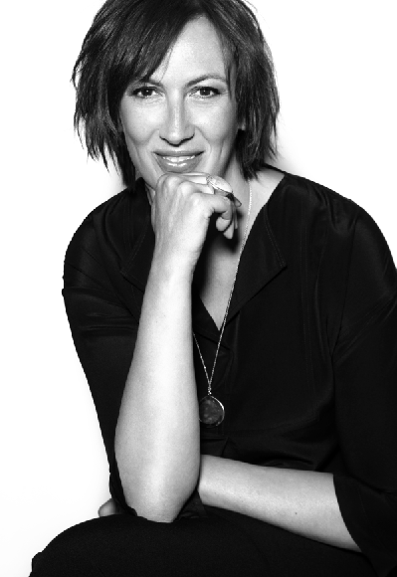
Miranda Hart – Camilla Cholomondely-Browne (“Chummy”)

Miranda Hart’s first excursion to the Edinburgh Festival in 1994 began her journey to becoming one of the UK’s top comedians. After 10 years on the stand-up and sketch club circuit, Miranda went on to make her mark in shows including “Smack the Pony,” “Absolutely Fabulous,” “Hyperdrive” and “Not Going Out,” but it was when her sitcom “Miranda” hit the screens in the UK in 2009 that her popularity rocketed.

Hart has since been crowned the Queen of Comedy at the British Comedy Awards, has garnered three comedy awards, three Royal Television Society Awards and four TV BAFTA nominations for the past two “Miranda” series. In 2012, Miranda appeared in her first drama acting role in the highly popular BBC/PBS series CALL THE MIDWIFE in a role that has won her a National Television Award for Best Drama Performance. The third series of “Miranda” aired at the end of 2012, with Hart nominated in the Female Performance in a Comedy Programme category at this year’s BAFTA Television Awards.

