PBS TO BRING SECOND SEASON OF CRITICALLY ACCLAIMED DRAMA “CALL THE MIDWIFE” TO THE U.S. ON SUNDAY, MARCH 31, 2013

– Debut Series From Neal Street Productions Draws Strong U.S. Audience in First Season;
Cements PBS as Destination for Drama on Sunday Nights –

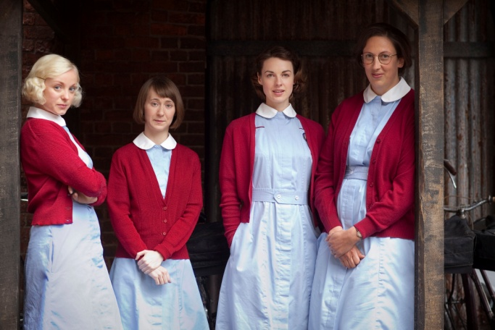
Helen George as Trixie, Bryony Hannah as Cynthia, Jessica Raine as Jenny and Miranda Hart as Chummy.
Credit: Laurence Cendrowicz © Neal Street Productions

PASADENA, CA; JANUARY 14, 2013 -- The critically acclaimed British drama CALL THE MIDWIFE returns for a second season, debuting March 31, 2013, at 8:00 p.m. ET on PBS. The series leads into MASTERPIECE CLASSIC’s new offering, “Mr. Selfridge” at 9:00 p.m.

Written by Heidi Thomas (“Cranford,” “Upstairs Downstairs”) and directed by Philippa Lowthorpe (“Five Daughters”) and Jamie Payne (“The Hour”), CALL THE MIDWIFE completed its first season in the U.S. in early November, drawing an average household audience rating of 2.1, translating into 3 million viewers — 50 percent above PBS’ primetime average for the 2011-12 season. In its UK debut, the series attracted 11.4 million viewers for its peak episode, making it the highest-rated BBC new drama launch on record.

“CALL THE MIDWIFE is a wonderful program and we are thrilled to bring it to PBS for a second season,” said Beth Hoppe, Chief Programming Executive and General Manager, General Audience Programming, PBS. “PBS has truly become a destination for drama on Sunday nights and we are pleased to continue this tradition with our BBC and Neal Street partners.”

CALL THE MIDWIFE, based on the best-selling memoirs of the late Jennifer Worth, is a highlight of PBS’ spring season. Extended to eight episodes, BBC One’s most successful new drama since ratings began sees the return of all its well-loved characters, as well as some new faces. Nonnatus House opens its doors to warmly welcome the audience back into 1950s East End London and continues to follow the Poplar neighborhood’s exceptional midwives and nursing nuns. The new season stays true to its roots — viewers can expect to see more births, babies and bicycling, plus blossoming romance from an unexpected quarter.

The second season opens with a Poplar woman in a dangerous relationship with the father of her unborn child and Trixie facing a difficult birth on board a Swedish trawler. Chummy makes a big decision that may mean major changes at Nonnatus House and Jenny Lee’s run-in with her old friend Jimmy brings out some feelings from her past she’d rather forget. Cynthia has her confidence shaken and doubts her ability as a midwife, while Jenny’s skills are tested in a setting that’s a far cry from the clinic and homes of Poplar. Sister Bernadette and Doctor Turner oversee an emotionally and technically challenging situation involving two sisters whose outdated views on childbirth put mother and child at risk.

“PBS has been the perfect home for our show,” said executive producer Pippa Harris, “and we are all thrilled that American audiences have embraced the midwives and nuns of London’s East End so warmly. It’s a testament to the enduring appeal of Jennifer Worth’s books, the skill of screen writer Heidi Thomas and the huge talent of our cast and crew.”

CALL THE MIDWIFE stars Jessica Raine as Jenny Lee, along with Jenny Agutter (“The Railway Children,” “Spooks”) as Sister Julienne, Pam Ferris (“Little Dorrit,” “Darling Buds of May”) as Sister Evangelina, Miranda Hart (“Miranda”) as Chummy, Judy Parfitt (“Little Dorrit,” Girl with a Pearl Earring) as Sister Monica Joan, Helen George (“Hollyoaks,” “Doctors”) as Trixie Franklin, Bryony Hannah (Cemetery Junction) as Cynthia Miller, Laura Main (“Monarch of the Glen”) as Sister Bernadette and Cliff Parisi (“East Enders”) as Fred. Vanessa Redgrave provides the voice of the mature Jennifer. CALL THE MIDWIFE is a Neal Street production for BBC, executive produced by Pippa Harris (Revolutionary Road, “The Hollow Crown”) and Heidi Thomas. The series is produced by Hugh Warren (“Survivors”).

CALL THE MIDWIFE Season 2 full episodes will be available for viewing on the PBS Video Portal for 30 days after each national broadcast.

CALL THE MIDWIFE contains mature content that may not be suitable for all audiences. Viewer discretion is advised. Rated TV-14.

About BBC Worldwide Americas Sales & Distribution
BBC Worldwide Americas Sales & Distribution is one of five core businesses operating in the U.S. under BBC Worldwide, the commercial arm and wholly-owned subsidiary of the UK public service broadcaster, BBC (British Broadcasting Corporation). BBC Worldwide exists to maximize the value of the BBC’s assets for the benefit of the UK license payer, and invests in programming in return for rights. The Sales & Distribution business negotiates, sells and distributes television programs to networks and secures co-production partners in the region.

About PBS
PBS, with its nearly 360 member stations, offers all Americans the opportunity to explore new ideas and new worlds through television and online content. Each month, PBS reaches nearly 123 million people through television and more than 21 million people online, inviting them to experience the worlds of science, history, nature and public affairs; to hear diverse viewpoints; and to take front row seats to world-class drama and performances. PBS’ broad array of programs has been consistently honored by the industry’s most coveted award competitions. Teachers of children from pre-K through 12th grade turn to PBS for digital content and services that help bring classroom lessons to life. PBS’ premier children’s TV programming and its website, pbskids.org, are parents’ and teachers’ most trusted partners in inspiring and nurturing curiosity and love of learning in children. More information about PBS is available at www.pbs.org, one of the leading dot-org websites on the Internet, or by following PBS on Twitter, Facebook or through our apps for mobile devices. Specific program information and updates for press are available at pbs.org/pressroom or by following PBS Pressroom on Twitter.

About Neal Street Productions
Neal Street Productions was formed in 2003 by Sam Mendes, Pippa Harris and Caro Newling. The company has been successful in film, theatre and television with hit movies including Revolutionary Road, Jarhead and Starter for Ten. Their upcoming contemporary British thriller, Blood, starring Paul Bettany and Mark Strong, will be released in March 2013. Their diverse television slate includes the award-winning Stuart A Life Backwards, with Tom Hardy and Benedict Cumberbatch, and the hugely successful CALL THE MIDWIFE, a ratings smash hit in the UK that returned with a Christmas Special and a second series which is currently on air. Neal Street also produced the critically acclaimed The Hollow Crown - a series of Shakespeare films for the BBC/PBS — starring Ben Whishaw, Tom Hiddleston and Jeremy Irons, and a new series, The Flavia de Luce Mysteries, based on the books by Alan Bradley, is being developed for the BBC. On the theatre side, they have produced The Bridge Project, Shrek the Musical, South Downs & The Browning Version, Enron, Three Days of Rain and are currently working on a new West End musical of Charlie and the Chocolate Factory, directed by Sam Mendes, which will make its world premiere in June 2013.

– PBS –

CONTACTS:
Izzy Forman or Alyssa Winters, DKC, 212-685-4300; Izzy_Forman@dkcnews.com, Alyssa_Winters@dkcnews.com

Carrie Johnson, PBS, 571-265-1738; cjohnson@pbs.org

For images and additional up-to-date information on this and other PBS programs, visit PBS PressRoom at pbs.org/pressroom.

