THE CHINESE EXCLUSION ACT
Premieres Tuesday, May 29, 2018, 8:00-10:00 p.m. ET on PBS

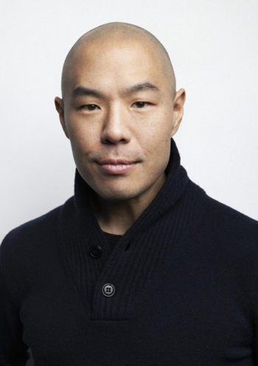
Hoon Lee, narrator of The Chinese Exclusion Act, is known for his role on Cinemax Original Series “Banshee.” He was featured in the action movie Premium Rush (with Joseph Gordon-Levitt, Michael Shannon), The Oranges (with Hugh Laurie and Oliver Platt) and as the voice of Master Splinter in Teenage Mutant Ninja Turtles (with Jason Biggs). Other television and film credits include We Own the Night, ”Blue Bloods” (NBC), “White Collar” (USA), “Royal Pains” (USA) and “Sex in the City” (HBO).

He has performed on Broadway in such shows as Pacific Overtures, Urinetown and Flower Drum Song. His New York and regional theater credits range from Shakespearean works such as The Winter’s Tale (Yale Rep), Love's Labor’s Lost and Hamlet (both at the Public Theatre) to new modern classics like David Ives’ School for Lies (Classic Stage Company) and American Hwangap (The Play Company and Ma-Yi Theatre Company). He received a Helen Hayes Award nomination for originating the role of LaBlache in Terrence McNally's Golden Age (Kennedy Center). His work in David Henry Hwang's pseudo-autobiographical play Yellow Face (Mark Taper Forum and The Public Theatre) garnered both a Theater World Award and Drama League nomination. He is the recipient of a Theatre Communication Group Fox Fellowship for Extraordinary Potential (in association with the Lark Play Development Center) and is a graduate of Harvard University.


Li-Shin Yu, a New York-based film editor, has collaborated with director Ric Burns for the past 23 years. Yu and Burns are best known for their epic series NEW YORK: a documentary film, an eight-part production chronicling the city’s rise from a remote Dutch outpost to the cultural and economic center of the world, for which Yu received a Primetime Emmy Award for Outstanding Achievement in Editing. Yu began her career collaborating with other New York independent filmmakers, including Jim Jarmusch, Spike Lee, Sara Driver and Peter Wang, and more recently with documentarians Christine Choy, Bill Moyers, Thomas Lennon and Stanley Nelson, among others.


Ric Burns has been producing, directing and writing historical documentaries for public television since collaborating on The Civil War (1990), which he produced with his brother Ken and co-wrote with Geoffrey C. Ward. In 1989, Burns founded Steeplechase Films and since that time he has produced many award winning films including Coney Island (1991); The Donner Party (1992); New York: a documentary film (1999, 2001, 2003); Eugene O’Neill (2006); Death & the Civil War (2011); American Ballet Theatre (2015); and The Pilgrims
(2015). His films have received seven Emmy Awards, three duPont-Columbia Awards and two Peabody Awards. Burns was educated at Columbia University and Cambridge University. He is currently at work on a film about the life and work of Dr. Oliver Sacks.

