

FOR IMMEDIATE RELEASE: Nov. 20, 2017
Contact: MiChelle Jones, NPT, (615) 259-9325 x2110, mjones@wnpt.org

Christmas at Belmont 2017 with Grammy-winning musician Sheryl Crow
Premieres in December on PBS stations

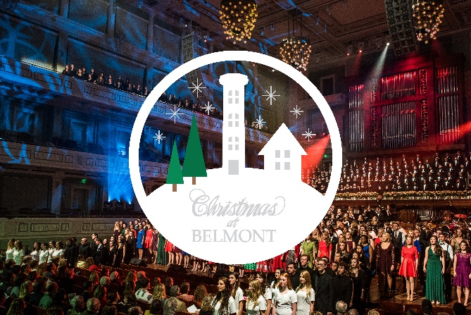
Nashville – Grammy-winning musician Sheryl Crow hosts the 2017 CHRISTMAS AT BELMONT holiday concert recorded in Nashville’s Schermerhorn Symphony Center. The festive production features nearly 700 musicians and performers, including Belmont University students, Belmont School of Music faculty and the Nashville Children’s Choir. CHRISTMAS AT BELMONT premieres on PBS on Friday, Dec. 22, at 9 p.m. ET (check local listings).

This year’s edition of CHRISTMAS AT BELMONT features Belmont Chorale, University Orchestra, Musical Theatre Ensemble, Jazzmin, Bluegrass Ensemble and Jazz Band 1. The music crosses a number of genres with songs such as “Angels We Have Heard on High,” “Run, Run Rudolf,” “What Child is This?” “Russian Dance” from The Nutcracker and the beautiful “There Is a Star,” performed by Sheryl Crow.

A nine-time Grammy Award recipient, Crow is an American music icon. Her nine studio albums have sold 35 million copies worldwide – seven of them charted in the Top 10 and five were certified for multi-platinum sales. Forty of Crow’s singles have made the Billboard Hot 100, Adult Top 40, Adult Contemporary, Mainstream Top 40 and Hot Country Songs charts. She has had more No. 1 singles in the Triple A listings than any other female artist. Crow is also known for her passionate support of multiple charities; City of Hope, Stand Up to Cancer, The World Food Program, Feeding America, the TJ Martell Foundation, the Elton John AIDS Foundation, MusiCares and the Special Olympics among them.

“I’m thrilled to appear as this year’s CHRISTMAS AT BELMONT guest artist,” Crow said. “It’s an honor to be asked to share the stage with hundreds of impressive student musicians and join in this beautiful Christmas tradition. I look forward to celebrating the holiday season with so many viewers across the country.”

The performance and taping of CHRISTMAS AT BELMONT returns for the sixth time to Nashville’s Schermerhorn Symphony Center, one of the few venues in the world featuring natural lighting and state-of-the-art acoustics, including motorized acoustic drapes and an acoustical isolation joint that encircles the entire concert hall and prevents sound waves traveling into or out of the hall.

Underwriters: The Beaman Family Foundation; The Jack C. Massey Foundation; Tyson Foods; Barbara Massey Rogers; and Marty and Betty Dickens.
Producer: Nashville Public Television (NPT)
Format: CC Stereo HD

(more)
About Nashville Public Television: Nashville Public Television, Nashville’s PBS station, is available free and over-the-air to nearly 2.4 million people throughout the Middle Tennessee and southern Kentucky viewing area. NPT’s three broadcast channels are NPT, the main channel; secondary channel NPT2; and NPT3, a 24/7 PBS Kids channel. NPT is also available to anyone in the world through its array of NPT digital services, including wnpt.org, YouTube channels and the PBS video app. NPT provides, through the power of traditional television and interactive digital communications, quality educational, cultural and civic experiences that address issues and concerns of the people of the Nashville region, and which thereby help improve the lives of those we serve. Join the conversation at facebook.com/nashvillepublictelevision and on Twitter @npt8.

About Belmont University: Ranked No. 5 in the Regional Universities South category and named as a “Most Innovative” university by U.S. News & World Report, Belmont University consists of more than 8,000 students who come from every state and more than 36 countries. Committed to being a leader among teaching universities, Belmont brings together the best of liberal arts and professional education in a Christian community of learning and service. The University’s purpose is to help students explore their passions and develop their talents to meet the world’s needs. With more than 90 areas of undergraduate study, more than 25 master’s programs and five doctoral degrees, there is no limit to the ways Belmont University can expand an individual's horizon. For more information, visit www.belmont.edu.

####

