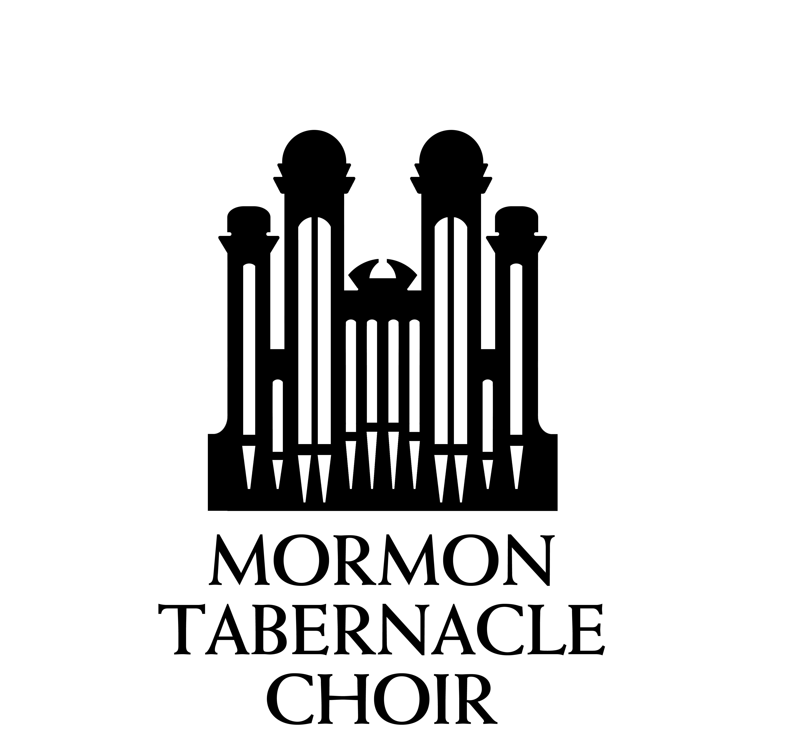

Christmas with the Mormon Tabernacle Choir featuring Deborah Voigt and John Rhys-Davies

DEBORAH VOIGT
A Chicago native raised in southern California, soprano Deborah Voigt is recognized as one of the world’s most versatile singers, and one of music’s most endearing personalities. A leading dramatic soprano revered for her performances in the operas of Richard Wagner and Richard Strauss, she has also portrayed heroines of Italian opera to great acclaim. An active recitalist and performer of Broadway standards and popular songs, Ms. Voigt has an extensive discography, including two popular solo recordings for EMI Classics, and has given enthusiastically received master classes. She appears regularly, as both performer and host, in the Metropolitan Opera’s “Live in HD” series, and recently starred as Brünnhilde in Robert Lapage’s innovative production of Wagner’s “Ring” cycle on the PBS series Great Performances from the Met. Deborah Voigt studied at California State University at Fullerton, was a member of San Francisco Opera’s Merola Program, and won both the Gold Medal in Moscow’s Tchaikovsky Competition and First Prize at Philadelphia’s Luciano Pavarotti Vocal Competition. She has been awarded the Chevalier dans l’Ordre des Arts et des Lettres in France, was Musical America’s Vocalist of the Year 2003 and in 2007 she won an Opera News Award for distinguished achievement. A participant in the Macy’s Thanksgiving Day Parade and July 4th fireworks celebration, Ms. Voigt has become America’s most visible and beloved diva.

JOHN RHYS-DAVIES
Acclaimed British actor and voice artist John Rhys-Davies is one of modern cinema’s most recognizable character actors, best known to film audiences for his role as Sallah, the Gilbert and Sullivan-singing Arab excavator, in Raiders of the Lost Ark and Indiana Jones and the Last Crusade, and more recently as the axe-wielding dwarf Gimli in Peter Jackson’s The Lord of the Rings trilogy. Raised in England, Africa, and Wales, he credits his early exposure to classical literature for his decision to pursue acting and writing. Mr. Rhys-Davies graduated from the University of East Anglia and studied at London’s renowned Royal Academy of Dramatic Art. Numerous theatrical credits followed with the works of William Shakespeare, Moliere, Ibsen, and others. Gaining wide-spread fame on British television he also appeared in several American television mini-series productions including the role of Vasco Rodrigues in James Clavell’s Shogun for which he received an Emmy nomination for Best Supporting Actor. His talent for voice work provided a second role for Mr. Rhys-Davies in The Lord of the Rings movies as Treebeard the Ent. Many video games, animated series, audiobooks, and documentaries have also benefitted from his deep and distinctive voice. Father of two sons one daughter, he divides his time between Los Angeles and the Isle of Man. Mr. Rhys-Davies is an avid collector of vintage automobiles.

