CITY IN THE SKY Takes Off on PBS with a Far-Reaching Look at the Global Aviation Industry

Three-part BBC-PBS co-production goes behind the scenes with rare access to showcase what keeps hundreds of thousands of flights aloft daily

Premieres February 8 at 10:00 p.m. ET

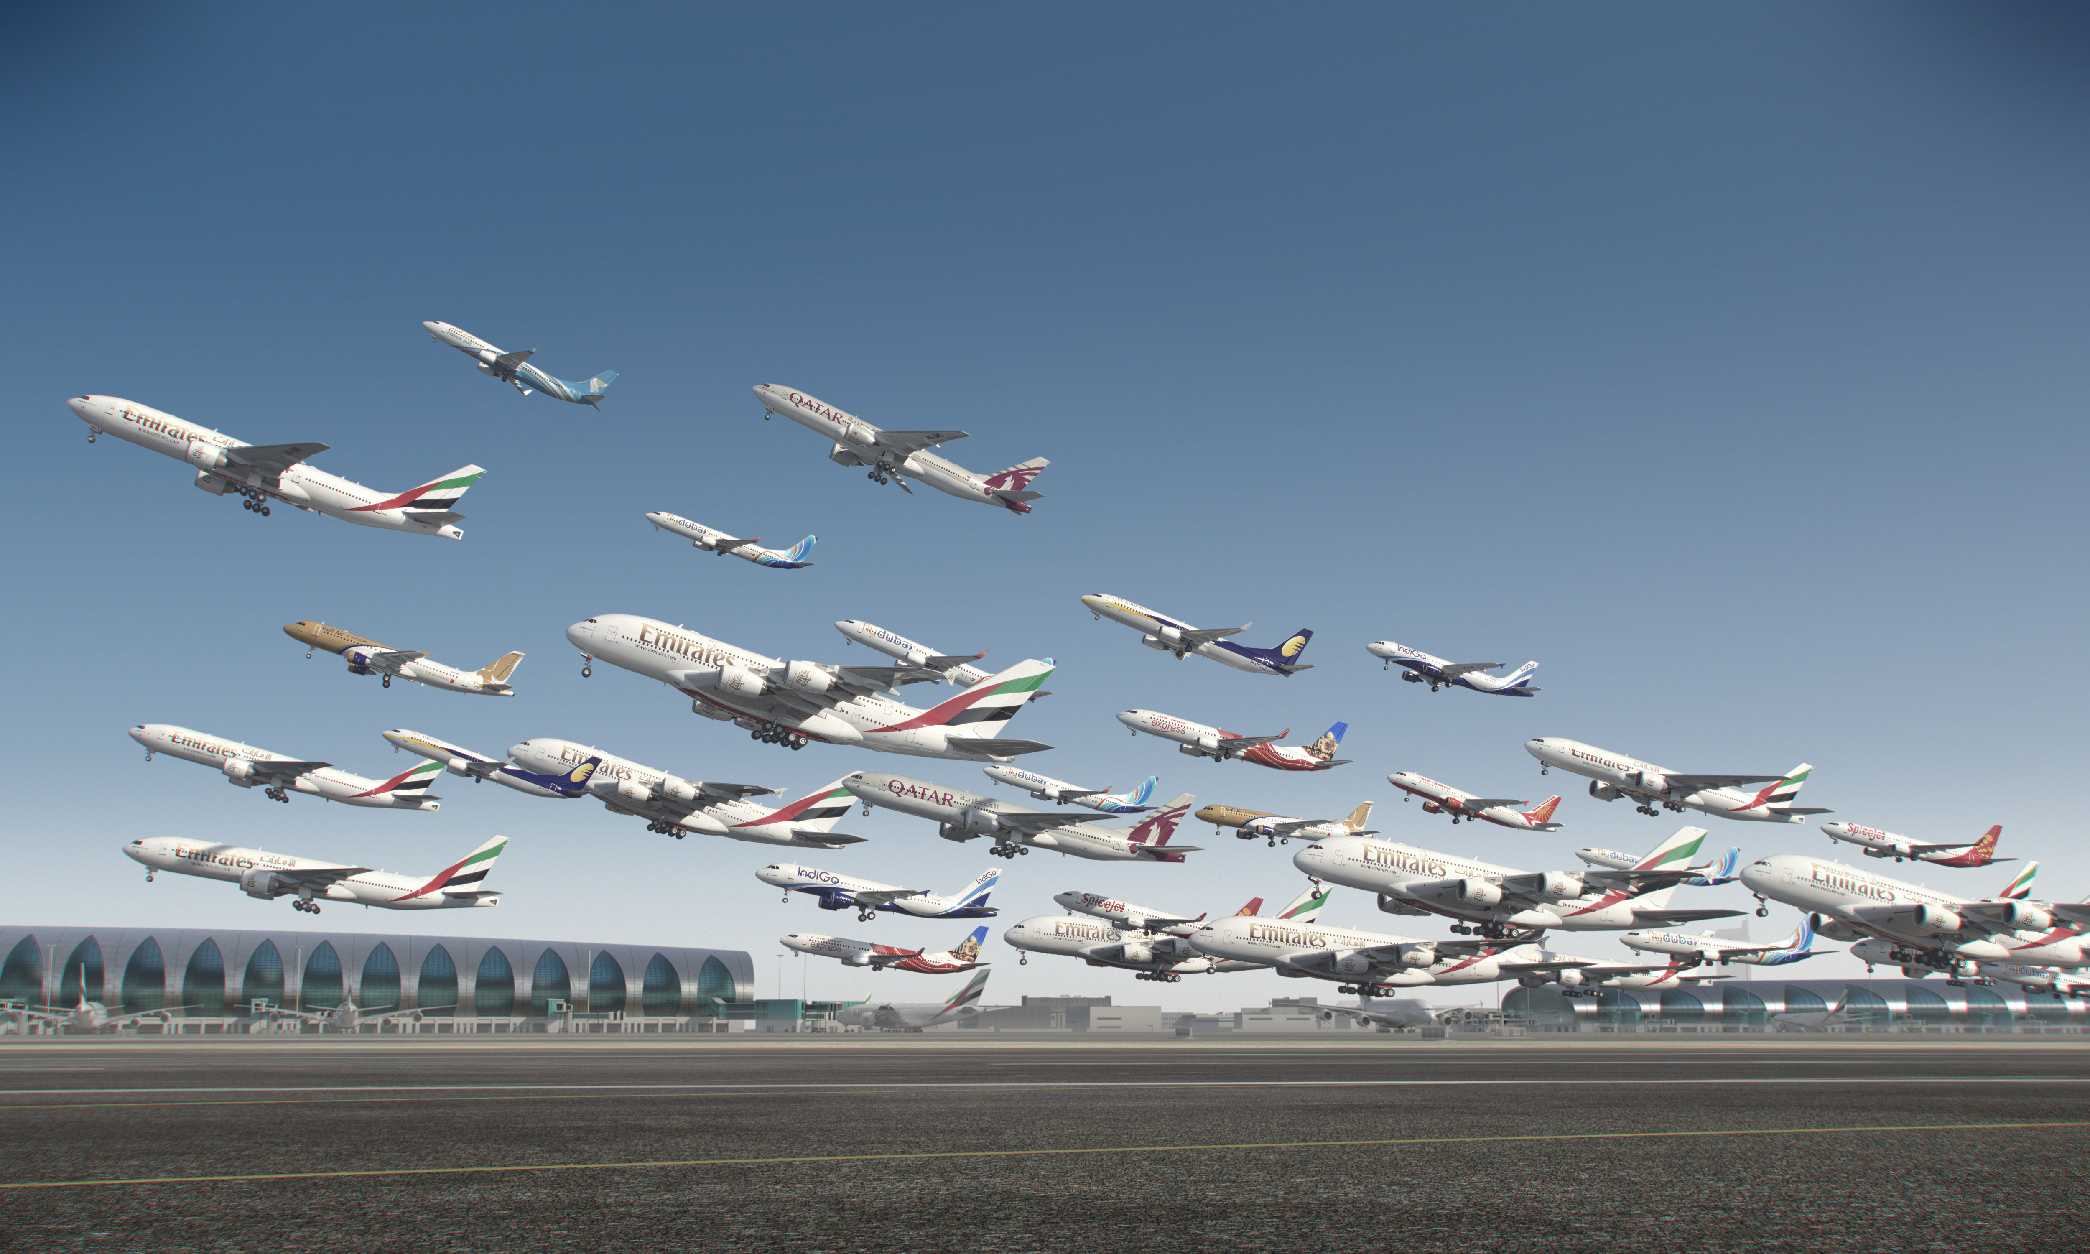
ARLINGTON, VA; January 6, 2016 – At any given moment, more than one million people are traveling by airplane, in 100,000 daily flights moving 30,000 feet above the Earth. This airborne metropolis and the armies of professionals needed to make it all work are captured in CITY IN THE SKY, a three-part documentary series co-produced with BBC, debuting February 8, 2017, at 10:00 p.m. on PBS (check local listings). From hidden cities of luggage below ground to the steady hands guiding flights around the globe, CITY IN THE SKY goes behind the scenes with rare access to uncover the invisible global networks and complex logistics that have allowed air travel to soar to new heights.
GFX image of planes taking off from Dubai International Airport. Courtesy of BBC.

“Anyone who flies, from annual vacationers to daily business travelers, will be amazed what it really takes to get them from place to place safely and efficiently,” says Beth Hoppe, PBS’ Chief Programming Executive and General Manager. “This is an extraordinary series that jet-sets around the world to show the inner-workings of a fascinating global industry many of us take for granted.”

From the coldest airport in the world (in Yakutsk, Russia), to one of the busiest (in Atlanta, Georgia), to the most dangerous (in the Himalayan town of Paro), the series takes viewers to remote, little known places such as the world’s largest luggage storage facility and the storage tanks in Europe and southeast America that hold and transport millions of gallons of jet fuel through underground pipes.

Through international in scope, CITY IN THE SKY highlights key American airports and aviation hot spots coast-to-coast, including:

- Atlanta’s Hartsfield-Jackson Airport, one of the three busiest in the world and America’s most advanced in passenger and airline traffic flow;
- Phoenix’s MedAire, Inc., at Banner University Medical Center, where a team of doctors and emergency specialists is on-call 24/7 to help cabin crews with mid-air medical crises;
- Seattle’s Boeing facility, which has developed a radical new material that has led to the biggest change in airplane design since the 1920s; and
- The Bangor, Maine International Airport, which boasts the size of a major international hub because it serves as the first U.S. point of arrival for troubled airliners crossing the Atlantic Ocean.

CITY IN THE SKY gives viewers a new appreciation for the paper stub or digital ticket that unlocks a precisely choreographed journey that starts the moment they walk into an airport terminal. Signage, lighting and flooring are designed to keep travelers on a flowing path to their gates. Vast underground machines give baggage the ride of its life from check-in to pick-up. Even non-consumer-facing parts of the industry bring fascination: the world’s largest cargo storage in China, for example, sees one-fifth of all global shipping come through its facility. A short recap of each episode follows:

- Episode 1 “Departure” – Learn what it takes to get a million people off the ground—from building the world’s biggest passenger plane to controlling the flow of passengers through the busiest airport on the planet to the perils of takeoff in the coldest city on Earth.
- Episode 2 “Airborne” – Examine the hidden army that keeps your plane safe, and explore just what it takes to keep the “city in the sky” functioning and safe between take-off and landing. Learn why flying has become safer than ever.
- Episode 3 “Arrival” – What goes up must come down—and getting passengers safely back to earth depends on complex global networks and some astonishing technology. Around the world, 100,000 flights a day make touchdown—almost every one safely. Learn what’s involved.

CITY IN THE SKY is presented as part of a multi-title co-production deal among PBS, BBC and BBC Worldwide North America. The partnership provides a pipeline of the high-quality, entertaining factual programs that PBS and BBC audiences have come to expect.

CITY IN THE SKY follows the second weekly installment of the BBC-PBS co-production, SPY IN THE WILD, A NATURE MINISERIES, which brings viewers an intimate look at animal behavior through extraordinary animatronic robot technology that reveals how animals’ emotions and behaviors are strikingly similar to humans.

About PBS
PBS, with nearly 350 member stations, offers all Americans the opportunity to explore new ideas and new worlds through television and online content. Each month, PBS reaches nearly 100 million people through television and nearly 33 million people online, inviting them to experience the worlds of science, history, nature and public affairs; to hear diverse viewpoints; and to take front row seats to world-class drama and performances. PBS’ broad array of programs has been consistently honored by the industry’s most coveted award competitions. Teachers of children from pre-K through 12th grade turn to PBS for digital content and services that help bring classroom lessons to life. PBS’ premier children’s TV programming and its website, pbskids.org, are parents’ and teachers’ most trusted partners in inspiring and nurturing curiosity and love of learning in children. More information about PBS is available at www.pbs.org, one of the leading dot-org websites on the Internet, or by following PBS on Twitter, Facebook or through our apps for mobile devices. Specific program information and updates for press are available at pbs.org/pressroom or by following PBS Pressroom on Twitter.

About BBC
The BBC has an unrivalled global reputation for the factual content it produces across arts, history, documentaries and natural history, and broadcasts some 7,000 hours of high-quality, distinctive factual programs a year on television. The BBC is recognized as an industry leader in terms of innovation, consistently pushing the boundaries of its productions, delivered to our audience by the most engaging and inspirational experts.

For additional information, photos, interviews and more, contact Goodman Media or PBS:

Sara Levin/Chelsey Saatkamp Carrie Johnson/Colleen Flanagan
Goodman Media International for PBS PBS
212-576-2700 703-739-5129/703-739-8130
PBSProgramming@goodmanmedia.com cjohnson@pbs.org; crflanagan@pbs.org

For images and additional up-to-date information on this and other PBS programs, visit PBS PressRoom at pbs.org/pressroom.

