Coming Back with Wes Moore

CHARACTER BIOS

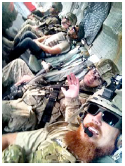
ANDY CLARK, 32
Denver, Colorado / Undisclosed Location, Afghanistan
Sergeant, Army (Retired)
Sometimes returning from military service doesn’t mean you’re back for good. When Andy Clark retired from the Army after deploying to both Iraq and Afghanistan, he and his wife began a life together raising their moderately autistic son CJ in Denver. They couldn’t make ends meet and Andy, an adrenaline junkie, was bored. Andy learned he could bring in around $250K a year if he was willing to deploy to Afghanistan as a contractor; soon he was back overseas. Now he’s facing a new hurdle: He loves his family, but he’s happier as a soldier, especially as a highly paid private one. His wife, Pam, doesn’t know how much longer she can wait to have her soldier at home. With cameras rolling, Pam conveys her frustrations to her husband.

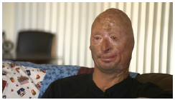
BOBBY HENLINE, 42
San Antonio, Texas
Sergeant, Army (Retired)
More than 40 percent of Bobby Henline’s body was burned when his Humvee was hit by an IED. His family relocated to San Antonio, Texas, to be near him at Brooke Army Medical Center. Bobby was so seriously disfigured that he was unrecognizable to his family, and he used humor to ease the discomfort that he sensed from his doctors. Eventually he found himself on stage as a stand-up comedian. As we meet Bobby, the spirit that bound his family in the early days of his recovery has dissipated. He’s living on his own, performing in odd clubs and making motivational speeches around the country. When he’s in San Antonio, he commutes home for dinner with his kids and wife, Connie. He makes an effort for his family, but something is holding him back from a full commitment. Bobby helps us understand the difference between the physical scars of war and the emotional ones. His PTSD has exacted a severe toll, one with which his family is losing patience.

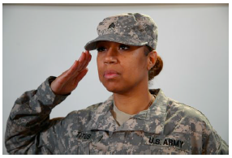
LETRICE TITUS, 38
Syracuse, New York
Staff Sergeant, Army Reserves
Letrice Titus joined the Army when her husband was deployed to Iraq. She had two small children and had finished her master’s degree in mental health counseling. When she didn’t pass the 12-week Officer Candidate School, Letrice, determined to lead in a meaningful way, became an Army behavioral health specialist. She evaluated soldiers deploying and those coming back. Now she spends her days as a counselor in the Canandaigua VA Hospital. All calls to the VA Veterans Crisis Line are routed to Canandaigua. When someone in crisis dials that number, the person on the other end of the line may be Letrice. We watch how she handles a call and learn about the influence her service has on her.

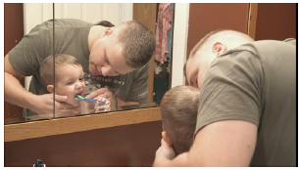
BRAD FARNSLEY, 29
Fort Knox, Kentucky
Sergeant, Army National Guard
Brad Farnsley dropped out of Purdue University in his junior year. He needed something bigger than himself, he needed a purpose, he needed the Army. Brad enlisted and convinced his best friend to deploy with him. Brad came home; his best friend did not. His guilt was so overwhelming he contemplated suicide. The Army placed him in a Warrior Transition Unit that he describes as a “battalion for broken soldiers.” He’s now in Ft. Knox, Kentucky, while his wife, Ashley, and their two children live two-and-a-half hours away in Indiana. He commutes to be with them on weekends, but as his income decreases because he’s not yet eligible for VA benefits, maintaining two homes is taking its toll. Brad is ready to go home. No one can say when that will happen. Brad has to bide his time and he and Ashley enact solutions to keep them on track.

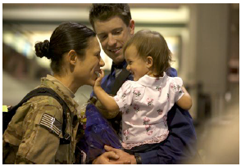
CHRISTOPHER PHELAN, 31 and STAR LOPEZ, 29
Los Angeles, CA / Kabul, Afghanistan
Sergeant, Marine Corps (Retired) / Captain, Air Force
Chris Phelan joined the LAPD not long after he concluded his career in the Marine Corps. The LAPD was thrilled to have an educated former Marine. He’s now a single father of a toddler, River, by day and a cop on the streets by night. His wife, Star Lopez, deployed to Afghanistan as an Air Force JAG attorney when River was learning to crawl. Despite meaningful work in Kabul, Star can hardly wait to return home to her family. But the adjustment we witness is rocky; their service is not without a toll.

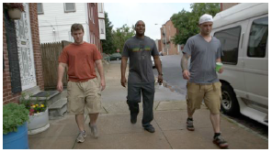
EARL JOHNSON, 32
Baltimore, Maryland
Army
Earl Johnson has wowed everyone in Baltimore,
including his friend Wes Moore and wife, Zina, with tales of his service. Now, Earl is determined to remake his Baltimore neighborhood – the Oliver – which was the setting of HBO’s “The Wire.” It’s working. Crime is down. But Earl has a devastating secret about his service. Later in the series, we see how Earl manages the revelation of his complicated past and how he pushes forward with his mission.


STACY PEARSALL, 33
Charleston, South Carolina
Staff Sergeant, Air Force (Retired)
Stacy Pearsall’s short-term memory is so impaired she often doesn’t remember the content of her last sentence. The former combat photographer remains undaunted, though. Driven by her passion for her work and her desire to continue to serve, she takes photographic portraits of veterans. Her goal is to make them feel, as individuals, like rock stars. The result is a series of simple, human portraits of individuals, including portraits of the 10 veterans you will have come to know in the series.


TAMMY DUCKWORTH, 45
Schaumburg, Illinois / Washington, DC
Lieutenant Colonel, Army National Guard
An accomplished freshman Congresswoman, Iraq war veteran and double amputee, Tammy Duckworth made a name for herself in a recent congressional hearing. She took on a government contractor who used the football injury he sustained when playing for a military prep school as a means of obtaining a $500K IRS contract. It was a “have you no shame” moment that went viral. Tammy offers a perspective on returning veterans and their future.


(BRIAN) TAYLOR URRUELA, 28
Tampa, Florida
Sergeant, Army (Retired)
Taylor Urruela longs to be normal. The 28-year-old college freshman on the GI Bill has a dream: to play on the University of Tampa junior varsity baseball team. That’s not an easy accomplishment for anyone; the University of Tampa has won six NCAA national baseball championships. But Taylor is 10 years older than his would-be teammates and he lost a leg in Iraq. The pain of training and the stress of adapting to college pose a challenge to Taylor’s journey to health. But Taylor calls on the skills he honed in the Army infantry. He assesses the mission, adjusts the goal and succeeds in a meaningful way.

