COUNTDOWN TO DOWNTON ABBEY!
Premieres January 3, 2016 on PBS

– Join Tony Award-winner Kelli O’Hara
and the “Downton Abbey” Cast and Filmmakers to Countdown to the Final Season –

– Additional New Special, DOWNTON ABBEY: A CELEBRATION,
Immediately Follows Premiere of First Episode of Season 6 –

ARLINGTON, VA; December 17, 2015 -- Anticipation for the premiere of the final season of “Downton Abbey,” a Carnival Films/MASTERPIECE co-production, is reaching a fever pitch. Now PBS offers viewers an opportunity to tune in early and countdown the moments until Season 6 begins on MASTERPIECE. Fans across the country are aching to know what will become of the Crawley family. What surprising twists and turns are in store as this exquisite period drama wraps up? More intrigue, drama, and romance? You can count on it! Hosted by Broadway star Kelli O’Hara and featuring exclusive clips from Season 6 and surprise appearances from cast and creators, COUNTDOWN TO DOWNTON ABBEY! premieres Sunday, January 3, 2016 from 8:00-9:00 pm ET (check local listings) on PBS.
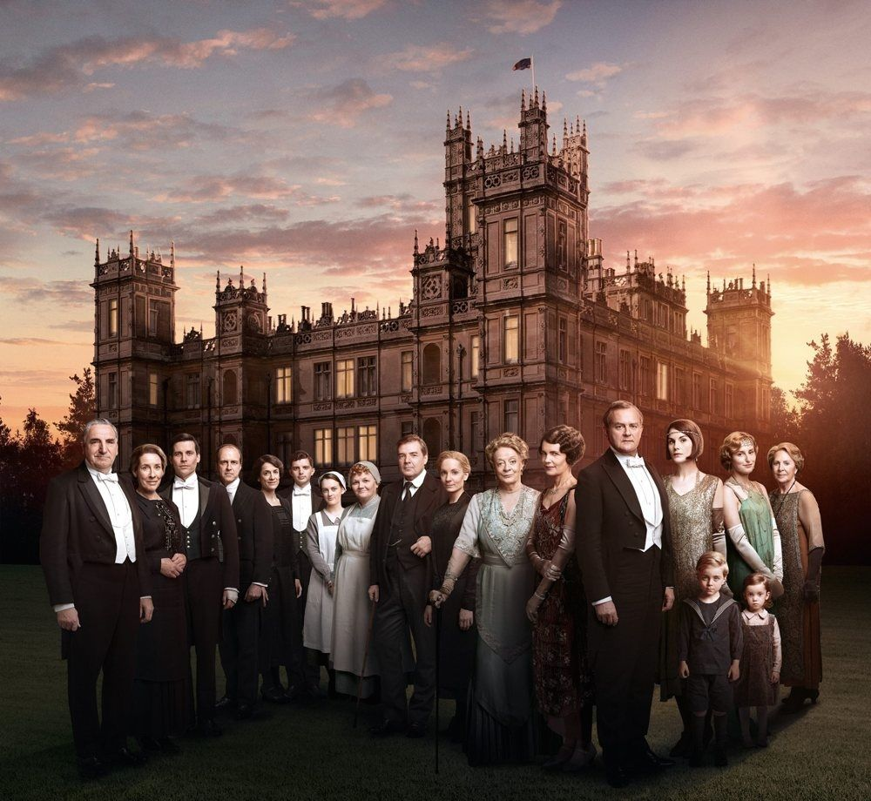
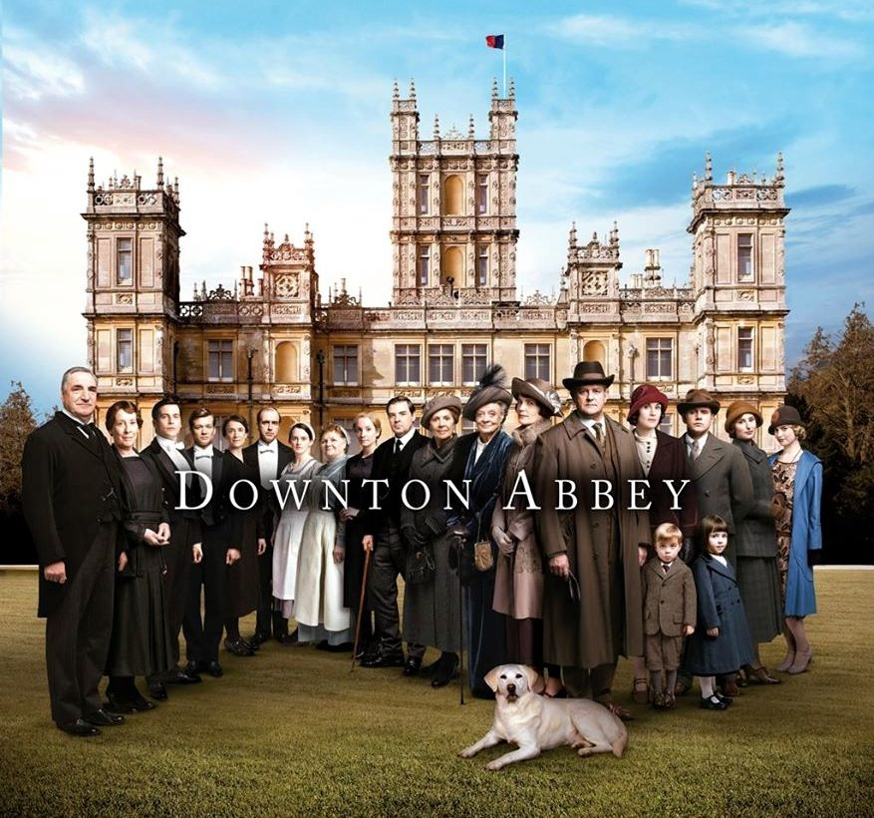
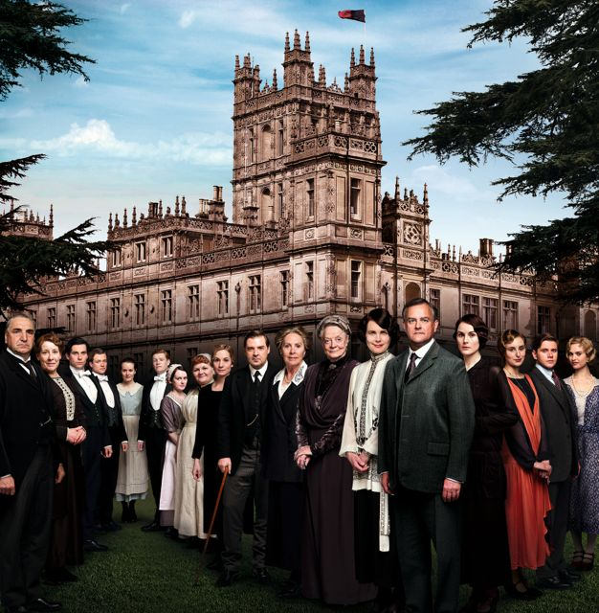

“Six years ago, it was impossible to imagine what a wonderful adventure millions of us would have with the Crawley family and those who serve them. We hope viewers will enjoy this countdown leading up to what’s in store for these beloved characters as the final season is at hand,” said Beth Hoppe, Chief Programming Executive and General Manager, General Audience Programming, PBS. “I know I’ll be right in front of the TV with everyone else, counting down the minutes until the first episode begins.”

And there’s more excitement in store for fans of the series. Immediately following the premiere of the first episode of Season 6 on MASTERPIECE, viewers can stay tuned for DOWNTON ABBEY: A CELEBRATION, which offers additional video clips and cast interviews, on Sunday, January 3, 2016, 10:15-11:00 p.m. ET (check local listings) on PBS.

COUNTDOWN TO DOWNTON ABBEY! explores burning questions anticipated to be answered in the upcoming final season, including:
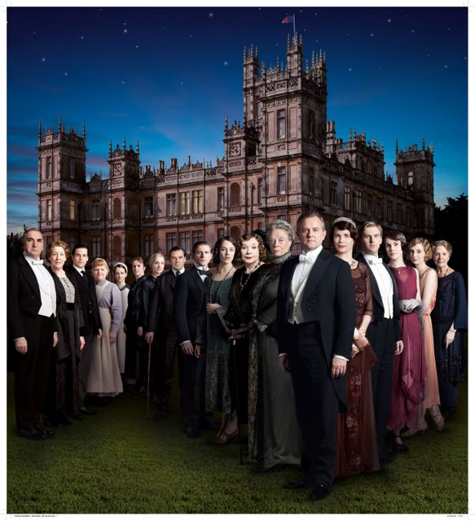
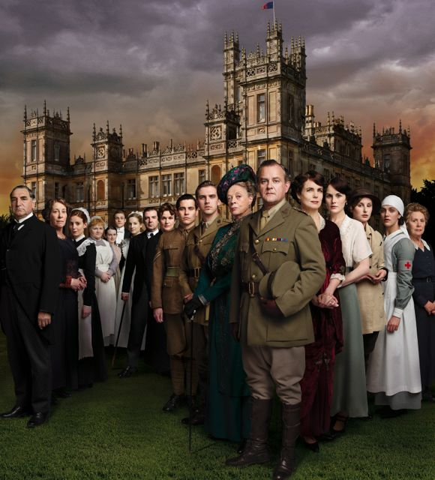
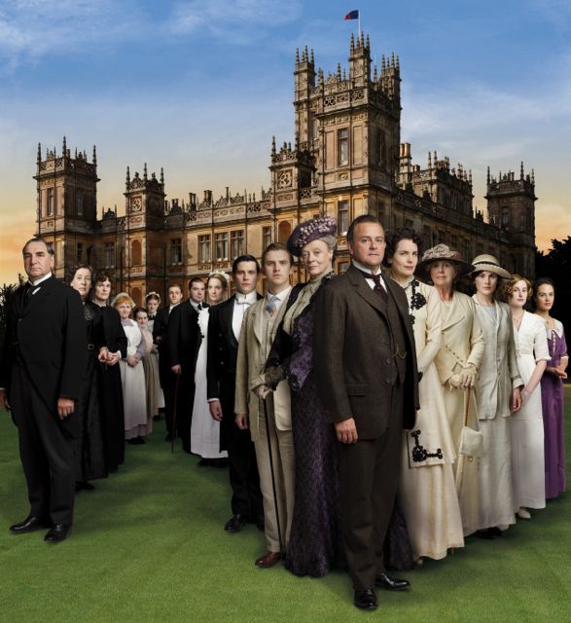

- Will Lady Mary find true love at last?
- Are Bates and Anna finally free of their dark cloud and allowed to be happy?
- What will become of Branson and Sybbie in America?
- What will become of Downton Abbey itself?
- Will Carson and Mrs. Hughes really walk down the aisle?

COUNTDOWN TO DOWNTON ABBEY! includes footage from the tribute to “Downton Abbey” by the British Academy of Film and Television Arts (BAFTA), including red carpet arrivals of the “Downton Abbey” cast, behind-the-scenes looks at the making of Season 6, and celebrity fans toasting this remarkable series. Julian Fellows shares the story of how the series began, and the actors discuss the global success of the television series and what makes it so special. During the hour-long special, cast members from upstairs and down, along with executive producers Julian Fellowes, Gareth Neame and Liz Trubridge, discuss romance, scandal, fashion and the most compelling plotlines.

Don’t miss the chance to join the cast and creators to count down and offer a toast to the moment everyone has been waiting for — the start of the final season of “Downton Abbey”!

PBS special programming invites viewers to experience the worlds of science, history, nature and public affairs; hear diverse viewpoints; and take front-row seats to world-class drama and performances. Viewer contributions are an important source of funding, making PBS programs possible. PBS and public television stations offer all Americans from every walk of life the opportunity to explore new ideas and new worlds through television and online content.

Underwriters: Public Television Viewers and PBS
Producer: Inky Dinky Worldwide, Inc.
Executive Producer: Bob Marty

About Kelli O’Hara

A native of Oklahoma, Kelli O’Hara has unequivocally established herself as one of Broadway’s great leading ladies through her many award-winning roles, including The King and I (Tony Award for Best Leading Actress in a Musical, along with Drama League and Outer Critics nominations); the 2014 musical adaptation of The Bridges of Madison County (Tony, Drama Desk, Drama League, and Outer Critics Circle nominations). That same year she starred as Mrs. Darling in NBC’s live telecast of “Peter Pan,” and on New Year’s Eve made her Metropolitan Opera debut in the production of The Merry Widow with Renee Fleming. O’Hara’s other roles include her Broadway debut in Jekyll & Hyde; Sondheim’s Follies; Sweet Smell of Success opposite John Lithgow; Dracula; The Light in the Piazza (Tony and Drama Desk Award nominations); The Pajama Game (Tony, Drama Desk, and Outer Critics Award nominations); the Tony Award-winning revival of South Pacific at Lincoln Center; and Nice Work if You Can Get It (Tony, Drama Desk, Drama League and Outer Critics Circle nominations, as well as the Fred Astaire Nomination for dance). O’Hara received critical acclaim for her performances in the New York Philharmonic’s productions of Carousel & My Fair Lady. She has released two solo albums including Always and Wonder in the World.

PBS, with its 350 member stations, offers all Americans the opportunity to explore new ideas and new worlds through television and online content. Each month, PBS reaches nearly 109 million people through television and over 28 million people online, inviting them to experience the worlds of science, history, nature and public affairs; to hear diverse viewpoints; and to take front row seats to world-class drama and performances. PBS’ broad array of programs has been consistently honored by the industry’s most coveted award competitions. Teachers of children from pre-K through 12th grade turn to PBS for digital content and services that help bring classroom lessons to life. PBS’ premier children’s TV programming and its website, pbskids.org, are parents’ and teachers’ most trusted partners in inspiring and nurturing curiosity and love of learning in children. More information about PBS is available at www.pbs.org, one of the leading dot-org websites on the Internet, or by following PBS on Twitter, Facebook or through our apps for mobile devices. Specific program information and updates for press are available at pbs.org/pressroom or by following PBS Pressroom on Twitter.

About MASTERPIECE
MASTERPIECE is presented on PBS by WGBH Boston. Rebecca Eaton is executive producer for MASTERPIECE. Funding for the series is provided by Viking Cruises and Audible with additional support from public television viewers and contributors to The MASTERPIECE Trust, created to help ensure the series’ future.

About Carnival Films
Carnival Films is a division of NBC Universal International Studios and is the UK’s largest drama specialist. The company is responsible for the global TV sensation Downton Abbey, winner of three Golden Globes and twelve Primetime Emmy awards, including Best Mini-series. It is the most nominated non-US show in the history of the Emmy’s with a total of 59 nominations and is now in over 250 territories worldwide. Among numerous national and international awards, including three Screen Actors Guild Awards and three National Television Awards, the show has even garnered a Guinness World Record for highest critical ratings for a TV show, and the BAFTA Special Award in recognition of its outstanding global success. Downton Abbey is executive produced by Carnival’s Managing Director Gareth Neame, who sold the production company to NBCUniversal in 2008.

Founded in 1978, Carnival Films has produced many hundreds of hours of popular drama both in the UK and US, including primetime series such as Poirot, Hotel Babylon, Whitechapel, Dracula andThe Philanthropist, as well as mini-series such as C4’s iconic Traffik, David Nicholl’s The 7:39, David Hare’s Worricker Trilogy as well as William Boyd’s BAFTA-winning Any Human Heart, and Peter Morgan’s BAFTA-winning The Lost Honour of Christopher Jefferies.

The sixth and final season of Downton Abbey is aired on ITV and return to PBS in January 2016. Carnival’s latest series The Last Kingdom aired on BBC TWO and BBC America. Stan Lee’s Lucky Man airs on Sky One in 2016.

Carnival Films was recognized as best production company at the 2011 Bulldog Awards and 2012 Broadcast Awards.

– PBS –

CONTACT:
Carrie Johnson, PBS, cjohnson@pbs.org; 703-739-5129
Cara White, CaraMar, Inc., cara.white@mac.com; 843-881-1480

For images and additional up-to-date information on this and other PBS programs, visit PBS PressRoom at pbs.org/pressroom.

Photos:
Caption for all: The cast of “Downton Abbey.”
Credit for all: © Carnival Film & Television Limited for MASTERPIECE.

