COUNTRY MUSIC
TCA Summer 2019 Panelist Bios

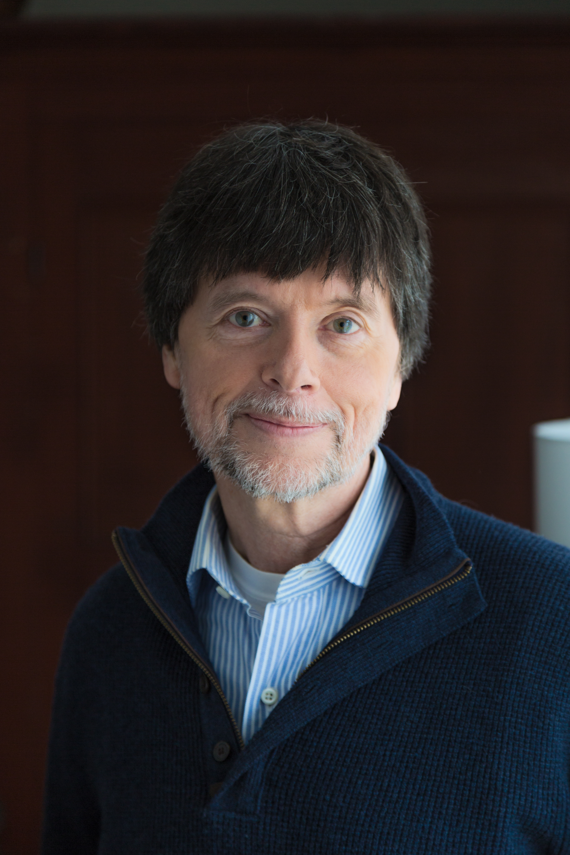
Ken Burns, director and producer
Ken Burns has been making documentary films for over 40 years. Since the Academy Award-nominated Brooklyn Bridge in 1981, Ken has gone on to direct and produce some of the most acclaimed historical documentaries ever made, including The Civil War; Baseball; Jazz; The Statue of Liberty; Huey Long; Lewis & Clark: The Journey of the Corps of Discovery; Frank Lloyd Wright; Mark Twain; Unforgivable Blackness: The Rise and Fall of Jack Johnson; The War; The National Parks: America’s Best Idea; The Roosevelts: An Intimate History; Jackie Robinson; Defying the Nazis: The Sharps’ War; The Vietnam War and, most recently, The Mayo Clinic: Faith - Hope - Science.

Future film projects include Ernest Hemingway, Muhammad Ali, the Holocaust and the United States, Benjamin Franklin, Lyndon B. Johnson, the American Buffalo, Leonardo da Vinci, the American Revolution, the history of crime and punishment in America, the history of Reconstruction, and Winston Churchill, among others.

Ken’s films have been honored with dozens of major awards, including 15 Emmy Awards, two Grammy Awards and two Oscar nominations; and in September of 2008, at the News & Documentary Emmy Awards, Ken was honored by the Academy of Television Arts & Sciences with a Lifetime Achievement Award.


Rosanne Cash, featured musician
One of the country’s pre-eminent singer/songwriters, Rosanne Cash has released 15 albums of extraordinary songs that have earned four Grammy Awards and 11 nominations, as well as 21 top 40 hits, including 11 No. 1 singles. Her most recent album is “She Remembers Everything” (November 2019), a poetic, lush and soulful collection of songs that reckon with a flawed and intricate world. “She Remembers Everything” follows Rosanne’s triple-Grammy winning 2014 album, “The River & the Thread,” and marks a return to more personal songwriting after a trio of albums that explored her southern roots and family heritage.

Cash is also an author whose four books include the bestselling memoir Composed, which the Chicago Tribune called “one of the best accounts of an American life you’ll likely ever read.” Her essays have appeared in The New York Times, Rolling Stone, the Oxford American, The Nation and many more print and online publications. A new book, Bird on a Blade, blending the images of acclaimed artist Dan Rizzie with strands of lyrics from a variety of Cash's songs, has just been published by UT Press. Cash is also currently writing the lyrics for a musical, Norma Rae, with John Leventhal, composer, and John Weidman, book writer.

In addition to recording, writing and regular touring, Cash has partnered in programming collaborations with Carnegie Hall, Lincoln Center, San Francisco Jazz, Minnesota Orchestra and The Library of Congress. She has received countless awards and accolades including being awarded the SAG/AFTRA Lifetime Achievement award for Sound Recordings in 2012, receiving the 2014 Smithsonian Ingenuity Award in the Performing Arts, being the recipient of the 2018 Spirit of Americana: Free Speech Award by the Americana Music Association and receiving an honorary doctorate degree from the Berklee College of Music. She also served as 2015 Artist-in-Residence at the Country Music Hall of Fame and Museum in Nashville and was inducted into the Nashville Songwriters’ Hall of Fame that same year.

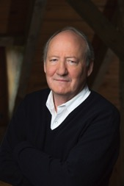
Dayton Duncan, producer and writer
Dayton Duncan is the lead producer and writer of Country Music. He is the author of 13 books and has been involved with the work of Ken Burns for nearly 30 years. For The West, broadcast in 1996, Duncan was the co-writer and consulting producer. It won the Erik Barnouw Award from the Organization of American Historians. He was the writer and producer of Lewis & Clark: The Journey of the Corps of Discovery, broadcast in November 1997. The film attained the second-highest ratings (following The Civil War) in the history of PBS and won a Western Heritage Award from the National Cowboy Hall of Fame, a Spur Award from the Western Writers of America and a CINE Golden Eagle, as well as many other honors. He was the co-writer and producer of Mark Twain, and writer and producer of Horatio’s Drive, about the first transcontinental automobile trip.

The National Parks: America’s Best Idea (2009), which Duncan wrote and produced, won two Emmy Awards – for Outstanding Nonfiction Series and Outstanding Writing for Nonfiction Programming – and earned him and Burns the designation of Honorary Park Ranger from the National Park Service. His most recent film with Burns was The Dust Bowl, a two-part series about the worst man-made ecological disaster in American history, broadcast in November 2012. It won a CINE Golden Eagle and a Western Heritage Award; his script won a Spur Award and was nominated for an Emmy. Duncan has also served as a consultant or consulting producing on all of Burns’s other documentaries, beginning with The Civil War and including Baseball, Jazz and The War.

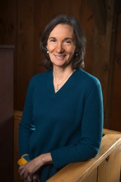
Julie Dunfey, producer
Julie A. Dunfey began her association with Ken Burns and Florentine Films in 1986 as a co-producer of The Civil War and Thomas Hart Benton. Thomas Hart Benton, which was broadcast in 1989, received a Blue Ribbon at the American Film Festival. The Civil War, for which Julie received an Emmy and a Christopher Award, premiered in 1990 and became the highest rated series in PBS history.

Julie returned to Florentine Films in 2006 as a co-producer for The National Parks: America's Best Idea, which was awarded an Emmy for Outstanding Nonfiction Series. Her next production with Ken Burns, The Dust Bowl, premiered on national PBS in November 2012 and was the highest rated show on PBS in five years, attracting over 17 million viewers. It won a CINE Golden Eagle and a Western Heritage Award. With Ken Burns and Dayton Duncan, Julie was nominated in 2013 by the Producers Guild for Outstanding Producer of Long Form-Television.

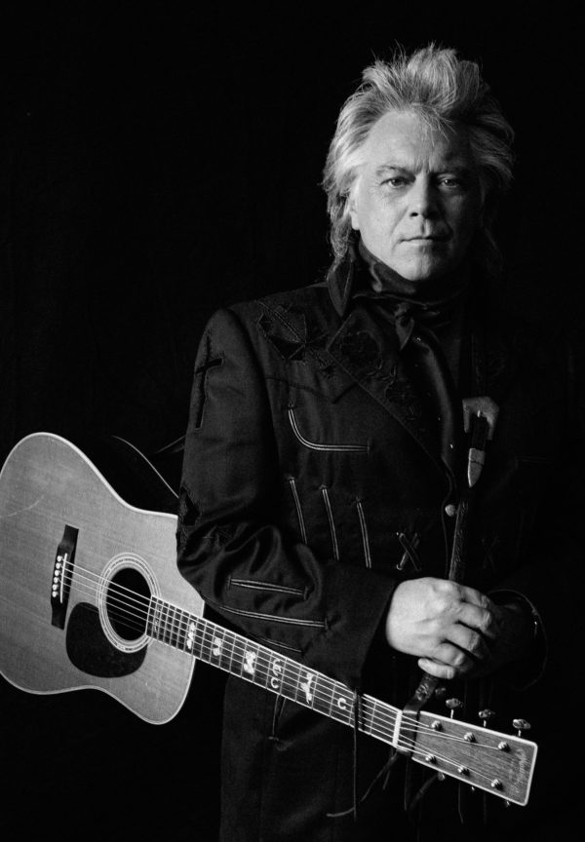
Marty Stuart, featured musician
With legends like George Jones, Johnny Cash and Merle Haggard all passed on, country music purists often echo the question Jones himself asked: “Who’s going to fill their shoes?” The answer, in part, is Marty Stuart.
While he’s too gracious to admit it himself, the Grammy-winning singer, songwriter and musician is living, breathing country music history. He’s played alongside the masters, from Cash to Lester Flatt, who discovered him; been a worldwide ambassador for Nashville, Bakersfield and points in between; and safeguarded country’s most valuable traditions and physical artifacts, including its literal shoes: Stuart counts the brogan of Carter Family patriarch A.P. Carter and an assortment of Cash’s black boots among his vast collection of memorabilia, which will be showcased at the Congress of Country Music in Philadelphia, MS: https://congressofcountrymusic.org.
But most importantly, Stuart continues to record and release keenly relevant music, records that honor country’s rich legacy while advancing it into the future. Way Out West, his 18th studio album, hits both of those marks. Produced by Mike Campbell (of Tom Petty and the Heartbreakers), the album is a cinematic tour-de-force, an exhilarating musical journey through the California desert that solidifies Stuart as a truly visionary artist.

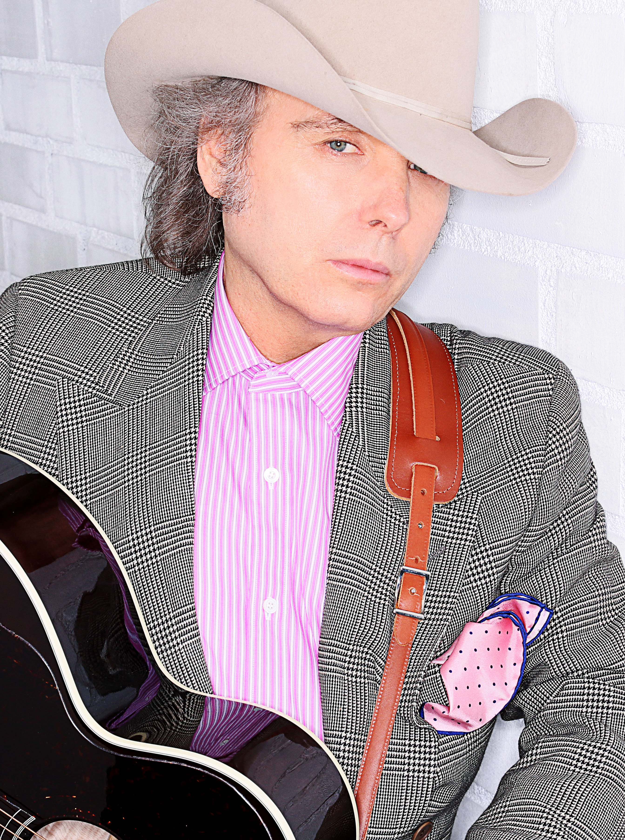
Dwight Yoakam, featured musician
Dwight Yoakam has sold more than 25 million albums worldwide, and he is a 21-time nominated, multiple GRAMMY Award winner. He has 12 gold albums and nine platinum or multi-platinum albums, with five of those albums topping Billboard’s Country Albums chart and another 14 landing in the Top 10. Nearly 40 of Yoakam’s singles have charted on Billboard, with 14 peaking in the Top 10. He is also the recipient of the Artist of the Year award from the Americana Music Association, the most prestigious award offered by the organization.

Yoakam’s self-curated SiriusXM channel, titled Dwight Yoakam and The Bakersfield Beat “Where Country Went Mod,” launched in April of 2018. The channel celebrates the Bakersfield sound and those whom it has inspired.

In 2016, Yoakam released his bluegrass album Swimmin’ Pools, Movie Stars… on Sugar Hill Records. Featuring a band of bluegrass luminaries, this album boasts a collection of reinterpreted favorites from his catalogue, as well as a cover of Prince’s “Purple Rain.” Produced by nine-time GRAMMY winner Gary Paczosa (Alison Krauss, Dolly Parton), Jon Randall (songwriter of “Whiskey Lullaby”) and Yoakam himself, and mixed by Chris Lord-Alge, this album reflects the love for bluegrass music that Yoakam developed at an early age in Kentucky and that has inspired him for many years.

In addition to his musical career, Yoakam is a formidable film and television actor who has appeared in over 40 feature films including Sling Blade and Panic Room. In 2016, he recurred in David E. Kelley’s Amazon series Goliath. Recently, he appeared in director Steven Soderbergh’s film Logan Lucky with Channing Tatum and Daniel Craig. Yoakam is capable of seamlessly melting into his roles and impressively standing toe-to-toe with some of the world’s top thespians over the course of his storied and successful acting career, including Jodie Foster, Tommy Lee Jones, Jared Leto, Forest Whitaker and Matthew McConaughey.

