For Immediate Release contact: Beverly Feldman
September 23, 2019 310.659.9022 (o)
beverly@craftinamerica.org

CRAFT IN AMERICA: QUILTS
New Episode Premieres on PBS Friday, December 27, 2019 at 9pm ET

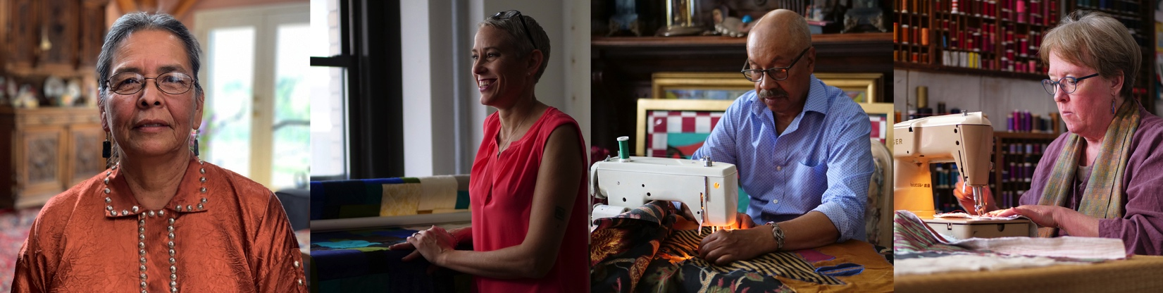

[Los Angeles] – Craft in America, the Peabody Award-winning documentary series discovering the beauty, significance and relevance of handmade objects and the artists who make them, announces QUILTS, premiering on PBS Friday, December 27, 2019 at 9pm ET. For more than a decade, Craft in America has taken viewers on cultural journeys across this nation, honoring the multiplicity of traditions that have come to define our country.

Craft in America: QUILTS looks at how quilts carry meaning, are rich with history, emotion, memories and beauty. They tell stories that would otherwise not be told, each one as unique as their maker.

We begin at the International Quilt Museum in Lincoln, Nebraska and meet Carolyn Ducey, Curator of Collections and Executive Director Leslie C. Levy, who introduce us to the world’s largest publicly held collection of approximately 6,000 quilts from more than 50 countries, dating from the 1600s to today. They serve as our touchstone through the episode. “Quilts are the textile pages of our shared history,” states Levy.

We turn to historian and storyteller, Ken Burns, an avid quilt collector who affirms quilts to be the “simplest and most authentic expression of who we are as a people.” 28 quilts from Burns’ American quilt collection were recently exhibited at the International Quilt Museum. “This is what human beings are required to do, to take raw materials and transform them into something greater than the sum of their parts. And that’s what a quilt is, that’s what art is.”

In Sheep Springs, NM, we meet Susan Hudson, a Navajo/Diné artist, taught to sew by her mother who was forced to sew at an “assimilation” boarding school. Hudson’s pictorial quilts honor her ancestors using a crossover style inspired by ledger art. Recounting the history of her people from a Navajo perspective through her quilts has made Hudson an activist storyteller chronicling pain and hardship endured by her ancestors.

New York-based international award-winning quilter, fabric designer, teacher, author and lecturer, Victoria Findlay Wolfe has a fine art degree in painting but found her life’s passion in quilt making. She is known for making quilts that look difficult to make, then teaching quilters to make them. Every new quilt Findlay Wolfe makes pushes boundaries, supporting her premise that creativity requires risk.

Nearby in the historic Sugar Hill neighborhood of Harlem, Michael A. Cummings, a nationally recognized narrative quilter, lives and works. Self-taught, Cummings brought years of painting and collage skills to his quilt making. Inspired by jazz and the African American experience, Cummings uses his sewing machine to tell stories across historical, cultural, philosophical and mythical realms.

Across the continent, Judith Content uses inspiration from nature and a Japanese resist dye technique, arashi shibori, to create glorious freeform wall quilts in her Palo Alto, CA studio. She dyes then composes fabric into an abstract kimono form and uses her sewing machine as a drawing tool to achieve an evanescent visual haiku that communicates both emotionally and intellectually. These Art Quilts, made to be viewed on walls rather than placed on beds, expand both the definition of the quilt and its place in the art world.

There is a great deal more to share with viewers and the Craft in America websites craftinamerica.org and pbs.org/craftinamerica will be the portal for that expanded journey. There will be additional video clips as well as resources, information about quilt guilds nationwide, lists of exhibitions and shows, interviews with quilters, an education guide for K-12 students, quilting projects and of course, a virtual gallery of quilts.
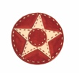
Major funding for Craft in America: QUILTS was provided by Cynthia Lovelace Sears, Lillian Pierson Lovelace, L.L. Brownrigg, Helen & Peter Bing, the National Endowment for the Arts, and the Coral Courts Donor Advised Fund.
####

CRAFT IN AMERICA is a 501(c)(3) non-profit organization dedicated to advancing original handcrafted work through the Peabody Award-winning documentary series on PBS nationwide and the free-to-the-public Craft in America Center in Los Angeles. With twenty-one episodes produced since 2007, CRAFT INAMERICA takes viewers on a journey to the artists, origins and techniques of American craft. Each episode contains stories from diverse regions and cultures, blending history with living practice and exploring issues of identity, ritual, philosophy and creative expression. Our websites craftinamerica.org and pbs.org/craftinamerica provide all episodes, hundreds of online videos and interactive learning materials, as well as object exhibitions, artist information, and the Random House book Craft in America: Celebrating Two Centuries of Artists and Objects and other Craft in America publications.

The Craft in America Center is an exhibition and learning space in Los Angeles. We give voice to traditional and contemporary craft through artist talks, workshops, exhibits and concerts. Our reference library contains over one thousand books and videos and is free to the public. We invite you to stop in and to join us for upcoming events and exhibitions – 8415 W. Third St., Los Angeles, CA 90048.

To view the Artist Bios: www.craftinamerica.org/release/quilts-artist-bios

For more about Craft in America:
craftinamerica.org pbs.org/craftinamerica facebook.com/craftinamerica
youtube.com/craftinamerica instagram.com/craftinamerica twitter.com/CraftinAmerica

Please contact for art and interviews: (310) 659-9022
Carol Sauvion, Executive Producer: carolsauvion@craftinamerica.org
Beverly Feldman, Press: beverly@craftinamerica.org

QUILTS Press images: www.dropbox.com/sh/hi3owo0amvwbfei/AAD2LKGNgwmDQI2Tp3wG-wNna?dl=0

