For Immediate Release contact: Beverly Feldman
September 23, 2019 310.659.9022 (o)
beverly@craftinamerica.org

CRAFT IN AMERICA: IDENTITY
New Episode Premieres on PBS Friday, December 27, 2019 at 10pm ET

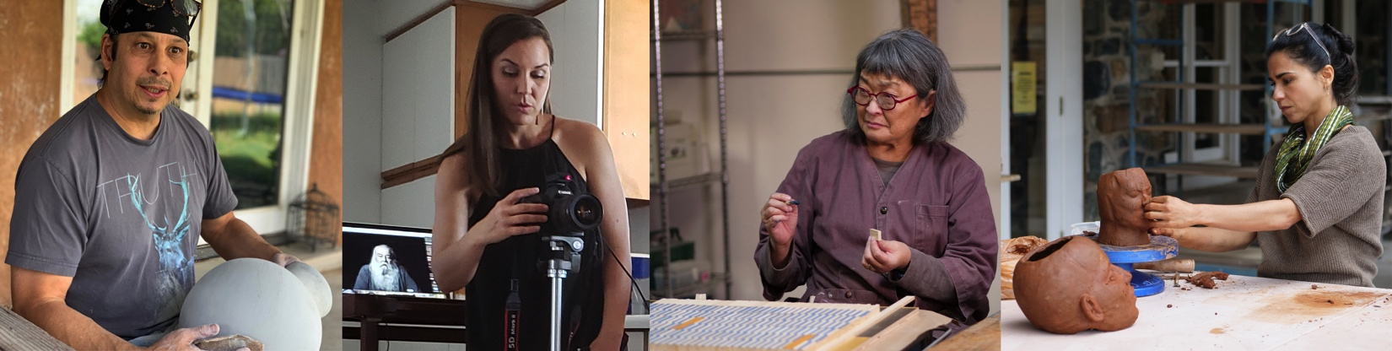

[Los Angeles] – Craft in America, the Peabody Award-winning documentary series discovering the beauty, significance and relevance of handmade objects and the artists who make them, announces IDENTITY premiering on PBS Friday, December 27, 2019 at 10pm ET. For more than a decade, Craft in America has taken viewers on cultural journeys across this nation, honoring the multiplicity of traditions that have come to define our country.

How do we define ourselves, what combination of work, ethnicity, nationality, family and heritage, go into the sum of who we are? Craft in America: IDENTITY explores how artists challenge accepted norms of gender, race, culture and place, offering truer expressions of their experience in this world.

We are introduced to Diego Romero, a potter living and working in Santa Fe, NM, a member of the Cochiti Pueblo tribe. “I am an Indian. I am a white man, too. Am I this white kid who grew up in Berkeley or am I this Johnny-come-lately, back-to-the-village, born again Indian? I think I’m neither and I’m both,” says Diego Romero. He makes art that transcends his Native American heritage by combining traditional materials, techniques and forms of ancient Mimbres, Anasazi and Greek pottery with comic book inspired imagery, to talk about contemporary issues. Romero is a self-proclaimed “chronologist on the absurdity of human nature,” whose comic narratives venture into taboo areas of politics, environment, racism, alcoholism, love, life, and loss. His trademark Chongo Brothers characters connect his work to Pop Art, inviting the viewer to look at Native Indian pottery in a new way. His work is in the collection of the British Museum among other world-class museums, and he is married to photographer Cara Romero.

Contemporary photographer Cara Romero, a member of the Chemehuevi Indian Tribe of the Chemehuevi Reservation (a branch of the Southern Paiute) of the Mojave Desert, CA, is outspoken on indigenous cultural and environmental issues. “Growing up on the reservation rests at the heart of who you are as a human being, it informs everything that you are, going forward in life,” says Cara Romero. Her complex and nuanced images combine traditional iconography with a contemporary perspective, bringing past, present and future into consideration. The artist orchestrates a balancing act in her photography by rewriting stories of Indian identity, battling cultural misappropriation, and confronting stereotypes, particularly of Native women, all the while preserving tradition and maintaining cultural sensitivity.

Delving into matters of ethnicity, gender and world issues in her studio in San Diego, CA, we meet Wendy Maruyama, furniture maker and educator. Born an American of Japanese heritage, Maruyama nurtures her artistic talent as a highly accomplished woodworker and furniture designer in a field dominated by men, and in the process, surmounts challenges related to her deafness and disability. “I realized… my being deaf was probably the first identity that I consciously was aware of…. then of course, being Japanese American, and then there was the issue of being a female in a male dominated field, so it’s a pretty unique identity,” says Wendy Maruyama.

Wendy speaks passionately about her work, including a recent series titled wildLIFE Project, inspired by the wrongful slaughter of African elephants and rhinoceroses, and The Tag Project, a 2012 commemorative installation memorializing the forcible relocation of 120,000 ethnic Japanese to internment camps during World War II. Historian Delphine Hirasuna elaborates. As a survival tactic, these American citizens, imprisoned in remote camps surrounded by barbed wire and machine gun wielding soldiers, turned to making art as a means of sustaining life, redefining themselves, and finding beauty in a place where others would never find it. It was their way to “gaman”, to bear the seemingly unbearable with patience and dignity.

We next travel to the green mountains of North Carolina where Cristina Córdova, sculptor, lives and works at Penland, far from her birthplace, Puerto Rico. “Puerto Rican identity is at the core of everything that I depart from to understand the world,” says Cristina Córdova. Her deeply affecting figurative clay work is rooted in renaissance sculptural traditions. Each piece represents a shared humanity while confronting contemporary issues of gender, race, beauty and power, and inviting the viewer’s participation.

Through the work of all the artists profiled, Craft in America: IDENTITIY explores how heritage and cultural identity contribute to the richness of America’s cultural landscape. The lives and work of the artists in IDENTITY personify the diversity of this country and how each unique tradition magnifies and illuminates a shared American experience.

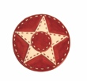
Major funding for Craft in America: QUILTS was provided by Cynthia Lovelace Sears, Lillian Pierson Lovelace, L.L. Brownrigg, the National Endowment for the Arts, and Coral Courts Donor Advised Fund.
####

CRAFT IN AMERICA is a 501(c)(3) non-profit organization dedicated to advancing original handcrafted work through the Peabody Award-winning documentary series on PBS nationwide and the free-to-the-public Craft in America Center in Los Angeles. With twenty-one episodes produced since 2007, CRAFT INAMERICA takes viewers on a journey to the artists, origins and techniques of American craft. Each episode contains stories from diverse regions and cultures, blending history with living practice and exploring issues of identity, ritual, philosophy and creative expression. Our websites craftinamerica.org and pbs.org/craftinamerica provide all episodes, hundreds of online videos and interactive learning materials, as well as object exhibitions, artist information, and the Random House book Craft in America: Celebrating Two Centuries of Artists and Objects and other Craft in America publications.

The Craft in America Center is an exhibition and learning space in Los Angeles. We give voice to traditional and contemporary craft through artist talks, workshops, exhibits and concerts. Our reference library contains over one thousand books and videos and is free to the public. We invite you to stop in and to join us for upcoming events and exhibitions – 8415 W. Third St., Los Angeles, CA 90048.

To view the Artist Bios: www.craftinamerica.org/release/identity-artist-bios

For more about Craft in America:
craftinamerica.org pbs.org/craftinamerica facebook.com/craftinamerica
youtube.com/craftinamerica instagram.com/craftinamerica twitter.com/CraftinAmerica

Please contact for art and interviews: (310) 659-9022
Carol Sauvion, Executive Producer: carolsauvion@craftinamerica.org
Beverly Feldman, Press: beverly@craftinamerica.org

IDENTITY Press images: www.dropbox.com/sh/6c4uur8isq84v5x/AAD8SnayBn3lxKXSYbv00t86a?dl=0

