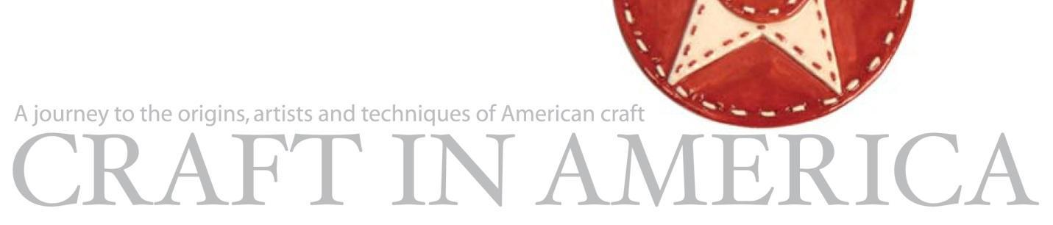
FOR IMMEDIATE RELEASE CONTACT: Beverly Feldman
DATE: June 7, 2016 beverly@craftinamerica.org
CRAFT IN AMERICA: TEACHERS
Season 8 Episode 1
Premieres on PBS Thursday, September 15 at 8:00pm*

[Los Angeles] - Craft in America, the Peabody Award-winning series, begins its eighth season on PBS with a unique hour that celebrates TEACHERS -- renowned individuals who are committed to their own artistic visions and are equally committed to sharing their skills and passion for craft with new generations of students and artists of all ages. As part of PBS’ Spotlight Education programming, Craft in America: TEACHERS premieres on Thursday, September 15th at 8pm*. *(check local listings)

Craft in America: TEACHERS takes an inclusive approach to education and craft, emphasizing that it is never too early – or too late – to acquire skills and appreciation for craft. The education covered in this episode starts with kindergarten exploration and discovery; goes through high school and university where the curriculum becomes simultaneously more liberating and challenging; and develops into the curiosity and enthusiasm of lifelong learning.

These artists/teachers are a special breed. By day they are found in classrooms and workshops ensuring that their hard-earned wisdom and practical skills are passed on. Across the country these craft artists are dedicated to education – inspiring, evaluating, critiquing and praising their students’ achievements.
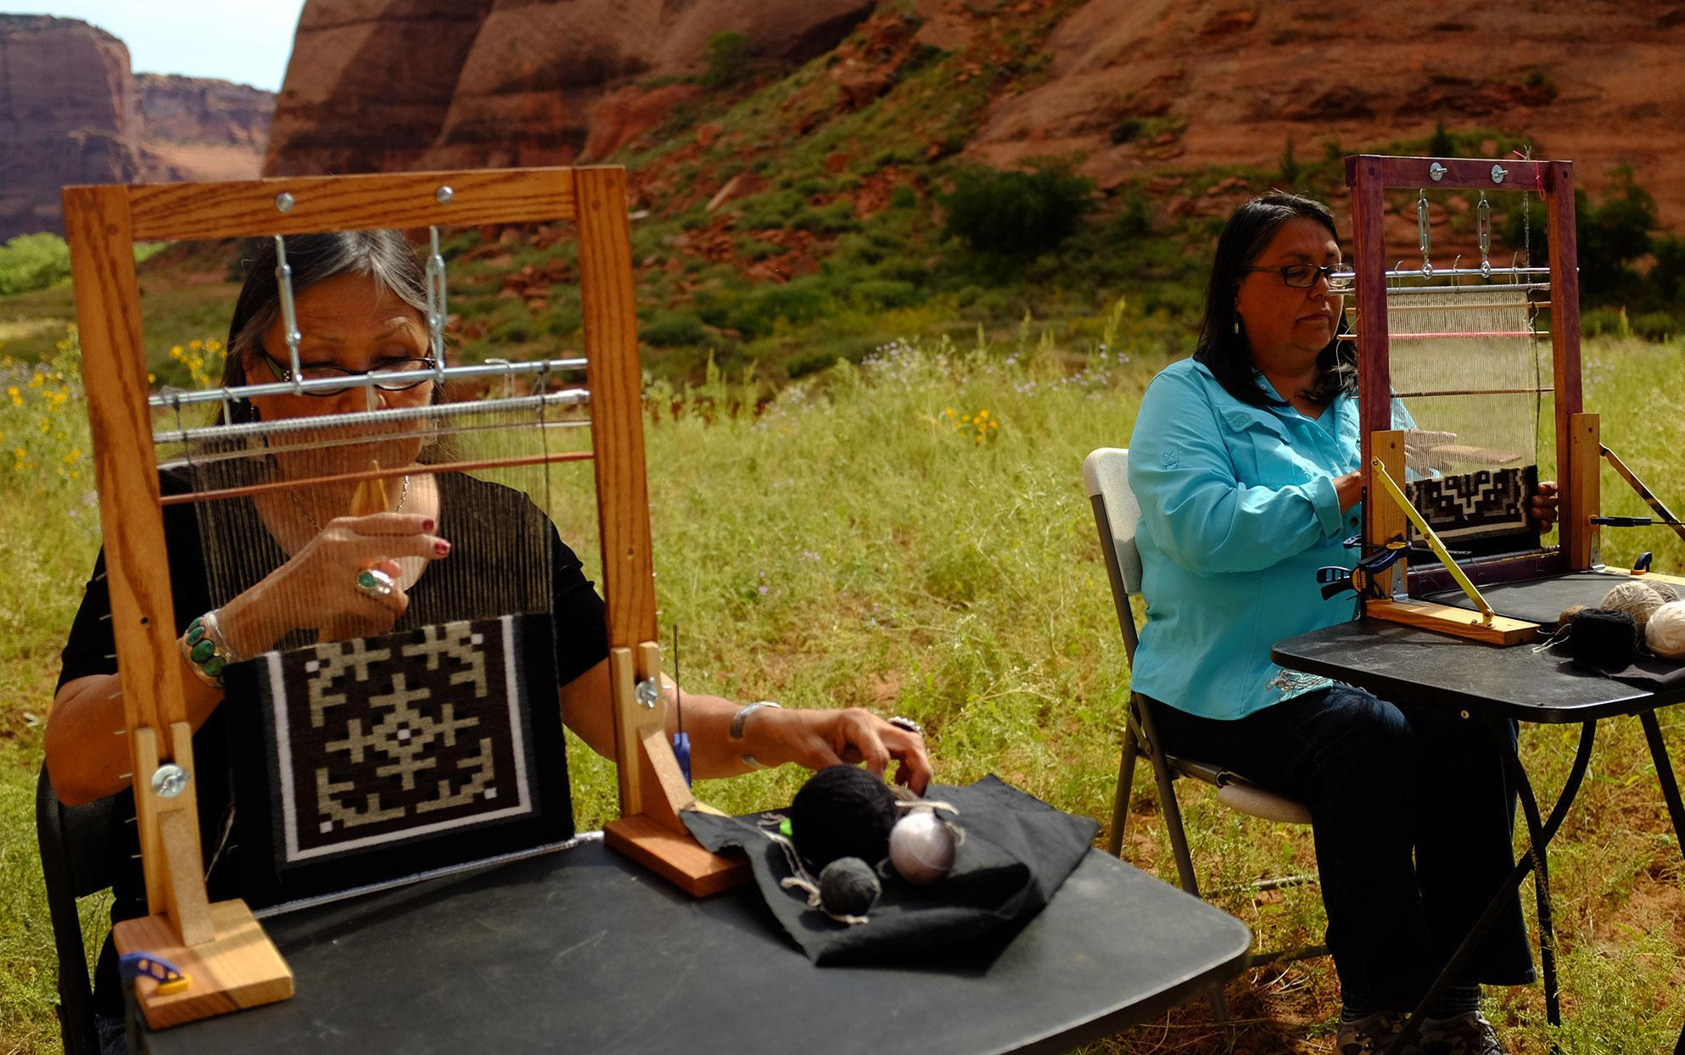
Our hour begins with the artistry of Navajo weavers Barbara Teller Ornelas and her sister Lynda Teller Pete, both of whom learned the craft of weaving the time-honored way – through family. Often this method of teaching begins with observation, when skills are absorbed. This legacy of learning is essential to Navajo weavers. The Teller sisters spent summers with their grandparents in Canyon de Chelly, New Mexico, ancestral home of the Navajo people, in an environment where weaving “is a way of life.” In early childhood they were introduced to weaving by their mother, Ruth Teller, who instilled the belief that beauty and harmony should be woven into every rug. We film as they teach outdoors amidst the extraordinary natural beauty of the Canyon. They recount the story of Spider Woman who, as ancient legend has it, taught the Navajos to weave. Our cameras then move with them to the Idyllwild Arts Native American Arts Program, where in the summer, they teach the practice of Navajo weaving atop a mountain overlooking Palm Springs, California.
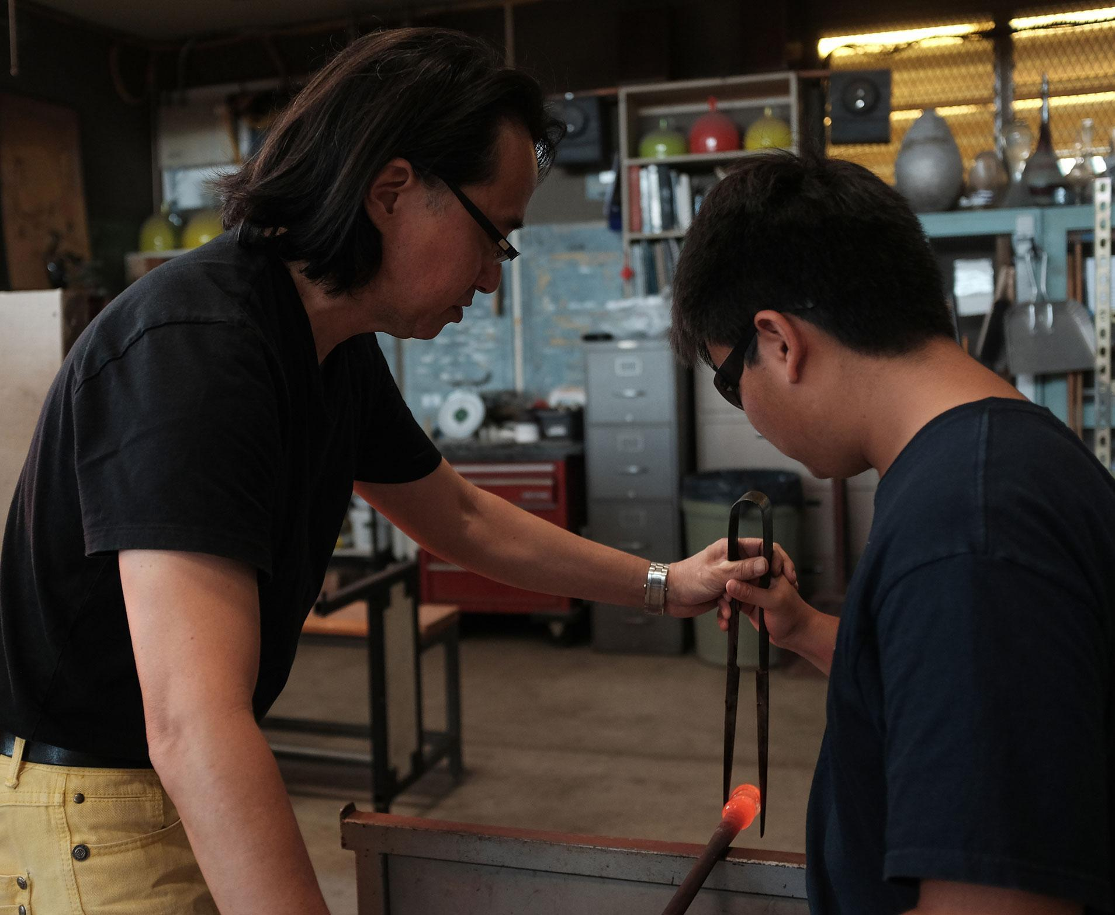
We travel to Honolulu, Hawaii where artist Mark Mitsuda introduces professional glass forming techniques to his students at Punahou School. In 1972, his mentor Hugh Jenkins started the high school glass program at Punahou, using recycled milk and mayonnaise bottles as raw materials. Mitsuda took charge of the program after Jenkins’ retirement in 1998. Since its inception, participation in the program has doubled. Underscoring the inter-generational mission of teaching, Mitsuda says that what he learned from Jenkins, he now passes on to his own students. “I feel fortunate to be teaching something that I feel passionate about and being able to inspire other people in the place that inspired me to first go into glassblowing.” Mitsuda’s early work was a balance between conceptual and functional, slowly he was drawn back to making objects of utility which he finds in his teaching especially, carry tremendous meaning for the student in the process of learning.

Craft in America: TEACHERS (cont.)
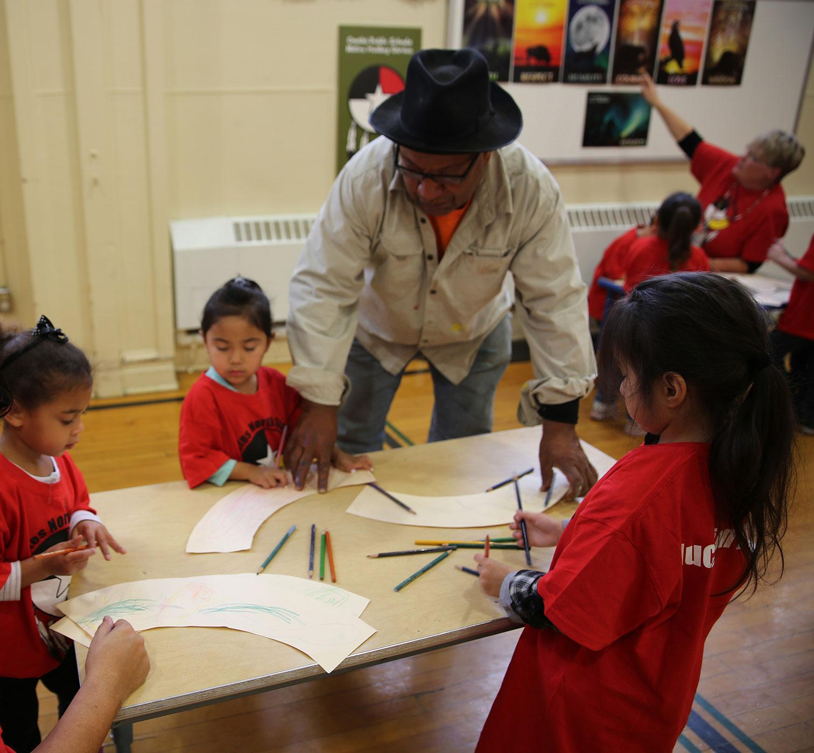
We next travel to Omaha, Nebraska, where Therman Statom, a major figure of the Studio Glass Movement, decided to start programs for underserved inner city students and at-risk youth. He states, “I think teaching is the highest form of advocacy in terms of influencing the world or having the chance to be a part of something that you can change.” Our cameras capture Therman at work in his studio and the excitement of his class at the Hot Shops Art Center, witnessing how art and glass blowing inspires youth.

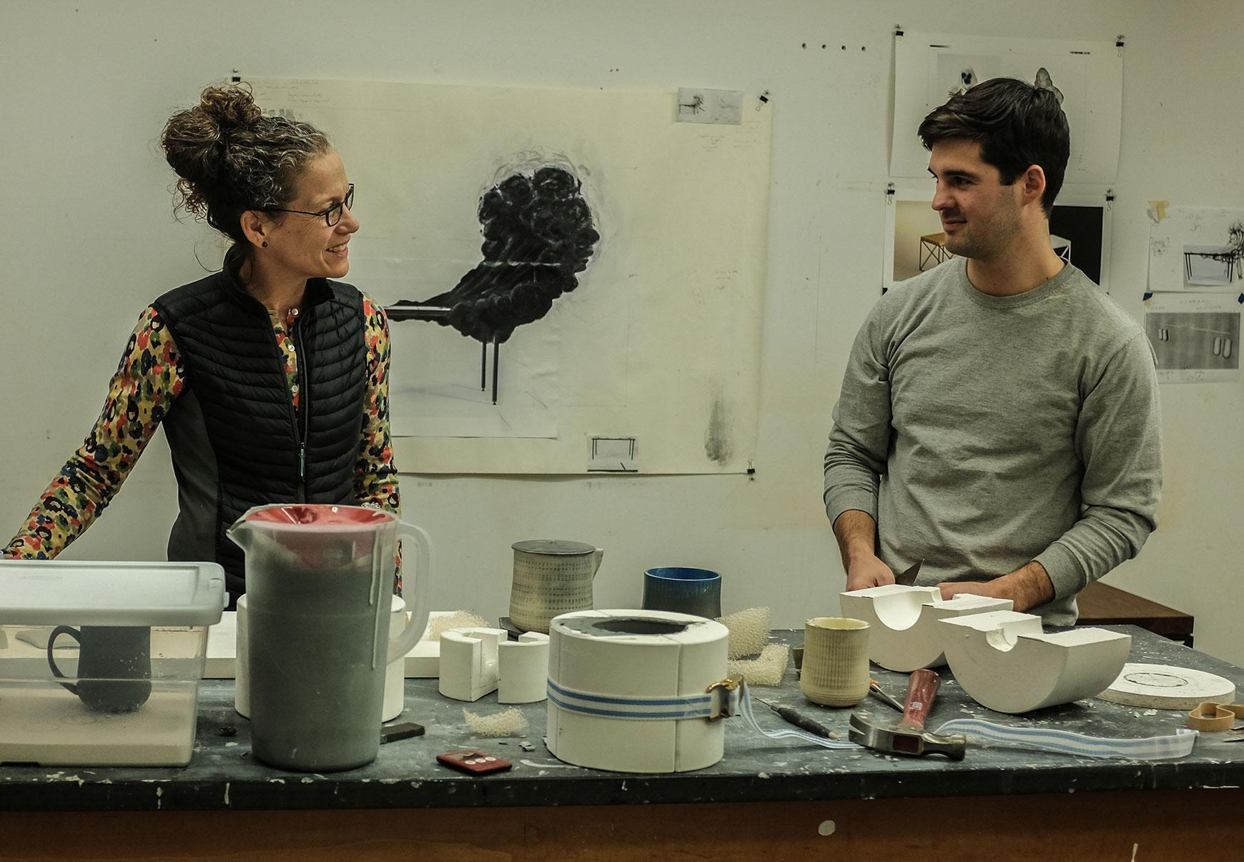
Alfred, New York is home to Alfred University, School of Art and Design. Here, Mark Mitsuda and so many other artists have honed their craft and earned degrees that allow them to become accredited teachers. The College of Ceramics includes a graduate program where conceptual thinking elevates the approach to clay. Professor Linda Sikora describes the program: “We teach many disciplines alongside what might be more strictly categorized as craft. This is deliberate and allows our students to become broad thinking in terms of visual and material culture regardless of how they specialize. It is also, I believe, what keeps our program vital and contemporary.”

Carol Sauvion, Executive Producer/ Director states: “Teachers in the crafts are gifted artists as well as educators. They share their skills and inspire us to create. In the TEACHERS episode, we explore the many unique ways a craft can be taught. We also learn how important teaching is.”

#####

CRAFT IN AMERICA is a non-profit organization dedicated to advancing original handcrafted work through the Peabody Award-winning documentary series on PBS nationwide and the free-to-the-public Craft in America Center located in Los Angeles, which offers artist talks, exhibitions, workshops and a library. With sixteen episodes produced since 2007, CRAFT IN AMERICA takes viewers on a journey to the artists, origins and techniques of American craft. Each episode contains stories from diverse regions and cultures, blending history with living practice and exploring issues of identity, ritual, philosophy and creative expression. Ancillary projects include extensive websites providing hours of online videos and interactive learning materials, as well as museum exhibitions, and the Random House book Craft in America: Celebrating Two Centuries of Artists and Objects.

For more about Craft in America:
Craftinamerica.org
pbs.org/craftinamerica
facebook.com/craftinamerica
youtube.com/craftinamerica
instagram.com/craftinamerica
twitter.com/CraftinAmerica

Photos courtesy of Mark Markley & Denise Kang.

Please contact for art and interviews: (310) 659-9022
Carol Sauvion, Executive Producer: carolsauvion@craftinamerica.org
Beverly Feldman, Press: beverly@craftinamerica.org

Additional images of all the artists’ work are available at:
- PBS Pressroom: http://pressroom.pbs.org/Programs/c/CRAFT-IN-AMERICA/801-Teachers.aspx
(Under the Photos tab, click on the download button next to each photo. Sign in/registration is required.)
- Dropbox (52 MB): https://dl.dropboxusercontent.com/u/21500868/TEACHERSpress.zip

