FOR IMMEDIATE RELEASE CONTACT: Beverly Feldman
DATE: July 19, 2016 beverly@craftinamerica.org

CRAFT IN AMERICA: NATURE
Premieres on PBS Friday, April 21, 2017, Earth Day Weekend
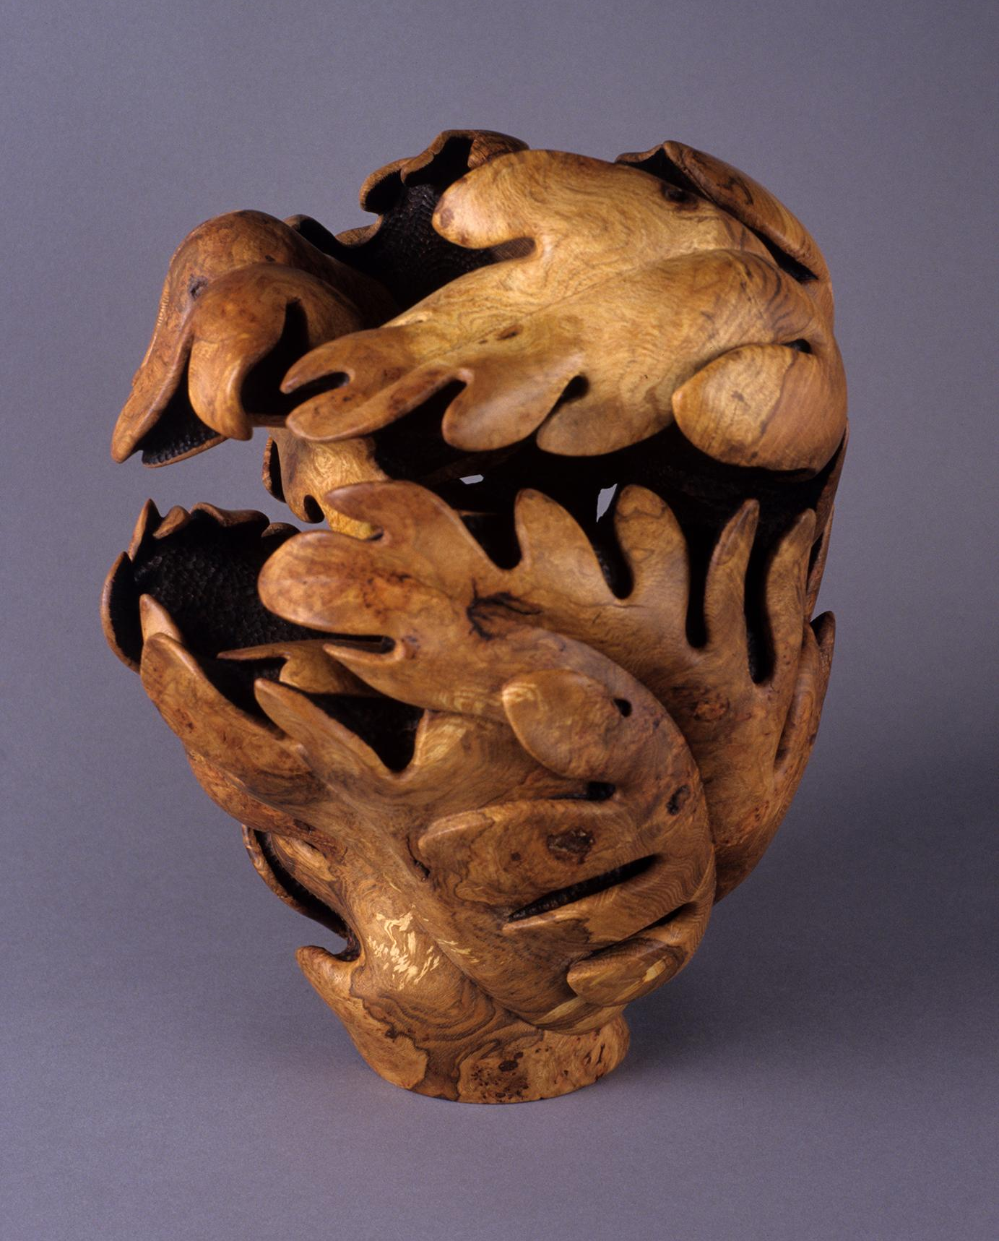
[Los Angeles] - Craft in America, the Peabody Award-winning series, continues its eighth season on PBS with NATURE, celebrating the beauty, inspiration, and future of the American landscape. Craft in America: NATURE airs on PBS, Friday, April 21, 2017 at 10pm. (*check local listings) To watch a 1-minute preview: https://youtu.be/3V5pX750jF4

Working with wood, glass and fiber as well as new materials, the artists profiled in NATURE challenge viewers to reassess their relationship to the natural world. Throughout history, the colors, textures, shapes, as well as scents and tastes of the physical world have inspired artists to produce works of astonishing dimension and power.

By emphasizing the profound connection between art and society, NATURE continues a hallmark of Craft in America: positioning artists as participants in larger global concerns while at the same time honoring them as pure visionaries. The women and men profiled in this hour are first and foremost artists, but in their direct inspirations from the environment, they are part of the important on-going conversation about the future of this planet.
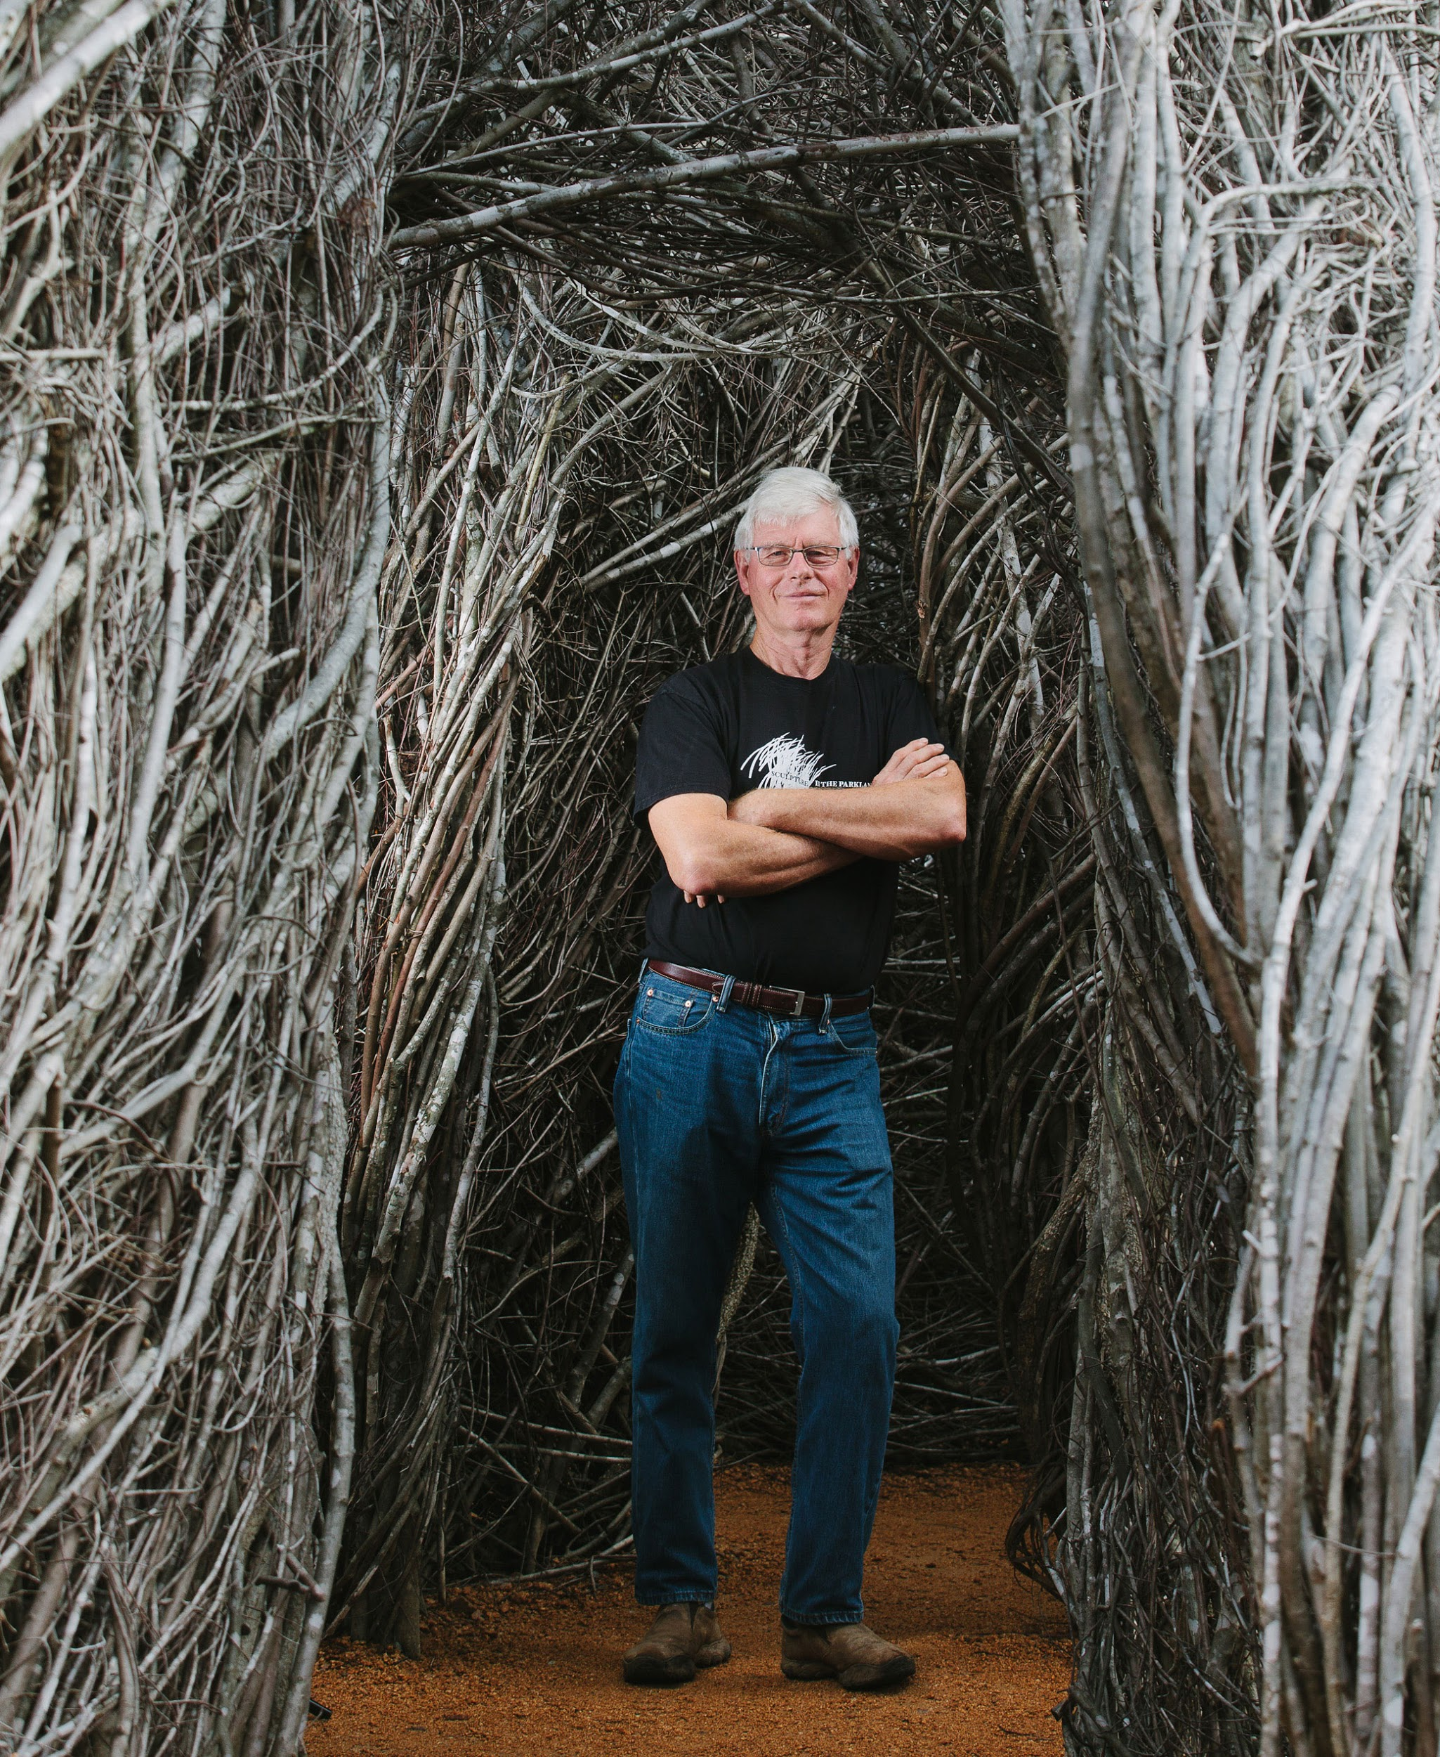
The hour begins in Hillsborough, North Carolina, where Patrick Dougherty, an internationally acclaimed sculptor, makes his home. Throughout his career, he has been committed to environmental issues with a focus on the ways in which art touches and involves the community. His whirling, enchanting architectural “stickworks” are created from saplings, twigs, and branches that are left outdoors to be reclaimed and recycled by nature. “I say of my work that I make large scale temporary sculptures from materials gathered in the nearby landscape.” Like a barn-raising, he invites, relies on and values the many volunteers who assist in harvesting the saplings and building each site-specific piece. His creations stimulate the imagination and invite people to explore. They are meant to be experienced from the interior as well as the exterior by people of all ages. Chief Curator of the Smithsonian American Art Museum, Renwick Gallery (Washington DC) Nicholas Bell, takes us on a walkthrough of Shindig, Dougherty’s installation for the Renwick’s recent re-opening exhibition WONDER.
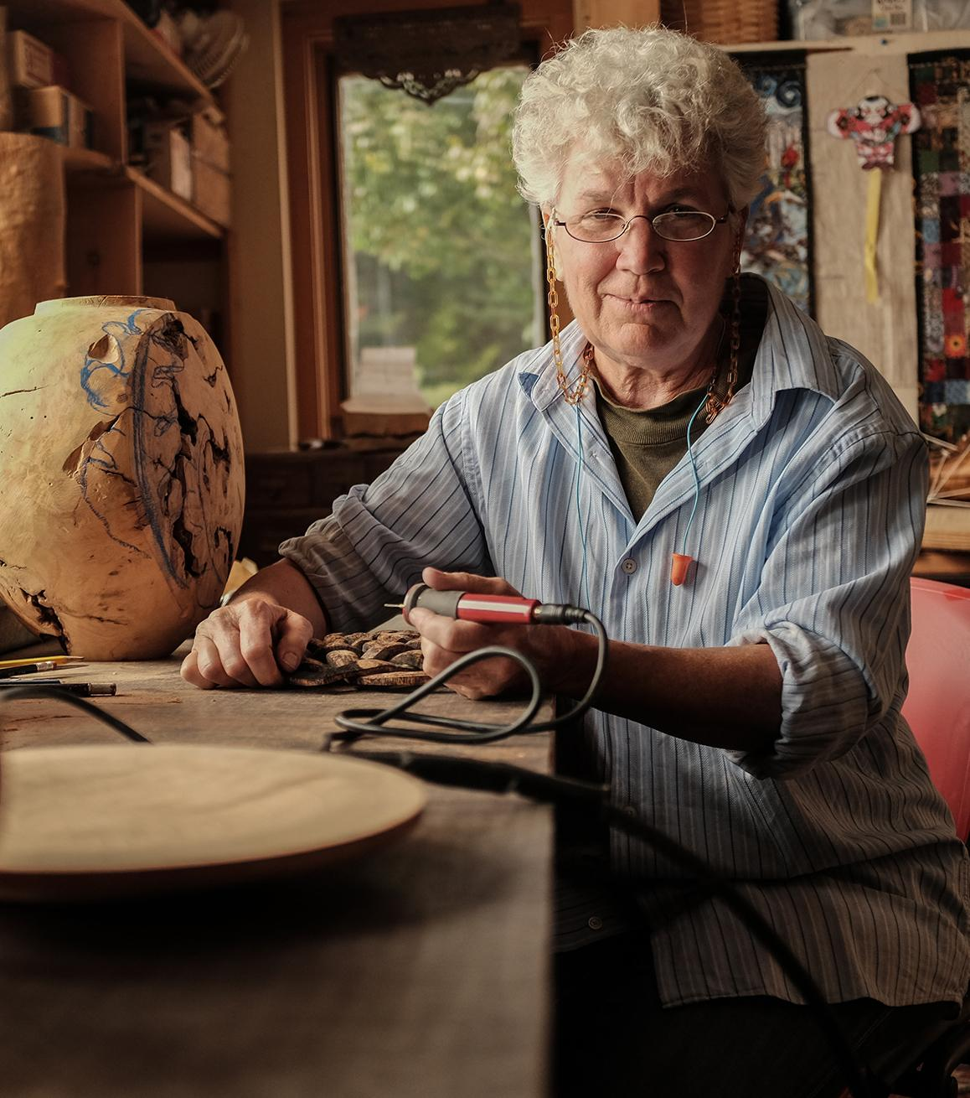
Rural Vermont is the homestead of Michelle Holzapfel and her husband, David. Wood is Michelle’s medium and she uses New England’s hardwoods and burls – maple, cherry, ash and butternut – as a way of honoring Mother Nature at her finest. The natural world around her inspires her creations - vessels, bowls, boxes, vases, and fanciful, unusual trompe l’oeil pieces which have brought her international recognition. She explains “I have a very strong feeling for basically everything that grows, but I’m most in awe of trees. I refer to them as the quintessential material. Well, it’s wood, to begin with, they contain fire, they transpire air, they transform water into water vapor and they’re rooted in the earth, so they really embody the five elements. And I think that’s why I find them so endlessly inspiring”.
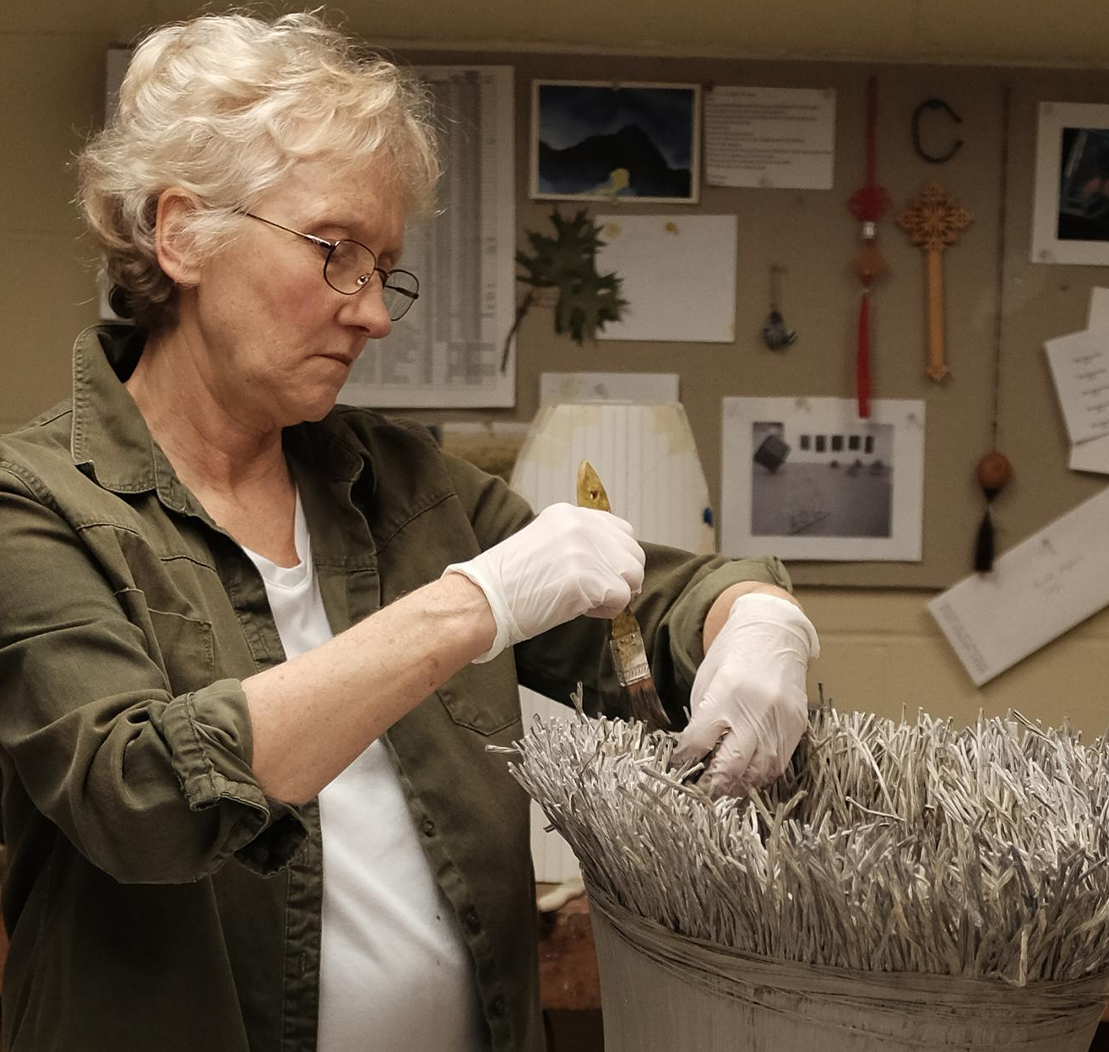
Mary Merkel-Hess makes her home in the tallgrass prairie of Iowa which she says, “speaks to me in a very deep way”. She is an Iowa-born artist who fashions basket-like forms inspired from the spare natural beauty of her beloved Midwest, forms that reference the abundance and bounty in nature and life. But she is not a basket maker, rather a sculptor working in paper, reed and paint to create “Landscape Reports”, fiber vessels that impart to the viewer a sense of place and containment. “One of the things I try to do in my work is to translate my experience of this environment for other people to enjoy and understand.” The source of her creativity, the Iowa landscape, is dominated by vast billowing fields of grass and corn. She says, “We almost entirely lost the prairie environment, and now with great struggle, we’re trying to bring it back… I think the prairie helps underpin everything that I make. And I like living here.”
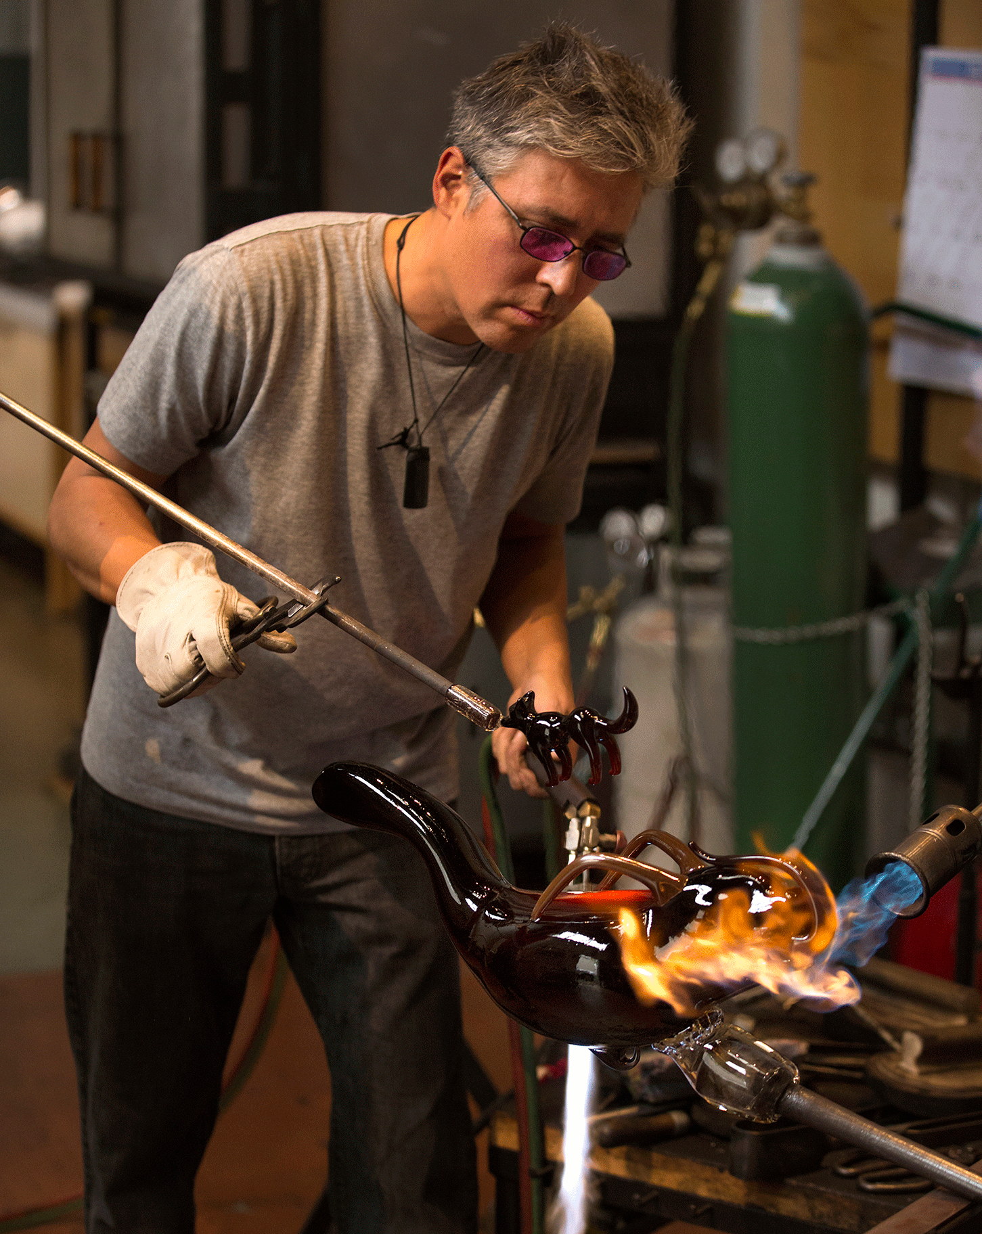
Native American glass artist of Tlingit heritage, Preston Singletary is surrounded by the wild natural beauty of the Pacific Northwest Coast. He is internationally recognized for his exceptional technique which captures the motion and magnificence of wild creatures in molten glass, then embellishes the cooled and hardened sculptures with symbols and designs from Tlingit culture. He is a pioneer, one of only a handful of Native American artists working in glass today. He explains as he works in his Seattle, WA studio, “When I began working with glass, I had no idea that I’d be so connected to the material in the way that I am. It was only when I began to experiment with using designs from the Tlingit cultural heritage that my work took on a new purpose and direction.” We capture him creating his newest body of work, “Raven and the Box of Daylight” the Tlingit creation myth in which the raven brought the sun, moon and stars to the world.
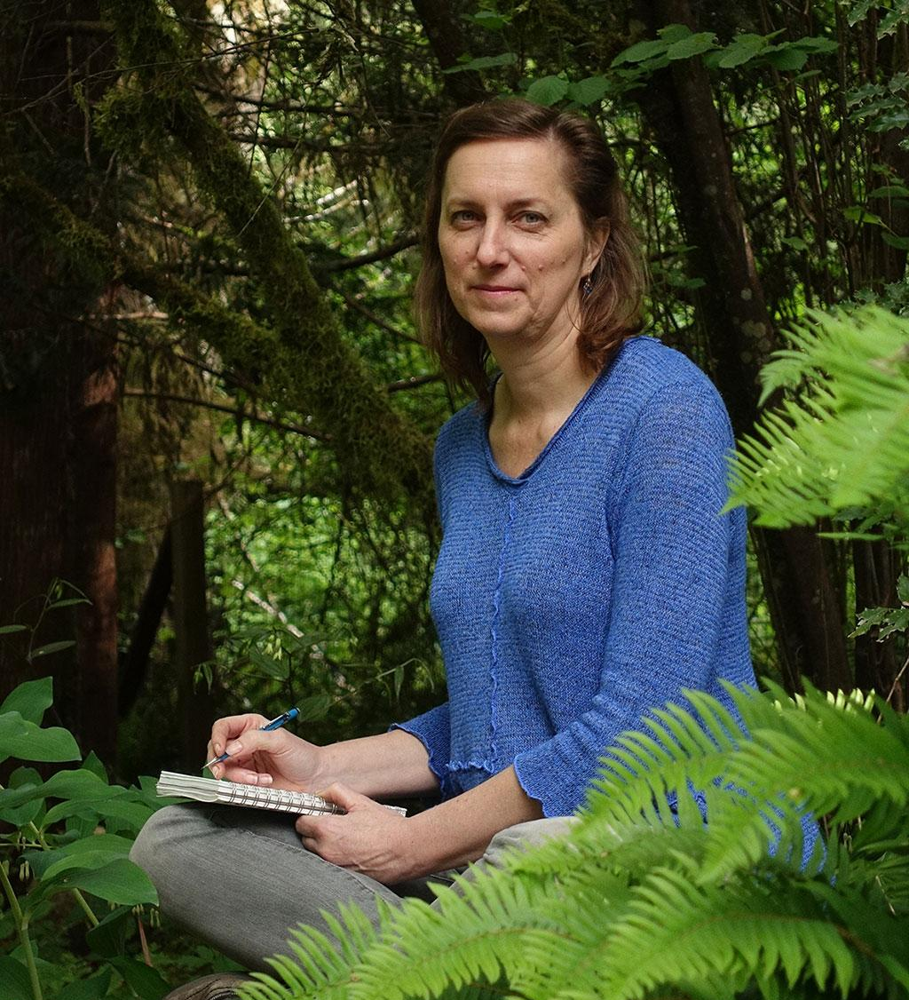
In Shelton, WA, Catherine Alice Michaelis designs books that reflect her relationship with what she calls “Mother Earth, my mystical companion”. Often her books start with original poems which are printed on a vintage letterpress printer on paper that she has already “pressure printed” with flowers and leaves. These unique books created through her own May Day Press are tactile, elegant, thoughtful, sensual and entirely handmade from the growing of the plants and flowers used in the paper design, to the printing of the images and text, to the hand-folding of the pages, to the sewing of the spine. Each book is a new vision of nature as seen through her eyes, an imaginatively designed, remarkable folded paper sculpture.

#####

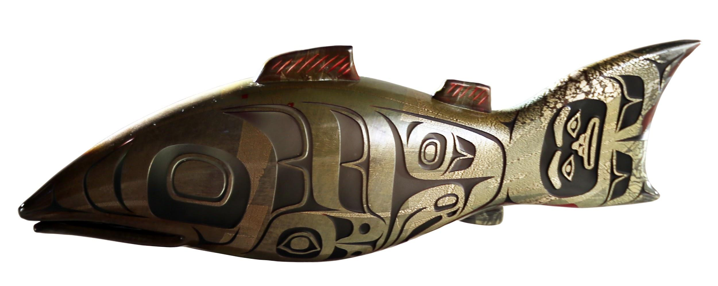
CRAFT IN AMERICA is a non-profit organization dedicated to advancing original handcrafted work through the Peabody Award-winning documentary series on PBS nationwide and the free-to-the-public Craft in America Center located in Los Angeles, which offers artist talks, exhibitions, workshops and a library. With seventeen episodes produced since 2007, CRAFT IN AMERICA takes viewers on a journey to the artists, origins and techniques of American craft. Each episode contains stories from diverse regions and cultures, blending history with living practice and exploring issues of identity, ritual, philosophy and creative expression. Our websites craftinamerica.org and pbs.org/craftinamerica provide all episodes, hours of online videos and interactive learning materials, as well as object exhibitions, artist information, and the Random House book Craft in America: Celebrating Two Centuries of Artists and Objects and other Craft in America publications.
Nature: Highlights from the Episode gathers together the work of the artists who are featured in the episode. These artists explore the beauty and wonder of the natural world. This exhibition opens March 18, 2017 and runs until May 13, 2017 at the Craft in America Center (8415 W. Third St. Los Angeles, CA 90048).

For more about Craft in America:
craftinamerica.org pbs.org/craftinamerica youtube.com/craftinamerica facebook.com/craftinamerica instagram.com/craftinamerica twitter.com/CraftinAmerica

*check local listings
Photos courtesy of Mark Markley, Michelle Holzapfel, Brianna Brough/Chapel Hill Magazine, Russell Johnson

Please contact for art and interviews: (310) 659-9022
Carol Sauvion, Executive Producer: carolsauvion@craftinamerica.org
Beverly Feldman, Press: beverly@craftinamerica.org

Additional images of all the artists’ work are available on Dropbox (74 MB): https://dl.dropboxusercontent.com/u/21500868/NATUREpress.zip

To view the Artist Bios: www.craftinamerica.org/press/craftinamerica-nature-artistbios
To preview the episode: https://youtu.be/bCi8C_8QihY (Broadcast version, not for distribution)

