RISING STARS AND CURRENT MASTERS
FEATURED IN SEASON 5 OF
DAVID HOLT’S STATE OF MUSIC
Series Explores Rich Musical Legacy of the Southeast
New Season to Air on PBS starting May 1, 2021 (Check local listings)

April 2, 2021 – In the fifth season of the PBS series David Holt’s State of Music, host David Holt shares tunes and stories with outstanding performers of American folk, bluegrass, and country music. The season comprises six 30-minute episodes and will be fed via satellite to PBS member stations beginning May 1. Check local listings for air dates.

Filmed entirely on location in North Carolina and Tennessee, David Holt's State of Music features music and interviews with emerging young performers as well as veteran masters.

A four-time Grammy winner himself, David Holt toured with the late Doc Watson for fourteen years. He says “The traditional music of this region is a treasure we’re privileged to share. Whether it’s bluegrass, gospel, a string band, or the blues, the artists we feature are performing at the very highest level. Some are young; some are older but deserve greater recognition. We help raise awareness of these artists by presenting them to the PBS audience nationwide.”

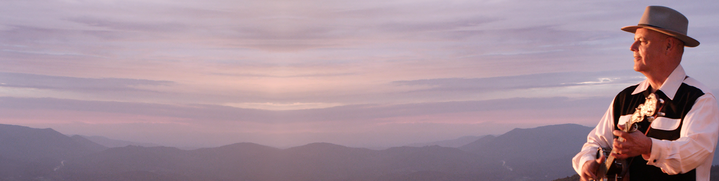


The series showcases the musical heritage and scenic beauty of Southern Appalachia while introducing viewers to bluegrass, roots music, blues, new acoustic, and gospel music genres. Season 5 features Keb’ Mo’, Zoe & Cloyd, John McCutcheon, Muriel Anderson, Lakota John Locklear, Tray Wellington, and Rob Ickes with Trey Hensley.

The first four seasons featured Rhiannon Giddens, Doyle Lawson & Quicksilver, Sam Bush, Jerry Douglas, Molly Tuttle, Jerron “Blind Boy” Paxton, April Verch, Joe Newberry, Wayne Henderson and Jeff Little, the Kruger Brothers, Dom Flemons, Amythyst Kiah, Alice Gerrard, Rayna Gellert, Laurelyn Dossett, the St. John AME Zion Unity Choir, Josh Goforth, the Branchettes, Bryan Sutton, Mipso, Balsam Range, the Steep Canyon Rangers, Della Mae, Darin and Brooke Aldridge with John Cowan, Taj Mahal; Presley Barker, Cane Mill Road band, the Burnett Sisters with Willow Dillon, and Josh Goforth and Zeb Holt playing with host David in a look back at his 50-year career in folk music.

The series premiered on North Carolina Public Television (UNC-TV) in 2015. It airs in more than 90% percent of PBS markets nationally.

The Will & Deni McIntyre Foundation is the prime fundraising entity for David Holt's State of Music. It is a 501(c)(3) charitable nonprofit established in 2009 to raise the profile of the arts and educational organizations through the creation of videos, books and photography for websites and related media.

To find out when you can see David Holt’s State of Music, check your local PBS station’s schedule. The series can also be streamed anytime on iTunes, Amazon Prime, or (for PBS Passport members) at PBS.org.

To learn more about David Holt’s State of Music, follow the show on Instagram, Facebook, Twitter, and YouTube.

Season 5 Locations:
Episode 501: Keb’ Mo’- Innisfree Farm in Hendersonville, NC
Episode 502: Zoe and Cloyd- Timber Hall in Leicester, NC
Episode 503: John McCutcheon- Perelandra Studios in Asheville, NC
Episode 504: Muriel Anderson- Pinebrook Manor in Hendersonville, NC
Episode 505: Lakota John and Tray Wellington- Timber Hall in Asheville, NC; Johnson City, TN; and Fairview, NC
Episode 506: Rob Ickes and Trey Hensley- Jeter Mountain Farm in Hendersonville, NC

About David Holt:
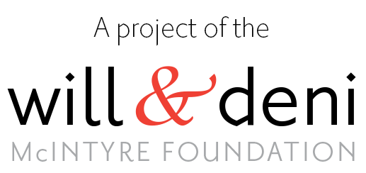
Early in his career, David Holt hosted the UNC-TV/PBS series Folkways that took viewers through the Southern mountains visiting traditional craftsmen and musicians. He also served as host of The Nashville Network’s Fire on the Mountain, Celebration Express, and American Music Shop. He was a frequent guest on Hee Haw, Nashville Now, and The Grand Ole Opry. David was cast as a musician in the popular Coen Brothers film O Brother Where Art Thou. He has hosted Riverwalk Jazz for Public Radio International and Great Scenic Railway Journeys on public television. In 2002, David and Doc Watson won two Grammy Awards for Best Traditional Folk Recording for Legacy, a three-CD collection of songs and stories reflecting Doc Watson’s life in music. Doc and David toured together from 1998 until Doc’s death in 2012. More information can be found at davidholt.com.

Creators:
Series Host: David Holt | Directed by Deni McIntyre | Produced by Will McIntyre
Director of photography: Jan Balster

© 2021 Will & Deni McIntyre Foundation. All rights reserved.

Funding:
Major funding is provided by the Rhea Bigelow Charitable Trust; The Community Foundation of Henderson County and its Perry N. Rudnick Endowment; Carlyle Adams Foundation; the National Endowment for the Arts; Blue Ridge Music Trails of NC; Terry Nienhuis; Cheri and Ron Allari; Myrna Harris; Ben and Laurie Duke; the J. Lyles Glenn Family Fund; A Bar A Ranch; Rich and Jenny Schwartz; Charlie and Lois Brummitt; and Fred and Lauren Weed. A complete list of underwriters is available at PBS.org.

To help celebrate and preserve the traditional and modern musical heritage of Appalachia, please consider supporting the production of David Holt’s State of Music by making a tax-deductible contribution to the Will & Deni McIntyre Foundation at WillandDeni.org.

Here is the link to downloadable photos from Season 5:
https://www.davidholttv.org/gallery
Password: Season 5

##

Contact: Will McIntyre, Producer, David Holt’s State of Music
77 Bear Rock Road
Hendersonville, NC 28739
336-399-2080
mail@macfoto.com
https://www.davidholttv.org/
https://www.pbs.org/show/david-holts-state-music/

