War Survivors Unite in Remembrance and Reflection As Part of Veterans Day Line-Up on PBS

– A Look at the Realities of Warfare Through Stories of Survival and Triumph in Two New Documentaries Airing in Early November –

Disabled WWI veteran at Walter Reed General Hospital, c. 1919.
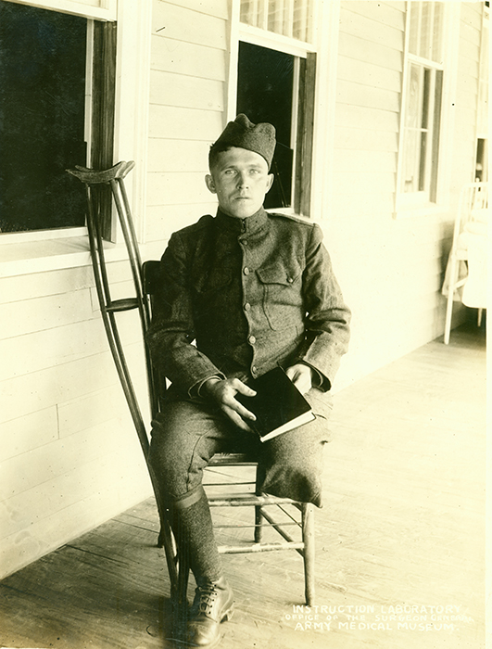
Credit: Courtesy of the Otis Historical Archives, National Museum of Health and Medicine
ARLINGTON, VA; OCTOBER 21, 2015 -- PBS will explore the lasting impact of war in new documentaries airing around Veterans Day. Through moving interviews with survivors from WWII to the War on Terror, the featured documentaries share personal stories from disabled veterans and reunited former enemies on opposite sides of the battlefield.

On Tuesday, November 10, 2015, 8:00-9:00 p.m., PBS viewers will take an unforgettable journey back to the iconic site of one of the fiercest battles of World War II. IWO JIMA: FROM COMBAT TO COMRADES is the powerful and moving story of American and Japanese servicemen who came together 70 years later for a historic reunion in March 2015. This island battlefield is the only former combat zone in the world that sees past enemies return as friends in a ceremony of peace and remembrance. Flags of Our Fathers actor Ryan Phillippe hosts. Click here to view a clip.

Also on Tuesday, November 10, 2015, is a new documentary film by six-time Emmy Award-winning director Ric Burns titled, DEBT OF HONOR: DISABLED VETERANS IN AMERICAN HISTORY. This film, airing from 9:00-10:00 p.m., examines the way in which the American government and society as a whole have regarded disabled veterans throughout history, beginning in the aftermath of the Revolutionary War and continuing through today’s conflicts in the Middle East. The film combines personal stories, told by distinguished disabled veterans, with deep history narrated by leading scholars in the fields of disability studies, history and psychology to illustrate the human cost of war and the enormous sacrifices of military service. These sacrifices are brought to life through hundreds of carefully curated still images and archival footage from across the country. Click here to view a clip.

“Through the very real and heart-wrenching personal stories told by war veterans, PBS hopes to shine a brighter light on the realities of life after battle,” said Beth Hoppe, Chief Programming Executive and General Manager of General Audience Programming at PBS. “At its core, our programs seek to provide viewers with a better understanding of the men and women who stood on the front lines. This year, we not only show viewers how veterans are living beyond their battle wounds and disabilities, but also how some veterans on opposing sides have sought to reunite.”

IWO JIMA: FROM COMBAT TO COMRADES and DEBT OF HONOR: DISABLED VETERANS IN AMERICAN HISTORY are part of PBS Stories of Service, a multiplatform initiative exploring veterans’ experiences and providing a deeper understanding of our country’s military history. Viewers are invited to join the conversation in social media using the hashtag #ServiceStoriesPBS and access a rich library of more than 50 archival programs and resources for educators, students and veterans at pbs.org/storiesofservice. Click here to view a clip.

On Monday, November 9, 2015, at 10:00 p.m., INDEPENDENT LENS airs “Stray Dog,” a documentary about motorcycle-riding, stereotype-shattering Vietnam veteran Ronnie “Stray Dog” Hall as he tries to come to terms with his combat experience and help others like him. November also brings an encore of NOT YET BEGUN TO FIGHT (check local listings), the story of a Vietnam veteran who brings five men, severely injured in Iraq and Afghanistan, to the rivers of Montana, where he teaches them to fish … and to hope.

In 2017, Ken Burns and Lynn Novick’s THE VIETNAM WAR, a documentary film series about the history and meaning of that conflict, will explore the military, political, cultural, social and human dimensions of what has been called “the war of lost illusions.” The primary focus will be the human experience, using eyewitness testimonies of so-called “ordinary” people — Americans as well as Vietnamese — whose lives were touched by the war.

Also for Veterans Day, WORLD Channel (check local listings) offers a week of 22 films, produced by or about veterans, that challenge audiences to understand the adversities and accomplishments that come with returning home and acclimating to civilian life after combat. Films include:

- Reserved to Fight
In May 2003, Fox Company of Marine Reserve Unit 2/23 returned home from combat on the frontlines in Iraq. America ReFramed’s Reserved to Fight follows four Marines of the Fox Company through their post-war minefield of social and psychological reintegration into civilian life. The return home to rejoin their communities proves to be as formidable a battle as the actual firefights of previous months, airs Tuesday, November 10, 2015.

- PTSD: Bringing the War Home
An examination of what has become all too common among U.S. veterans returning home from combat zones. PTSD: Bringing the War Home illuminates those affected by war-related post-traumatic stress disorder: a devastating injury pushes one former soldier into darkness; the family of a Navy Seal tells his tragic story; a woman rebuilds her post-war life; and a program at the City College of San Francisco is committed to rehabbing veterans, airs Monday, November 16, 2015.

Also surrounding Veterans Day, Veterans Coming Home — a national public media effort funded by CPB — will work with local public media stations to honor veterans in their communities through local content and services designed to help returning veterans translate their military experience to jobs in the civilian workforce. Stations’ local content and events will be augmented by national programming from PBS, NPR and other content producers that highlights the stories, triumphs and challenges of veterans as they transition back to civilian life.

PBS LearningMedia, a digital library of more than 100,000 resources for educators and students, will add additional content for classroom use to the “Soldiers, Veterans & War in American Life” resource collection from recent PBS programs like THE DRAFT, COMING BACK WITH WES MOORE, THE HOMEFRONT, D-DAY 360 and LAST DAYS IN VIETNAM. Additional content from ON TWO FRONTS: LATINOS & VIETNAM and IWO JIMA: FROM COMABT TO COMRADES will also be available. In addition, the “Georgia World War II Oral History Project” from PBS member station Georgia Public Broadcasting chronicles World War II through the personal accounts of men and women from Georgia whose lives were touched by war. The collection includes interviews, photographs, and letters to support lessons in social studies, history and geography and features American television journalist Tom Brocaw.

About PBS Stories of Service
As America’s storyteller, PBS is bringing together multi-platform content and powerful conversations around U.S. military veterans under the banner of Stories of Service. The national programming content features compelling stories of those who have served and provides a deeper understanding of our nation’s military history. Through public television on air and on PBS.org, PBS member stations will create their own local content and provide community resources for returning veterans and their families. The initiative will educate the civilian population about our military history and highlight the contributions from the veteran community. The Stories of Service initiative was announced in May 2014 along with a community engagement campaign for select PBS member stations and their local veterans and funded by the Corporation for Public Broadcasting (CPB), called Veterans Coming Home. The PBS programming under Stories of Service, some with funding support from CPB, includes a comprehensive list of titles, many of which can be found here. The initiative runs through 2017 with the premiere of Ken Burns and Lynn Novick’s THE VIETNAM WAR.

About CPB
The Corporation for Public Broadcasting (CPB), a private, nonprofit corporation created by Congress in 1967, is the steward of the federal government's investment in public broadcasting. It helps support the operations of more than 1,400 locally-owned and -operated public television and radio stations nationwide, and is the largest single source of funding for research, technology, and program development for public radio, television and related online services.

About PBS
PBS, with over 350 member stations, offers all Americans the opportunity to explore new ideas and new worlds through television and online content. Each month, PBS reaches more than 103 million people through television and over 33 million people online, inviting them to experience the worlds of science, history, nature and public affairs; to hear diverse viewpoints; and to take front row seats to world-class drama and performances. PBS’ broad array of programs has been consistently honored by the industry’s most coveted award competitions. Teachers of children from pre-K through 12th grade turn to PBS for digital content and services that help bring classroom lessons to life. PBS’ premier children’s TV programming and its website, pbskids.org, are parents’ and teachers’ most trusted partners in inspiring and nurturing curiosity and love of learning in children. More information about PBS is available at www.pbs.org, one of the leading dot-org websites on the Internet, or by following PBS on Twitter, Facebook or through our apps for mobile devices. Specific program information and updates for press are available at pbs.org/pressroom or by following PBS Pressroom on Twitter.

– PBS –

CONTACTS:
Michaé Godwin, PBS, 703-739-8483, mmgodwin@pbs.org
Carrie Johnson, PBS, 703-739-5129, cjohnson@pbs.org

For images and additional up-to-date information on this and other PBS programs, visit PBS PressRoom at pbs.org/pressroom.

