“DEFYING THE NAZIS: THE SHARPS’ WAR,” A NEW FILM BY KEN BURNS AND
ARTEMIS JOUKOWSKY, TO AIR ON PBS SEPTEMBER 20
Documentary Tells Untold Story of American Husband and Wife Who Spent Nearly Two Years on Life-Threatening Missions in Europe to Save Refugees and Dissidents
The United States Memorial Holocaust Museum and Unitarian Universalist Association Partner on Screenings and Community Engagement Programs

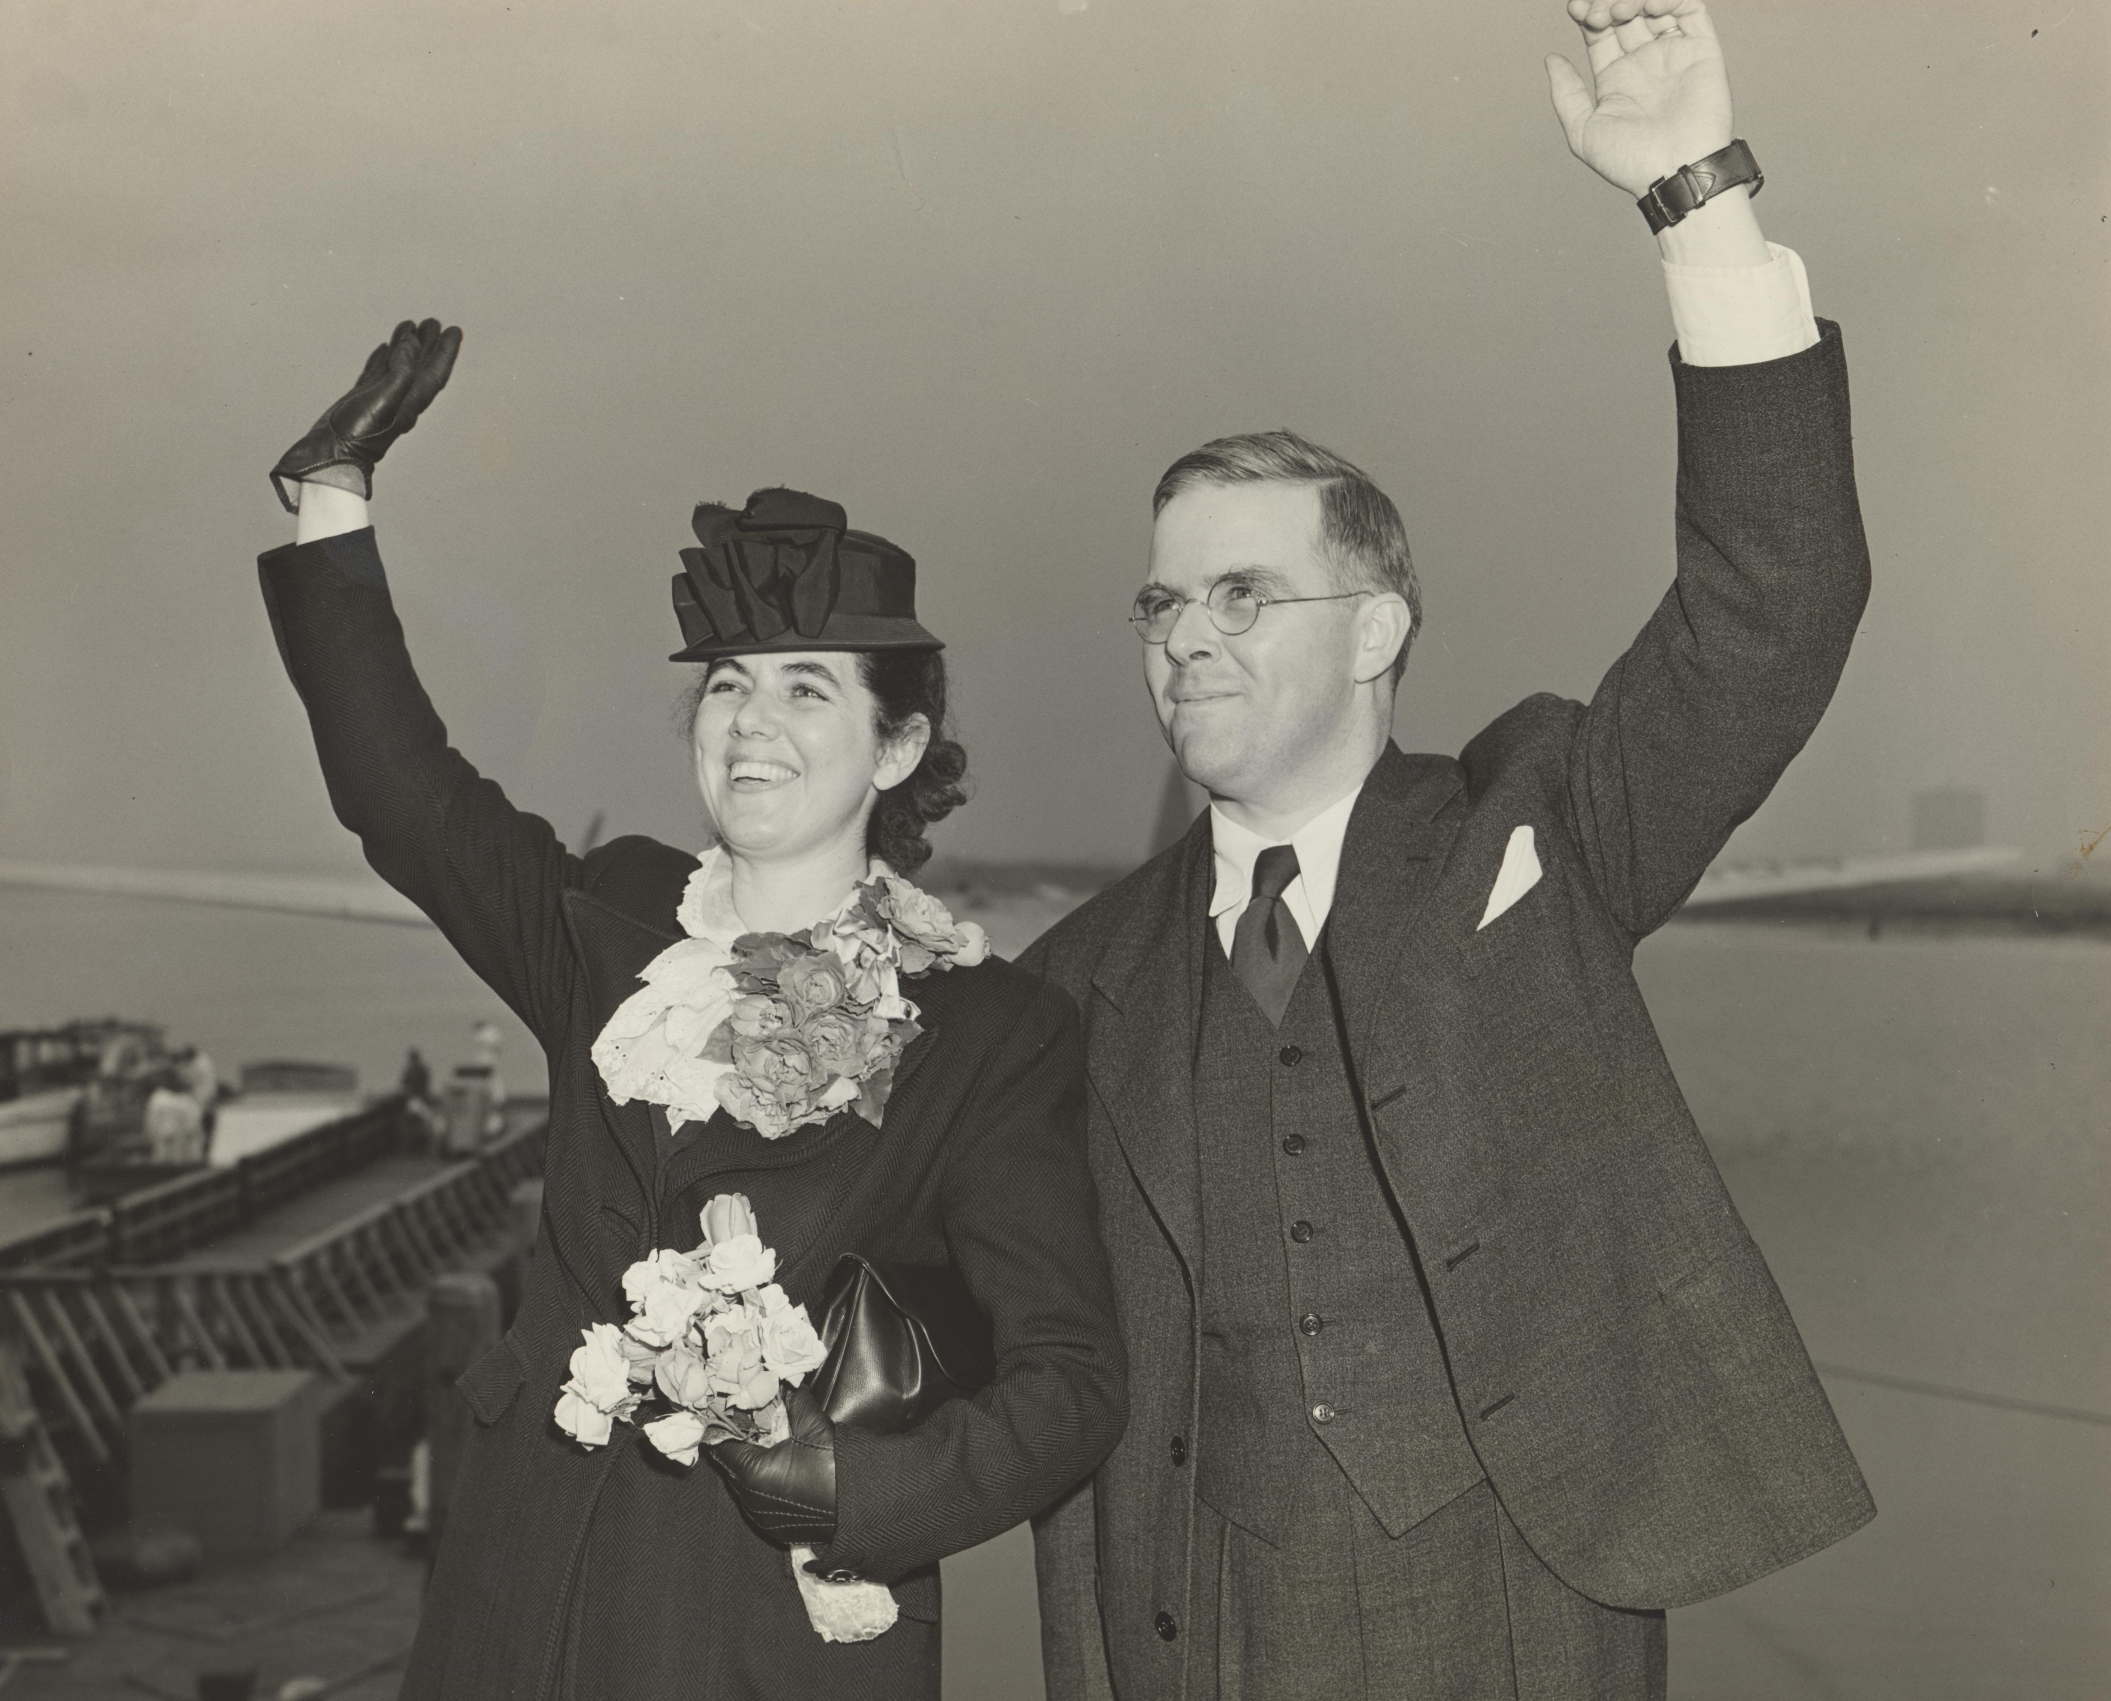
DEFYING THE NAZIS: THE SHARPS’ WAR, a new documentary co-directed by Ken Burns and Artemis Joukowsky, will air on September 20, 2016, at 9:00 p.m. ET (check local listings) on PBS. The film tells the story of a little-known but important mission by an American minister and his wife to rescue refugees and dissidents in Europe before and after the start of World War II. A trailer for DEFYING THE NAZIS is available here.
The 90-minute film tells the story of Waitstill and Martha Sharp, a Unitarian minister and his wife from Wellesley, Massachusetts, who left their children behind in the care of their parish and boldly committed to numerous life-threatening missions in Europe. Over two dangerous years, they helped to save hundreds of imperiled political dissidents and Jewish refugees fleeing the Nazi occupation across Europe.
Martha and Waitstill Sharp embark for Czechoslovakia, 1939.
Credit: Andover Harvard Theological Library

“The story of Waitstill and Martha Sharp is one of the most incredible tales of compassion, sacrifice and heroism that I have ever heard, and I was completely unaware of it until five years ago when Artemis Joukowsky first shared it with me,” said Ken Burns. “Nearly three years before America as a nation became involved in the Second World War, these two unassuming, so-called ‘ordinary’ Americans gave up everything they knew and loved and risked their lives to become involved in a war 4,000 miles away because they knew there were people in grave danger who needed help.”
Artemis Joukowsky, a film producer and co-founder of No Limits Media, is the grandson of Waitstill and Martha Sharp and has spent decades researching their story. He is the author of a companion book to the film, featuring a foreword by Burns, which will be published by Beacon Press and released on September 6.
“Beyond the cloak-and-dagger suspense of my grandparents’ experience, it is a story of what America meant to refugees fleeing war-torn countries to build new lives. And it underscores what Waitstill would call ‘a collaborative effort’ of how a small but effective underground network of rescue workers saved as many lives as they could, and how important that lesson is for what is happening today,” said Joukowsky.
In January of 1939, as Americans remained mostly detached from news reports of the growing refugee crisis in the escalating war in Europe, Waitstill received a call from the Rev. Everett Baker, Vice President of the American Unitarian Association, asking if he and Martha would travel to Czechoslovakia to help provide relief to people trying to escape Nazi persecution. He invited them to take part in “the first intervention against evil by the denomination to be started immediately overseas.” The mission would involve secretly helping Jews, refugees and dissidents to escape the expanding Nazi threat in Europe. If they were discovered, they would face imprisonment, probable torture and death. Seventeen other members of the church had declined. With two young children at home, the Sharps accepted. They expected to be gone for several months.
Instead, their mission would last almost two years.
During this time, the Sharps would face harrowing encounters with Nazi police, narrowly escape arrest and watch as the Third Reich invaded Eastern Europe. Their marriage would be tested severely and the two children they left behind would be saddened by their parents’ absence. But dozens of Jewish scientists, journalists, doctors, powerful anti-Nazi activists and children would find their way to freedom and start new lives as a result of their efforts. To recognize their heroic sacrifice, Martha and Waitstill were honored at Yad Vashem in Israel and declared “Righteous Among the Nations.” Of the thousands so honored, there are only five Americans, including the Sharps.
DEFYING THE NAZIS is cinematically told through the letters and journals of the Sharps, with Tom Hanks as the voice of Waitstill and Marina Goldman as the voice of Martha. It features firsthand interviews with the now adult children whom the Sharps saved, as well as leading historians, authors and Holocaust scholars, including William Schulz, Deborah Dwork, Modecai Paldiel, Ghanda DiFiglia and Yehuda Bauer.
In conjunction with the broadcast, a wide range of organizations will participate in community outreach and engagement activities, creating screening events and conversations that focus on what it means to be “righteous,” both as it relates to the Holocaust and genocide across the globe today. These include The United States Memorial Holocaust Museum, Hillel House, The Anti-Defamation League, The Unitarian Universalist Association, The Unitarian Universalist Service Committee, Jewish Community Centers, The Cohen Center for Holocaust and Genocide Studies at Keene State College, Brown University, Harvard University, No Limits Media and others (a full list is available at DefyingtheNazis.org).
“The Sharps’ early grasp of the true nature of the Nazi threat and their willingness to leave the safety of America and take action to help endangered refugees was a rare act at a time of widespread indifference,” said Sara J. Bloomfield, director, United States Holocaust Memorial Museum. “Their courage and sacrifice should inspire us to reflect deeply on our own responsibilities in a world that also faces many challenges.”
“The Sharps’ story is inspiring modern day faith leaders to action. Unitarian Universalists are partnering with Jews, Christians and Muslims to carry on the Sharps’ legacy by standing up against religious bigotry, Islamophobia and indifference in the face of today’s refugee crises. Hundreds of actions are being planned for the book and film’s release across the country through the Defying the Nazis UU Action Project. The Unitarian Universalist Association, Unitarian Universalist Service Committee and Meadville Lombard Theological School are encouraging all UUs and multi-faith partners to honor the Sharps by working to advance the values for which they sacrificed,” said UUSC President Rev. Dr. William F. Schulz. “The Sharps answered the call of their faith, risking their life to save others. Their selfless dedication to a more just world is an example for Unitarian Universalists and all who care about human rights.”
In addition, WETA, the presenting public television station for DEFYING THE NAZIS, has partnered with Facing History and Ourselves, one of the world’s most respected educational organizations. FHAO is dedicated to raising students’ awareness of injustice and intolerance. Together, WETA and FHAO are creating curriculum materials to help middle and high school teachers use the film and additional primary sources to engage students in the Sharps’ story of sacrifice, rescue and moral courage. Materials will be available free to schools through PBS’ LearningMedia Services.
Funding is provided by members of The Better Angels Society, including Jan and Rick Cohen and Jonathan and Jeannie Lavine; The Starr Foundation; The Threshold Foundation; Sea Stone Foundation; and donations from individuals.
DEFYING THE NAZIS: THE SHARPS’ WAR is a co-production of No Limits Media, Inc., and Florentine Films, in association with WETA Washington, D.C. A film by Ken Burns and Artemis Joukowsky. Produced by Ken Burns and Matthew Justus. Executive produced by Ken Burns. Edited by Erik Angra. Music by Sheldon Mirowitz. Copyright: Farm Pond Pictures, LLC.

#SharpsWarPBS

About PBS
PBS, with 350 member stations, offers all Americans the opportunity to explore new ideas and new worlds through television and online content. Each month, PBS reaches nearly 100 million people through television and nearly 33 million people online, inviting them to experience the worlds of science, history, nature and public affairs; to hear diverse viewpoints; and to take front row seats to world-class drama and performances. PBS’ broad array of programs has been consistently honored by the industry’s most coveted award competitions. Teachers of children from pre-K through 12th grade turn to PBS for digital content and services that help bring classroom lessons to life. PBS’ premier children’s TV programming and its website, pbskids.org, are parents’ and teachers’ most trusted partners in inspiring and nurturing curiosity and love of learning in children. More information about PBS is available at www.pbs.org, one of the leading dot-org websites on the Internet, or by following PBS on Twitter, Facebook or through our apps for mobile devices. Specific program information and updates for press are available at pbs.org/pressroom or by following PBS Pressroom on Twitter.
About WETA
WETA Washington, D.C., is one of the largest producing stations of new content for public television in the United States. WETA productions and co-productions include PBS NewsHour, Washington Week With Gwen Ifill, The Kennedy Center Mark Twain Prize, The Library of Congress Gershwin Prize for Popular Song, In Performance at the White House and documentaries by scholar Henry Louis Gates, Jr., and filmmaker Ken Burns including The Civil War, Baseball, The War, The National Parks: America’s Best Idea, The Central Park Five, The Roosevelts: An Intimate History and Jackie Robinson. Sharon Percy Rockefeller is president and CEO. The WETA studios and administrative offices are located in Arlington, Virginia. More information on WETA and its programs and services is available at www.weta.org. On social media, visit www.facebook.com/wetatvfm on Facebook or follow @WETAtvfm on Twitter.
– PBS –
CONTACT:
Brian Moriarty, DKC Public Relations, 212-685-4300; brian_moriarty@dkcnews.com

For images and additional up-to-date information on this and other PBS programs, visit PBS PressRoom at pbs.org/pressroom.

