Nine of America’s Most Popular Chefs –
José Andrés, Rick Bayless, Carla Hall, Vivian Howard,
Sara Moulton, Jacques Pépin, Éric Ripert,
Marcus Samuelsson and Martha Stewart –
Pay Tribute to the Original TV Chef in
DISHING WITH JULIA CHILD

New Six-Part Series Available to Stream February 28 via
PBS Passport and PBS Living, Available on
Prime Video Channels and Apple TV

Broadcast Premiere on Fridays, April 3-17 on PBS

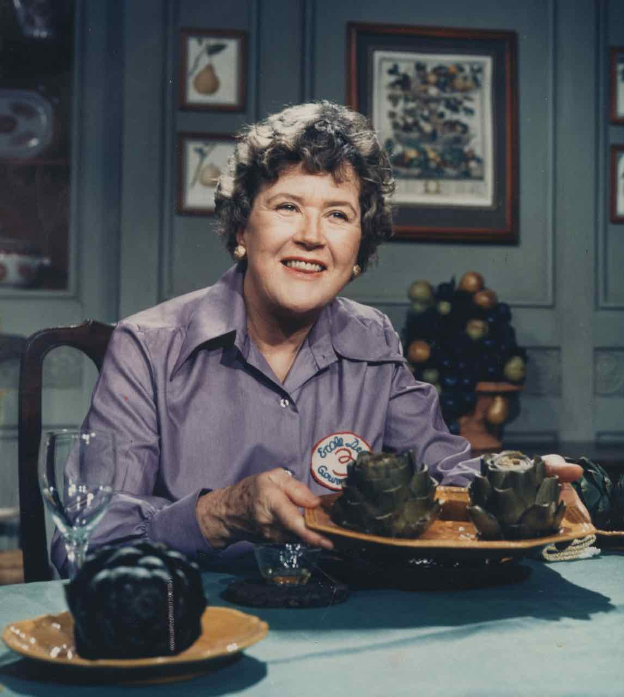
Arlington, VA – February 20, 2020 – When Julia Child’s seminal show The French Chef debuted in 1963, little did anyone know that she would change the way Americans thought about cooking forever. With her distinctive voice and infectious passion for French cuisine, she demystified classic dishes and empowered and inspired millions of home cooks and professional chefs. In DISHING WITH JULIA CHILD, nine of today’s most respected chefs — José Andrés, Rick Bayless, Carla Hall, Vivian Howard, Sara Moulton, Jacques Pépin, Éric Ripert, Marcus Samuelsson and Martha Stewart — gather together to screen — and delight in — favorite episodes of Child’s iconic show. As they watch, they share personal reminiscences, anecdotes and a few laughs as they discuss the immeasurable impact she had on their lives, careers and the American food scene. An affectionate look at a true pioneer, DISHING WITH JULIA CHILD streams exclusively on PBS LIVING , available on Prime Video Channels and Apple TV, and via PBS Passport beginning February 28, 2020. The series then has its broadcast premiere on three consecutive Fridays, April 3-17, 2020,10:00-11:00 p.m. ET (check local listings) on PBS, PBS.org and the PBS Video App.
Caption: Julia Child
Credit: The Julia Child Foundation.

Part of the PBS 50th anniversary celebration of the iconic personalities that shaped both broadcast history and pop culture, DISHING WITH JULIA CHILD is a delightful look at the one-and-only Julia through the eyes of chefs — many of them PBS personalities — who continue her legacy, bringing a sense of fun and the joy of preparing food into American homes.

Andrea Downing, Co-President of PBS Distribution comments, “We are more than excited to be bringing for the very first-time original content to the PBS Living Prime Video Channel. Julia Child pioneered what cooking shows have become today and to get a once-in-a-lifetime look at how she impacted the master chefs of the modern age is truly a treat.”

“As we celebrate PBS icons like Julia Child during our 50th anniversary, audiences will also get an exciting look at how these legacies will shape and inspire the future of PBS,” Jerry Liwanag, Vice President, Fundraising Programming said. “This nostalgic series is just one example of the rich food and culture programming that PBS makes available to audiences across multiple platforms.”

"DISHING WITH JULIA CHILD showcases how pioneering and timeless Julia Child's television teaching is. The Foundation is thrilled PBS has connected some of Julia's iconic episodes to the streaming age through the eyes of chefs who embody her legacy," said Eric W. Spivey, Chairman of The Julia Child Foundation for Gastronomy and the Culinary Arts.

Episode Titles/Broadcast Premiere Dates:

#1 “The Whole Fish Story” (April 3, 10:00-10:30 p.m.)

Good friends and renowned chefs José Andrés, host of the PBS series Made in Spain, and Éric Ripert of Le Bernardin are amazed and amused by Julia’s hands-on treatment of a staggering array of whole fish. They discuss her fearless ability to fillet while encouraging viewers to attempt techniques they might have considered the purview of professionals only. Both are impressed with the amount of information in the show and how Julia works completely fluidly, live-to-tape, without any retakes. Each tells great stories about personal encounters with Julia in their own restaurants and her ability to stop even the most gifted chefs in their tracks.

#2 “The Good Loaf” (April 3, 10:30-11:00 p.m.)

Two pairs of celebrity chefs — Vivian Howard and Marcus Samuelsson, and Carla Hall and Sara Moulton — follow Julia as she makes the classic pain de mie and raisin bread. Sara reminds us that in an era of frozen food and TV dinners, Julia completely transformed our perception of food, showing Americans that cooking was fun and rewarding.

Carla points out that Julia makes ingredients and techniques accessible, doesn’t mind creating a mess and radiates contagious enjoyment. Marcus and Vivian agree that dirty dishes in the background and flour flying around make viewers feel at home and that the complicated process of making bread is something that even they can do.
All four chefs note that by this point in Julia’s television career she has her on-camera look honed: a distinctive coif, a bit of bling and a complete sense of confidence.

#3 “Your Own French Onion Soup” (April 10, 10:00-10:30 p.m.)

Rick Bayless, host of the PBS series Mexico: One Plate at a Time, marvels over Julia’s knife skills and the excellent training she provides. He describes watching the first season of The French Chef as a ten-year-old, writing down everything Julia did because “it was like magic to me.”

Martha Stewart reminds us how Julia completely changed the way Americans thought about food and cooking. Frequent Julia collaborator (and dear friend) Jacques Pépin weighs in on how genuine she was, off-camera and on, her love of butter, and her gracious approach to meeting all of the staff — down to the dishwasher — at the restaurants where they dined.

José Andrés and Éric Ripert are also impressed with Julia’s teaching. “If anyone can cut onions and not cry, it’s Julia,” points out José. They’re amazed at her technique to rid hands of the smell of onions and wonder how many other tips are in the 200 episodes of The French Chef.

#4 “Boeuf Bourguignon” (April 10, 10:30-11:00 p.m.)

Sara Moulton, Julia’s protégé and longtime colleague (and host of PBS’s Sara's Weeknight Meals) and Carla Hall, host of The Chew, share commentary on Julia’s first French Chef episode with José Andrés and Éric Ripert. Sara, who worked with Julia for many years, offers insight into her approach to cooking and hosting the series.

José and Éric remark on how purposeful and comfortable Julia is as a teacher, with a magnetic personality evident even in her first episode. They recall how nervous and disorganized their first TV appearances were. “She has all the tricks, all the information, and it’s seamless,” says Éric. “She’s really advertising the French way — wine, recipe, technique. In the 60s this was intimidating and she makes it look simple.”

#5 “The Potato Show” (April 17, 10:00-10:30 p.m.)

Rick Bayless provides pointed and humorous commentary on Julia’s high-wire performance preparing potatoes and defends her famed use of butter. Sara Moulton tells Carla Hall about working with Julia and praises her great combination of knowledge and humor. Rick also talks about the fact that Julia is such a practiced cook who shares knowledge and techniques, including how to work with proportions to get the best taste, not just with fixed measurements.

#6 “To Roast a Chicken” (April 17, 10:30-11:00 p.m.)

Vivian Howard, host of PBS’s Somewhere South and A Chef’s Life, and Marcus Samuelsson, host of PBS’s No Passport Required, enjoy how Julia presents an entire counter filled with raw chickens — not something today’s chefs would feel comfortable doing.

Martha Stewart reveals how Julia influenced her personally and, more broadly, how she opened up the world of international cuisine to Americans.

Vivian and Marcus also point out how informative Julia is and how she’s inventing cooking on television with no existing rulebook. “I have been cooking professionally for a long time and I’m learning here,” says Vivian. “We get all this detail that’s not meant to be entertaining but it’s incredibly entertaining.” Marcus points out that contemporary cooking shows often focus solely on entertainment, but Julia’s approach is so informative, educating viewers on the value of prime ingredients as well as how to shop for and prepare them.

They appreciate that Julia clearly wants the viewer to be successful and enjoy the moment when she proudly completes the detailed task of trussing the bird.

About PBS DISTRIBUTION
PBS Distribution is a leading distributor of public media content around the world, reaching audiences through multiple platforms and formats including direct-to-consumer subscription video-on-demand (DTC-SVOD), transactional video-on-demand (TVOD), subscription video-on-demand (SVOD) licensing, and physical products on DVD and Blu-ray. In addition, the company operates three streaming channels – PBS MASTERPIECE, PBS KIDS, and PBS LIVING – all on Amazon Prime Video Channels, with PBS LIVING also available on the Apple TV App. Other divisions of the company include: theatrical releasing, educational, non-theatrical, inflight and international licensing businesses. PBS Distribution offers consumers and educators the highest quality factual, scripted and children’s programming, including films from producer Ken Burns, hit dramas from MASTERPIECE, entertaining and educational children’s series and award-winning documentaries from NOVA, FRONTLINE, AMERICAN MASTERS, NATURE, AMERICAN EXPERIENCE and many independent producers. For over 20 years, the company has extended the reach of programming beyond broadcast while generating revenue for the public television system stations and producers. Follow PBS LIVING on Facebook and Twitter.

About PBS
PBS, with more than 330 member stations, offers all Americans the opportunity to explore new ideas and new worlds through television and digital content. Each month, PBS reaches over 120 million people through television and 26 million people online, inviting them to experience the worlds of science, history, nature and public affairs; to hear diverse viewpoints; and to take front row seats to world-class drama and performances. PBS’ broad array of programs has been consistently honored by the industry’s most coveted award competitions. Teachers of children from pre-K through 12th grade turn to PBS for digital content and services that help bring classroom lessons to life. Decades of research confirms that PBS’ premier children’s media service, PBS KIDS, helps children build critical literacy, math and social-emotional skills, enabling them to find success in school and life. Delivered through member stations, PBS KIDS offers high-quality educational content on TV – including a 24/7 channel, online at pbskids.org, via an array of mobile apps and in communities across America. More information about PBS is available at www.pbs.org, one of the leading dot-org websites on the internet, or by following PBS on Twitter, Facebook or through our apps for mobile and connected devices. Specific program information and updates for press are available at pbs.org/pressroom or by following PBS Pressroom on Twitter.

CONTACTS:

For PBS Distribution:
Jill Goldstein
JGoldsteinPR
Jill@jgoldsteinpr.com
For PBS:
Cara White / Mary Lugo
CaraMar, Inc.
cara.white@mac.com; lugo@negia.net

Stephanie Kennard
skkennard@pbs.org
703-739-5454

For images and additional up-to-date information on this and other PBS programs, visit PBS PressRoom at pbs.org/pressroom

