DOWNTON ABBEY LIVE!
Premieres Sunday, August 18, 2019 on PBS

– Join Cast Members and Creators of “Downton Abbey” for a Live Celebration of the Beloved Television Series and a Sneak Peek of the Upcoming Feature Film –

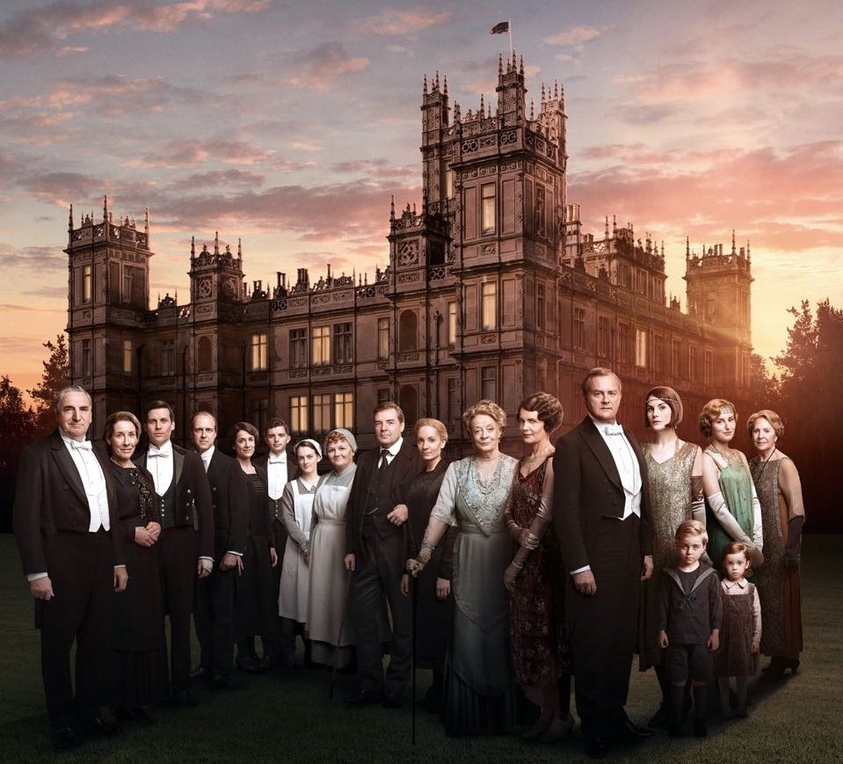
Credit: Courtesy of ©Nick Briggs/Carnival Film and Television Limited 2015 for MASTERPIECE

In anticipation of the September 2019 release of the Downton Abbey feature film, DOWNTON ABBEY LIVE! is a celebration of all aspects of the wildly successful British drama – the stellar cast, superb writing, spectacular locations and dazzling costumes. Broadcast from New York City before a live studio audience, scheduled participants include cast members Laura Carmichael (Lady Edith), Phyllis Logan (Mrs. Hughes), Lesley Nicol (Mrs. Patmore), Kevin Doyle (Molesley), Harry Hadden-Paton (Bertie) and Michael C. Fox (Andrew Parker) with executive producers Gareth Neame and Liz Trubridge. Composer John Lunn will also be live in the New York studio, performing piano arrangements of his evocative themes from the series. Additional live segments currently scheduled include costume designer Anna Mary Scott Robbins from WTTW Chicago; new taped interviews with Hugh Bonneville and Julian Fellowes will also be featured. Hosted by award-winning ABC News journalist (and huge “Downton” fan!) Deborah Roberts, DOWNTON ABBEY LIVE! premieres Sunday, August 18, 2019, at 9:00 p.m. ET / 6:00 p.m. PT on PBS.

“We are thrilled to be able to bring this exciting live event to PBS viewers,” said Jerry Liwanag, Vice President of Fundraising Programming at PBS. “As a new chapter in the lives of the Crawleys and their beloved staff is about to unfold, it seemed fitting to bring everyone together to celebrate fond memories of the drama, romance and intrigue of the series, which riveted viewers for six record-breaking seasons.”

Driven by lively conversation between host Roberts and guests, DOWNTON ABBEY LIVE! will reveal never-before-heard stories from the PBS series plus clips of the upcoming movie and a warm look back at one of the most successful period dramas in history. In addition, PBS viewers from around the country will have an opportunity to have their questions about the “Downton Abbey” series and upcoming movie answered by the cast and creators. What secrets will be revealed?

PBS special programming invites viewers to experience the worlds of science, history, nature and public affairs; hear diverse viewpoints; and take front-row seats to world-class drama and performances. Viewer contributions are an important source of funding, making PBS programs possible. PBS and public television stations offer all Americans from every walk of life the opportunity to explore new ideas and new worlds through television and online content.

DOWNTON ABBEY LIVE! is produced and directed by Bob Marty of Inky Dinky Worldwide, Inc. Support for the program is provided by Viking Cruises, public television viewers and PBS.

About CARNIVAL FILMS
Carnival Films is a division of NBCUniversal International Studios and one of the UK's leading drama specialists. Since 1978, Carnival has produced hundreds of hours of drama that have been broadcast and performed around the world, garnering over 200 award wins and nominations, including Primetime Emmys®, Golden Globes, BAFTAs, Oscars and TONYs. Carnival’s shows include global phenomenon Downton Abbey and series such as Poirot, Hotel Babylon, Whitechapel, US shows Dracula and The Philanthropist, as well as mini-series such as the original Traffik, David Nicholl’s The 7:39, David Hare’s Worricker Trilogy, William Boyd’s BAFTA-winning Any Human Heart, The Hollow Crown, a co-production with Neal Street, and Peter Morgan’s BAFTA-winning The Lost Honour of Christopher Jefferies.
Carnival’s current slate includes The Last Kingdom for Netflix, and Jamestown and Stan Lee’s Lucky Man for Sky One.

Carnival is responsible for the TV sensation Downton Abbey, winner of three Golden Globes and fifteen Primetime Emmy awards, including Best Mini-Series. It is the most nominated non-US show in the history of the Emmy’s with a total of 69 nominations and is distributed in over 250 territories worldwide. Among numerous national and international awards, including three Screen Actors Guild Awards and four National Television Awards, the show has even garnered a Guinness World Record for highest critical ratings for a TV show, and a BAFTA Special Award in recognition of its outstanding global success.
Carnival was recognized as best production company at both the Bulldog Awards and Broadcast Awards.

About Viking Cruises
Viking was founded in 1997 with the purchase of four ships in Russia. Designed for discerning travelers with interests in science, history, culture and cuisine, Chairman Torstein Hagen often says Viking offers guests “the thinking person’s cruise” as an alternative to mainstream cruises. In its first four years of operation, Viking has been rated the #1 ocean cruise line in Travel + Leisure’s 2016, 2017, 2018 and 2019, “World’s Best” Awards. Viking currently operates a fleet of 78 vessels, offering scenic cruising on rivers and oceans around the world. In addition to the Travel + Leisure honors, Viking has also been honored multiple times on Condé Nast Traveler’s “Gold List” as well as recognized by Cruise Critic as “Best Overall” Small-Mid size ship in the 2018 Cruisers’ Choice Awards, “Best River Cruise Line” and “Best River Itineraries,” with the entire Viking Longships® fleet being named “Best New River Ships” in the website’s Editors’ Picks Awards. For additional information, contact Viking at 1-855-8-VIKING
(1-855-884-5464) or visit www.vikingcruises.com

About PBS
PBS, with more than 330 member stations, offers all Americans the opportunity to explore new ideas and new worlds through television and digital content. Each month, PBS reaches over 126 million people through television and 26 million people online, inviting them to experience the worlds of science, history, nature and public affairs; to hear diverse viewpoints; and to take front row seats to world-class drama and performances. PBS’ broad array of programs has been consistently honored by the industry’s most coveted award competitions. Teachers of children from pre-K through 12th grade turn to PBS for digital content and services that help bring classroom lessons to life. Decades of research confirms that PBS’ premier children’s media service, PBS KIDS, helps children build critical literacy, math, and social-emotional skills, enabling them to find success in school and life. Delivered through member stations, PBS KIDS offers high-quality educational content on TV – including a 24/7 channel, online at pbskids.org, via an array of mobile apps and in communities across America. More information about PBS is available at www.pbs.org, one of the leading dot-org websites on the internet, or by following PBS on Twitter, Facebook or through our apps for mobile and connected devices. Specific program information and updates for press are available at pbs.org/pressroom or by following PBS Pressroom on Twitter.

- PBS –

CONTACT:
Cara White, CaraMar, Inc., 843-881-1480; cara.white@mac.com
Mary Lugo, CaraMar, Inc., 770-623-8190; lugo@negia.net

For images and additional up-to-date information on this and other PBS programs, visit PBS PressRoom at pbs.org/pressroom.

