FOR IMMEDIATE RELEASE:

“ELLA WISHES YOU A SWINGING CHRISTMAS WITH VANESSA WILLIAMS” Premieres Tuesday, December 15 on PBS

Maestro LUKE FRAZIER and THE AMERICAN POPS ORCHESTRA perform Ella Fitzgerald’s iconic holiday album, ELLA WISHES YOU A SWINGING CHRISTMAS, with host VANESSA WILLIAMS and featuring performances by DEE DEE BRIDGEWATER, CARMEN RUBY FLOYD, MORGAN JAMES, NORM LEWIS and NOVA Y. PAYTON

Watch the First Trailer for “ELLA WISHES YOU A SWINGING CHRISTMAS WITH VANESSA WILLIAMS”
https://www.pbs.org/video/trailer-6jgbke/

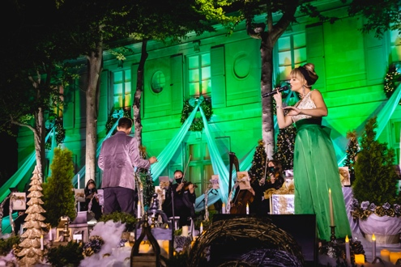
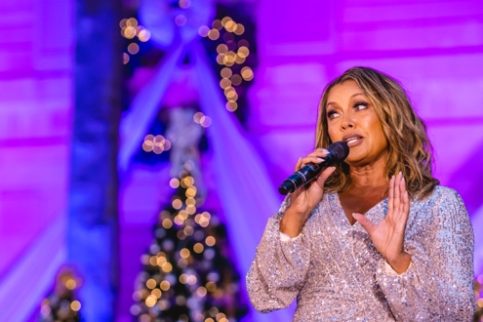
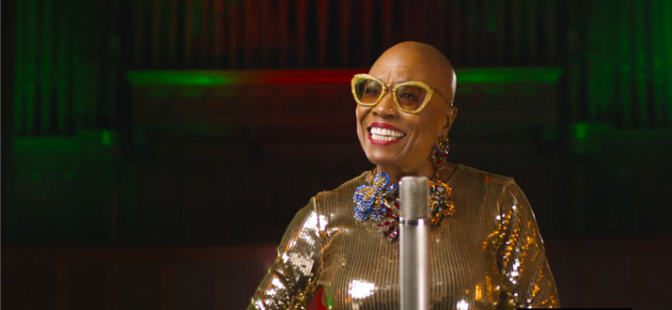

Photos by Kevin Parisi – (from Left to Right) – MORGAN JAMES & The American Pops Orchestra; host VANESSA WILLIAMS; DEE DEE BRIDGEWATER

WASHINGTON, D.C. (November 19, 2020) – The American Pops Orchestra (APO) announced today the release of “Ella Wishes You a Swinging Christmas with Vanessa Williams,” which premieres Tuesday, December 15, 2020, 8:00-9:00 p.m. ET (check local listings) on PBS, PBS.org and the PBS Video App. In partnership with The Ella Fitzgerald Charitable Foundation, Maestro Luke Frazier and APO present a new take on Ella’s classic 1960 holiday album, Ella Wishes You a Swinging Christmas, performed in its entirety by a stellar lineup of artists. One of the most celebrated holiday albums of all time, it featured classic American songs of the season, including “Santa Claus Is Coming to Town,” “Have Yourself a Merry Little Christmas,” “The Christmas Song,” “Sleigh Ride” and “Winter Wonderland.”

Filmed in front of a small, socially-distanced live audience under strict COVID-19 mitigation procedures at the Meridian International Center in Washington, D.C., “Ella Wishes You A Swinging Christmas with Vanessa Williams” features performances by Grammy and Tony Award-winner Dee Dee Bridgewater (joining APO from New Orleans); Broadway and jazz vocalist Carmen Ruby Floyd; Broadway star and recording artist Morgan James; Grammy and Tony Award nominee Norm Lewis; and celebrated recording artist Nova Y. Payton. The program also features performances by its host, the multi-Grammy, Emmy and Tony Award-nominee Vanessa Williams. All performers are joined by The American Pops Orchestra under the baton of Maestro Luke Frazier.

“To me, it feels more important than ever that we embrace the things that take us back to a simpler time—a time of celebrating the holidays with a sense of nostalgia. This extraordinary holiday album has been the soundtrack for so many of us for more than four decades. To share Ella’s iconic music interpreted by a new generation of extraordinary singers is a gift to us all!” said APO Founder and Music Director, Luke Frazier.

“Ella Wishes You A Swinging Christmas with Vanessa Williams” will stream simultaneously with broadcast and be available on all station-branded PBS platforms, including PBS.org and the PBS Video App, available on iOS, Android, Roku streaming devices, Apple TV, Amazon Fire TV, Android TV, Samsung Smart TV and Chromecast.

About the American Pops Orchestra
APO was founded in 2015 with a mission to build community through the preservation, promotion and reimagination of American popular music. Through live and virtual performances, educational initiatives and collaborations, APO makes the highest quality art accessible to the broadest audiences. Seeing an opportunity to challenge the status-quo of the repertoire an orchestra performs, Founder and Music Director Luke Frazier created The American Pops with the intent of breaking the mold of the traditional pops orchestra. This new, distinctly “American” orchestra brings together versatile musicians and reimagined programming focused around the Great American Songbook, and presents it with an approachable, fresh spin in order to engage diverse audiences and make attending a live orchestral show fun again. Through non-traditional orchestral settings, APO aims to deliver popular American classics to those who already know and love them, while also introducing these timeless pieces to younger generations in approachable settings.

To learn more, visit www.TheAmericanPops.org.

About Luke Frazier, Music Director and Conductor
Growing up in West Virginia and spending most of his career in New York City and Washington, D.C., Luke knows the breadth of audiences that can have their lives changed by music of all kinds. A classically trained pianist and conductor, Luke spends every day focusing not only on musical excellence but also on using music as a tool to connect people from all walks of life. Gone are the days of programming and conducting in a vacuum—the arts today are about the communities we serve and the patrons, both existing ones and those yet to be reached. This philosophy has led Luke to be a pioneer in how, where, and what orchestras perform. This commitment to innovation led Luke to start The American Pops Orchestra in 2015 to serve as an artistic model of this thinking. In Luke’s shows, it’s not uncommon to hear pop singers, classical musicians and television stars all in the same program. Each concert, whether it be with his own APO or another orchestra around the country, is curated as an opportunity to highlight music, particularly American Popular Music. This music that we’ve created together can be used as a rallying point in our collective lives. Luke crafts each concert with a dramatic arc featuring both innovative and classic arrangements to keep both audiences and artists engaged at every measure.
Luke is lucky to call many of the world’s most acclaimed artists friends and collaborators. These friendships with Renée Fleming, Brian Stokes Mitchell, Patti Labelle, Kelli O’Hara, Juanes, Wynton Marsalis, Rita Moreno, Morgan James, Joshua Bell and so many more have led to concerts all over the country both in iconic venues and to millions of viewers on television. Passionately committed to the next generation of musicians, Luke spends a significant amount of time and resources with all levels of aspiring musicians. Each year APO hosts a free national collegiate vocal competition, hosts instrumental and vocal masterclasses for collegiate musicians, creates original children’s programming of the highest caliber and spends two weeks visiting schools free of charge in some of the poorest regions of our country. Luke believes in the power of music to open new doors for children. In fact, it was an elementary school gymnasium performance which included live musicians that inspired his own career.
To get to know more about Luke or The American Pops Orchestra, check out @fraziersedge and www.LukeFrazierMusic.com, or @theamericanpops and www.theamericanpops.org.

About The Ella Fitzgerald Charitable Foundation
The Ella Fitzgerald Charitable Foundation was created and funded in 1993 by Ella Fitzgerald, the First Lady of Song, in order to fulfill her desires to use the fruits of her success to help people of all races, cultures and beliefs. Ella hoped to make their lives more rewarding, and she wanted to foster a love of reading, as well as a love of music. In addition, she hoped to provide assistance to the at-risk and disadvantaged members of our communities - assistance that would enable them to achieve a better quality of life.

For more information, please visit www.ellafitzgerald.com/foundation.

About PBS
PBS, with more than 330 member stations, offers all Americans the opportunity to explore new ideas and new worlds through television and digital content. Each month, PBS reaches over 120 million people through television and 26 million people online, inviting them to experience the worlds of science, history, nature and public affairs; to hear diverse viewpoints; and to take front row seats to world-class drama and performances. PBS’s broad array of programs has been consistently honored by the industry’s most coveted award competitions. Teachers of children from pre-K through 12th grade turn to PBS for digital content and services that help bring classroom lessons to life. Decades of research confirms that PBS’s premier children’s media service, PBS KIDS, helps children build critical literacy, math and social-emotional skills, enabling them to find success in school and life. Delivered through member stations, PBS KIDS offers high-quality educational content on TV— including a 24/7 channel, online at pbskids.org, via an array of mobile apps and in communities across America. More information about PBS is available at www.pbs.org, one of the leading dot-org websites on the internet, or by following PBS on Twitter, Facebook or through our apps for mobile and connected devices. Specific program information and updates for press are available at pbs.org/pressroom or by following PBS Pressroom on Twitter.
###

MEDIA CONTACTS

For Nouveau Productions and APO: For PBS:
Camille Cintrón Devlin Cara White / Mary Lugo, CaraMar, Inc.
571-317-9317 843-881-1480; 770-623-8190
camiletapr@gmail.com cara.white@mac.com; lugo@negia.net

For images and additional up-to-date information on “Ella Wishes You A Swinging Christmas with Vanessa Williams” and other PBS programs, visit PBS PressRoom at pbs.org/pressroom.

