E.O. WILSON − OF ANTS AND MEN Tells the Story of the Remarkable Life and Groundbreaking Ideas From One of America’s Greatest Living Scientists

−Two-hour film premieres Sept. 30, 2015, 9:00-11:00 p.m. ET–

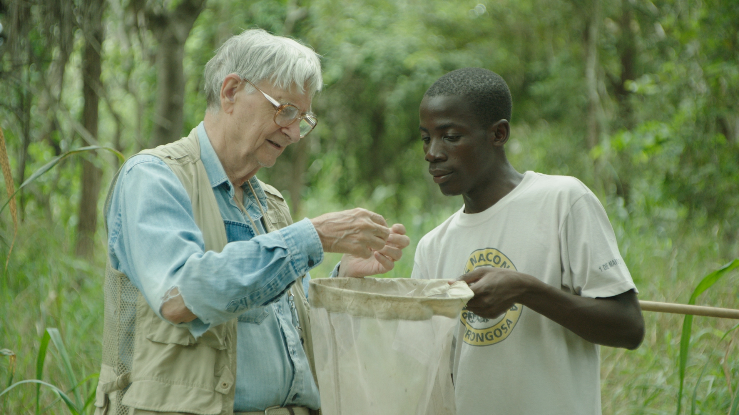
E.O. Wilson with Fernando Bebe Ussene (Gorongosa) Credit: Courtesy of Lentsoe Mamatela

ARLINGTON, VA; Sept. 9, 2015 -- A portrait of one of the greatest scientific thinkers of our time, E.O. WILSON − OF ANTS AND MEN premieres Wednesday, September 30, 2015, at 9:00 p.m. ET on PBS (check local listings.) The two-hour film explores the life and times — and the revolutionary ideas — of Pulitzer Prize-winning biologist E.O. Wilson, the founder of the scientific discipline of sociobiology and a world authority on insects and human nature.

E.O. Wilson’s life-long passion for insects and the natural world led him from his Alabama childhood to become one of the world’s foremost experts on ants, which led him to study human nature. Sparked by his observations of ant and other insect communities, Wilson has made groundbreaking contributions to human evolutionary theory and population dynamics. His 1967 book — The Theory of Island Biogeography, co-written with mathematician Robert MacArthur — is widely considered the definitive treatise on conservation biology. Wilson’s greatest contribution may be to the study of social behavior in the animal world. His 1975 book Sociobiology created one of the greatest academic controversies of the late 20th century by revolutionizing contemporary thought about animal societies, including that of humans.

E.O. WILSON − OF ANTS AND MEN inspires viewers with Wilson’s revolutionary thinking and joyful exploration of the natural world, painting an engaging portrait of an extraordinary man often called “a Darwin for the modern day.” Through engaging interviews and investigations around the globe, the film brings together three great themes of Wilson’s life and work: the wonder of nature; the evolution of human social behavior; and humanity’s need to come to terms with our place in the natural world.

About PBS
PBS, with over 350 member stations, offers all Americans the opportunity to explore new ideas and new worlds through television and online content. Each month, PBS reaches more than 103 million people through television and over 33 million people online, inviting them to experience the worlds of science, history, nature and public affairs; to hear diverse viewpoints; and to take front row seats to world-class drama and performances. PBS’ broad array of programs has been consistently honored by the industry’s most coveted award competitions. Teachers of children from pre-K through 12th grade turn to PBS for digital content and services that help bring classroom lessons to life. PBS’ premier children’s TV programming and its website, pbskids.org, are parents’ and teachers’ most trusted partners in inspiring and nurturing curiosity and love of learning in children. More information about PBS is available at www.pbs.org, one of the leading dot-org websites on the Internet, or by following PBS on Twitter, Facebook or through our apps for mobile devices. Specific program information and updates for press are available at pbs.org/pressroom or by following PBS Pressroom on Twitter.

– PBS –

CONTACTS:
Ellen Stanley Booth, PBS, 703-739-5120, esbooth@pbs.org
Colleen Flanagan, PBS, 703-739-8130, crflanagan@pbs.org
Chelsey Saatkamp, Goodman Media for PBS, 212-576-2700, PBSProgramming@goodmanmedia.com

For images and additional up-to-date information on this and other PBS programs, visit PBS PressRoom at pbs.org/pressroom.

