PBS Explores World War II’s Most Successful Prison Revolt in
ESCAPE FROM A NAZI DEATH CAMP

–Special Airs Tuesday, May 20, 2014, 9:00-10:00 p.m. ET –

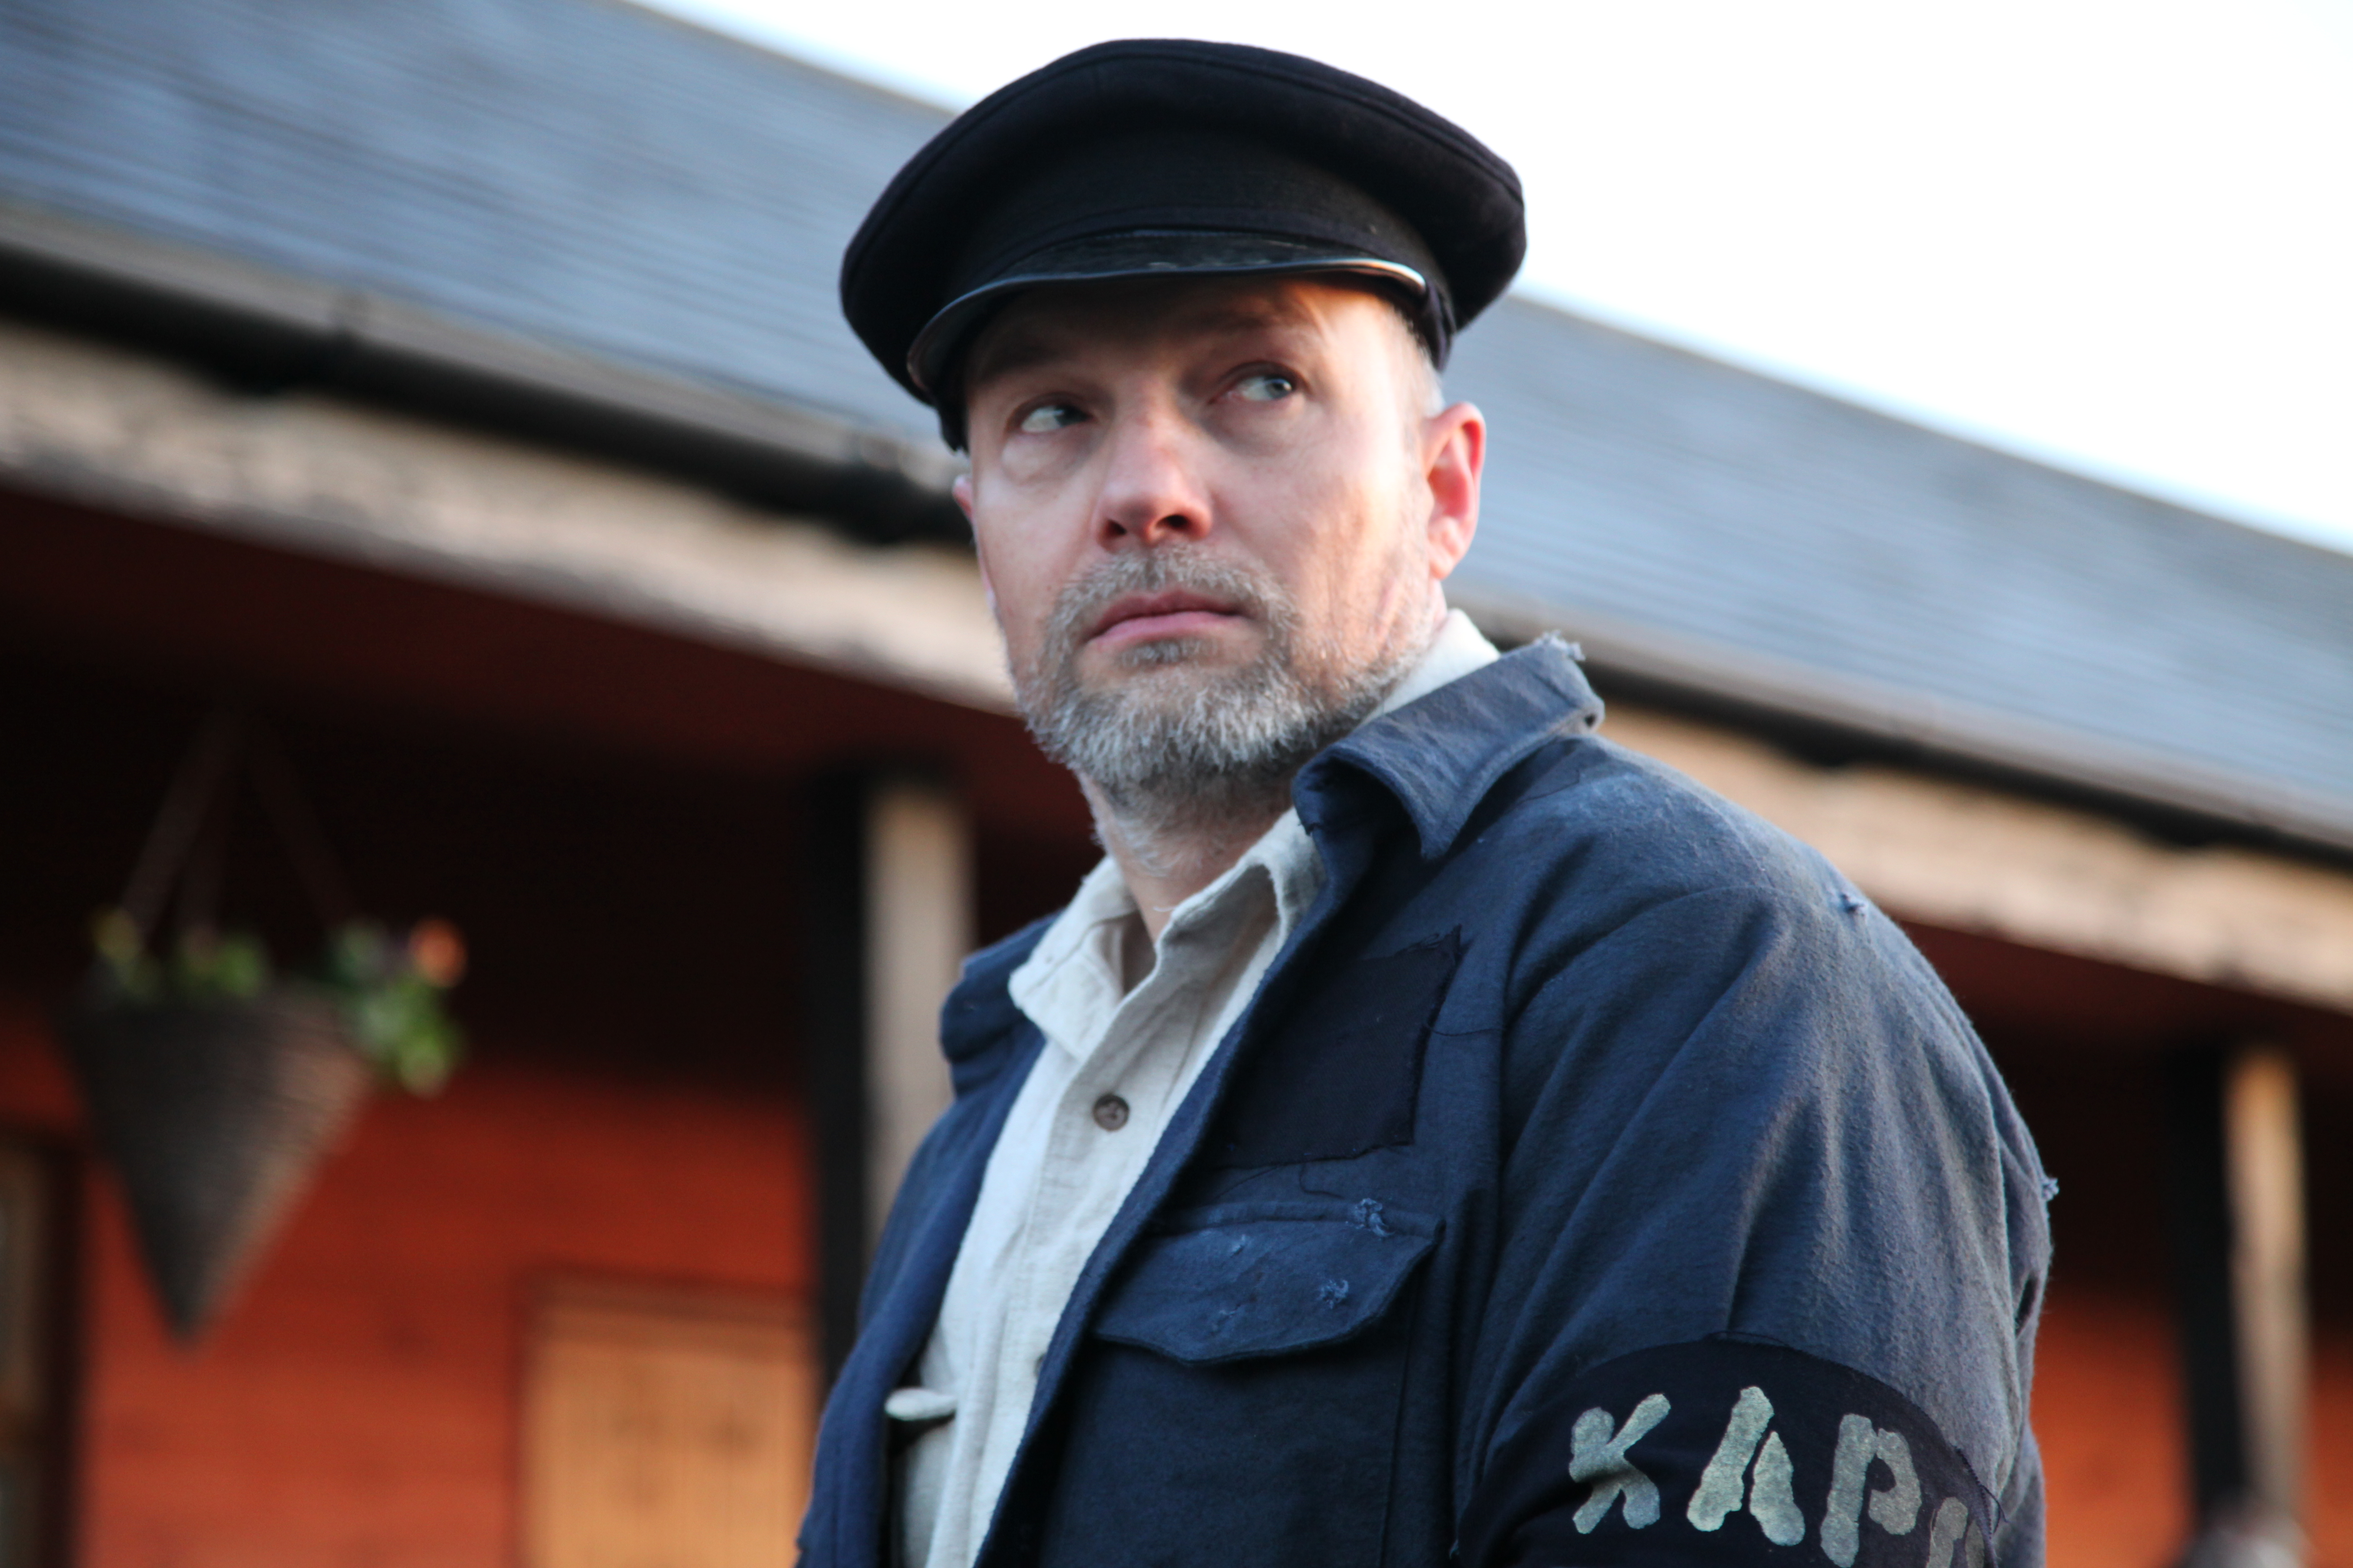
Kapo Berliner (German-Jew worker) waits for prisoners arrival. Credit: Yasemin Rashit/ Darthow Smithson Productions
ARLINGTON, VA; April 24, 2014 – PBS announced today the broadcast of ESCAPE FROM A NAZI DEATH CAMP, the story of the largest and most successful prison revolt of World War II. The docu-drama about the insurrection at Sobibor, a Nazi death camp created solely for mass extermination, airs Tuesday, May 20, 2014, 9:00-10:00 p.m. ET on PBS.

Using firsthand accounts and dramatic sequences, ESCAPE FROM A NAZI DEATH CAMP returns to Sobibor with the last remaining survivors to reveal their extraordinary story of courage, desperation and determination.

Through the compelling accounts of Thomas “Toivi” Blatt, Philip Bialowitz, Selma Engel-Wijnberg and former Russian POW Semjon Rozenfled, the true horror of life in Sobibor emerges. Unlike Auschwitz and Dauchau, Sobibor was created purely for extermination. Within 17 months, a quarter of a million people arrived at the camp and were put to death almost immediately. A “lucky” few men and women were plucked from the crowds to work as prisoners in the camp as bakers, tailors, metalworkers and carpenters. However, being selected for this work meant only that one’s life was on loan. No one was supposed to leave Sobibor alive.

The idea to escape began in spring 1943, when prisoners began to hear rumors that Sobibor might be shut down. In June, a note discovered in the coat pocket of a recently exterminated prisoner revealed that when the Belzec death camp was closed, all its prisoners were put to death. Determined that they would not meet the same fate, the Sobibor inmates formed an “underground” group.

Led by Leon Feldhendler, former head of the Zolkiewka ghetto, and Russian POW Lieutenant Alexander “Sasha” Pechersky, the underground prisoners agreed to a large-scale organized escape. Dramatic re-creations transport viewers to the afternoon of October 14, 1943, as the prisoners’ audacious plot unfolds. In key locations around the camp, the program tracks the action minute-by-minute — from the first Nazi killed in the storeroom to the perilous ascent up the communication pole to sever the phone wires. By the end of the day, after two hours of covert action, more than a dozen Nazis and Ukrainian guards were killed and more than 300 prisoners escaped.

"We’re honored to bring this amazing story of fortitude and survival to the PBS audience,” said Bill Gardner, Vice President of Programming and Development, PBS. “The dramatic recreations coupled with searing first hand accounts help bring a new perspective to the heroic events at Sobibor. Additionally, PBS will air a special line-up of WWII and other military related programs that analyze the impact of war throughout the month of May.”

“Although Sobibor represents a devastating aspect of the Third Reich and its reign of terror, it is important to remember the determination and courage of the prisoners to escape,” said Simon Young, executive producer, Darlow Smithson Productions. “Every facet of this multi-layered story unfolds like a Hollywood blockbuster — from the last-minute change of the escape plan to the systematic ensnaring of camp guards — yet every terrible and inspiring moment is absolutely true.”

ESCAPE FROM A NAZI CAMP is part of a series of new and encore programs airing on PBS this spring that focus on unique aspects of World War II. NAZI MEGA WEAPONS, a three-part series that uncovers the engineering secrets of iconic megastructures, airs Wednesdays, April 30-May 14, 10:00-11:00 p.m. ET. NOVA premieres “Escape from Nazi Alcatraz,” May 14, 9:00-10:00 p.m. ET and rebroadcasts “Bombing Hitler’s Dams” on May 21, 9:00-11:00 p.m. ET. NOVA will conclude special programming with a premiere of “D-Day’s Sunken Secrets,” May 28, 9:00-11:00pm ET. D-DAY UNCOVERED, airing May 27, 9:00-10:00 p.m. ET, dissects the most meticulously planned operation in military history, a logistical effort on a scale never seen before or since.

About Darlow Smithson Productions
Darlow Smithson Productions (DSP) is one of the world’s leading television production companies. The company has achieved global industry recognition for its groundbreaking drama-docs and documentaries. From its base in London, DSP produces more than 100 hours of high-quality programming every year for most of the world’s leading broadcasters. Darlow Smithson Productions have been the proud recipients of more than 30 industry awards, including Baftas, Emmys and Royal Television Society Awards. Recent specials have included the critically- acclaimed and Emmy-nominated CURIOSITY: DID GOD CREATE THE UNIVERSE? and the Emmy-nominated docudrama 9/11: HEROES OF THE 88TH FLOOR. DSP is also setting new benchmarks in the fast-growing arena of fact-based drama with forthcoming series for both UK and International broadcasters. Above all, Darlow Smithson Productions prides itself on combining rigorous accuracy and powerful story-telling to lead the field in factual television.

About PBS
PBS, with its over 350 member stations, offers all Americans the opportunity to explore new ideas and new worlds through television and online content. Each month, PBS reaches nearly 120 million people through television and over 29 million people online, inviting them to experience the worlds of science, history, nature and public affairs; to hear diverse viewpoints; and to take front row seats to world-class drama and performances. PBS’ broad array of programs has been consistently honored by the industry’s most coveted award competitions. Teachers of children from pre-K through 12th grade turn to PBS for digital content and services that help bring classroom lessons to life. PBS’ premier children’s TV programming and its website, pbskids.org, are parents’ and teachers’ most trusted partners in inspiring and nurturing curiosity and love of learning in children. More information about PBS is available at www.pbs.org, one of the leading dot-org websites on the Internet, or by following PBS on Twitter, Facebook or through our apps for mobile devices. Specific program information and updates for press are available at pbs.org/pressroom or by following PBS PressRoom on Twitter.

– PBS –
CONTACTS:
Nicole Wells Foster, PBS: 703-739-5351; Njwells@pbs.org
Carrie Johnson, PBS: 703-739-5351, cjohnson@pbs.org

For images and additional up-to-date information on this and other PBS programs, visit PBS PressRoom at pbs.org/pressroom.

