EXPEDITION WITH STEVE BACKSHALL
TCA Winter 2020 Panelist Bios

Steve Backshall, host and explorer
One of television’s busiest presenters, BAFTA Award-winning wildlife expert Steve Backshall has been passionate about the wild world ever since he could crawl. Steve is hugely popular with young television audiences, who are both terrified and delighted to watch his encounters with extraordinary and inspiring predators. Steve is an old-fashioned action hero whose leisure pursuits include mountaineering, kayaking, scuba diving, martial arts and endurance running, which, together with his unsurpassed wildlife knowledge, make him a compelling and motivational speaker for a multitude of audiences.

Steve's most recent credits include “Wild Alaska Live” (BBC One, PBS), “Hedgehog A&E” (Channel 5), “Down The Mighty River with Steve Backshall” (BBC Two), “Extreme Mountain Challenge” (BBC Two), “Fierce” (ITV), “Big Blue Live” (BBC One, PBS) live from Monterey, California, and “Strictly Come Dancing” (BBC One). Steve also fronts the CBBC Deadly series, travelling the world to film “Deadly Pole to Pole,” “Deadly 60,” “Live and Deadly,” “Deadly 360,” “Deadly on a Mission,” and most recently, “Backshall’s Deadly Adventures.” Other credits include “Lost Land of the Tiger” (BBC One), “Lost Land of the Volcano” (BBC One), “Lost Land of the Jaguar” (BBC One), “Expedition Borneo” (BBC One), “Expedition Alaska” (Discovery), “Britain’s Lost World,” “Extreme Caving,” “Inside Out,” “The One Show,” “The Nature of Britain” and “The Really Wild Show.”

In 2011, Steve was recognized with a BAFTA Award for The Best Children’s Television Presenter for his work on “Deadly 60,” as well as the series itself being honored with a BAFTA for The Best Factual Series. Steve was also an on-air correspondent for the PBS and BBC co-production BIG BLUE LIVE, which won the BAFTA for a Live Event in 2016.
Steve is also a prolific author, having published 13 books, and is a proud ambassador for The Scouts and the Get Outside champion for Ordinance Survey.

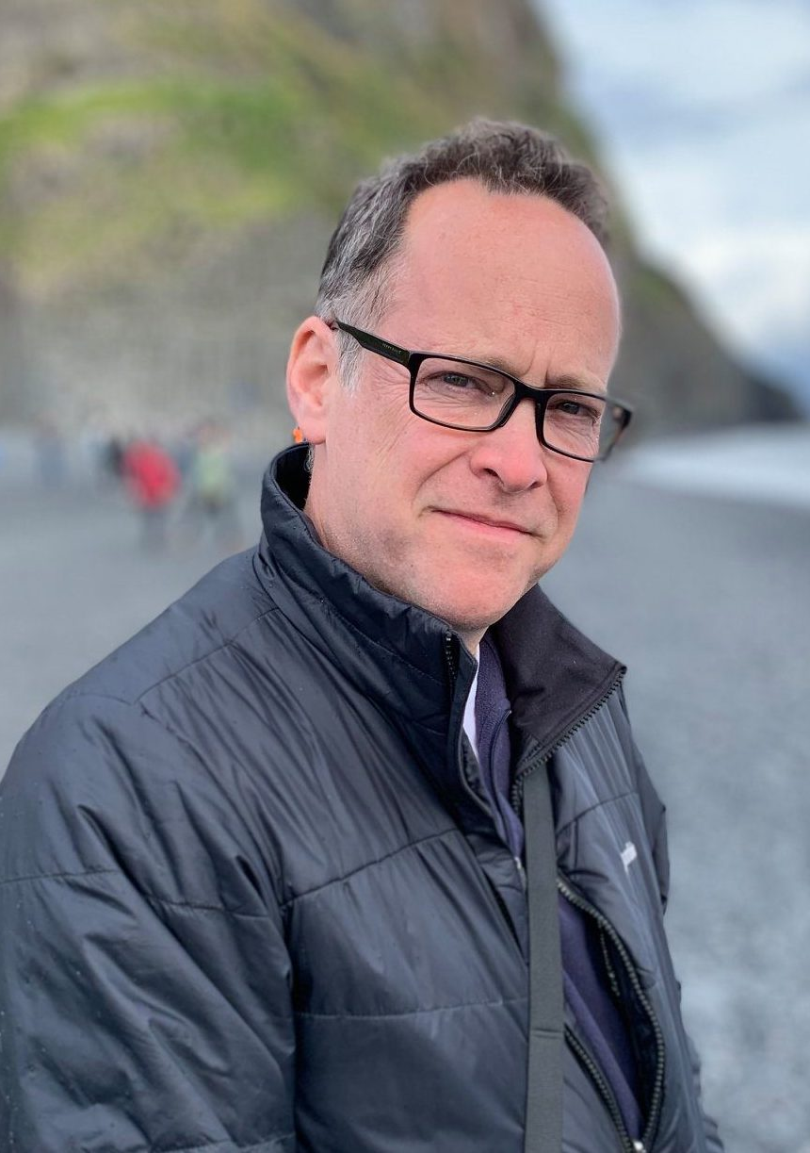
Bill Margol, Senior Director, General Audience Programming & Development, PBS
Bill Margol has spent over 30 years working in the media industry, covering the ground of writer, producer, editor, developer and executive. A graduate of Syracuse University's S.I. Newhouse School of Public Communications and Loyola University’s Masters in Emerging Media program, Bill was Executive Producer of Special Projects at Sci-Fi Channel, overseeing specials, documentaries, stunts and events from 1993-1998. He joined TNT in Atlanta as Director of Production in 1998, and in 2003, joined Travel Channel as VP of Production, where he was responsible for the launch of such groundbreaking series as “Anthony Bourdain: No Reservations.” In 2008, Bill joined National Geographic Television as VP Development, where he created the Emmy-nominated series "Brain Games.”

In 2014, Bill joined PBS as Sr. Director of Programming & Development, and has overseen such programs as the Emmy-winning documentary A YEAR IN SPACE, the groundbreaking series WE’LL MEET AGAIN WITH ANN CURRY, as well as programming such as 8 DAYS: TO THE MOON AND BACK, BIG BLUE LIVE, IN THEIR OWN WORDS, LIFE FROM ABOVE, BEYOND A YEAR IN SPACE, GENIUS: WITH STEPHEN HAWKING and WILD ALASKA LIVE.

