FAMILY PICTURES USA
TCA Bios
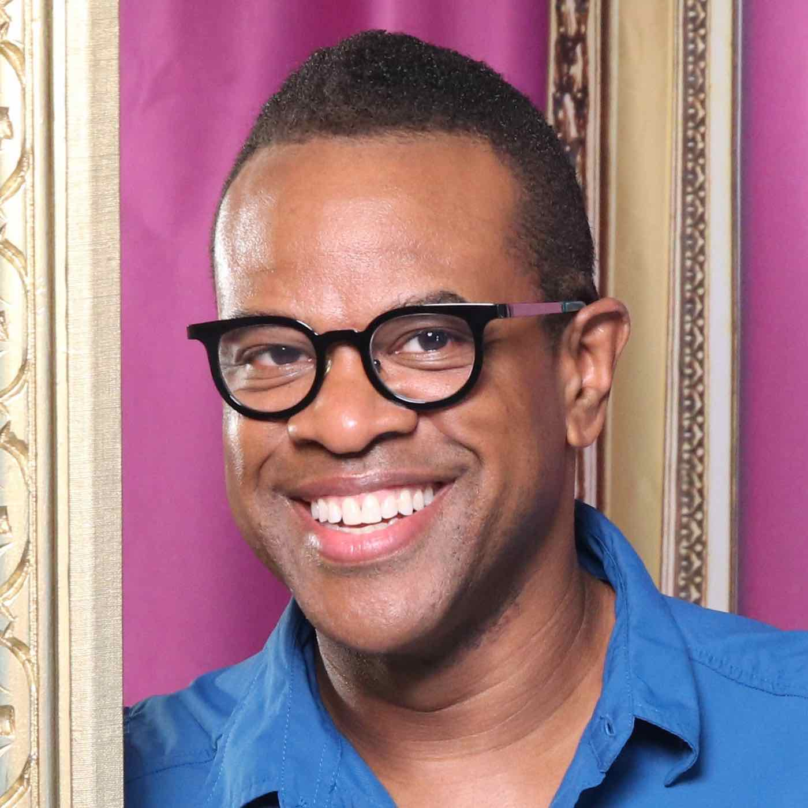
Thomas Allen Harris (Host and Executive Producer) is a filmmaker and artist whose work across film, video, photography and performance illuminates the human condition and the search for identity, family and spirituality. Graduate of Harvard College and the Whitney Independent Study Program, member of the Academy of Motion Pictures Arts and Sciences and published writer/curator, Harris lectures widely on the use of media as a tool for social change. Harris is Senior Lecturer at Yale University, jointly appointed in African American Studies and Film and Media, where he teaches courses and curates exhibitions related to FAMILY PICTURES USA.

His deeply personal films — VINTAGE-Families of Value (1995), É Minha Cara/That’s My Face (2001) and The Twelve Disciples of Nelson Mandela (2005) — have received critical acclaim at international film festivals such as Sundance, Berlin, Toronto, FESPACO, Outfest, Flaherty and Cape Town. His most recent feature film, Through a Lens Darkly: Black Photographers and the Emergence of a People (2014), which looks at the ways photographs serve as tools of representation and self-representation through history, was nominated for both an Emmy and a Peabody, and won over seven international awards including the 2015 NAACP Image Award for Outstanding Documentary Film. His latest short film, About Face: The Evolution of a Black Producer (2017), had its premiere on World AIDS Day at the Whitney Museum of American Art and over 100 institutions worldwide as part of Visual AIDS’ 28th annual Day With(out) Art.

In 2009, Harris founded Digital Diaspora Family Reunion, LLC (DDFR), a social engaged transmedia project that has incorporated community organizing, performance, virtual gathering spaces and storytelling into over 70 unique audio-visual events in over 65 cities. With this project, Harris has toured nationally and internationally, most recently as a Montgomery Fellow at Dartmouth College and at the Yale University Afro American Cultural Center, to invite individuals to explore and share the rich and revealing narratives found within their family photo albums. To date, DDFR has brought over 4500 people together in live events and gathered in excess of 30,000 images, sharing content through social media, television, articles, newspapers, and radio to receive over 70 million impressions worldwide. Harris is bringing DDFR to national television with FAMILY PICTURES USA.

Zulaika Quintero (Participant) is principal of Immokalee Community School, a public charter elementary school with 250 students in the agricultural heart of Florida. The area received national attention as the subject of Edward R. Murrow’s 1960 documentary “Harvest of Shame,” which depicted the terrible plight of area migrant workers. Originally from Zacatecas, Mexico, the Quintero family emigrated to Immokalee when Zulaika was five years old; they too found employment in the Florida fields. After years of harvesting produce, Zulaika’s father and oldest brother Felipe decided to open their own company. Brother Jose was the first in the family to graduate from college and Zulaika followed in his footsteps, receiving an academic scholarship from the University of Florida. As principal of Immokalee Community School, Zulaika remains connected to her former life through her students, 90% of whose families work in the fields.


Zulaika shares photos of her family working in the fields with her students so they will know that she has had similar experiences. She is also teaching them the importance of family photos. “We didn’t have a lot of photos of us growing up,” she says. “It makes me reflect on what it’s like not to have those images. I just feel like we need more.”
Clint Raulerson (Participant) is a fifth-generation cowboy who oversees more than 2000 head of cattle in Immokalee, Florida, on several ranches, one of which is owned by the granddaughter of the man for whom his grandfather worked. Of English descent traceable back to 1690, Clint married his high school sweetheart, Diane, a Mexican American woman born in Miami, who grew up in Immokalee. They raised three daughters and have three grandchildren with another on the way. Clint competes in rodeo and is a poet.
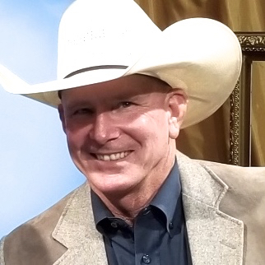

Looking through his family photos, Clint says, “Nowadays, we put pictures on phones and erase them. All these family photographs aren't edited — there are no filters. They're just here and that's what makes them perfect.”

