FAMILY PICTURES USA EXPLORES OUR SHARED HISTORY THROUGH THE TREASURED PHOTOGRAPHS THAT
TELL OUR STORIES

New Three-Part Series Premieres Monday and Tuesday, August 12-13, on PBS

Producer and Host Thomas Allen Harris Travels Across the Country, Meeting People Whose Family Photos Reveal Our Nation’s History,
Diversity and Common Values

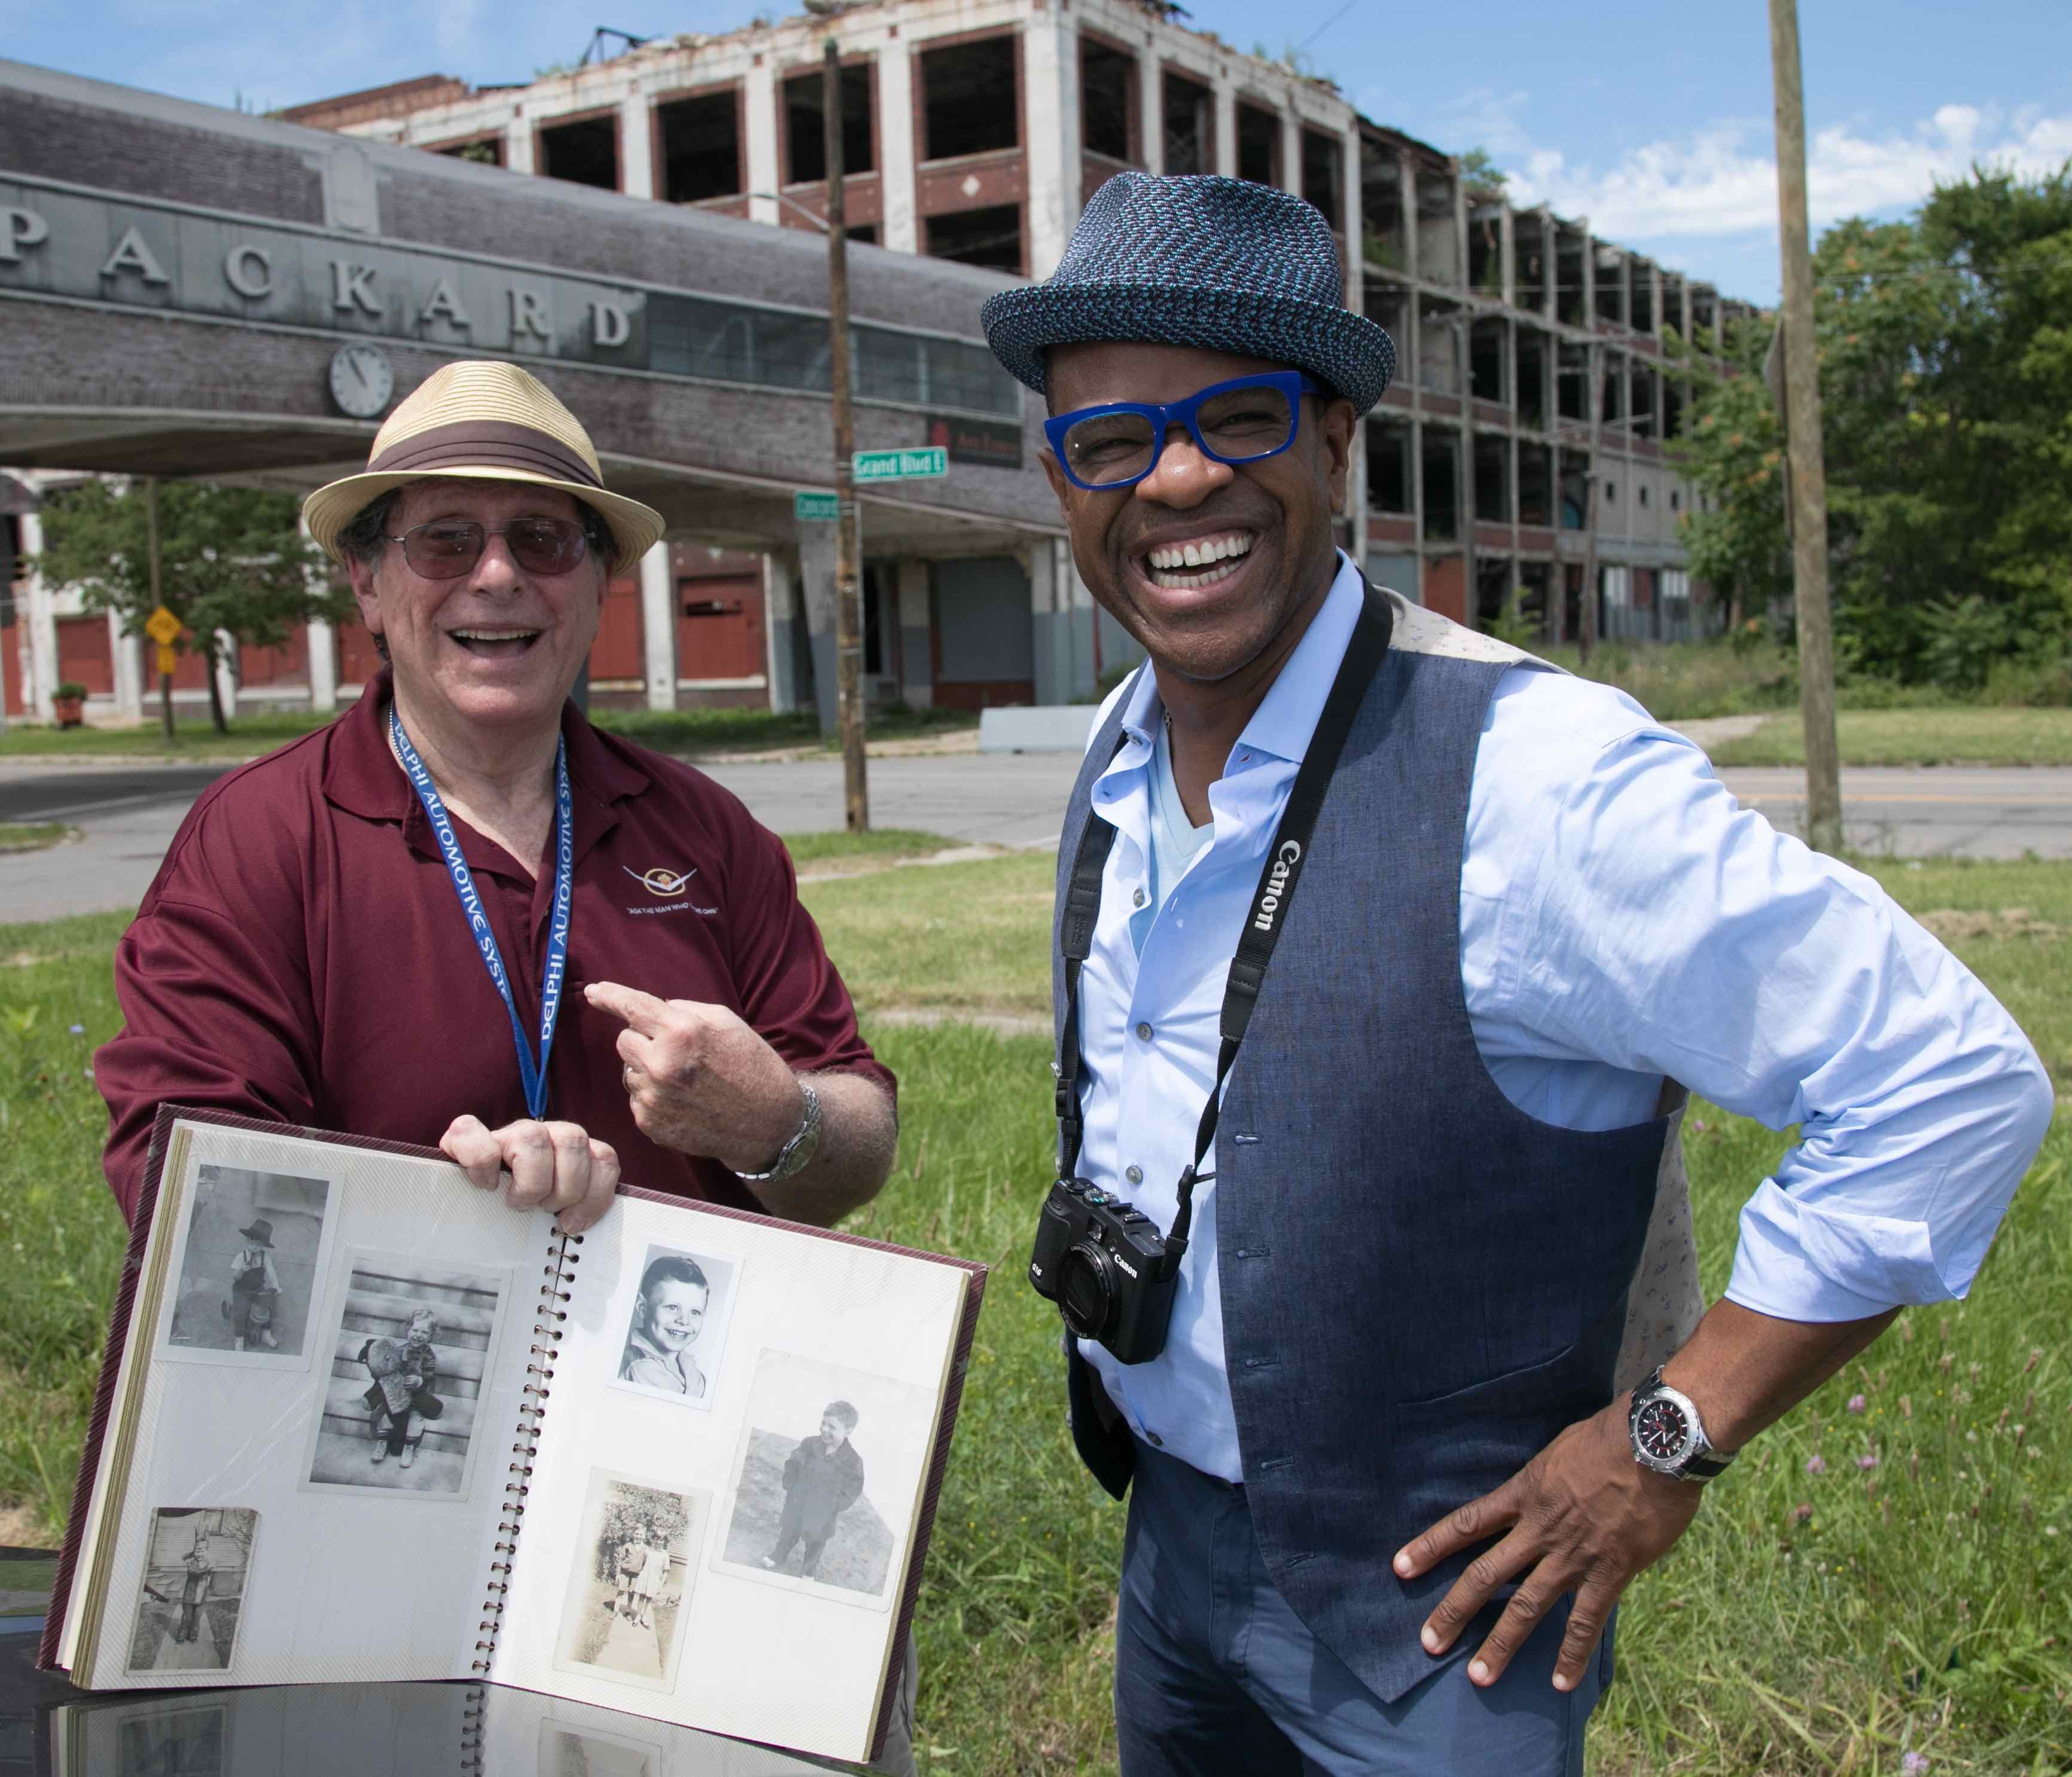
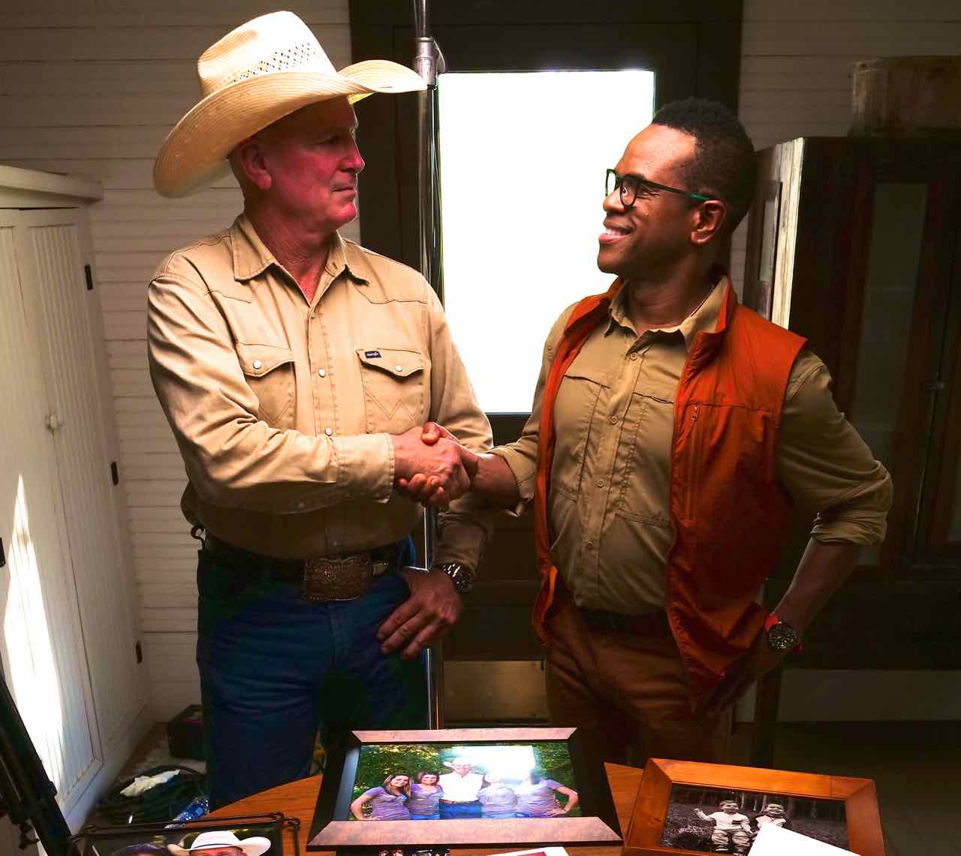
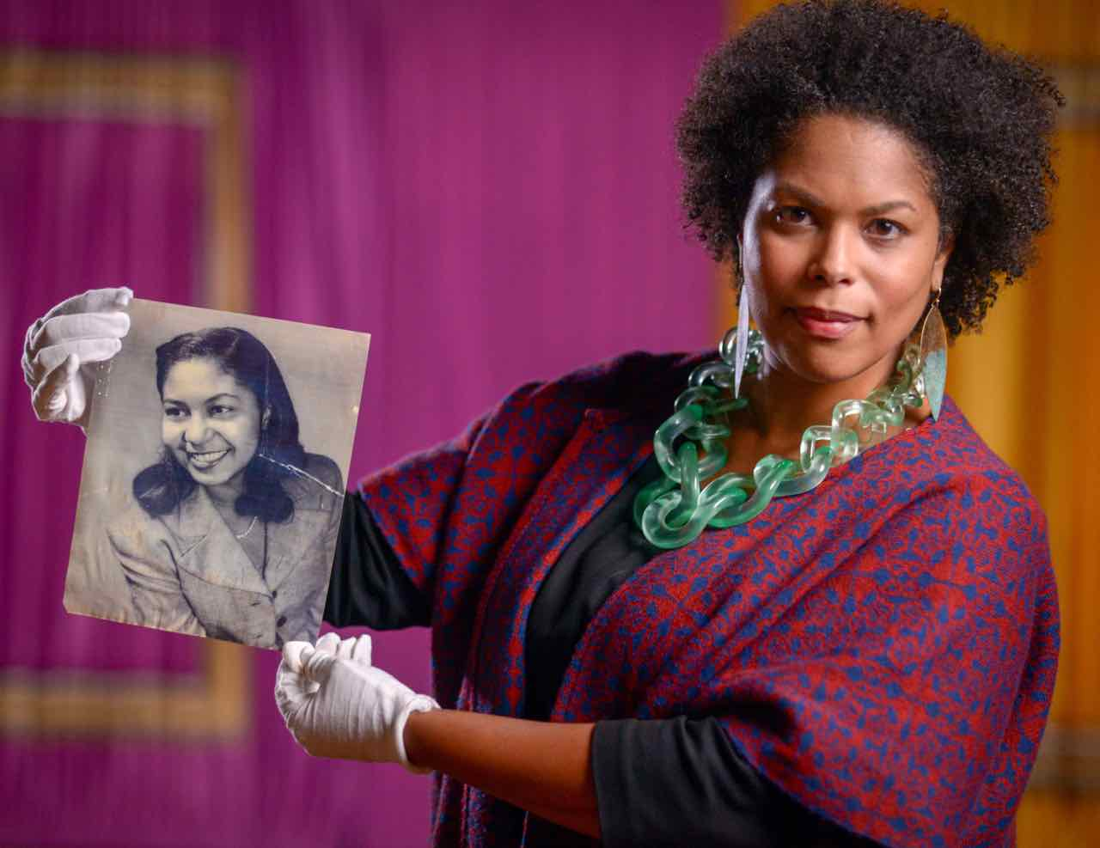

ARLINGTON, VA — FAMILY PICTURES USA, a new three-part PBS series created and hosted by filmmaker and photographer Thomas Allen Harris, explores American cities, towns and rural communities through the lens of the family photo album, unearthing rich personal stories that expand our understanding of our shared history, diversity and common values. Family photos of everyday milestones — marriage, childhood, a new car, a growing business — provide a visual portal through which to examine the roots, surprising connections and provocative parallels that shed light on our collective past and our shared future. From the streets of Detroit to the shores of Southwest Florida to the farm fields of North Carolina, participants introduce ancestors, parents and old friends — fascinating characters brought to life through a treasure trove of images and stories handed down through generations. Produced in partnership with Detroit Public Television, UNC-TV Public Media North Carolina and WGCU Public Media, FAMILY PICTURES USA premieres Monday, August 12, 9:00-10:00 p.m. ET and Tuesday, August 13, 8:00-10:00 p.m. (check local listings) on PBS, PBS.org and the PBS Video App.

Each episode of FAMILY PICTURES USA begins at a community photo-sharing event, where people present images long stored in photo albums or stashed away in dusty boxes. Using these pictures as a starting point, Thomas engages participants in conversation, guiding them through stories of hardship, perseverance and love. The series then goes on location in their communities to expand these family narratives into a deeply personal people’s history of the region.

“For the past 150 years, families have used the photo album to pass on their stories from one generation to the next,” said Harris. “The family album has kept us together. But in today’s digital age, we have to work harder to keep and maintain the stories of our families and our communities. Everyone is a photographer, but the stories and communities behind our photos are being lost. FAMILY PICTURES USA strives to keep these stories alive and – by sharing them – remind us of our common roots and strengthen connections with our friends, families and neighbors.”

“Meaningful content and local community engagement are vital parts of public media’s service mission. FAMILY PICTURES USA leverages these elements on both national and local levels to underscore public media’s value,” said Maja Mrkoci, CPB Chief Content Officer. “We are excited by the possibilities of this innovative approach, and look forward to learning more about our shared history through the lens of the family photo album.”

With an economy founded on tobacco and textiles, “North Carolina” (Monday, August 12, 9:00 p.m. ET) is a historically rural state that is changing rapidly. Through family photos, we learn how tobacco money transformed Durham from a sleepy small town into a prosperous city with a thriving African American middle class and a financial district known as “Black Wall Street.” Outside of Burlington, the Occaneechi Band of the Saponi Nation have repurchased ancestral lands to serve as a legacy for their children and a cultural and educational gathering place for the tribe. Families long separated by race and class are finding healing through recognizing their kinship as black and white descendants from the same ancestors. And a sign of the new North Carolina is found in a church headed by a Korean American pastor whose mission is to help integrate the region’s latest immigrants into the community.

In America’s comeback city, “Detroit” (Tuesday, August 13, 8:00 p.m. ET), the series introduces descendants of both Native Americans and slaves whose ancestors helped build the city. Thomas visits the oldest hat store in the U.S. and learns about a border wall paid for by the U.S. government that was constructed to separate black and white neighborhoods. One of America’s most prosperous cities in 1960, Detroit’s rise and fall and rise again is revealed through personal photos and stories of the city’s proud inhabitants. The enormous influence of the auto industry, the rise of labor unions, cultural touchstones like the Motown sound, the devastating impacts of the 1967 riots and the city’s renaissance today are all explored via family narratives and memories, expanding our understanding of Detroit and its multilayered story.

FAMILY PICTURES USA also visits Fort Myers and the Paradise Coast of “Southwest Florida” (Tuesday, August 13, 9:00 p.m. ET), a tropical region that stretches from Caloosahatchee River to the Everglades, where Native Americans, cattle ranchers, members of fishing communities and restaurateurs recount their family stories with pride. In rural Immokalee, we learn that Florida is still cattle country and meet former migrant workers who now own the companies that harvest produce. Descendants of Seminole leader Osceola preserve their tribal way of life and pass down centuries-old traditions to their children. An African American family confronts the divisions of the past and moves forward as they uncover the story of their pioneering bi-racial ancestor and meet their white relatives. And in a surprise twist, a couple who successfully saved Estero Bay and formed the state’s first aquatic preserve meet the woman whose father tried to develop it.

FAMILY PICTURES USA invites viewers to share their own images and stories, which will be aggregated across social media and posted to the Digital American Family Album.

FAMILY PICTURES USA is a co-production of Digital Diaspora Family Reunion, LLC and ITVS in association with Center for Asian American Media (CAAM) and Black Public Media (BPM) for PBS. The series is created by Executive Producers Thomas Allen Harris & Don Perry, and hosted by Thomas Allen Harris.

FAMILY PICTURE USA is presented by UNC-TV Public Media North Carolina and WGCU Public Media.

Support for FAMILY PICTURES USA is provided by the Corporation for Public Broadcasting, Wyncote Foundation, Ford Foundation, Oasis Senior Advisors, ElectriCities and Capitol Broadcasting Company.

About Thomas Allen Harris
Thomas Allen Harris is a filmmaker and artist whose work across film, video, photography, and performance illuminates the human condition and the search for identity, family, and spirituality. Graduate of Harvard College and the Whitney Independent Study Program, member of the Academy of Motion Pictures Arts and Sciences, and published writer/curator, Harris lectures widely on the use of media as a tool for social change. Harris is Senior Lecturer at Yale University, jointly appointed in African American Studies and Film and Media, where he teaches courses and curates exhibitions related to FAMILY PICTURES USA.
His deeply personal films — VINTAGE-Families of Value (1995), É Minha Cara/That’s My Face (2001), and The Twelve Disciples of Nelson Mandela (2005) — have received critical acclaim at international film festivals such as Sundance, Berlin, Toronto, FESPACO, Outfest, Flaherty, and Cape Town. His most recent feature film, Through a Lens Darkly: Black Photographers and the Emergence of a People (2014), which looks at the ways photographs serve as tools of representation and self-representation through history, was nominated for both an Emmy and Peabody, and won over seven international awards including the 2015 NAACP Image Award for Outstanding Documentary Film. His latest short film, About Face: The Evolution of a Black Producer (2017) had its premiere on World AIDS Day at the Whitney Museum of American Art and over 100 institutions worldwide as part of Visual AIDS’ 28th annual Day With(out) Art.

In 2009, Harris founded Digital Diaspora Family Reunion, LLC (DDFR) a social engaged transmedia project that has incorporated community organizing, performance, virtual gathering spaces and storytelling into over 45 unique audio-visual events in over 30 cities. With this project, Harris has toured nationally and internationally, most recently as a Montgomery Fellow at Dartmouth College and at the Yale University Afro American Cultural Center, to invite individuals to explore and share the rich and revealing narratives found within their family photo albums. To date, DDFR has brought over 3000 people together in live events and gathered in excess of 30,000 images, sharing content through social media, television, articles, newspapers, and radio to receive over 70 million impressions worldwide. Harris is bringing DDFR to national TV with FAMILY PICTURES USA.

About the Corporation for Public Broadcasting
The Corporation for Public Broadcasting (CPB), a private, nonprofit corporation created by Congress in 1967, is the steward of the federal government’s investment in public broadcasting. It helps support the operations of more than 1,500 locally owned and operated public television and radio stations nationwide. CPB is also the largest single source of funding for research, technology and program development for public radio, television and related online services. For more information, visit cpb.org, follow us on Twitter @CPBmedia, Facebook and LinkedIn
and subscribe for other updates.

About Detroit Public Television
Detroit Public Television (DPTV) is Michigan's only community-licensed public television station, operating entirely independent of any educational institution or governmental entity. Its funding comes from the community it serves. With more than 2 million weekly viewers across its four channels, DPTV is the state's largest and most watched public television station, as well as having the most diverse public television audience in America. In addition, another 90,000 visit its website dptv.org each week for videos, blogs, photo galleries and other content. DPTV also manages WRCJ 90.9 FM, Detroit's classical and jazz radio station, which reaches nearly 200,000 listeners each week over the air or on digital devices. DPTV is licensed to the Detroit Educational Television Foundation and governed by a volunteer board of trustees from the local business, civic and cultural communities.

About UNC-TV Public Media North Carolina
On air, online and in person, UNC-TV Public Media North Carolina connects North Carolinians to each other, the world and endless possibilities. Through its unique partnership of public investment and private support, the statewide network includes in-person engagement, digital-first social and online content delivery, and four over-the-air channels—UNC-TV PBS & More, the North Carolina Channel, Rootle 24/7 PBS KIDS and the Explorer Channel. Additionally, it provides emergency services support for the state and free educational services and resources for teachers. Visit unctv.org and join the conversation by connecting with us at facebook.com/publicmediaNC, instagram.com/publicmediaNC and @publicmediaNCon Twitter.

About WGCU Public Media
WGCU is Southwest Florida’s source for PBS and NPR programming. As a member-supported service of Florida Gulf Coast University, WGCU’s mission is to provide educational programming that inspires, informs and engages our community. Serving seven counties, representing one-fifth of the state of Florida, with five distinct digital TV channels, two FM radio channels and two HD radio channels and multiple websites, WGCU delivers national and international programming and develops, produces and delivers relevant, informative and educational local programs to the Southwest Florida community.

WGCU provides alerts and information about weather emergencies and other critical situations to the Southwest Florida region as a member of FPREN, the Florida Public Radio Emergency Network. More information about WGCU is available online and by following us on Facebook.

###

CONTACTS:
CaraMar Publicity
Mary Lugo, 770-623-8190, lugo@negia.net
Cara White, 843-881-1480, cara.white@mac.com
Abbe Harris, 908-244-5516, abbe.harris@caramar.net

For additional information and photos visit http://www.pbs.org/pressroom

