FIGHT THE POWER: HOW HIP HOP CHANGED THE WORLD
TCA Panelist Bios

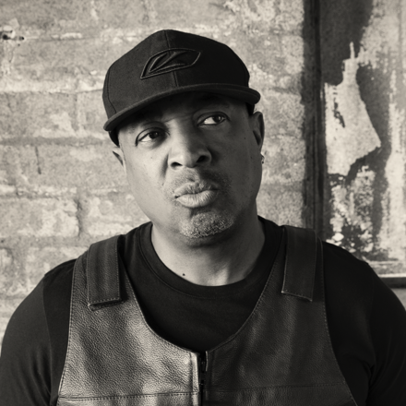
Chuck D is the leader and co-founder of the legendary rap group Public Enemy, a social activist, multimedia producer, visual artist and digital music pioneer. He has been featured in more than 100 documentaries on music, technology, politics and race, and co-curated the Smithsonian Anthology of Hip Hop. He has also been a national spokesperson for Rock the Vote, the National Urban League, Americans for the Arts Council and the National Alliance of African American Athletes, is a member of the Rock and Roll Hall of Fame and has earned a GRAMMY Lifetime Achievement Award.

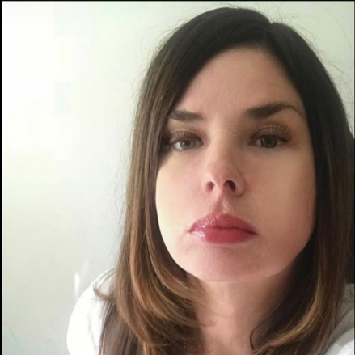
Lorrie Boula is Chuck D's longtime producing partner. Together they are committed to telling the stories of unique cultural icons and significant moments in time, with a focus on elevating people of color, women and outliers, across all media platforms.

Some of Boula’s credits include executive producer of PBS’s FIGHT THE POWER: HOW HIP HOP CHANGED THE WORLD, NFL Network's "The Superbowl That Wasn't,” The MTV docu-series "Rebel Music,” and producer for award-winning documentary shorts "Manifest Hope: DC” and "Obey The Artist.”

For the podcast space, she has produced Apple's "Shattered: Story of The Knicks," Spotify's "Born Free: Story of The Clash" and the Audible Original "Songs That Shook The Planet."
She also co-authored the best-selling book This Day in Rap and Hip-Hop History alongside Chuck D, published in 2017.

A 25+-year veteran of the entertainment industry, Boula is also president and founder of Soul Kitchen Music, an artist management and consulting company. Boula was previously vice president of marketing at Warner Bros. Records and was a marketing and artist development executive at Interscope and Geffen Records.

She was born and raised in the South Bronx and still remembers her first uprock.
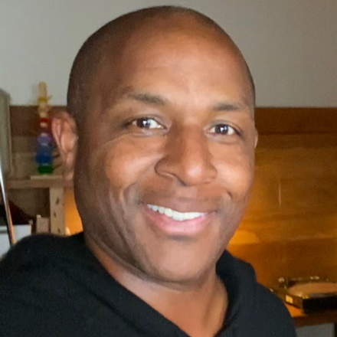
Todd L. Williams (writer / producer / director) has been fascinated with the media multiverse since he first sat mesmerized by the special effects of Star Wars, obsessively played video game Pong, pressed record on a Magnavox camcorder and listened to the sonic revolution of “Rapper’s Delight.” Woke ever since, he’s spent decades crafting thought-disrupting, pop-culture minded docs, TV shows, shorts and other media ephemera. In 2004, Williams was awarded the prestigious Peabody Award for writing and directing the feature documentary The N Word (Samuel L. Jackson, Whoopi Goldberg, Chris Rock, et al.), which examined the power and pain of the centuries-old epithet.

His professional career started as a freelance journalist, covering pop culture for Spin, Elle, Premiere, Interview, Rap Pages and Essence. Later, he joined notorious hip hop magazine The Source as a full-time editor. With a move to Los Angeles, he realized a lifelong dream to work in TV and film. First hired as a segment producer on the late-night show “The Keenan Ivory Wayans Show,” he quickly earned his stripes as a freelance producer, working on “Russell Simmons’ One World Music Beat,” FOX’s TV Guide’s Truth Behind the Sitcom” and VH1’s docu-series “Behind the Music” (Public Enemy, Salt N Pepa, Jennifer Lopez).

In 2002, he formed Post Consumer Media (PCM), a full-fledged production company, which specialized in DVD Added Value for clients Sony, MGM, Paramount, FOX and New Line. PCM afforded him the opportunity to create a range of projects—feature-length docs such as The N Word and Black Church, Inc.; “Wonderful Life of Michael Gruber,” a comedy film short with Academy Award winners Jamie Foxx and George Clooney; and scripted drama series “Black Book Diaries,” which he conceived and executive produced for BET networks.

In more recent years, he’s produced and directed for VH1’s Rock Doc division, serving as writer and director of Defest Story Ever Told, a 90-minute documentary about legendary hip hop label Def Jam. Returning to his docu-series roots, Williams embedded himself with a film crew for “Streets of Compton” (A&E), chronicled the life of rap icon “Biggie” (A&E) and explored history’s impact on music in the CNN docuseries “Soundtracks.” The last decade saw him pivot toward more dramatic fare, which included producing and directing the docudramas “Legends & Lies” (FNC) and “The History of Cars” (History Channel). In 2019, he embarked on an ambitious three-part investigative series that deconstructs the assassination of Dr. Martin Luther King: “The Plot to Kill King” (VIACOM+) His most recent project was writing and directing a documentary about a Maryland furnace run by slaves during Revolutionary War and the War of 1812, called “Catoctin” (Smithsonian).

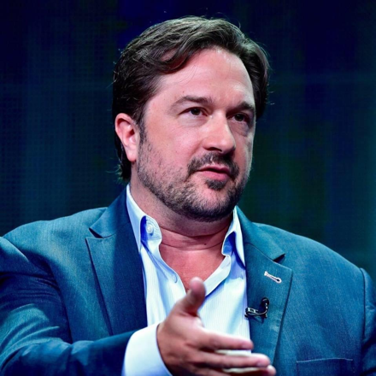
As Vice President, Multiplatform Programming & Head of Development, Bill Gardner oversees PBS content strategy, development and production across platforms and formats in the genres of History, Science, Natural History and Arts & Culture. He and his team work closely with flagship PBS strands such as NATURE, NOVA, AMERICAN MASTERS and GREAT PERFORMANCES as well as managing a large portfolio of series and premier documentaries in collaboration with PBS stations, public media organizations, and independent producers and content creators.

Gardner and team especially emphasize the development of projects that feature significant outreach, education and digital content components, with particular focus on climate and the environment, and contemporary cultural history, identity and artistic expression.

Gardner also specializes in assembling blue-chip co-productions with partners across the globe, from public broadcasters to commercial networks and new media platforms to international impact organizations. He helped launch and leads the PBS-BBC co-production partnership, which provides dozens of hours of premium multiplatform factual content to the PBS schedule each year such as SPY IN THE WILD, THE PLANETS and THE GREEN PLANET in the Science and Natural History genres and BASQUIAT: RAGE TO RICHES, 8 DAYS and CIVILIZATIONS in the History, Arts & Culture space.

Since joining PBS in 2012, projects he has overseen have won three Emmy Awards, two Peabody Awards, two duPont-Columbia Awards, an Imagen Award, an NAACP Image Award, a James Beard Award, and numerous Jackson Wild and Wildscreen Awards. International co-productions he has co-created, developed or commissioned have also earned several BAFTA, Grierson and IDA Awards in Europe.

During this time, PBS rose from the 12th to the sixth-most watched linear network in the United States, reaching hundreds of millions of viewers annually across platforms. Gardner’s commissions and strategies have helped make PBS the #1 multicaster in unscripted content and routinely attract younger, more diverse content creators and audiences to PBS.

Other recent projects include major PBS specials and series such as America Outdoors with Baratunde Thurston; Finding Your Roots; The Farthest- Voyager in Space; The Age of Nature; Native America; The African Americans: Many Rivers to Cross, The Black Church: this is Our Story, this is Our Song; Reconstruction: America After the Civil War; Latino Americans; Makers: Women Who Make America; American Epic and Soundbreaking: Stories from the Cutting Edge of Recorded Music.

Before joining PBS, Gardner was executive producer at Discovery Studios, where he developed and produced national and global productions in the documentary, reality, lifestyle and CGI genres for multiple networks with partners such as the NFLPA, Petfinder.com and the Department of Defense. Prior to that, he spent over a decade in the independent production world, working as director, producer, writer and showrunner on projects for multiple networks both in the U.S. and globally, including National Geographic, CNN, Discovery and the History Channel. He has produced programs in over 30 countries and spent two months embedded with U.S. Special Forces investigating the looting of Baghdad’s Iraq museum in 2003. During this time, he was the first Westerner to film inside the holy Shi’a shrines of Abbas and Hussein in Karbala.

Gardner holds a master’s degree in cultural anthropology and has taught university courses in Arkansas and Marrakech, Morocco. He serves on several advisory boards and is presently board chair of the Jackson Wild Film Festival and Summit, where he helped launched the Jackson Wild Collective, a global database of local and indigenous filmmakers dedicated to diversifying the wildlife media community.

