PBS Explores Humankind’s First Arrivals in FIRST PEOPLES

New Five-Part Series Examines How Homo sapiens
Moved Around the Globe to Become its Dominant Human Species

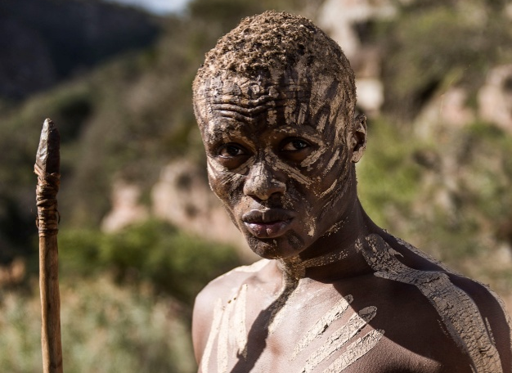

First Peoples - 200,000 years ago on the African savanna Credit: Graham Bartholomew

ARLINGTON, VA; April 16, 2015
200,000 years ago our ancestors took their first steps on the African savanna. Today, seven billion of us live across the planet. How did we beat the odds and spread from continent to continent?

FIRST PEOPLES is a global detective story that traces the arrival of the first Homo sapiens on five continents. Airing Wednesdays on June 24-July 1 at 9:00 and 10:00 p.m. ET and July 8 at 9:00 p.m. ET, FIRST PEOPLES is part of PBS’ “Think Wednesday” programming block (watch a clip here.)

FIRST PEOPLES tells the story of how early Homo sapiens moved around the globe and became the dominant human species. Each episode of the five-part series focuses on a different continent and meets the earliest Homo sapiens on that continent – the Americas, Africa, Asia, Australia and Europe. Where did they come from? How did they get there? What role did art, culture and technology play in their lives? Whom did they meet along the way? It used to be thought our ancestors kept a distance from other types of human. But now DNA reveals they mated with them and interbred. As a result, our species is a patchwork of modern and ancient humans – we are all hybrids.

“Scientific developments in genetics have dramatically changed the thinking of who we are as a species and where we came from,” said Beth Hoppe, PBS’ Chief Programming Executive and General Manager of General Audience Programming. “The story that FIRST PEOPLES tells is vastly different from the story of our origins we knew just five or ten years ago. This cinematic, extraordinary series of films is up-to-the-minute science; the kind of program people expect from PBS.”

“FIRST PEOPLES is the first chance most people will get to see extraordinary new research in human origins brought to life – real science, happening in remote places around the globe, with an international team of leading scientists,” said John Hawks, a paleoanthropologist at University of Wisconsin, Madison who worked as a consultant and appears in each episode. “FIRST PEOPLES is grounded in the latest genetics, archaeology and anthropology research, yet it also shines a light on different viewpoints from an indigenous perspective.”

With a camera crew winging its way around the world, FIRST PEOPLES dives into the underwater caves of Yucatan, soars above the Australian outback and journeys to the Himalayas. In every location, key experts are on hand to reveal their findings, but the biggest breakthroughs are taking place in genetic laboratories. It is now possible to extract high quality DNA from ancient fossils, and the sequences that emerge are re-writing the human story.

“Throughout our filming, we learned that our family tree is not a simple one. It looks more like a bush, with interweaving branches and tangled roots. We are the product of many species that were similar and different at the same time,” said Tim Lambert, series producer, Wall to Wall Media “Using dramatic reenactments and movie style prosthetics, we have tried to tell this compelling story and explain how our ancient ancestors survived and ultimately thrived.”

Descriptions of each episode are below:

Episode 1 - Americas
As early humans spread out across the world, their toughest challenge was colonizing the Americas because a huge ice sheet blocked the route. It has long been thought that the first Americans were Clovis people, who arrived 13,000 years ago. But an underwater discovery in Mexico suggests people arrived earlier — coming by boat, not on foot. How closely related were these early Americans to today’s Native Americans? It’s an emotive issue, involving one of the most controversial fossils in the world, Kennewick Man. Wednesday, June 24, 9:00 p.m. ET

Episode 2 - Africa
200,000 years ago, a new species, Homo sapiens, appeared on the African landscape. While scientists have long imagined eastern Africa as a real-life Garden of Eden, the latest research suggests humans evolved in many places across the continent at the same time. Now, the DNA of a 19th-century African-American slave reveals that during the early days of our species, our ancestors continued meeting, mating and hybridizing with other human types in Africa — creating ever greater diversity within us. Wednesday, June 24, 10:00 p.m. ET

Episode 3 - Asia
What happened when early humans ventured out of Africa and into Asia? Where did they go and whom did they meet along the way? The latest evidence suggests they left far earlier than previously thought and interbred with a newly discovered type of ancient human — the Denisovans, whose existence was established only four years ago when geneticists extracted DNA from a tiny fragment of finger bone. Because our ancestors mated with them, their genes found a home within our DNA. More than that, they’ve helped us survive and thrive. Wednesday, July 1, 9:00 p.m. ET

Episode 4 - Australia
When humans arrived in Australia, they were, for the first time, truly alone, surrounded by wildly different flora and fauna. How did they survive and populate a continent? There is a close cultural and genetic link between early Australians and modern-day Aborigines; here the ancient and modern story intersect as nowhere else. The secret to this continuity is diversity. Intuitively, early Australians found the right balance between being separate and connected. Wednesday, July 1, 10:00 p.m. ET

Episode 5 - Europe
When Homo sapiens turned up in prehistoric Europe, they ran into the Neanderthals. The two types of human were similar enough to interbreed — and both created artifacts of similar complexity. As more and more Homo sapiens moved into Europe, the balance of power shifted. Neanderthals were overwhelmed. Ever since, we’ve had Europe and the rest of the world to ourselves. Wednesday, July 8, 9:00 p.m. ET

FIRST PEOPLES is produced for PBS by Wall to Wall Media, one of the UK's leading production companies, making high quality shows for broadcasters across the world. Series producer, Tim Lambert, has made a number of shows about the crossover between science and history, including Guns, Germs & Steel (PBS); Neanderthal Code (National Geographic); Mankind - The Story of All of Us (History). Executive Producer, Jonathan Hewes has overseen major series for PBS including Black in Latin America and America Beyond the Color Line with Henry Louis Gates Jr. For PBS the series was overseen by Bill Gardner, VP, Programming and Development, and Bill Margol, Senior Director, Programming and Development.

PBS LearningMedia will add FIRST PEOPLES resources in June to its growing library of digital assets for teachers and students. New material includes program clips, support materials, and an interactive map that allows users to track the migration routes Homo sapiens took as they moved out of Africa and journeyed across the world. Visit PBS LearningMedia (pbslearningmedia.org) to access these free resources.

First Peoples will be available on DVD from PBS Distribution: ShopPBS.org; 800-PLAY-PBS, 24 hours a day, 7 days a week. The film will also be available for digital download.
About PBS
PBS, with over 350 member stations, offers all Americans the opportunity to explore new ideas and new worlds through television and online content. Each month, PBS reaches more than 103 million people through television and over 33 million people online, inviting them to experience the worlds of science, history, nature and public affairs; to hear diverse viewpoints; and to take front row seats to world-class drama and performances. PBS’ broad array of programs has been consistently honored by the industry’s most coveted award competitions. Teachers of children from pre-K through 12th grade turn to PBS for digital content and services that help bring classroom lessons to life. PBS’ premier children’s TV programming and its website, pbskids.org, are parents’ and teachers’ most trusted partners in inspiring and nurturing curiosity and love of learning in children. More information about PBS is available at www.pbs.org, one of the leading dot-org websites on the Internet, or by following PBS on Twitter, Facebook or through our apps for mobile devices. Specific program information and updates for press are available at pbs.org/pressroom or by following PBS Pressroom on Twitter.

– PBS –

For additional information, photos, interviews and more, contact Goodman Media or PBS:

Nisa Kiang / John Michael Kennedy Ellen Stanley Booth / Colleen Flanagan
Goodman Media International PBS
212-576-2700 esbooth@pbs.org; 703.739.5120
PBSProgramming@goodmanmedia.com crflanagan@pbs.org703 739-8130

For images and additional up-to-date information on this and other PBS programs, visit PBS PressRoom at pbs.org/pressroom.

