FOOD − DELICIOUS SCIENCE, A PBS AND BBC CO-PRODUCTION, SEEKS WHAT TEMPTS OUR TASTEBUDS WITH A MOLECULAR EXPLORATION INTO THE FOOD WE EAT

–Part of PBS’ Food-Themed Program Buffet, the Fun Begins Wednesday, May 17, 2017 –

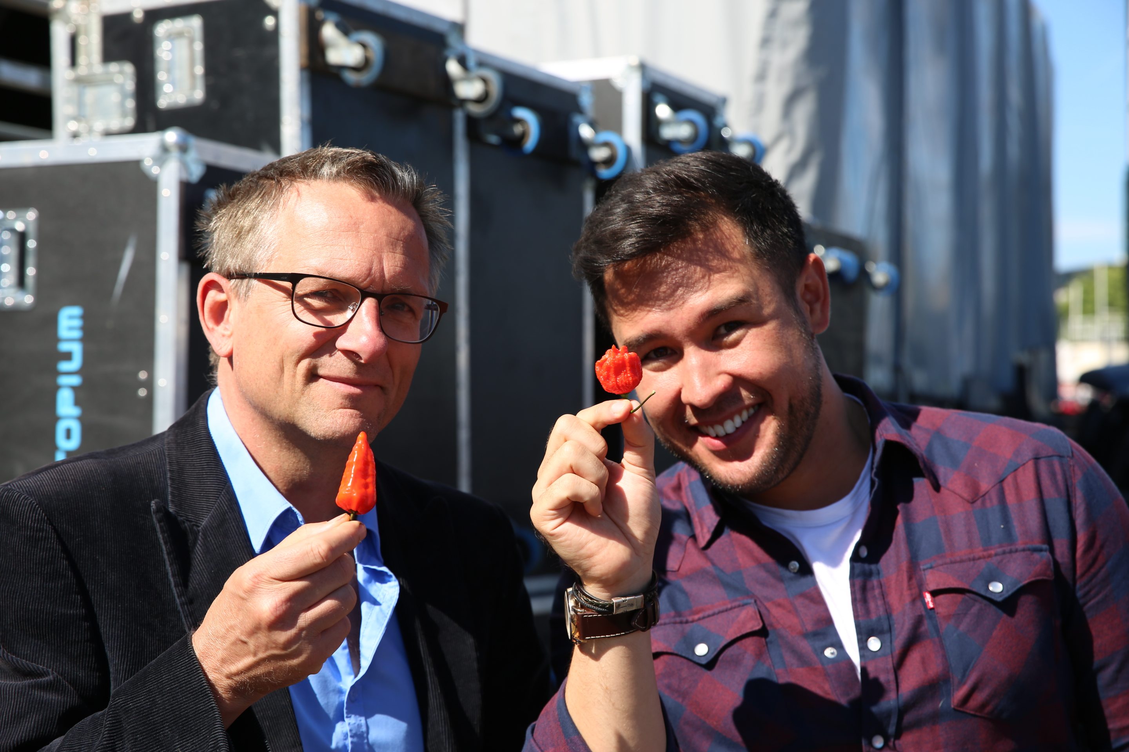
ARLINGTON, VA; April 25, 2017 – On Wednesday, May 17, PBS serves up the premiere of FOOD − DELICIOUS SCIENCE, a three-part series that travels the world and breaks down the natural history, chemistry and biology of food, offering a fun, startling and completely new view of what we eat and why we eat it. Co-produced with the BBC, FOOD − DELICIOUS SCIENCE airs 10:00-11:00 p.m. ET (check local listings).

From a home base at the UK’s leading food lab, the show takes viewers on a savory global journey with hosts Dr. Michael Mosley, a physician and PBS veteran documentarian with an interest in dietary science, and James Wong, a botanist whose childhood in the jungles of Borneo sparked a lifelong passion for plants and their uses. Together, the pair travels the world to explore how the hidden chemistry in every mouthful of food contributes to the nourishment and building of the human body. Meeting people of various cultures, they learn how we naturally use food to meet our bodies’ needs.
Michael Mosley and James Wong with chilis; Credit: BBC

“Humans take for granted the food we eat, but FOOD − DELICIOUS SCIENCE offers a precise and fascinating dissection of why we crave certain foods, what they do for our bodies and how the tastes of people around the world differ,” said Beth Hoppe, PBS Chief Programming Executive and General Manager, General Audience Programming. “Michael and James are terrific guides to global cuisine and to the science behind what we consume.”

In episode one, “Food on the Brain” (May 17), Mosley and Wong show how the brain is one of the body’s greediest organs — for the amount of energy it needs to run — and how it influences human diets by generating cravings for fat, salt, caffeine and other ingredients. They explore the impact of mouth-feel and eating sensation, as well as the brain-altering impact of chilies, chocolate and alcohol.

Episode two, “A Matter of Taste” (May 24), explains how the marriage of chemistry and biology is the root of all sensations, tastes and flavors we enjoy in our food. The pair takes viewers to Thailand, Spain, France and Peru to deconstruct the five tastes — sweet, sour, salty, bitter and the less well-known “umami” flavors —and their effects on the tongue.
In episode three, “We Are What We Eat” (May 31), Wong and Mosley explore how food chemistry feeds and builds bodies. They explain that a world full of different cuisines and thousands of different meals, when reduced to their essences, are actually all the same — just a handful of ingredients the human body needs to survive. Time in the food laboratory breaks down the highly nutritional qualities of breast milk, and a trip to the Philippines uncovers how carbohydrates play an important dietary role.

FOOD − DELICIOUS SCIENCE is part of a multi-title, co-production deal among PBS, BBC and BBC Worldwide North America. It is a BBC Studios production for PBS and BBC.

FOOD − DELICIOUS SCIENCE kicks off a summer of food-themed programming on PBS that includes AMERICAN MASTERS “CHEFS FLIGHT,” a series of four documentaries about iconic chefs James Beard, Julia Child, Jacques Pépin and Alice Waters, airing May 19 and 26; season four of the international cooking show phenomenon THE GREAT BRITISH BAKING SHOW, premiering June 16; and season five of Martha Stewart’s Cooking School (times vary, check local listings), which presents treasured recipes from the Arabian Gulf. PBS and its member stations have a long and storied history of presenting the best in food programming, from groundbreaking cooking shows to documentaries to highly rated competition shows and more.

About PBS
PBS, with nearly 350 member stations, offers all Americans the opportunity to explore new ideas and new worlds through television and digital content. Each month, PBS reaches nearly 100 million people through television and nearly 28 million people online, inviting them to experience the worlds of science, history, nature and public affairs; to hear diverse viewpoints; and to take front row seats to world-class drama and performances. PBS’ broad array of programs has been consistently honored by the industry’s most coveted award competitions. Teachers of children from pre-K through 12th grade turn to PBS for digital content and services that help bring classroom lessons to life. Decades of research confirms that PBS’ premier children’s media service, PBS KIDS, helps children build critical literacy, math and social-emotional skills, enabling them to find success in school and life. Delivered through member stations, PBS KIDS offers high-quality educational content on TV – including a new 24/7 channel, online at pbskids.org, via an array of mobile apps and in communities across America. More information about PBS is available at www.pbs.org, one of the leading dot-org websites on the internet, or by following PBS on Twitter, Facebook or through our apps for mobile and connected devices. Specific program information and updates for press are available at pbs.org/pressroom or by following PBS Pressroom on Twitter.

About BBC
The BBC has an unrivalled global reputation for the factual content it produces across arts, history, documentaries and natural history, and broadcasts some 7,000 hours of high-quality, distinctive factual programs a year on television. The BBC is recognized as an industry leader in terms of innovation, consistently pushing the boundaries of its productions, delivered to our audience by the most engaging and inspirational experts.

– PBS –

For additional information, photos, interviews and more, contact:

Atiya Frederick/ Lela McCrea PBS
afrederick@pbs.org / lmccrea@pbs.org
703-739-5147 / 703-739-5186

Sara Levin/Melissa Goldberg, Goodman Media for PBS
PBSProgramming@goodmanmedia.com; 212-576-2700

For more information on this and other PBS programs, visit PBS PressRoom at pbs.org/pressroom.

