

THE FOOD FLIRTS SAUNTER ONTO THE PRIMETIME SCENE:
NEW SERIES DEBUTS FRIDAY, JULY 28 ON PBS
AT 10PM AND 10:30PM ET

The Brass Sisters Flirt Their Way Through a Culinary Bucket List,
Premiering After an Episode of The Great British Baking Show

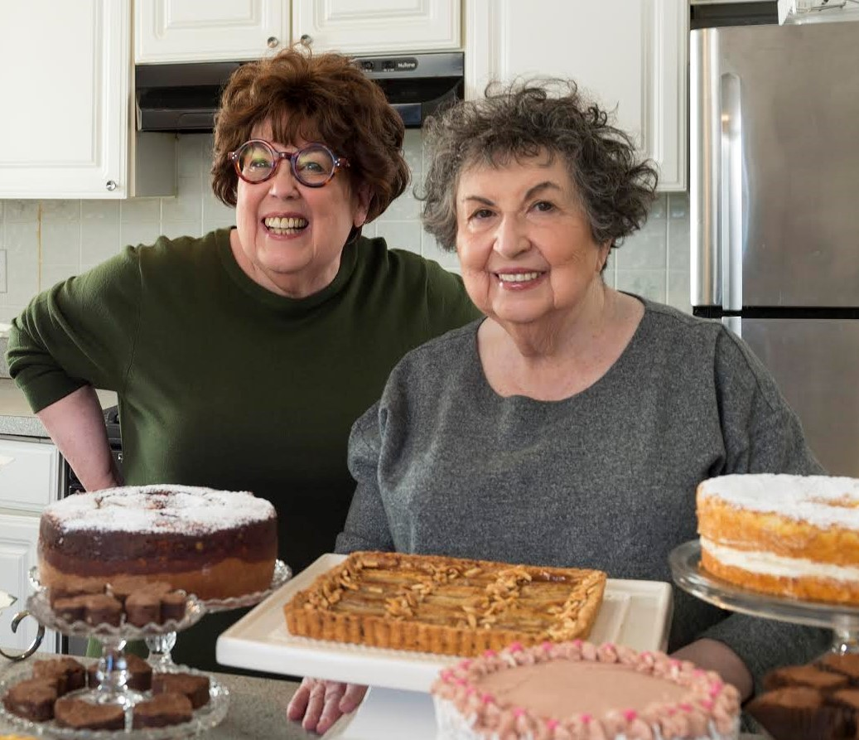
FOR IMMEDIATE RELEASE – Cookbook authors and culinarians Marilyn and Sheila Brass – the Brass Sisters known as “The Food Flirts” (Instagram: @thefoodflirts) – are passionate food explorers of a certain age on a mission to tackle their culinary bucket list one bite at a time. In each episode of this new, six-episode series on PBS, the Boston-based ladies “flirt” their way into chefs’ kitchens to uncover ethnically unique and delicious foods, then head home to experiment with the recipes themselves -- creating cross-cultural culinary mash-ups that viewers can try at home. The first two episodes of THE FOOD FLIRTS premiere Friday, July 28, 2017, 10:00-11:00 p.m. ET (check local listings), after episode eight of the food show phenomenon THE GREAT BRITISH BAKING SHOW.
L.-r. Sisters Marilyn and Sheila Brass are the stars of “The Food Flirts” on PBS

Produced by former Food Network and Cooking Channel executive Bruce Seidel (Instagram: @bruceseidel) of Hot Lemon Productions, the series follows the ladies through mash-up adventures in which a “modern” burger mixes an Indian dosa with a cheeseburger, or a pastrami ramen noodle kugel recipe. The sisters’ fanciful recipes and unscripted realness brings together their unique tastes and unique personalities. Future episodes find the Flirts working culinary magic with baklava crust milk tart, curried golden raisin and cashew rugelach, and “Bunny Chow” pasticcio bread bowls with turmeric hollandaise.

“The Brass Sisters have always been two favorite food people in Boston, and I’m thrilled to bring them to a wider audience with THE FOOD FLIRTS series, in partnership with PBS,” said Seidel. “It’s Two Fat Ladies meets Julia Child – these women have food chops, an alluring sense of humor, and they’re always ready to share wisdom learned along the way!”

The longtime Cambridge. Mass., residents have 130 years of combined baking and cooking experience. Recently named “Food Heroes” for their various food contributions by the Mayor of Cambridge, Marilyn and Sheila are the authors of Baking With The Brass Sisters (St. Martin’s Press 2015), Heirloom Cooking With The Brass Sisters (Black Dog & Leventhal, 2008), and Heirloom Baking With The Brass Sisters (Black Dog & Leventhal, 2006), which was a finalist for the James Beard Foundation award in the Dessert and Baking category. Their books are consistently best-sellers; Food & Wine magazine has called the sisters “dessert geniuses,” and selected their books for its annual The Best of the Best 25 Cookbooks.

The Brass Sisters have appeared on many television programs during their careers. Nationally, the duo headlined a one-hour special on Cooking Channel, “The Brass Sisters Celebrate the Holidays,” hosted the public television show “The Brass Sisters: Queens of Comfort Food” and appeared on “Throwdown with Bobby Flay” on Food Network (beating Iron Chef Flay with their pineapple upside-down cake). Marilynn and Sheila have appeared on local television and radio programs in 22 cities in 15 states, as well as in Canada, and have appeared three times at The James Beard House as part of the Beard on Books series.

The Brass Sisters have curated one of the country’s most comprehensive collections of culinary antiques, including: a copper batterie de cuisine from the early 19th century; chocolate, ice cream, candy, aspic and other food molds; menus; and food advertising signs and artifacts. Their collection includes 6,500 cookbooks, some dating from the 1600s, as well as 1,800 books on antiques.

About PBS FOOD
PBS is the original home of cooking and still offers the very best in food and cooking. PBS FOOD on-air programming this summer includes: THE GREAT BRITISH BAKING SHOW, premiering June 16; FOOD – DELICIOUS SCIENCE, the scientific story of food that reveals the physics, chemistry and biology hidden inside every bite; and season five of MARTHA STEWART’S COOKING SCHOOL, which explores treasured recipes from the Arabian Gulf. From A CHEF'S LIFE to THE MIND OF A CHEF, PBS programs and chefs have received more Peabody Awards, Daytime Emmy® Awards and James Beard Foundation Awards than any other network. Viewers can explore more deeply on the PBS FOOD site pbs.org/food, which brings together the best food and cooking content from across public television with award-winning digital videos, recipes, articles and more.

About PBS
PBS, with nearly 350 member stations, offers all Americans the opportunity to explore new ideas and new worlds through television and digital content. Each month, PBS reaches nearly 100 million people through television and nearly 28 million people online, inviting them to experience the worlds of science, history, nature and public affairs; to hear diverse viewpoints; and to take front row seats to world-class drama and performances. PBS’ broad array of programs has been consistently honored by the industry’s most coveted award competitions. Teachers of children from pre-K through 12th grade turn to PBS for digital content and services that help bring classroom lessons to life. Decades of research confirms that PBS’ premier children’s media service, PBS KIDS, helps children build critical literacy, math and social-emotional skills, enabling them to find success in school and life. Delivered through member stations, PBS KIDS offers high-quality educational content on TV – including a new 24/7 channel, online at pbskids.org, via an array of mobile apps and in communities across America. More information about PBS is available at www.pbs.org, one of the leading dot-org websites on the internet, or by following PBS on Twitter, Facebook or through our apps for mobile and connected devices. Specific program information and updates for press are available at pbs.org/pressroom or by following PBS Pressroom on Twitter.

About Hot Lemon:
Hot Lemon is a Los Angeles-based lifestyle industry media and agency leader connecting consumers to culinary and lifestyle experiences through television, digital and event production, culinary connections and lifestyle and media consultation. Hot Lemon was founded in 2014 by award-winning eminent culinary voice and lifestyle trend leader Bruce Seidel. For current Hot Lemon projects and more information, please visit our website and follow Hot Lemon on Twitter, and Instagram.

# # #

PR Contacts
FOR PBS: John Michael Kennedy, Goodman Media International, jmkennedy@goodmanmedia.com or 857-293-0882.
FOR HOT LEMON: Carrie Welch, Little Green Pickle, carrie@littlegreenpickle.com

