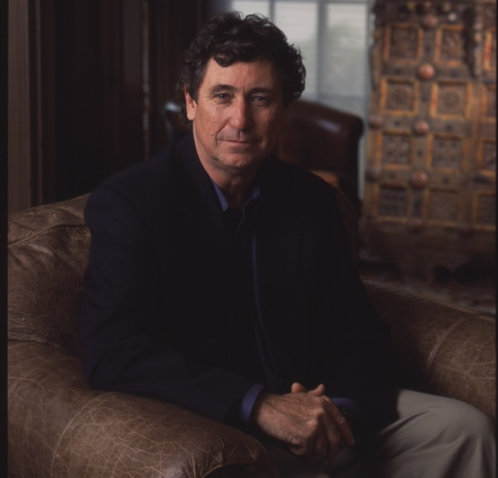
David Fanning
Executive Producer, FRONTLINE

David Fanning has been executive producer of FRONTLINE since its first season in 1983. After 30 seasons and more than 530 films, FRONTLINE remains America’s longest-running investigative documentary series on television. The series has won all of the major awards for broadcast journalism: 46 Emmys, including a special Emmy Award for excellence in documentary filmmaking; 27 duPont-Columbia University Awards; 15 Peabody Awards; 11 Robert F. Kennedy Journalism Awards; eight Television Critics Awards; and eight Banff Television Awards. In 1990 and in 1996, FRONTLINE was recognized with the Gold Baton — the highest duPont-Columbia Award — for its “total contribution to the world of exceptional television.” In 2002, the series was honored with an unprecedented third Gold Baton for its post-September 11 coverage, a series of seven hour-long documentaries on the origins and impact of terrorism.

Fanning — recently awarded the 2010 Goldsmith Career Award for Excellence in Journalism — began his filmmaking career as a young journalist in South Africa. His first films, Amabandla AmaAfrika (1970) and The Church and Apartheid (1972), produced for BBC-TV, dealt with race and religion in his troubled homeland. He came to the U.S. in 1973 and began producing and directing local and national documentaries for KOCE, a public television station in California. His film Deep South, Deep North (1973) was a PBS/BBC co-production and the first in a long succession of collaborations between U.S. and European television. In 1977, Fanning came to WGBH Boston to start the international documentary series WORLD. As executive producer, he produced and presented more than 50 films for PBS in five years. With director Antony Thomas, Fanning produced and co-wrote Death of a Princess (1980). Then in 1982, again with Thomas, he produced Frank Terpil: Confessions of a Dangerous Man, which won the Emmy Award for best investigative documentary.

In 1982, Fanning began the development of FRONTLINE. The series has worked with well over 200 producers and as many journalists, covering a wide range of domestic and foreign stories. Its signature has been to combine good reporting with good filmmaking. Reviewers and critics have been lavish in their praise, calling it “the most consistently important weekly hour on television” (Cleveland Plain Dealer) and “one of the most distinguished in television history” (The Philadelphia Inquirer).

With Fanning’s enthusiastic encouragement, one of FRONTLINE’s singular achievements has been its embrace of the internet. In 1995, FRONTLINE developed one of the first deep-content websites in history. By putting interviews, documents and additional editorial materials on the web, the series made its journalism transparent and changed the nature and content of broadcast journalism. Rather than an ephemeral one-time transmission, the documentaries and all their ancillary materials are now preserved on the series’ website. And, as of 2009, there are more than 85 hours of full-length documentaries streamed on the site, one of the largest sites of its kind. “This is the great promise of public media,” says Fanning. “This is where we hold our work for the future, our public library, our contribution to the intellectual commons.”

In 1987, Fanning created the PBS series ADVENTURE, which ran for five seasons and aired 50 programs. With adventurers Lorne and Lawrence Blair, Fanning produced RING OF FIRE, an epic four-part travel series that explored the Indonesian archipelago. The series produced films with travelers and writers from Peter Mathiessen to Gerald Durrell.

In 2001, Fanning’s determination to bring more foreign stories to American audiences led to the creation of FRONTLINE/World, a television magazine-style series of programs designed to encourage a new, younger generation of producers and reporters. The emphasis has been on bringing a largely unreported world to viewers through a series of journeys and encounters. Like its counterpart series, FRONTLINE/World has made a deep commitment to its website (www.pbs.org/frontlineworld/), offering original web-exclusive video and reporting by graduate journalism students and an international network of correspondents. Fanning sees it as a prototype for the future, and a place to build a community of enterprising journalists.

In 2004, Fanning received the Columbia Journalism Award, the highest honor awarded by the faculty of the Columbia University Graduate School of Journalism, recognizing “Singular journalistic performance in the public interest … David Fanning and his signature program, FRONTLINE, have turned a commitment to probing journalism and public service into an enduring national conversation, without which far too many important issues would remain veiled or hidden altogether.”

Fanning and his wife, the television writer and producer Renata Simone, live in Marblehead, Mass.


Raney Aronson-Rath
Deputy Executive Producer, FRONTLINE

As deputy executive producer for PBS’ flagship public affairs documentary series FRONTLINE, Raney Aronson-Rath guides the editorial development and execution of the series, from primetime television broadcasts to multiplatform initiatives. With executive producer David Fanning, she oversees all phases of production and runs the daily editorial management of the series, as well as FRONTLINE’s new monthly magazine program. Instrumental in spearheading the magazine launch, Aronson-Rath works to re-imagine long-form documentary while maintaining the excellence in journalism and production for which FRONTLINE is known.

Since joining FRONTLINE in 2007, Aronson-Rath has expanded the series’ reach and reporting capabilities. Under her leadership, FRONTLINE has significantly grown its broadcast and digital audiences. Aronson-Rath has also developed and managed more than a dozen in-depth, cross-platform journalism partnerships with some of the nation’s premiere news outlets, including ProPublica, American Public Media’s “Marketplace,” PBS NEWSHOUR, CBC Television and most recently ESPN. Committed to exploring innovative approaches to long-form storytelling, Aronson-Rath has helmed a number of experimental, multiplatform projects, including the Polk Award-winning “Law & Disorder,” a yearlong investigation into questionable police shootings in the wake of Hurricane Katrina; “Post Mortem,” an exposé on death investigation in America; “Big Money 2012,” an examination of campaign finance following the Citizens United Supreme Court case; and, most recently, “League of Denial: The NFL’s Concussion Crisis,” a joint project with ESPN investigating the ongoing story of concussions in the NFL.

Before helping to manage the series, Aronson-Rath produced, directed and wrote several award-winning FRONTLINE films, including “News War,” “The Last Abortion Clinic” and “The Jesus Factor.” Prior to joining FRONTLINE, she worked on award-winning series at ABC News, The Wall Street Journal and MSNBC. Early in her career, while living in Taipei, she was a newspaper reporter for The China Post.

Aronson-Rath has a bachelor’s degree in South Asian studies and history from the University of Wisconsin. She received her master’s from the Columbia University Graduate School of Journalism.

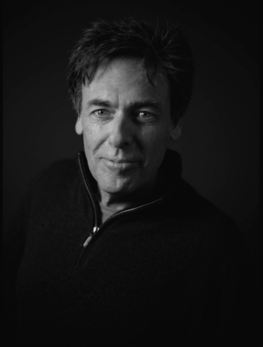
Michael Kirk
Producer, Director, Writer

Award-winning documentary filmmaker Michael Kirk has produced more than 200 national television programs. A former Nieman Fellow in Journalism at Harvard University, Kirk was the senior producer of FRONTLINE from the series’ inception in 1983 until the fall of 1987, when he created his own production company, The Kirk Documentary Group.

Kirk is currently in production on two one-hour programs in association with ESPN titled “League of Denial: The NFL’s Concussion Crisis” for FRONTLINE. His most recent FRONTLINE productions include “Cliffhanger” (spring 2013), a look into the nation’s fiscal crises and the inside history of how Washington has failed to solve the country’s problems of debt and deficit; “Inside Obama’s Presidency” (winter 2013), an in-depth examination of the political battles of Barack Obama’s first term; “The Choice 2012,” the FRONTLINE special that examined the political and personal biographies of presidential candidates Barack Obama and Mitt Romney — he also produced the special in 2008, which covered Barack Obama and John McCain, and the 2000 version that featured the stories of George W. Bush and Al Gore; “Money, Power and Wall Street” (Polk Award), the four-hour series that tells the inside story of the financial crisis; “Top Secret America,” a year-long examination into the huge, unwieldy, top-secret world the government has created since 9/11; “The Anthrax Files,” a reinvestigation into the Anthrax case a decade after the attacks; “Obama’s Deal,” a look at the push to reform health care and three investigations of the recent financial crisis: “The Warning” (Emmy Award), the unique story of a regulator’s warning about the dangers of derivatives in the 1990s, “Breaking the Bank,” an inside look into the complicated financial and political web threatening Bank of America, and “Inside the Meltdown,” a major investigation into the collapse of the American economy.

In the spring of 2008, he produced, directed and wrote the four-and-a-half-hour, two-part special “Bush’s War” (Emmy Award). He has produced 10 films on the “war on terror,” including “Cheney’s Law” (Peabody Award), “Endgame,” “The Lost Year in Iraq (Emmy Award),” “Rumsfeld’s War,” “The Torture Question” (Emmy Award), “The Dark Side,” “The War Behind Closed Doors,” an analysis of the political infighting that led to the war with Iraq, and “The Man Who Knew,” the extraordinary saga of FBI Agent John O’Neil. Kirk’s long relationship with FRONTLINE also includes the Peabody Award-winning “Waco — The Inside Story” (1995), a behind-the-scenes look at the FBI siege of the Branch Davidian compound; and the EMMY Award-winning “The Kevorkian File” (1994), an in-depth examination of Dr. Jack Kevorkian’s controversial record and cases.

Kirk also produces programs that concentrate on social and cultural issues in America. “Death by Fire” is the story of a controversial case of one man at the center of the death penalty debate; “Caring for Your Parents” tells the story of five families caring for their elderly parents; “Navy Blues” (Emmy Award) examines gender politics in the military; “The Way the Music Died” is a behind-the-scenes report on the recording industry; and the groundbreaking “Misunderstood Minds” is a two-year examination of the personal stories of five families confronting the challenges of a child’s learning disabilities.

The winner of every major award in journalism, including The Peabody Award (2), The George Polk Award (1), duPont-Columbia Award (2), eleven EMMYs, and six Writer’s Guild of America awards, Kirk frequently lectures on topics ranging from current events to issues confronting journalism. He has appeared on a variety of television programs, including “Charlie Rose”; “The Today Show”; “Bill O’Reilly Show”; CNN, MSNBC and FOX news programs and a wide variety of radio broadcasts, including “Fresh Air” on NPR and hundreds of others.
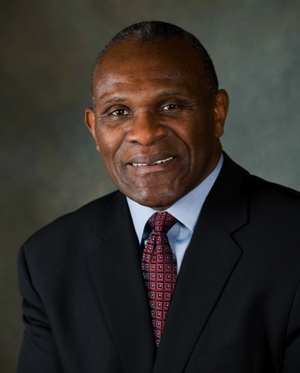
Harry Carson
Legendary Former NFL Linebacker

Harry Carson’s 13-year stint with the New York Giants is one of the longest tenures in club history. The indestructible former linebacker served as team captain for 10 of his 13 seasons, including the 1986 season when the Giants defeated the Denver Broncos 39-20 in Super Bowl XXI. Rated the #1 “Inside Linebacker” in NFL history according to Pro Football Weekly, Carson was named to the All-Rookie Team after his first NFL season. Subsequently, during his NFL career, he was named to the All-NFL Team seven times, the All-NFC Team eight times, and NFC Linebacker of the Year twice. He once made an amazing 25 tackles in a Monday Night Football game against the Green Bay Packers. With performances like that, he was selected by his peers to play in the NFC-AFC Pro Bowl nine times. He is among the top 250 players ever to play professional football with his induction as the 231st member of the Pro Football Hall of Fame. Bill Belichick, an assistant coach for the Giants for 12 years, considers Carson “the best all-around linebacker” he ever coached.

Carson set the pace for his outstanding career while a student at South Carolina State University, where he earned a Bachelor of Science Degree in Education. He continued his graduate studies at South Carolina State and Fairleigh Dickinson University. Before college, Carson attended Wilson Senior High and McClenaghan High Schools in Florence, South Carolina. There he served as senior class president, co-chairman of the school’s bi-racial committee and ROTC commander.

While at South Carolina State, the two-time captain never missed a game during his four seasons as a defensive lineman for the Bulldogs. During his college football career, Carson received honors for the Kodak All-American Football Team, NAIA All-American Team, Pittsburgh Courier All-American Team, All-State (South Carolina), All Mid-Eastern Athletic Conference and MEAC Defensive Player of the Year twice. He excelled academically as well, winning awards for the highest academic average amongst Black College All-Americans.

Carson has been named to the Sheridan Broadcasting Network 100 Year Anniversary Black College All-American Team. He is a member of the All Division II College Football Team of the Quarter Century (1975-1999) and he has been recognized as the South Carolina College Athlete of the Millennium by The State Newspaper of South Carolina. Carson has also been recognized as a Kentucky Colonel and he has been presented The Order of the Palmetto, the highest honor given to a native of South Carolina.

The end of Carson’s football career marked the beginning of his career in sports broadcasting. Retiring from the NFL after the 1988 season, Carson co-hosted CNN’s NFL Preview, appeared on WCBS as a broadcast analyst and was a special correspondent for playoff and Super Bowl on ABC-TV’s Good Morning America. Carson has worked as a broadcast analyst with ABC Sports College Football, as well as New York’s Madison Square Garden Network. He is currently a co-host of the New York Giants game day magazine program “Giants Opening Drive Live.”

Carson is CEO and president of Harry Carson Inc., a sports consulting and promotions company. The company works with media outlets, educational sources and corporations on sports and non-sports related issues. Harry Carson Inc. provides expert television, radio, print media and internet commentary on sports-related matters. His company is a provider of former professional athletes to schools and corporations to deliver motivational and inspirational sports theme presentations.

Carson serves as executive director of the Fritz Pollard Alliance. The alliance is an organization that represents all National Football League minority coaches, coordinators, scouts, player personnel and game day officials dedicated to creating a greater sense of racial and gender diversity within non-player roles within the National Football League.

Carson is the author of two books. Point of Attack was published in 1985 by McGraw-Hill; his second and more comprehensive book reflecting on his career and life after football, Captain for Life, was published by St. Martin’s Press in August 2011.

He is affiliated with many organizations and is involved with numerous charities such as The Miami Project to Cure Paralysis, The United Way, The United Way’s Celebrity Read Program, The Boys & Girls Clubs of America, Boys Scouts of America, The Young Father’s Program (at UMDNJ), The Literacy Council of New Jersey, Habitat for Humanity, The Tomorrow’s Children Fund, MANetc, Inc. and The Autism Coalition.

Carson is a lecturer and motivational speaker to diverse groups that range from juvenile and prison inmates to high school scholars, from college athletes to corporate executives and political leaders.

In his spare time, he enjoys enhancing his own wellness and physical fitness as well as mentoring young people and current athletes, playing golf, bass fishing, auto racing and target shooting.

Carson is married to Maribel and is the father of Aja Gurley Carson (mother of Andrew, Jamison and Kellen), Dr. Donald Carson and United States Marine Corps Lance Corporal Kip (“Lucky”) Baker-Carson.
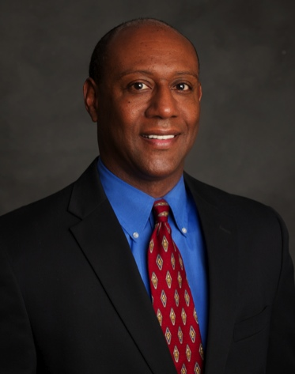
Dwayne Bray
Senior Coordinating Producer, ESPN

Dwayne Bray is journalist with experience in print, digital and electronic media. He has reported and edited stories on hard news and sports, on both the local and national levels. Currently, he is the senior coordinating producer for ESPN’s Outside the Lines investigative brand, content that appears on “Outside the Lines,” “SportsCenter,” ESPN.com, ESPN the Magazine and other platforms at the giant sports media company.

Bray previously was a journalist at various newspapers across the country: the Dallas Morning News, the Los Angeles Times, the Dayton Daily News and the Medina (Ohio) Gazette. He has written one book, The Gift: Learning to Appreciate the Value of Life (Longstreet Press, 1999), and numerous articles for magazines and other periodicals.

At ESPN, Bray manages the television Enterprise Reporting Unit, which is responsible for the enterprise and investigative reporting for the cable network. Under Bray’s leadership, the unit won the 2011 Edward R. Murrow Award for Video Investigative Reporting for a story on human trafficking and the World Cup. That honor marked the first time a sports story was awarded the Murrow for investigative reporting. The Enterprise Unit also captured Murrow awards for Radio Sports Reporting in 2011 and 2013. Under Bray’s tenure, the unit also has also been recognized with a Gracie for Outstanding Sports Program, an NABJ Salute to Excellence Award for Radio Sports Reporting and three national Emmy nominations for Sports Journalism.

Before joining ESPN Television in October 2006, Bray spent 18 years in print journalism. As a reporter, he was nominated three times for the Pulitzer Prize and was a 1998 finalist for the Livingston Award honoring the nation’s best young journalists. A series of stories he launched in Dayton on the recruitment of foreign basketball players was a Pulitzer Prize finalist for Investigative Reporting in 2001.

Bray was deputy managing editor of the Dallas Morning News, where he managed the metro, suburban and religion departments. Before that, Bray was sports editor at the Morning News, and his initial duties at the Dallas paper included overseeing coverage of the Dallas Cowboys and the Texas Rangers, as well as rodeo, auto racing and soccer.

Bray started his career as a business reporter at the Medina Gazette (1988). He then covered the police beat at the Dayton Daily News (1989-1993). His reporting on excessive use of force by some Dayton police officers earned him the award for Best Investigative Series from the Associated Press Society of Ohio. He was a courts reporter for the Los Angeles Times (1993-1995), where he covered civil and criminal legal matters in Simi Valley and the rest of Ventura County shortly after the verdict was handed down in the case of the officers accused of beating Rodney King. He contributed to the Times’ coverage of the OJ Simpson murder trial. Bray left Los Angeles and returned to Dayton, Ohio (1995-2000) as assistant metro editor and then sports editor.

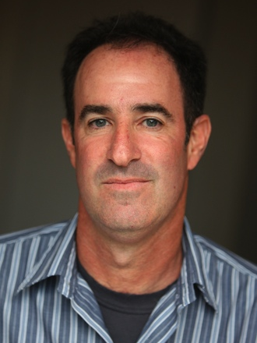
Steve Fainaru
Investigative Reporter, ESPN

Steve Fainaru is an investigative reporter for ESPN’s investigations/enterprise unit.

He previously worked 10 years at the Washington Post, where he was awarded the 2008 Pulitzer Prize for international reporting for his investigation into abuses committed by private security contractors in Iraq. He also received the Overseas Press Club’s Hal Boyle award for best newspaper or wire service reporting from abroad.

From 2011-12, Fainaru worked as managing editor for news and interim editor of the Bay Citizen, a non-profit online news organization based in San Francisco.

While at the Post, Fainaru covered sports investigations, Iraq, the Mexican drug war and civil liberties and the War on Terror. He was Pulitzer finalist in 2006 for his coverage of U.S. soldiers as they contended with the escalation of a bloody insurgency.

Fainaru also worked previously at the Boston Globe, where he covered the Boston Red Sox, Wall Street and Latin America. He was a sportswriter for the Hartford Courant and San Jose Mercury News. He graduated from the University of Missouri School of Journalism.


Mark Fainaru-Wada
Investigative Reporter, ESPN

Mark Fainaru-Wada is an investigative reporter for ESPN. Prior to that, he worked in the same capacity at the San Francisco Chronicle.

Fainaru-Wada and Chronicle colleague Lance Williams earned a string of national honors in 2004 and 2005, including the prestigious George Polk award, for their coverage of the BALCO steroids scandal.

In March 2006, Fainaru-Wada and Williams published Game of Shadows: Barry Bonds, BALCO, and the Steroids Scandal That Rocked Professional Sports. (Gotham) The book became an immediate New York Times bestseller and prompted Major League Baseball to investigate steroid use in its sport.

Fainaru-Wada is a member of ESPN’s investigations/enterprise unit, which produces work for the award-winning program “Outside the Lines.” He and his colleague/brother, Pulitzer Prize-winning reporter Steve Fainaru, are currently working on a book about the NFL and concussions.

Fainaru-Wada previously worked for the San Francisco Examiner, Scripps Howard News Service, The National, the Los Angeles Daily News and the Knoxville (Tenn.) News-Sentinel.

Fainaru-Wada is a graduate of Northwestern’s Medill School of Journalism.

