“Generation Like” TCA Panelist Biographies


Raney Aronson-Rath
Deputy executive producer, FRONTLINE

As deputy executive producer for PBS’ flagship public affairs documentary series FRONTLINE, Raney Aronson-Rath guides the editorial development and execution of the series, from primetime television broadcasts to multiplatform initiatives. With executive producer David Fanning, she oversees all phases of production and runs the daily editorial management of the series, as well as FRONTLINE’s new monthly magazine program. Instrumental in spearheading the magazine launch, Aronson-Rath works to re-imagine long-form documentary while maintaining the excellence in journalism and production for which FRONTLINE is known.

Since joining FRONTLINE in 2007, Aronson-Rath has expanded the series’ reach and reporting capabilities. Under her leadership, FRONTLINE has significantly grown its broadcast and digital audiences. Aronson-Rath has also developed and managed more than a dozen in-depth, cross-platform journalism partnerships with some of the nation’s premiere news outlets, including ProPublica, American Public Media’s “Marketplace,” PBS NEWSHOUR, CBC Television and, most recently, ESPN. Committed to exploring innovative approaches to long-form storytelling, Aronson-Rath has helmed a number of experimental, multiplatform projects, including the Polk Award-winning “Law & Disorder,” a yearlong investigation into questionable police shootings in the wake of Hurricane Katrina; “Post Mortem,” an exposé on death investigation in America; “Big Money 2012,” an examination of campaign finance following the Citizens United Supreme Court case; and, most recently, “League of Denial: The NFL’s Concussion Crisis,” a joint project with ESPN investigating the ongoing story of concussions in the NFL.

Before helping to manage the series, Aronson-Rath produced, directed and wrote several award-winning FRONTLINE films, including “News War,” “The Last Abortion Clinic” and “The Jesus Factor.” Prior to joining FRONTLINE, she worked on award-winning series at ABC News, The Wall Street Journal and MSNBC. Early in her career, while living in Taipei, she was a newspaper reporter for The China Post.

Aronson-Rath has a bachelor’s degree in South Asian studies and history from the University of Wisconsin. She received her master’s from the Columbia University Graduate School of Journalism.

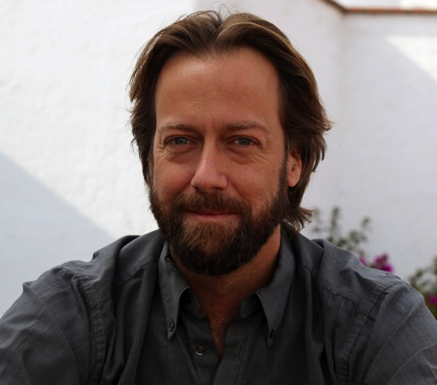
Frank Koughan
Writer and director

Frank Koughan is a journalist and documentary filmmaker whose work has appeared on PBS, CBS, TruTV and the History Channel. He has produced documentaries for Dan Rather, Bill Moyers and, most recently, PBS’s FRONTLINE (“Dropout Nation,” “Middle School Moment,” “Raising Adam Lanza,” “A Death in St. Augustine”). He spent eight years producing stories for CBS News’ “60 Minutes,” has written for Mother Jones Magazine and is a co-author of City Adrift: New Orleans Before and After Katrina, published in 2007 by LSU Press. Koughan has won numerous awards, including the George Polk Award, two Investigative Reporters and Editors Awards, a duPont–Columbia Silver Baton, and two News & Documentary Emmys. He began his career as a researcher and fact-checker at a number of magazines, including Harper’s, Vanity Fair and Spy.

Koughan was raised in Swampscott, Massachusetts, and is a graduate of Boston College. He currently resides in New York City and Querétaro, Mexico.

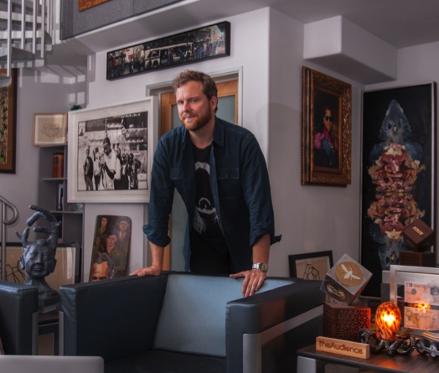
Oliver Luckett
Founder and CEO, theAudience

theAudience is the leading content programming and distribution network built for entertainment brands to engage large-scale fan bases and manage successful businesses across social media platforms. Using a systematic, analytics-based process, theAudience leverages network scale to consistently drive deeper fan relationships and incremental monetization opportunities. theAudience currently reaches more than 800 million people on a monthly basis.

Prior to theAudience, Oliver co-founded DigiSynd, a social media outlet that was ultimately acquired by the Walt Disney Company. Luckett served at Disney as co-head of innovation, overseeing Disney brands in social media?.

Additional companies that Luckett founded or in which he held senior positions: Revver, Inc., a video sharing service of which he was co-founder and senior vice president of network development; iBlast, where he was co-founder and chief technology officer; Anschutz Digital Media, where he was vice president of network development; Qwest Communications, a fiber optic network of which he was chief IP services architect; and Revilopark, a consulting firm.

Luckett was also heavily involved in the 2004 presidential election through his Internet efforts with Norman Lear’s non-partisan “Declare Yourself” campaign, which achieved more than one million online voter registrations through partnerships with Yahoo!, Google, IAC/InterActiveCorp and Friendster.


Tyler Oakley
YouTube personality

Tyler Oakley is a YouTube personality with more than 3.2 million subscribers and 100 million views. From discussing boy bands and pop culture to sponsored collaborations and interviews, he does it all in his weekly videos.

Oakley began making videos in 2007 when he was a freshman at Michigan State University. Today he is described as having “one of the loudest voices on YouTube,” and Bloomberg defines him as a “YouTube sensation.”

Beyond YouTube, Oakley also posts regularly and has developed a large following on every major social networking site, including Facebook, Twitter, Tumblr and Instagram.

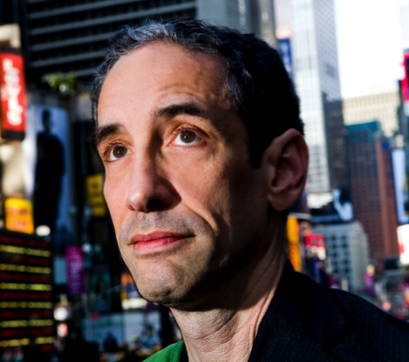
Doug Rushkoff
Writer and correspondent

Winner of the Media Ecology Association’s first Neil Postman award for Career Achievement in Public Intellectual Activity, Dr. Douglas Rushkoff is an author, teacher and documentarian who focuses on the ways people, cultures and institutions create, share and influence each other’s values. He is technology and media commentator for CNN, digital literacy advocate for Codecademy.com and has taught and lectured around the world about media, technology, culture and economics.

His new book, Present Shock: When Everything Happens Now, explores the always-on, simultaneous society in which we live, as well as how this new temporal landscape influences media, culture, economics, politics and meaning. His previous best-selling books on media and popular culture have been translated to more than 30 languages. They include Program or Be Programmed: Ten Commands for a Digital Age, a followup to his Frontline documentary, “Digital Nation,” and Life Inc, an analysis of the corporate spectacle, which was also made into a short, award-winning film.

His other books include Cyberia, Media Virus, Playing the Future, Nothing Sacred: The Truth About Judaism, Get Back in the Box: Innovation from the Inside Out and Coercion, winner of the Marshall McLuhan Award for best media book. Rushkoff also wrote the acclaimed novels Ecstasy Club and Exit Strategy and graphic novel Club Zero-G. He wrote the graphic novels Testament and A.D.D. for Vertigo.

He has written and hosted three award-winning PBS FRONTLINE documentaries —“The Merchants of Cool,” about the influence of corporations on youth culture; “The Persuaders,” about the cluttered landscape of marketing and new efforts to overcome consumer resistance; and most recently, “Digital Nation,” about life on the virtual frontier.

He has served on the National Advisory Board of the National Association for Media Literacy Education, The Harrington School of Communications and Media at University of Rhode Island, the Board of Directors of the Media Ecology Association, The Center for Cognitive Liberty and Ethics, the United Nations Commission on World Culture, and as a founding member of Technorealism. He is on the Advisory Boards of MeetUp.com, Liquid Information, Artizens, and World Wide Workshop.

Rushkoff earned his PhD in New Media and Digital Culture from Utrecht University with a dissertation entitled Monopoly Moneys: The media environment of corporatism and the player’s way out. He graduated magna cum laude from Princeton University, received an MFA in Directing from California Institute of the Arts, a post-graduate fellowship (MFA) from The American Film Institute, a Fulbright award to lecture on narrative in New Zealand, and a Director’s Grant from the Academy of Motion Picture Arts and Sciences. He has worked as a certified stage fight choreographer, an SAT tutor and as keyboardist for the industrial band PsychicTV

